**Problem 2**

Given two [strings](http://rosalind.info/glossary/string/) s and t of equal length, the [**Hamming distance**](http://rosalind.info/glossary/hamming-distance/) between s and t, denoted dH(s,t), is the number of corresponding symbols that differ in s and t. See [**Figure 2**](http://rosalind.info/media/problems/hamm/Hamming_distance.png).

**Given:** Two [DNA strings](http://rosalind.info/glossary/dna-string/) s and t of equal length (not exceeding 1 [kbp](http://rosalind.info/glossary/kbp/)).

**Return:** The Hamming distance dH(s,t).

**Sample Dataset**

**GAGCCTACTAACGGGAT**

**CATCGTAATGACGGCCT**

**Sample Output**

**7**

**[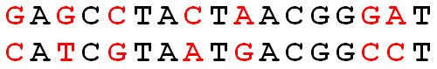](http://rosalind.info/media/problems/hamm/Hamming_distance.png)**

**Figure 2**. The Hamming distance between these two strings is 7. Mismatched symbols are colored red.