Step 1: Log into Azure Portal and create New User.

<https://portal.azure.com/#home>

Then search or Navigate to create a new user as below:

[**https://portal.azure.com/#view/Microsoft_AAD_UsersAndTenants/UserManagementMenuBlade/~/AllUsers**](https://portal.azure.com/#view/Microsoft_AAD_UsersAndTenants/UserManagementMenuBlade/~/AllUsers)

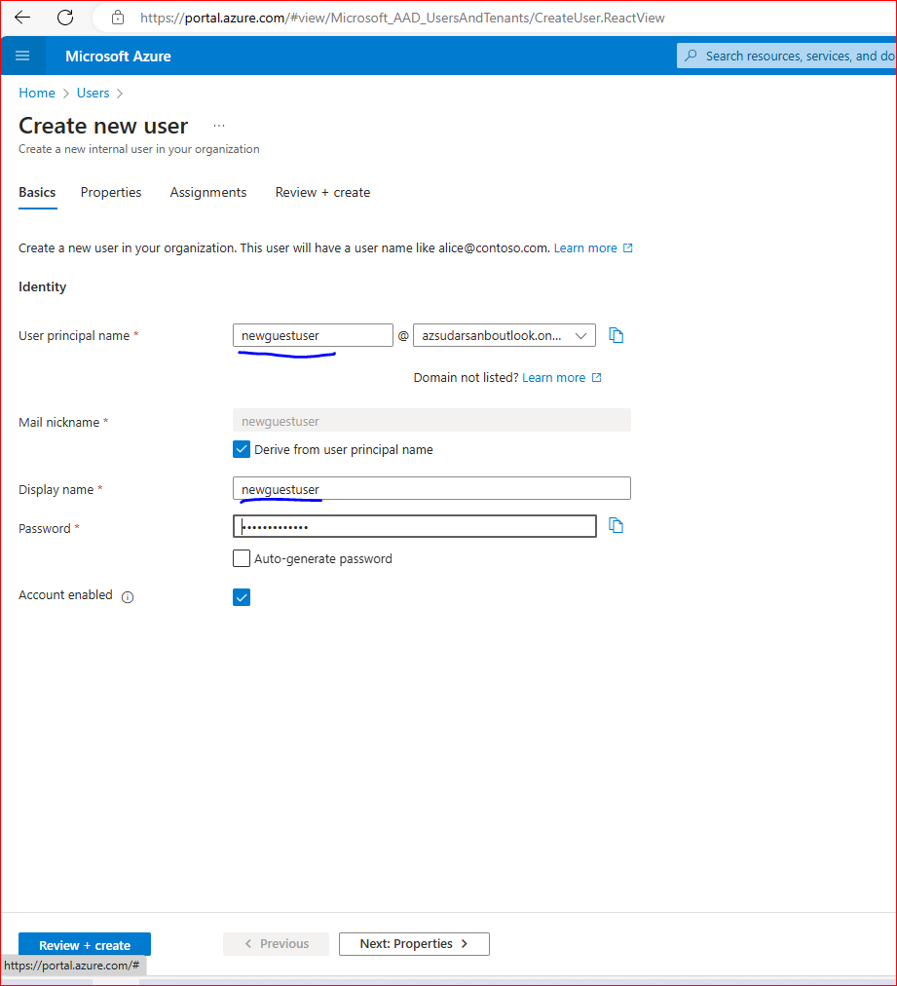

Click on “Review + Create”

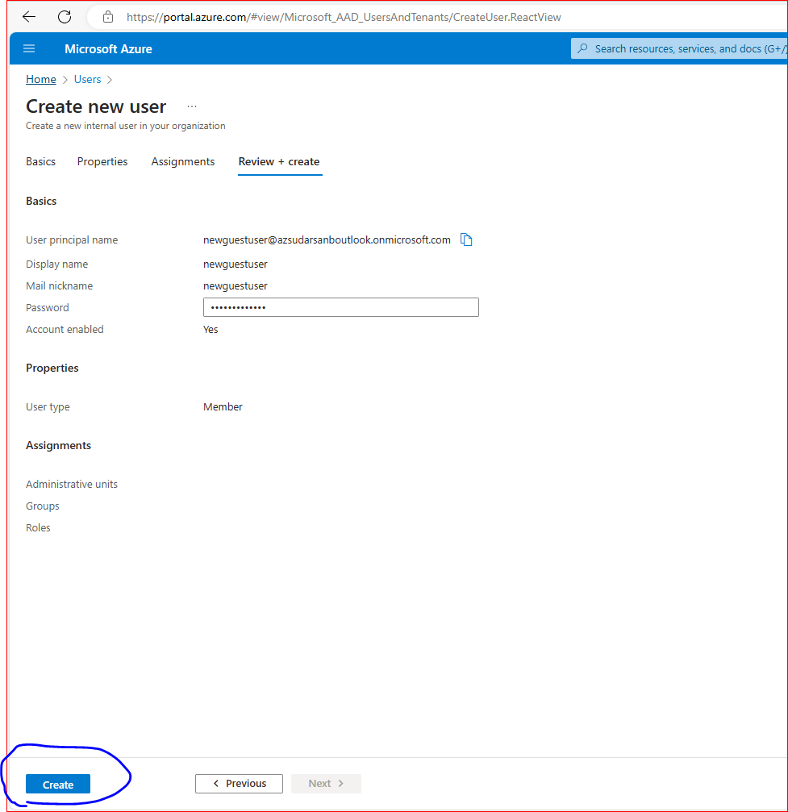

Now go back to the user screen and refresh to ensure the user has been created successfully as below:

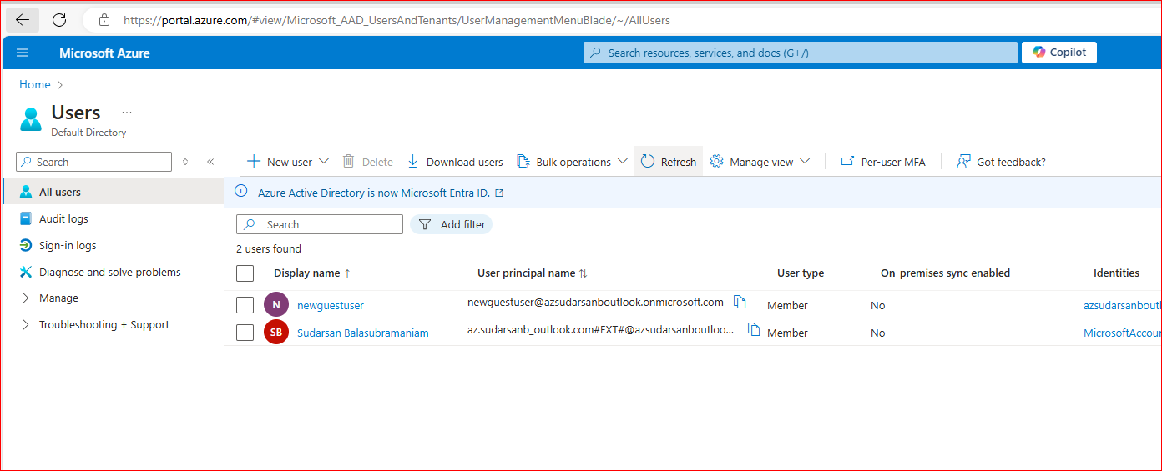

Step 2: Give Global Administrator Access to the Newly created user as below:

Click on the newly created user.

As highlighted below, “Assigned Roles” should say ‘0’, now click on this ‘0’ and go to next screen:

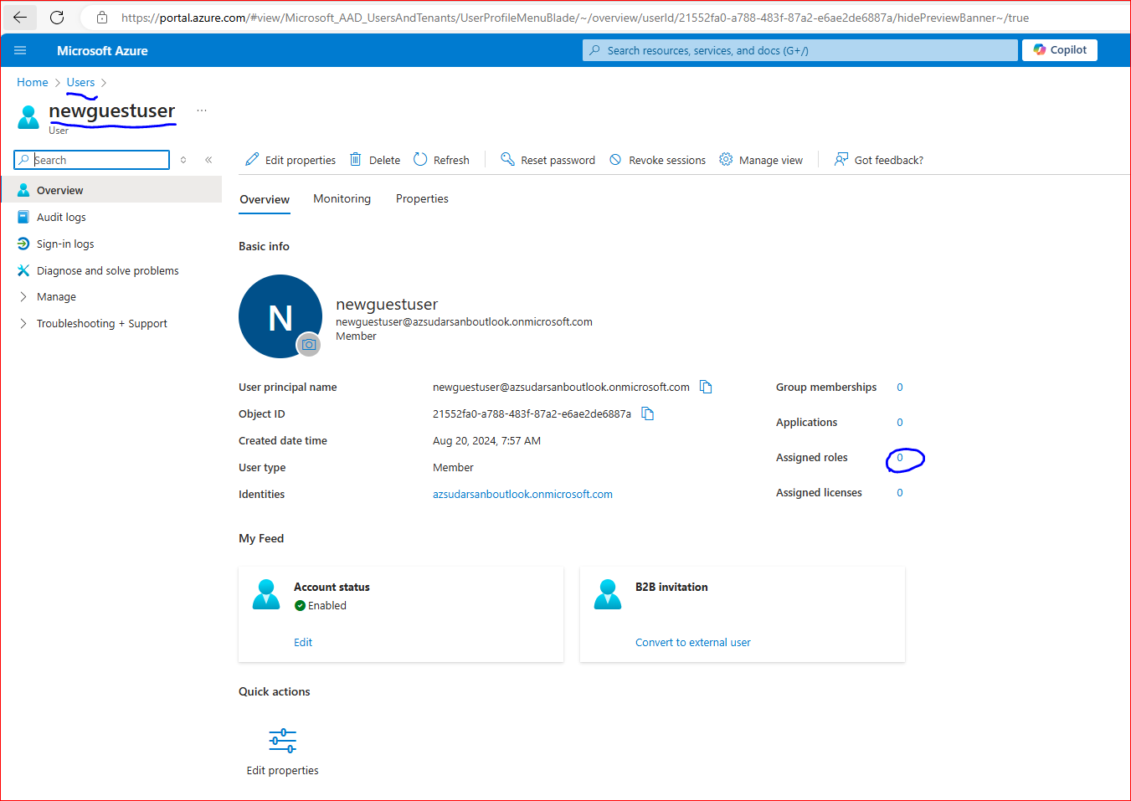

Now in the next screen, click on “Add Assignments” and then search for “Global” and select “Global Administrator” as below and ADD it to the new user.

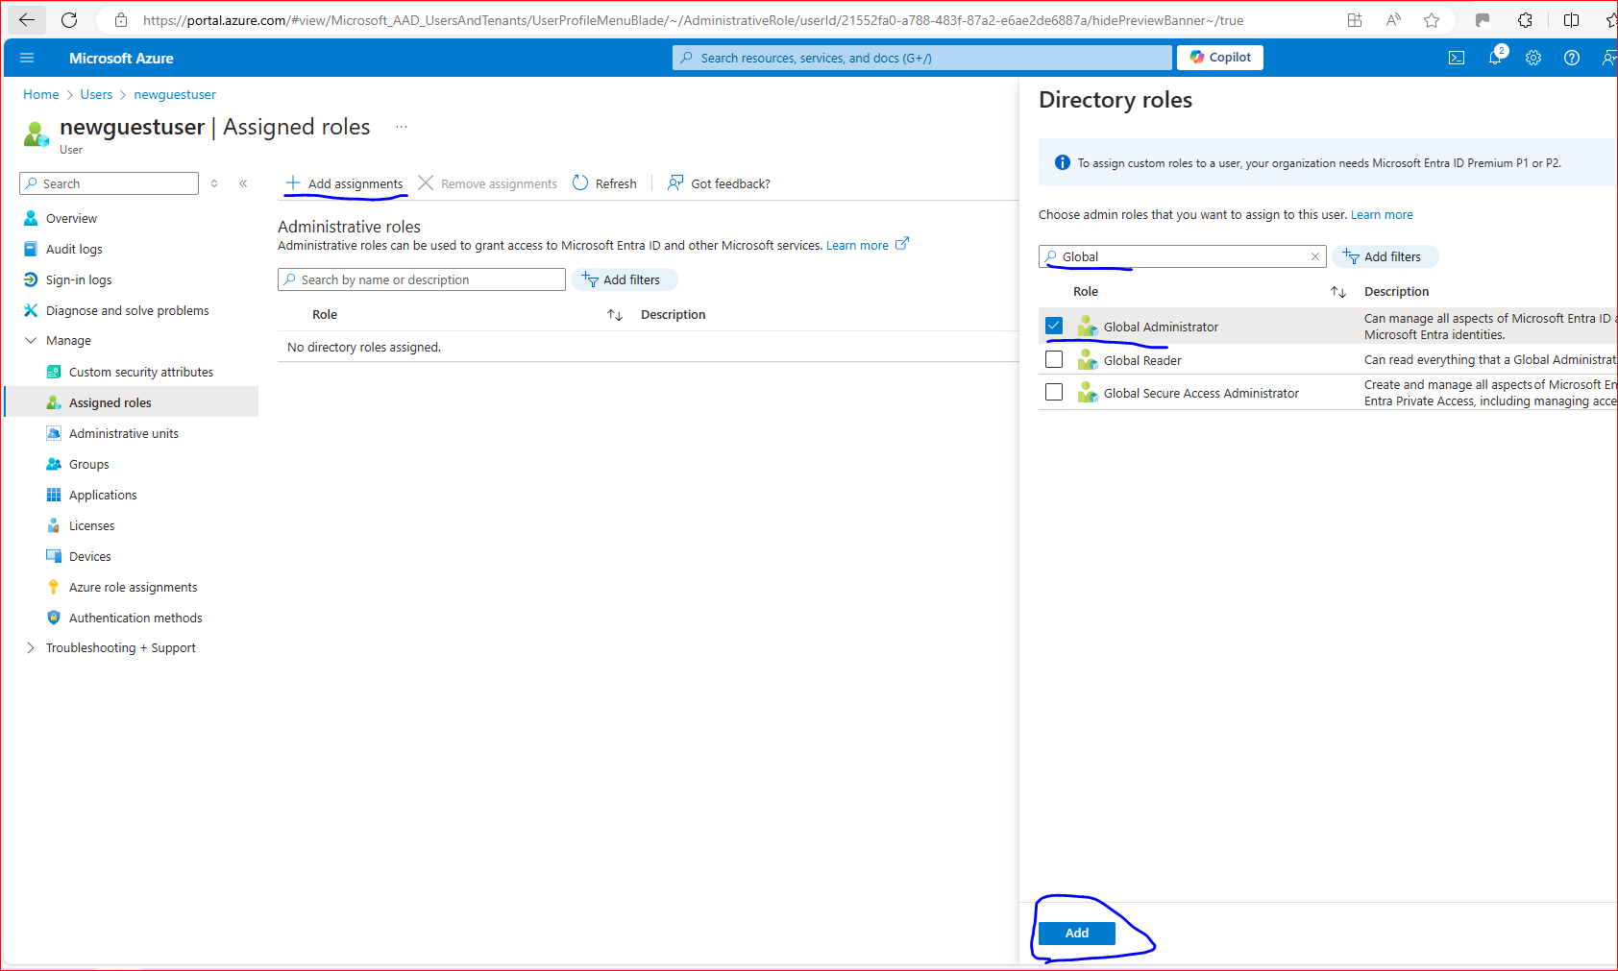

Now once this has been added successful, you should be able to see the assigned role as below:

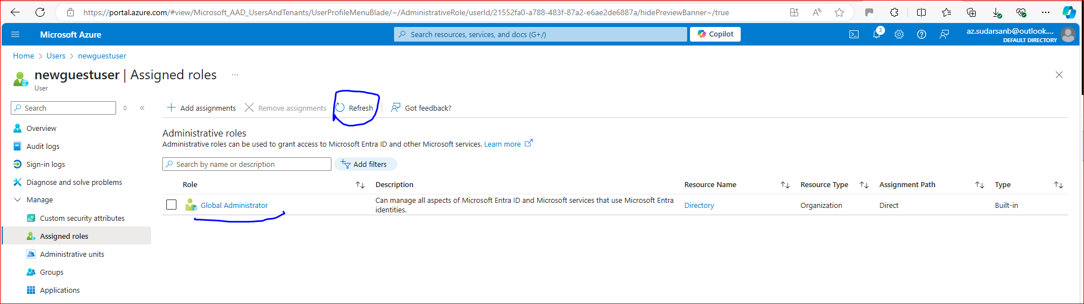

And this can be confirmed by looking that now Assigned roles will be updated to ‘1’

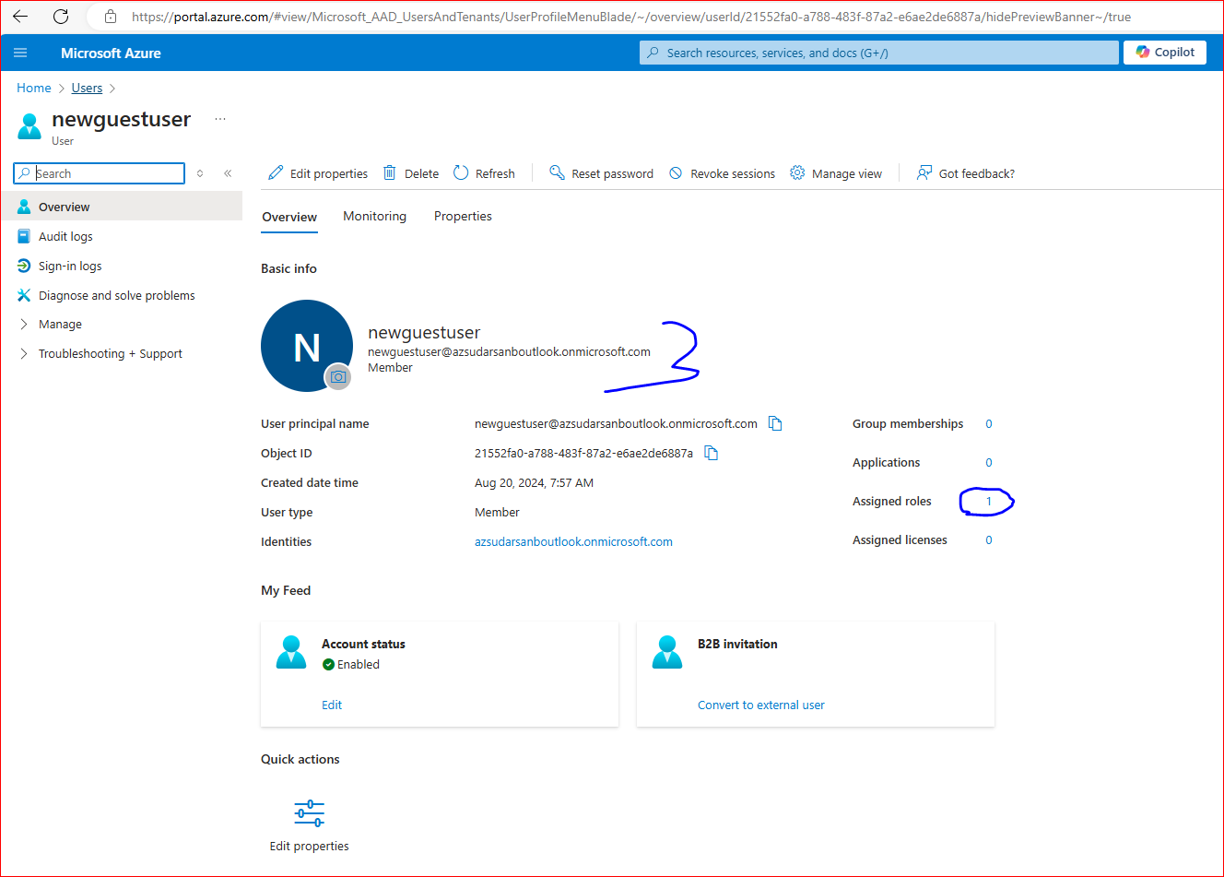

Step 3: Log into Azure Databricks

Enter <https://accounts.azuredatabricks.net/login> and you will be presented with the below screen:

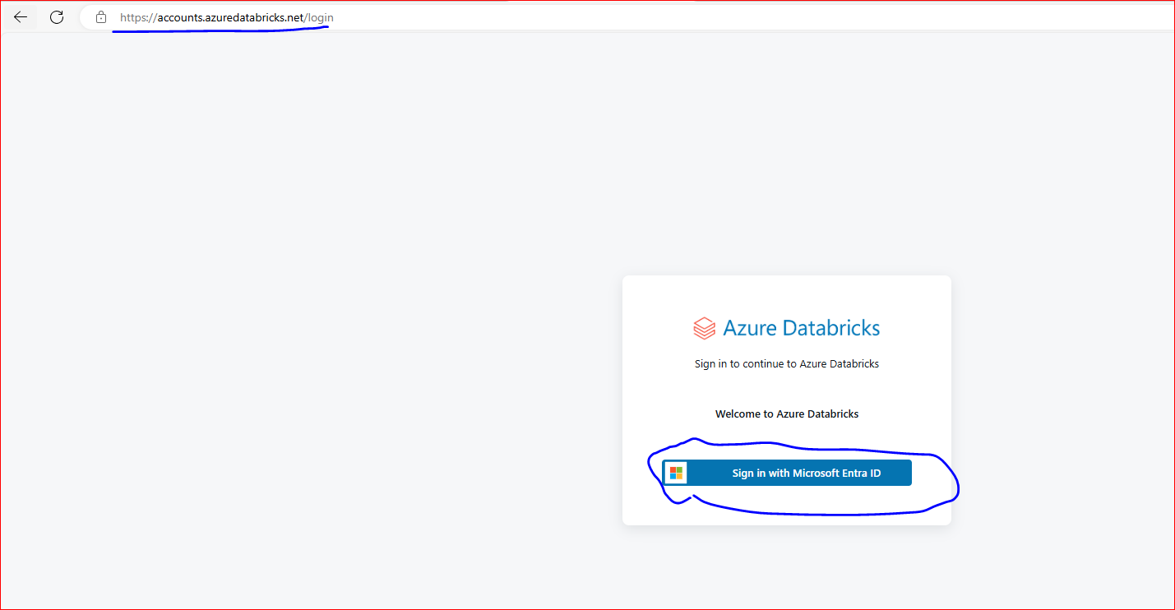

Click on “Sign in with Microsoft Entra ID” to proceed and then click on “Use Another Account”:

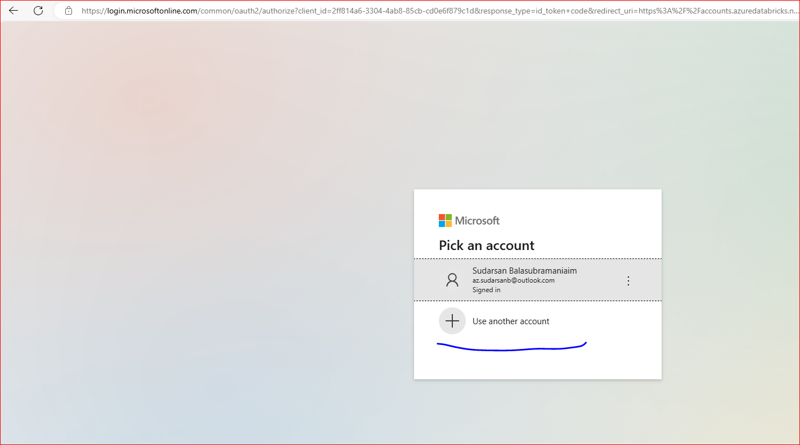

Now enter the newly created user ID, its [newguestuser@azsudarsanboutlook.onmicrosoft.com](mailto:newguestuser@azsudarsanboutlook.onmicrosoft.com) in my case as below:

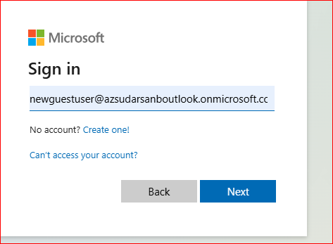

When you proceed, it will ask you to change the password for the first log in as below, please proceed and change the password.

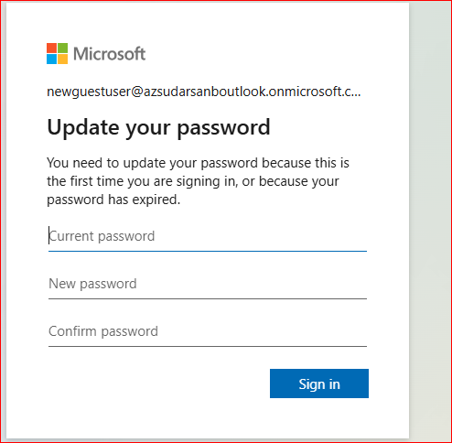

After entering old password and new password, it should bring you to below Manage Account Databricks screen as below:

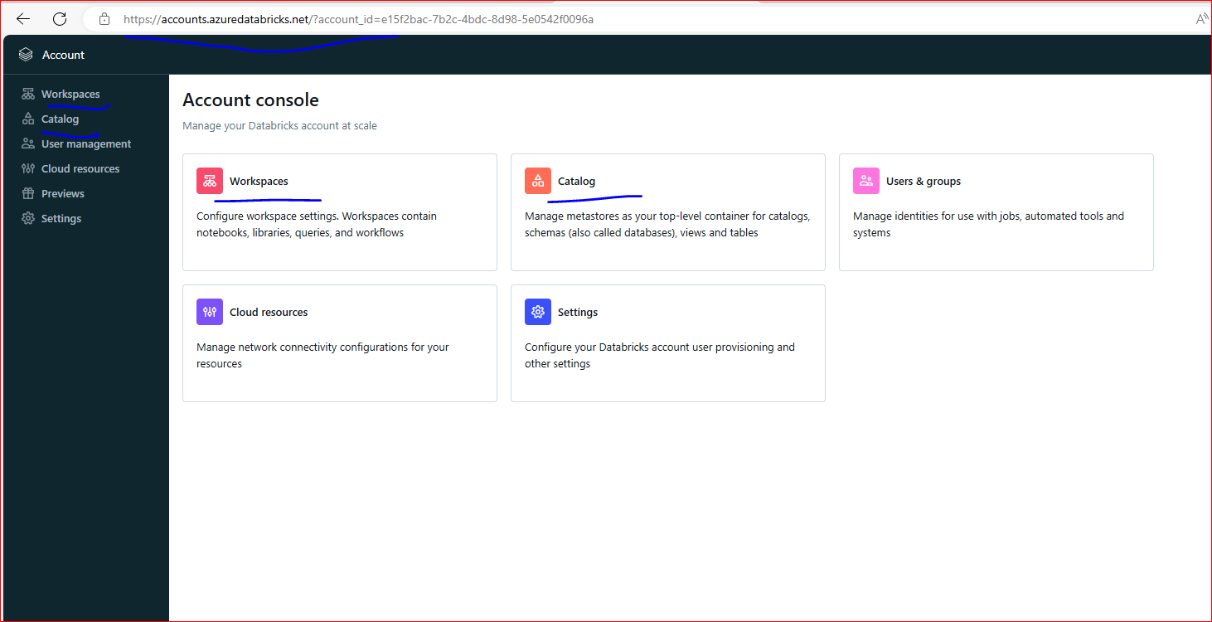

Now you should be able to follow instructions as given by Ramesh in another Q&A to remove the Unity Catalog and go with normal Metastore creation and continue with the rest of the course.

<https://www.udemy.com/course/azure-databricks-spark-core-for-data-engineers/learn/lecture/27518010#questions/21400192>

