Министерство образования Республики Беларусь

Учреждение образования
«Белорусский государственный университет
информатики и радиоэлектроники»

Факультет компьютерных систем и сетей

Кафедра программного обеспечения информационных технологий

Дисциплина «Теория информации»

ОТЧЁТ
к лабораторной работе №2

ПОТОКОВОЕ ШИФРОВАНИЕ
Вариант 2

Студент гр. 451001
Пузик В. А.
Преподователь:
Болтак С.В.

Минск, 2026
СОДЕРЖАНИЕ

1 Задание к лабораторной работе 3
2 Тестирование программы 3
3 Пример работы LFSR 28

1 Задание к лабораторной работе

Вариант 2.
Реализовать систему потокового шифрования и дешифрования для файла с любым содержимым (с любым расширением) с помощью генератора ключевой последовательности на основе линейного сдвигового регистра с обратной связью LFSR (размерность регистра равна 24). Начальное состояние регистра ввести с клавиатуры. Поле для ввода состояния регистра должно игнорировать любые символы кроме 0 и 1. Вывести на экран сгенерированный ключ (последовательность из 0 и 1), исходный файл и зашифрованный файл в двоичном виде. На диск сохранить зашифрованный/расшифрованный файл в виде потока байтов. Программа не должна быть написана в консольном режиме. Результат работы программы – зашифрованный/расшифрованный файл.

2 Тестирование программы

2.1 Текстовый файл
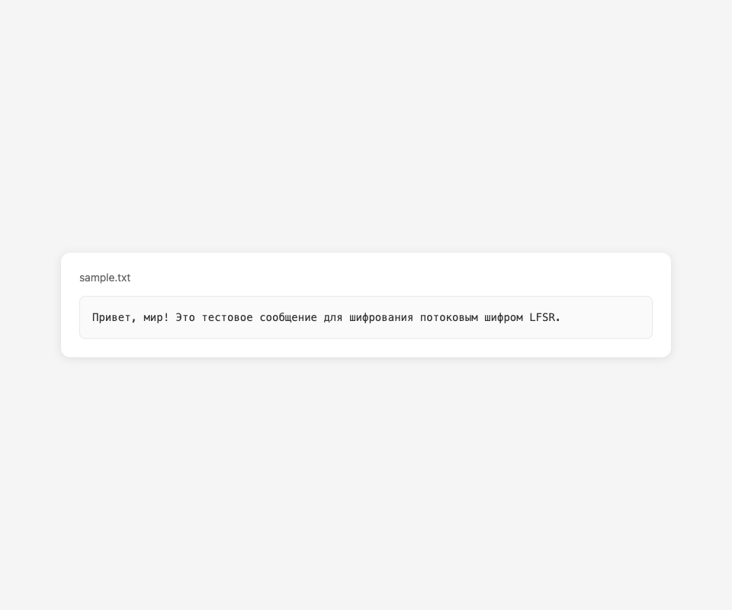
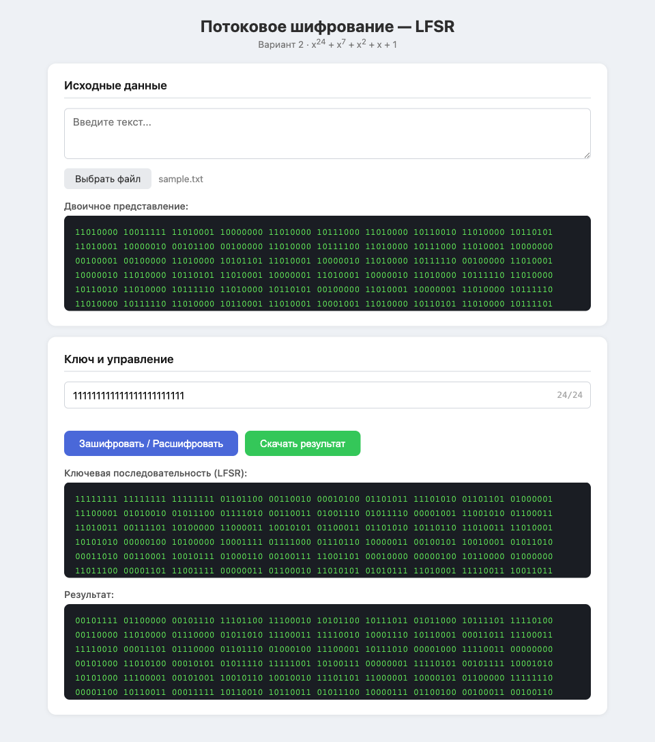
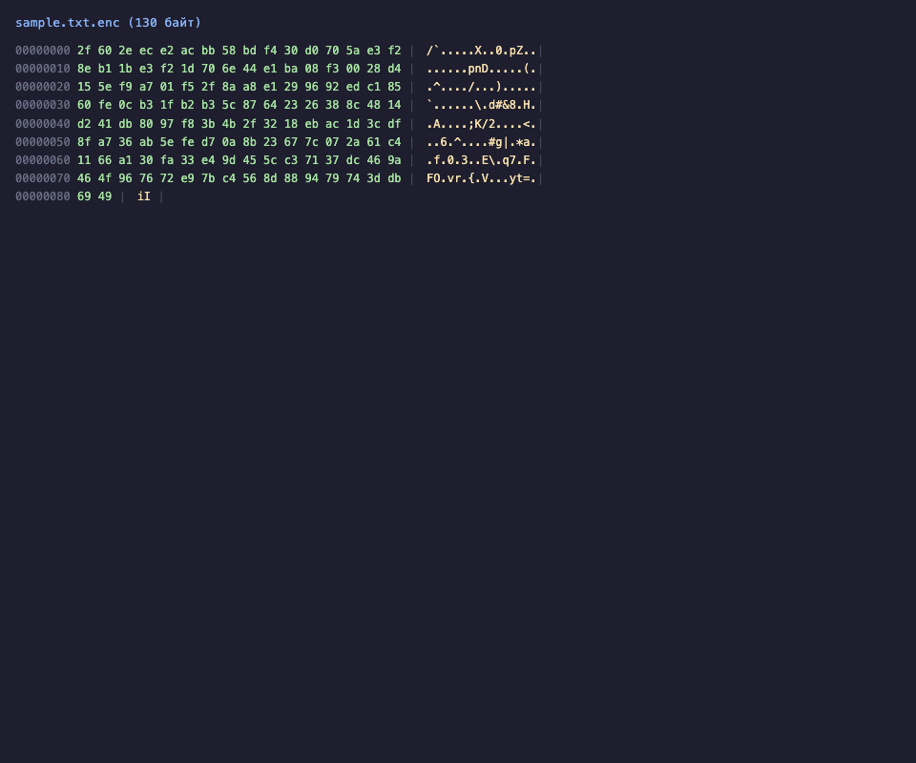
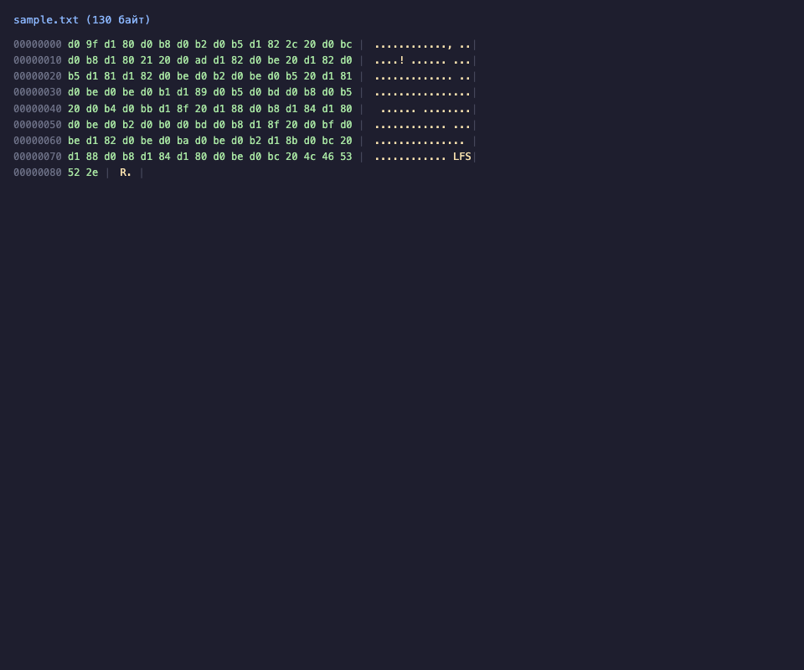
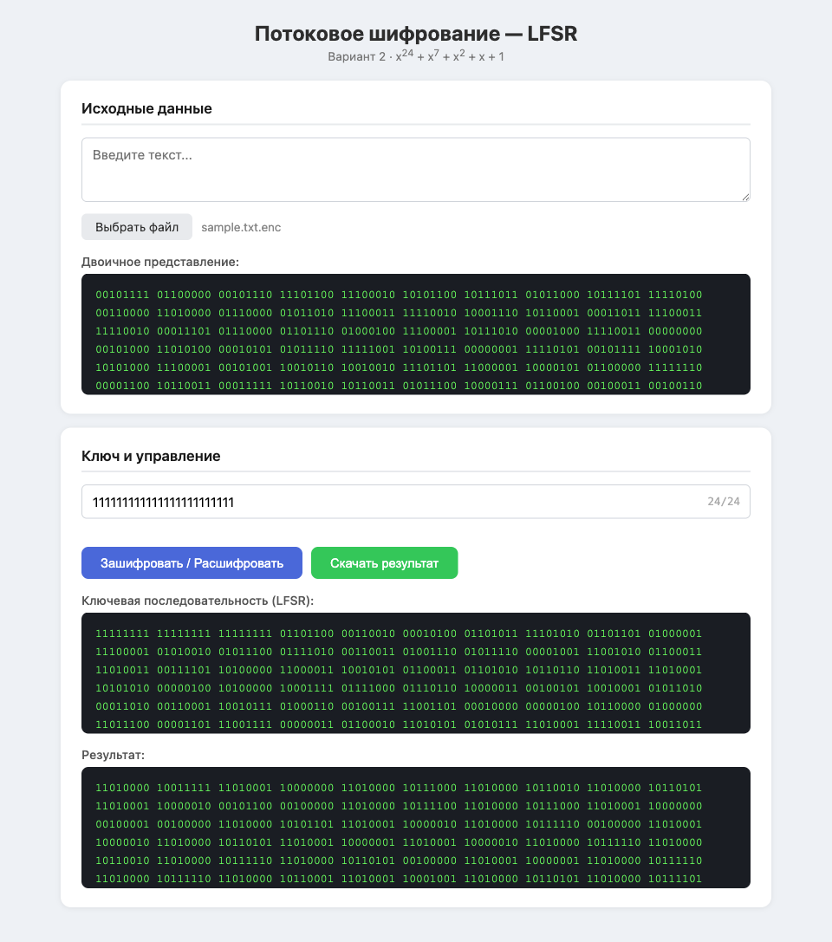


2.2 Видеофайл
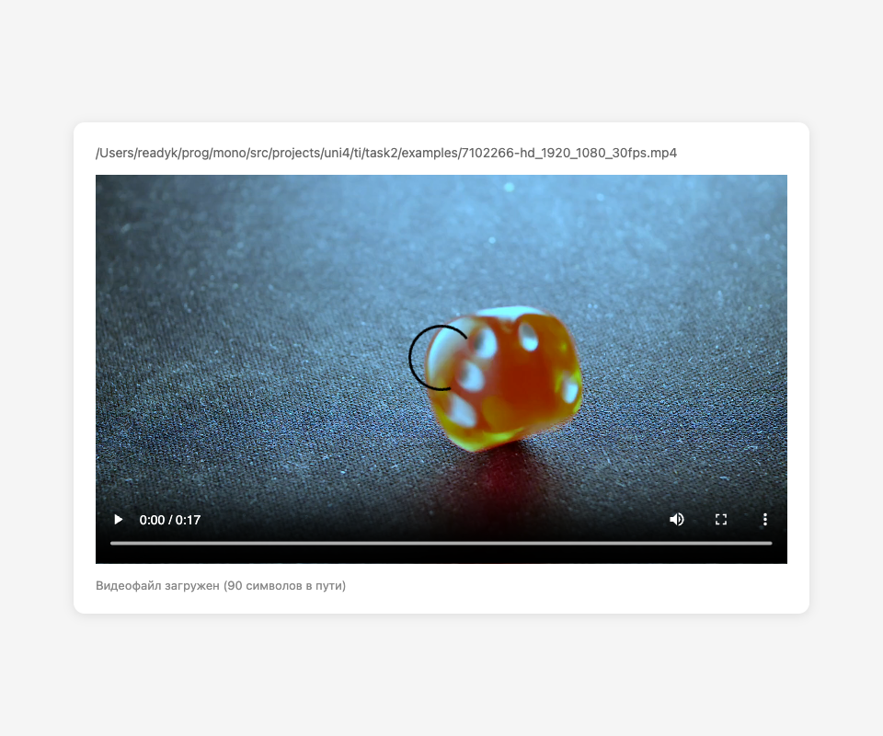
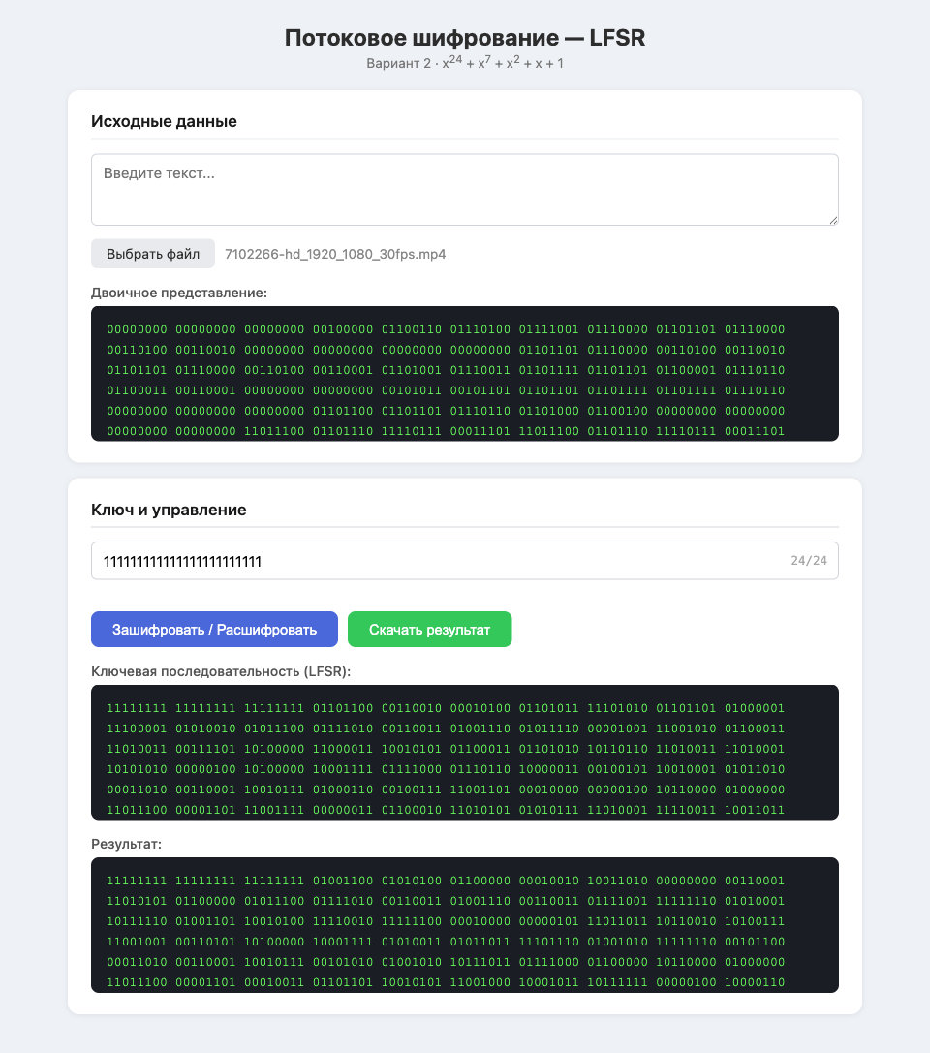
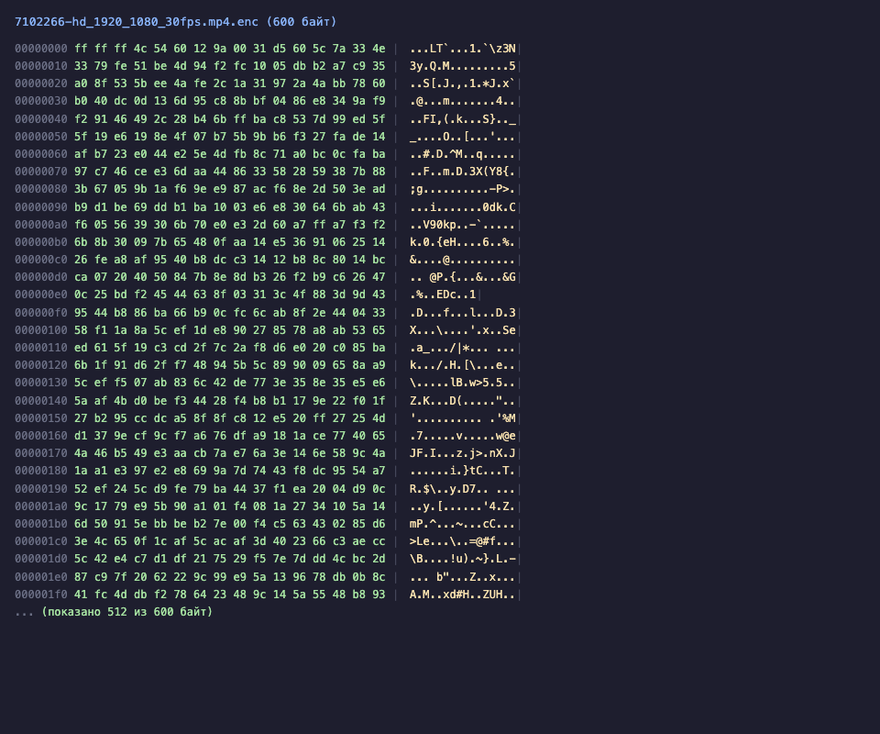
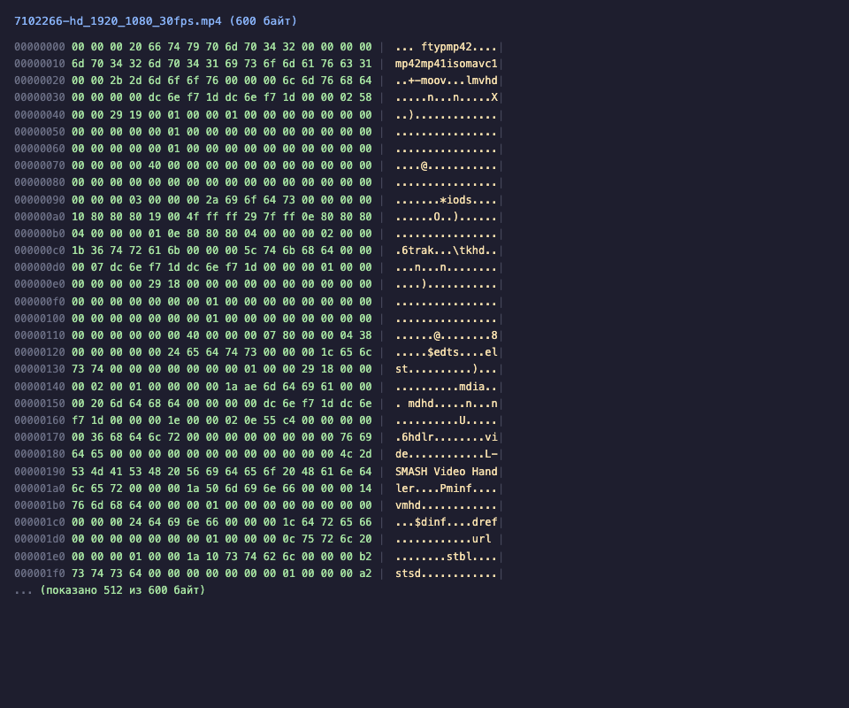
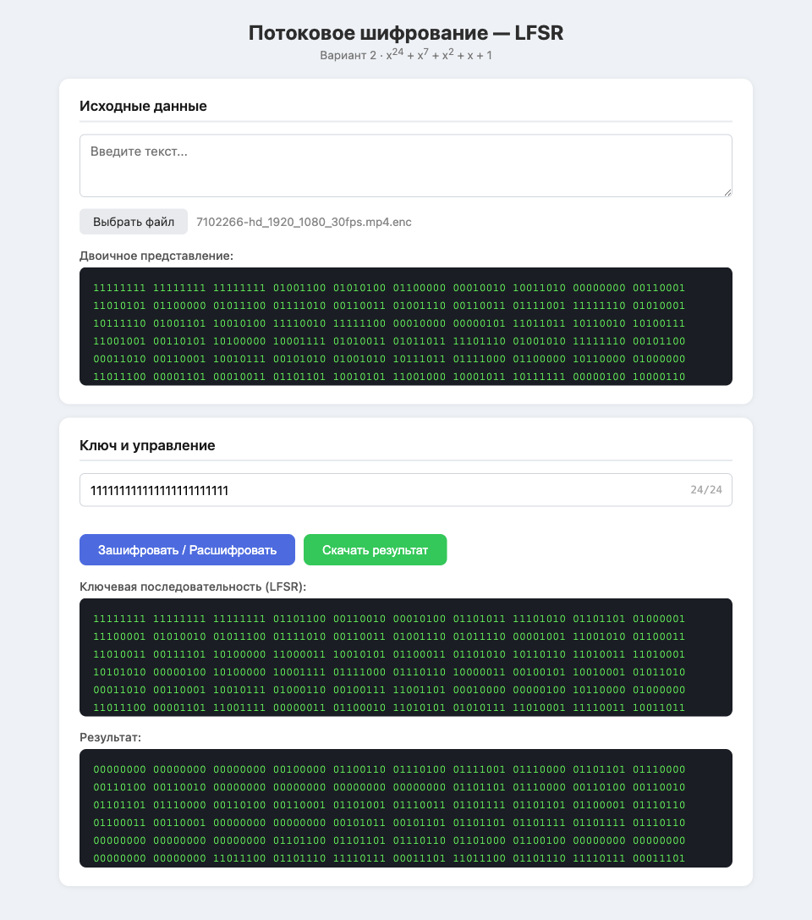


2.3 Аудиофайл

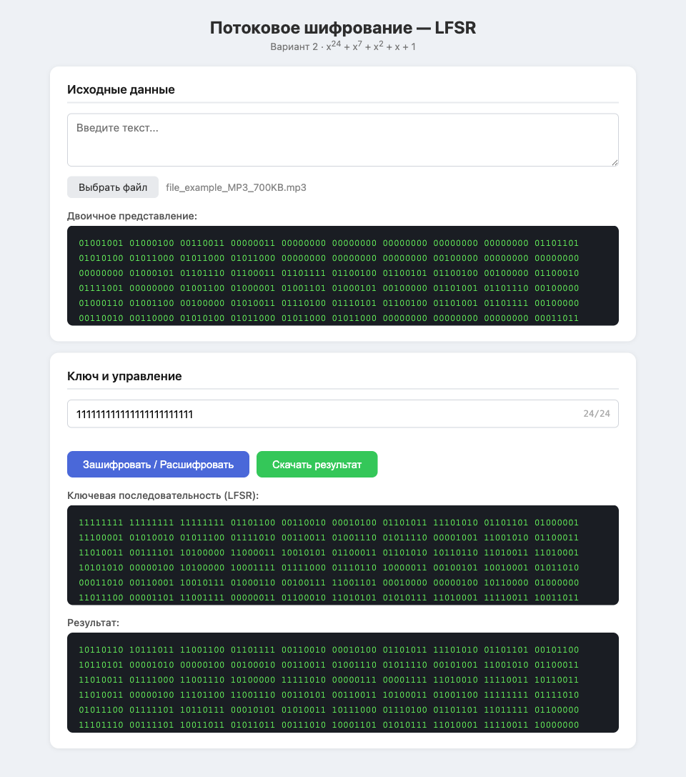
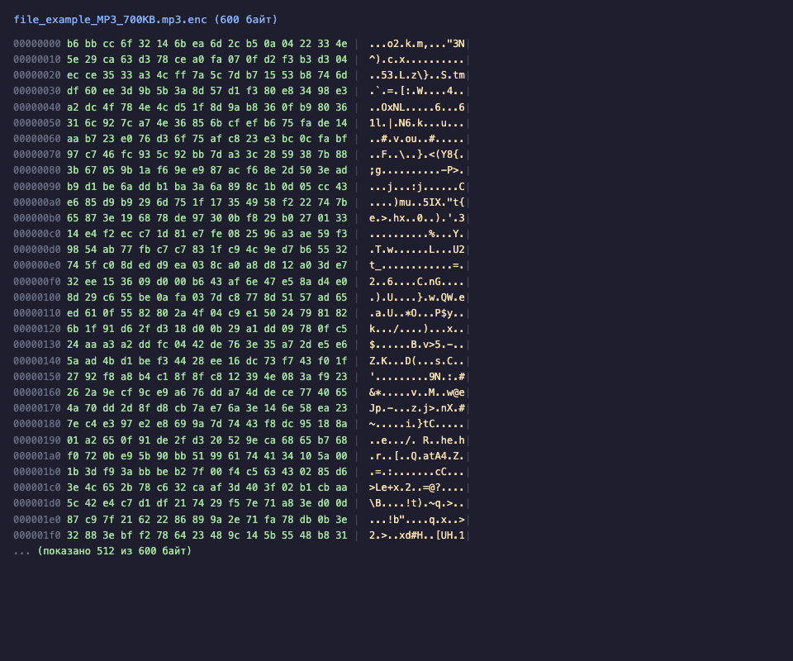
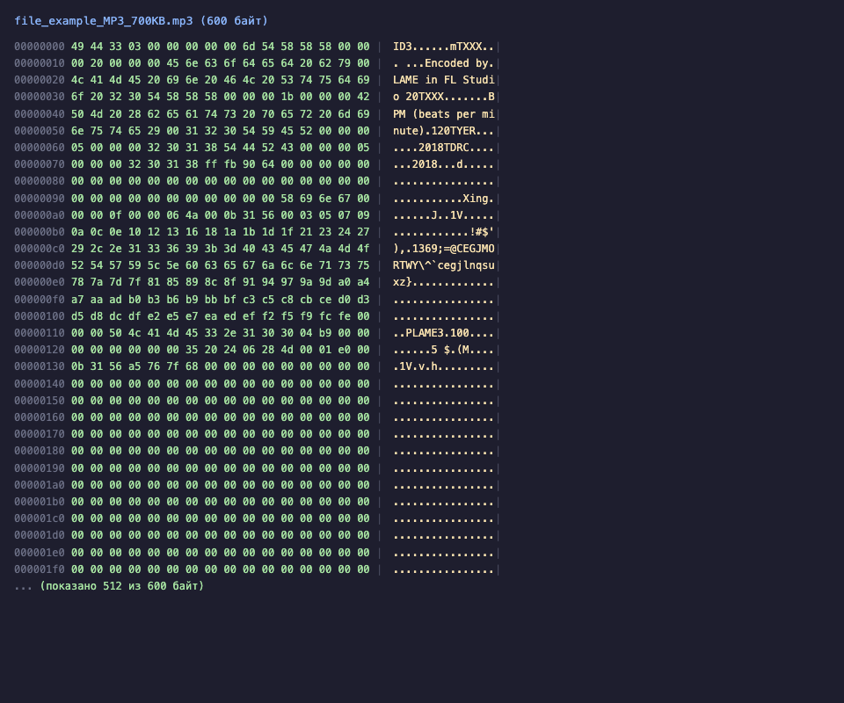
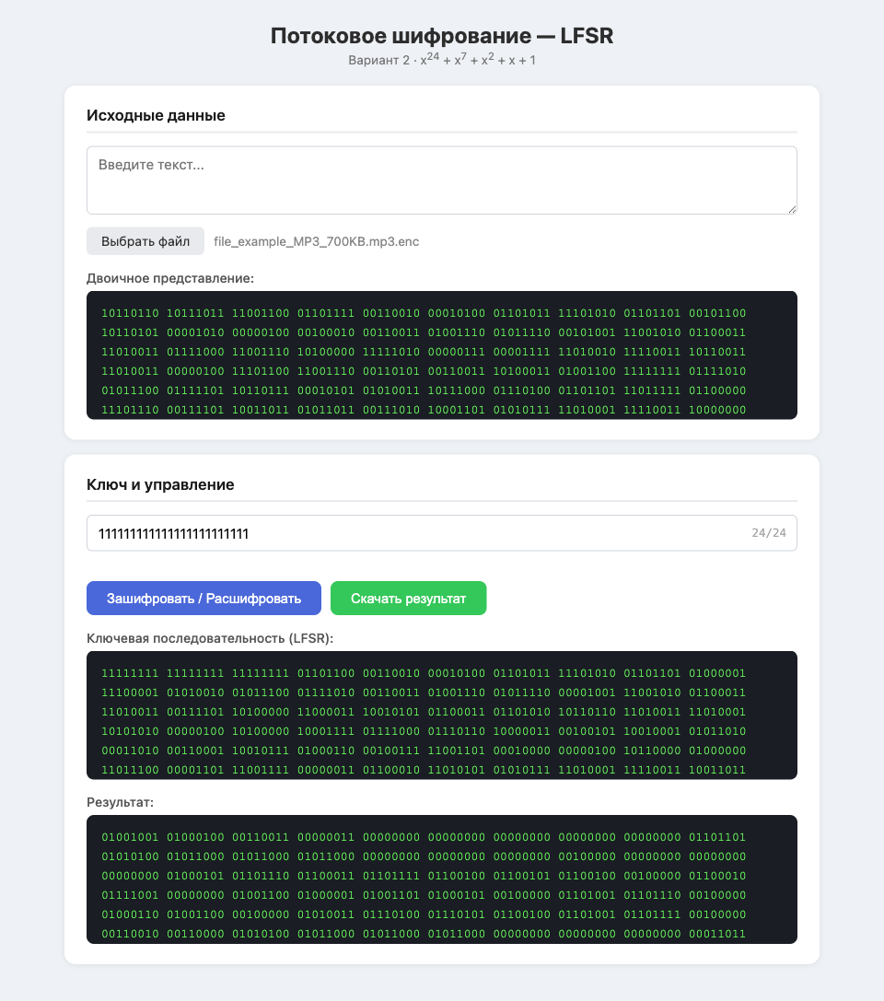


2.4 Картинка
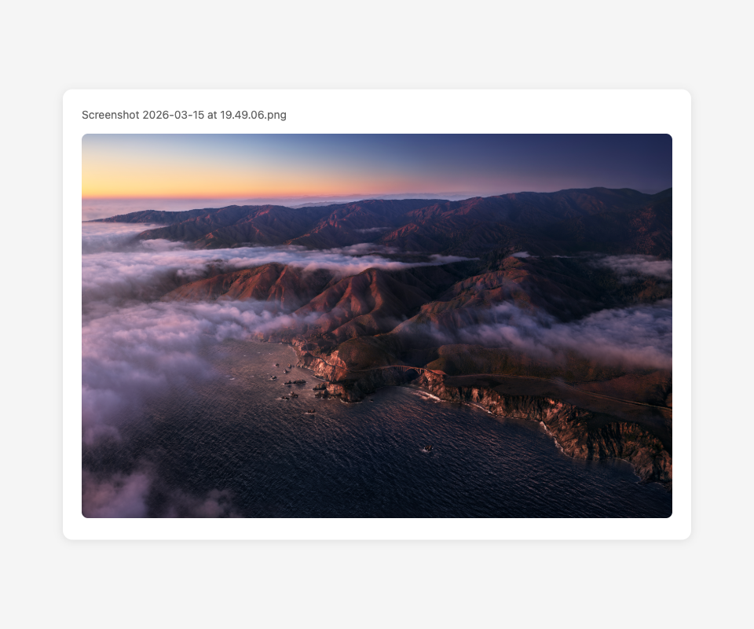
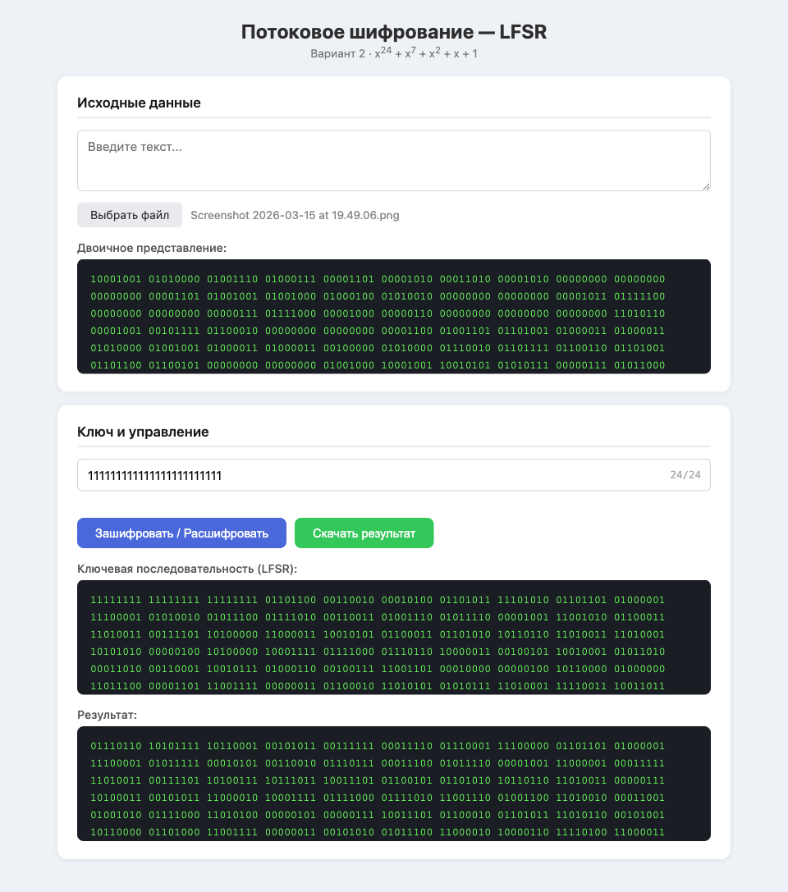
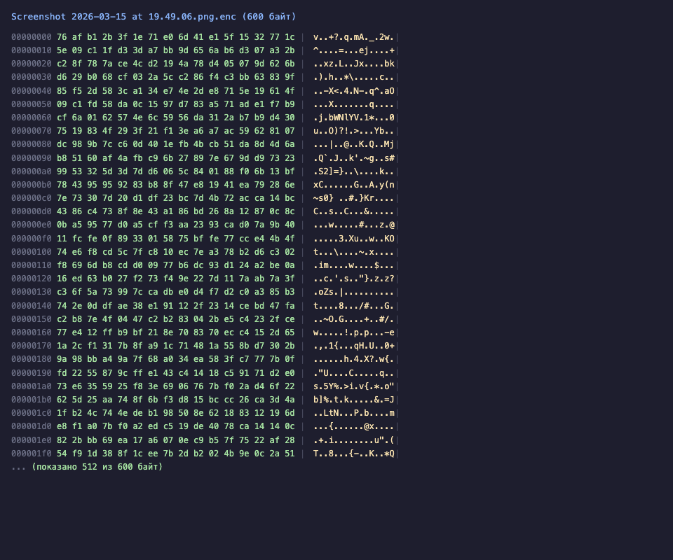
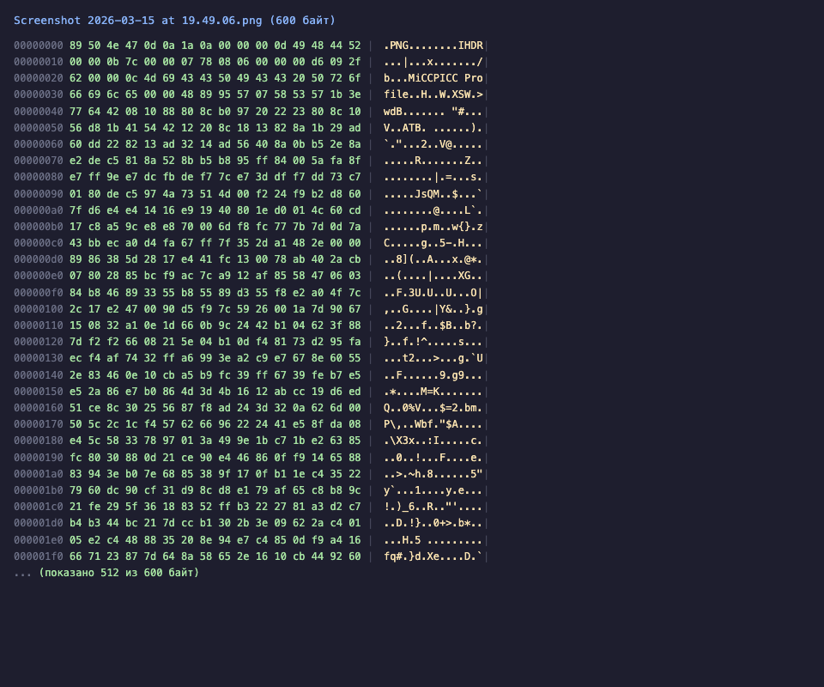
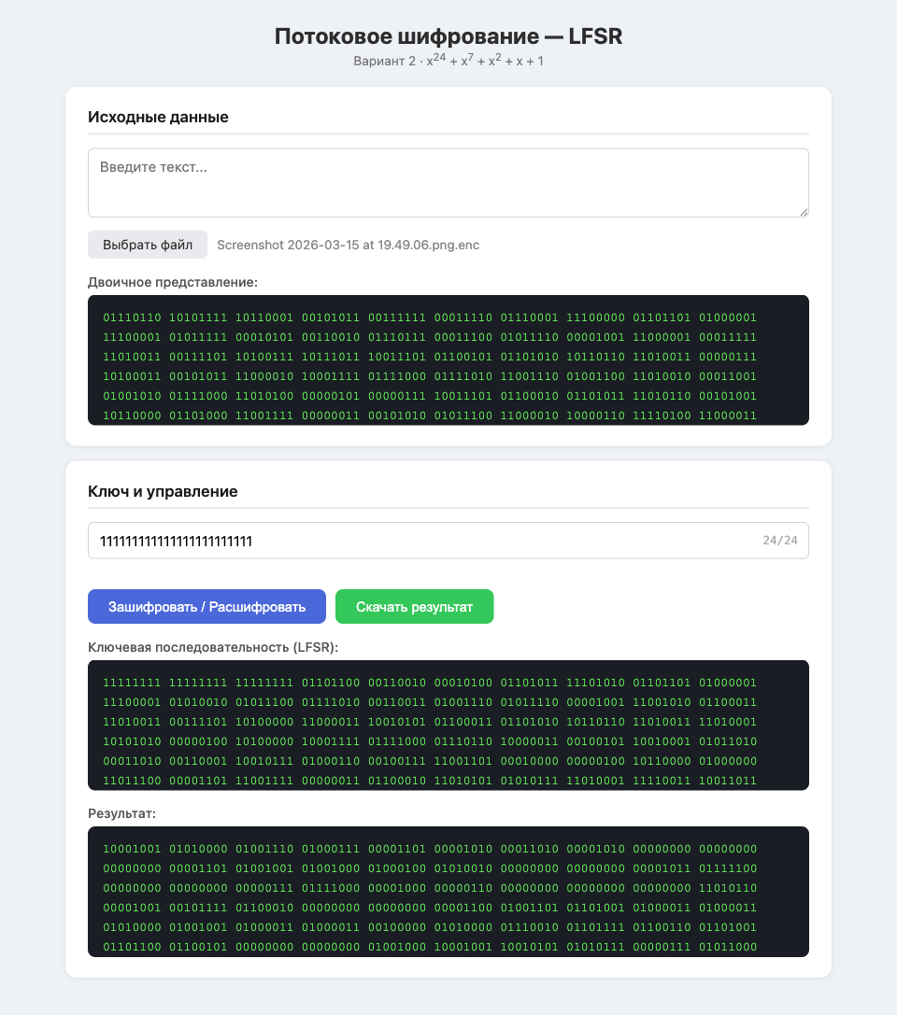
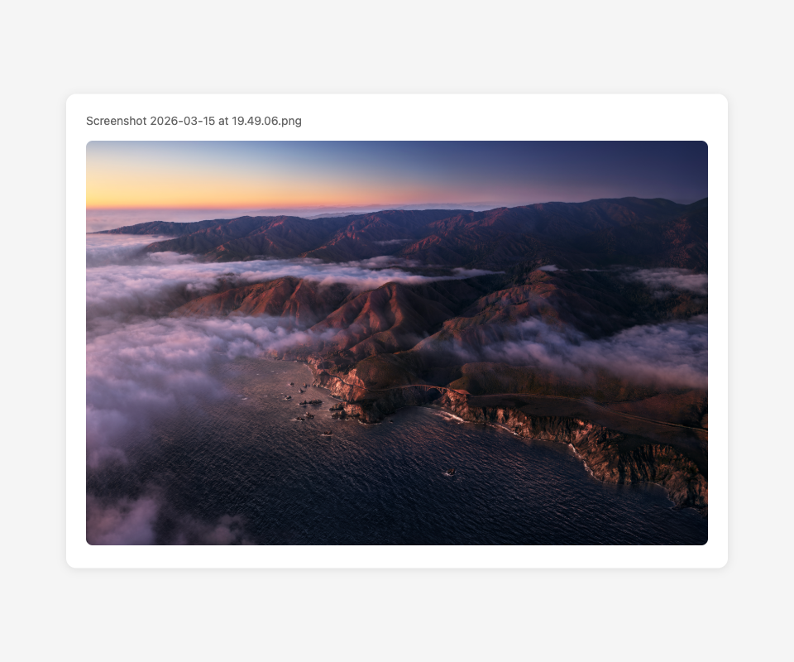

2.5 Неверный ключ
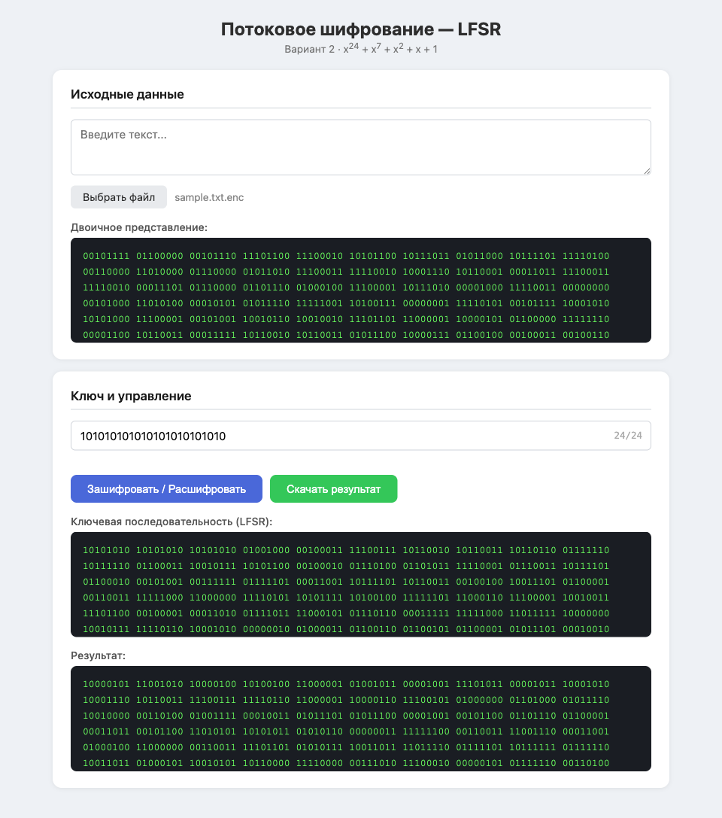
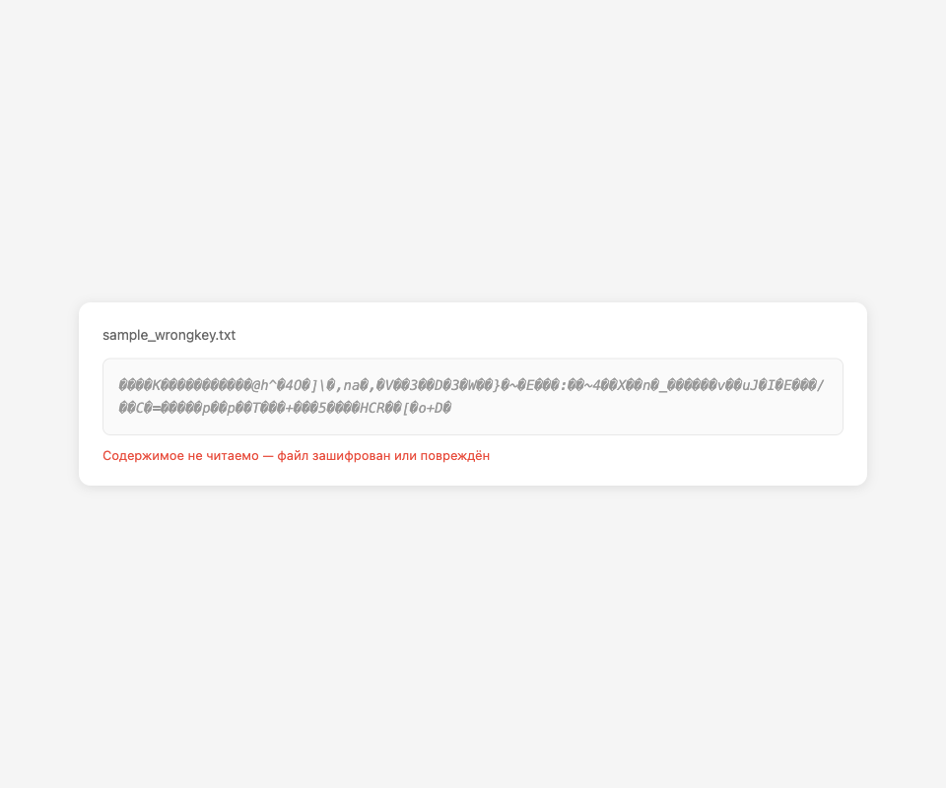

3 Пример работы LFSR

 |  |  | Степени |  |  |  |  |  |  |  |  |  |  |  |  |  |  |  |  |  |  |  |  |  |  |  | xor
 |  |  | 24 | 23 | 22 | 21 | 20 | 19 | 18 | 17 | 16 | 15 | 14 | 13 | 12 | 11 | 10 | 9 | 8 | 7 | 6 | 5 | 4 | 3 | 2 | 1 |  |  | x^24+x^7+x^2+x+1
 | Шаги / Состояние регистра | 1 | 1 | 1 | 1 | 1 | 1 | 1 | 1 | 1 | 1 | 1 | 1 | 1 | 1 | 1 | 1 | 1 | 1 | 1 | 1 | 1 | 1 | 1 | 1 | 1 | 0
 |  | 2 | 1 | 1 | 1 | 1 | 1 | 1 | 1 | 1 | 1 | 1 | 1 | 1 | 1 | 1 | 1 | 1 | 1 | 1 | 1 | 1 | 1 | 1 | 1 | 0 | 1
 |  | 3 | 1 | 1 | 1 | 1 | 1 | 1 | 1 | 1 | 1 | 1 | 1 | 1 | 1 | 1 | 1 | 1 | 1 | 1 | 1 | 1 | 1 | 1 | 0 | 1 | 1
 |  | 4 | 1 | 1 | 1 | 1 | 1 | 1 | 1 | 1 | 1 | 1 | 1 | 1 | 1 | 1 | 1 | 1 | 1 | 1 | 1 | 1 | 1 | 0 | 1 | 1 | 0
 |  | 5 | 1 | 1 | 1 | 1 | 1 | 1 | 1 | 1 | 1 | 1 | 1 | 1 | 1 | 1 | 1 | 1 | 1 | 1 | 1 | 1 | 0 | 1 | 1 | 0 | 1
 |  | 6 | 1 | 1 | 1 | 1 | 1 | 1 | 1 | 1 | 1 | 1 | 1 | 1 | 1 | 1 | 1 | 1 | 1 | 1 | 1 | 0 | 1 | 1 | 0 | 1 | 1
 |  | 7 | 1 | 1 | 1 | 1 | 1 | 1 | 1 | 1 | 1 | 1 | 1 | 1 | 1 | 1 | 1 | 1 | 1 | 1 | 0 | 1 | 1 | 0 | 1 | 1 | 0
 |  | 8 | 1 | 1 | 1 | 1 | 1 | 1 | 1 | 1 | 1 | 1 | 1 | 1 | 1 | 1 | 1 | 1 | 1 | 0 | 1 | 1 | 0 | 1 | 1 | 0 | 0
 |  | 9 | 1 | 1 | 1 | 1 | 1 | 1 | 1 | 1 | 1 | 1 | 1 | 1 | 1 | 1 | 1 | 1 | 0 | 1 | 1 | 0 | 1 | 1 | 0 | 0 | 0
 |  | 10 | 1 | 1 | 1 | 1 | 1 | 1 | 1 | 1 | 1 | 1 | 1 | 1 | 1 | 1 | 1 | 0 | 1 | 1 | 0 | 1 | 1 | 0 | 0 | 0 | 0
 |  | 11 | 1 | 1 | 1 | 1 | 1 | 1 | 1 | 1 | 1 | 1 | 1 | 1 | 1 | 1 | 0 | 1 | 1 | 0 | 1 | 1 | 0 | 0 | 0 | 0 | 1
 |  | 12 | 1 | 1 | 1 | 1 | 1 | 1 | 1 | 1 | 1 | 1 | 1 | 1 | 1 | 0 | 1 | 1 | 0 | 1 | 1 | 0 | 0 | 0 | 0 | 1 | 1
 |  | 13 | 1 | 1 | 1 | 1 | 1 | 1 | 1 | 1 | 1 | 1 | 1 | 1 | 0 | 1 | 1 | 0 | 1 | 1 | 0 | 0 | 0 | 0 | 1 | 1 | 0
 |  | 14 | 1 | 1 | 1 | 1 | 1 | 1 | 1 | 1 | 1 | 1 | 1 | 0 | 1 | 1 | 0 | 1 | 1 | 0 | 0 | 0 | 0 | 1 | 1 | 0 | 0
 |  | 15 | 1 | 1 | 1 | 1 | 1 | 1 | 1 | 1 | 1 | 1 | 0 | 1 | 1 | 0 | 1 | 1 | 0 | 0 | 0 | 0 | 1 | 1 | 0 | 0 | 1
 |  | 16 | 1 | 1 | 1 | 1 | 1 | 1 | 1 | 1 | 1 | 0 | 1 | 1 | 0 | 1 | 1 | 0 | 0 | 0 | 0 | 1 | 1 | 0 | 0 | 1 | 0
 |  | 17 | 1 | 1 | 1 | 1 | 1 | 1 | 1 | 1 | 0 | 1 | 1 | 0 | 1 | 1 | 0 | 0 | 0 | 0 | 1 | 1 | 0 | 0 | 1 | 0 | 0
 |  | 18 | 1 | 1 | 1 | 1 | 1 | 1 | 1 | 0 | 1 | 1 | 0 | 1 | 1 | 0 | 0 | 0 | 0 | 1 | 1 | 0 | 0 | 1 | 0 | 0 | 0
 |  | 19 | 1 | 1 | 1 | 1 | 1 | 1 | 0 | 1 | 1 | 0 | 1 | 1 | 0 | 0 | 0 | 0 | 1 | 1 | 0 | 0 | 1 | 0 | 0 | 0 | 0
 |  | 20 | 1 | 1 | 1 | 1 | 1 | 0 | 1 | 1 | 0 | 1 | 1 | 0 | 0 | 0 | 0 | 1 | 1 | 0 | 0 | 1 | 0 | 0 | 0 | 0 | 1
 |  | 21 | 1 | 1 | 1 | 1 | 0 | 1 | 1 | 0 | 1 | 1 | 0 | 0 | 0 | 0 | 1 | 1 | 0 | 0 | 1 | 0 | 0 | 0 | 0 | 1 | 0
 |  | 22 | 1 | 1 | 1 | 0 | 1 | 1 | 0 | 1 | 1 | 0 | 0 | 0 | 0 | 1 | 1 | 0 | 0 | 1 | 0 | 0 | 0 | 0 | 1 | 0 | 1
 |  | 23 | 1 | 1 | 0 | 1 | 1 | 0 | 1 | 1 | 0 | 0 | 0 | 0 | 1 | 1 | 0 | 0 | 1 | 0 | 0 | 0 | 0 | 1 | 0 | 1 | 0
 |  | 24 | 1 | 0 | 1 | 1 | 0 | 1 | 1 | 0 | 0 | 0 | 0 | 1 | 1 | 0 | 0 | 1 | 0 | 0 | 0 | 0 | 1 | 0 | 1 | 0 | 0
 |  | 25 | 0 | 1 | 1 | 0 | 1 | 1 | 0 | 0 | 0 | 0 | 1 | 1 | 0 | 0 | 1 | 0 | 0 | 0 | 0 | 1 | 0 | 1 | 0 | 0 | 0
 |  | 26 | 1 | 1 | 0 | 1 | 1 | 0 | 0 | 0 | 0 | 1 | 1 | 0 | 0 | 1 | 0 | 0 | 0 | 0 | 1 | 0 | 1 | 0 | 0 | 0 | 1
 |  | 27 | 1 | 0 | 1 | 1 | 0 | 0 | 0 | 0 | 1 | 1 | 0 | 0 | 1 | 0 | 0 | 0 | 0 | 1 | 0 | 1 | 0 | 0 | 0 | 1 | 1
 |  | 28 | 0 | 1 | 1 | 0 | 0 | 0 | 0 | 1 | 1 | 0 | 0 | 1 | 0 | 0 | 0 | 0 | 1 | 0 | 1 | 0 | 0 | 0 | 1 | 1 | 0
 |  | 29 | 1 | 1 | 0 | 0 | 0 | 0 | 1 | 1 | 0 | 0 | 1 | 0 | 0 | 0 | 0 | 1 | 0 | 1 | 0 | 0 | 0 | 1 | 1 | 0 | 1
 |  | 30 | 1 | 0 | 0 | 0 | 0 | 1 | 1 | 0 | 0 | 1 | 0 | 0 | 0 | 0 | 1 | 0 | 1 | 0 | 0 | 0 | 1 | 1 | 0 | 1 | 0
 |  | 31 | 0 | 0 | 0 | 0 | 1 | 1 | 0 | 0 | 1 | 0 | 0 | 0 | 0 | 1 | 0 | 1 | 0 | 0 | 0 | 1 | 1 | 0 | 1 | 0 | 1
 |  | 32 | 0 | 0 | 0 | 1 | 1 | 0 | 0 | 1 | 0 | 0 | 0 | 0 | 1 | 0 | 1 | 0 | 0 | 0 | 1 | 1 | 0 | 1 | 0 | 1 | 1
 |  | 33 | 0 | 0 | 1 | 1 | 0 | 0 | 1 | 0 | 0 | 0 | 0 | 1 | 0 | 1 | 0 | 0 | 0 | 1 | 1 | 0 | 1 | 0 | 1 | 1 | 1
 |  | 34 | 0 | 1 | 1 | 0 | 0 | 1 | 0 | 0 | 0 | 0 | 1 | 0 | 1 | 0 | 0 | 0 | 1 | 1 | 0 | 1 | 0 | 1 | 1 | 1 | 1
 |  | 35 | 1 | 1 | 0 | 0 | 1 | 0 | 0 | 0 | 0 | 1 | 0 | 1 | 0 | 0 | 0 | 1 | 1 | 0 | 1 | 0 | 1 | 1 | 1 | 1 | 1
 |  | 36 | 1 | 0 | 0 | 1 | 0 | 0 | 0 | 0 | 1 | 0 | 1 | 0 | 0 | 0 | 1 | 1 | 0 | 1 | 0 | 1 | 1 | 1 | 1 | 1 | 0
 |  | 37 | 0 | 0 | 1 | 0 | 0 | 0 | 0 | 1 | 0 | 1 | 0 | 0 | 0 | 1 | 1 | 0 | 1 | 0 | 1 | 1 | 1 | 1 | 1 | 0 | 1
 |  | 38 | 0 | 1 | 0 | 0 | 0 | 0 | 1 | 0 | 1 | 0 | 0 | 0 | 1 | 1 | 0 | 1 | 0 | 1 | 1 | 1 | 1 | 1 | 0 | 1 | 0
 |  | 39 | 1 | 0 | 0 | 0 | 0 | 1 | 0 | 1 | 0 | 0 | 0 | 1 | 1 | 0 | 1 | 0 | 1 | 1 | 1 | 1 | 1 | 0 | 1 | 0 | 1
 |  | 40 | 0 | 0 | 0 | 0 | 1 | 0 | 1 | 0 | 0 | 0 | 1 | 1 | 0 | 1 | 0 | 1 | 1 | 1 | 1 | 1 | 0 | 1 | 0 | 1 | 0
 |  | 41 | 0 | 0 | 0 | 1 | 0 | 1 | 0 | 0 | 0 | 1 | 1 | 0 | 1 | 0 | 1 | 1 | 1 | 1 | 1 | 0 | 1 | 0 | 1 | 0 | 0
 |  | 42 | 0 | 0 | 1 | 0 | 1 | 0 | 0 | 0 | 1 | 1 | 0 | 1 | 0 | 1 | 1 | 1 | 1 | 1 | 0 | 1 | 0 | 1 | 0 | 0 | 1
 |  | 43 | 0 | 1 | 0 | 1 | 0 | 0 | 0 | 1 | 1 | 0 | 1 | 0 | 1 | 1 | 1 | 1 | 1 | 0 | 1 | 0 | 1 | 0 | 0 | 1 | 1
 |  | 44 | 1 | 0 | 1 | 0 | 0 | 0 | 1 | 1 | 0 | 1 | 0 | 1 | 1 | 1 | 1 | 1 | 0 | 1 | 0 | 1 | 0 | 0 | 1 | 1 | 0
 |  | 45 | 0 | 1 | 0 | 0 | 0 | 1 | 1 | 0 | 1 | 0 | 1 | 1 | 1 | 1 | 1 | 0 | 1 | 0 | 1 | 0 | 0 | 1 | 1 | 0 | 1
 |  | 46 | 1 | 0 | 0 | 0 | 1 | 1 | 0 | 1 | 0 | 1 | 1 | 1 | 1 | 1 | 0 | 1 | 0 | 1 | 0 | 0 | 1 | 1 | 0 | 1 | 1
 |  | 47 | 0 | 0 | 0 | 1 | 1 | 0 | 1 | 0 | 1 | 1 | 1 | 1 | 1 | 0 | 1 | 0 | 1 | 0 | 0 | 1 | 1 | 0 | 1 | 1 | 0
 |  | 48 | 0 | 0 | 1 | 1 | 0 | 1 | 0 | 1 | 1 | 1 | 1 | 1 | 0 | 1 | 0 | 1 | 0 | 0 | 1 | 1 | 0 | 1 | 1 | 0 | 1
 |  | 49 | 0 | 1 | 1 | 0 | 1 | 0 | 1 | 1 | 1 | 1 | 1 | 0 | 1 | 0 | 1 | 0 | 0 | 1 | 1 | 0 | 1 | 1 | 0 | 1 | 0
 |  | 50 | 1 | 1 | 0 | 1 | 0 | 1 | 1 | 1 | 1 | 1 | 0 | 1 | 0 | 1 | 0 | 0 | 1 | 1 | 0 | 1 | 1 | 0 | 1 | 0 | 1
 |  | 51 | 1 | 0 | 1 | 0 | 1 | 1 | 1 | 1 | 1 | 0 | 1 | 0 | 1 | 0 | 0 | 1 | 1 | 0 | 1 | 1 | 0 | 1 | 0 | 1 | 0
 |  | 52 | 0 | 1 | 0 | 1 | 1 | 1 | 1 | 1 | 0 | 1 | 0 | 1 | 0 | 0 | 1 | 1 | 0 | 1 | 1 | 0 | 1 | 0 | 1 | 0 | 0
 |  | 53 | 1 | 0 | 1 | 1 | 1 | 1 | 1 | 0 | 1 | 0 | 1 | 0 | 0 | 1 | 1 | 0 | 1 | 1 | 0 | 1 | 0 | 1 | 0 | 0 | 0
 |  | 54 | 0 | 1 | 1 | 1 | 1 | 1 | 0 | 1 | 0 | 1 | 0 | 0 | 1 | 1 | 0 | 1 | 1 | 0 | 1 | 0 | 1 | 0 | 0 | 0 | 0
 |  | 55 | 1 | 1 | 1 | 1 | 1 | 0 | 1 | 0 | 1 | 0 | 0 | 1 | 1 | 0 | 1 | 1 | 0 | 1 | 0 | 1 | 0 | 0 | 0 | 0 | 0
 |  | 56 | 1 | 1 | 1 | 1 | 0 | 1 | 0 | 1 | 0 | 0 | 1 | 1 | 0 | 1 | 1 | 0 | 1 | 0 | 1 | 0 | 0 | 0 | 0 | 0 | 1
 |  | 57 | 1 | 1 | 1 | 0 | 1 | 0 | 1 | 0 | 0 | 1 | 1 | 0 | 1 | 1 | 0 | 1 | 0 | 1 | 0 | 0 | 0 | 0 | 0 | 1 | 1
 |  | 58 | 1 | 1 | 0 | 1 | 0 | 1 | 0 | 0 | 1 | 1 | 0 | 1 | 1 | 0 | 1 | 0 | 1 | 0 | 0 | 0 | 0 | 0 | 1 | 1 | 1
 |  | 59 | 1 | 0 | 1 | 0 | 1 | 0 | 0 | 1 | 1 | 0 | 1 | 1 | 0 | 1 | 0 | 1 | 0 | 0 | 0 | 0 | 0 | 1 | 1 | 1 | 1
 |  | 60 | 0 | 1 | 0 | 1 | 0 | 0 | 1 | 1 | 0 | 1 | 1 | 0 | 1 | 0 | 1 | 0 | 0 | 0 | 0 | 0 | 1 | 1 | 1 | 1 | 0
 |  | 61 | 1 | 0 | 1 | 0 | 0 | 1 | 1 | 0 | 1 | 1 | 0 | 1 | 0 | 1 | 0 | 0 | 0 | 0 | 0 | 1 | 1 | 1 | 1 | 0 | 0
 |  | 62 | 0 | 1 | 0 | 0 | 1 | 1 | 0 | 1 | 1 | 0 | 1 | 0 | 1 | 0 | 0 | 0 | 0 | 0 | 1 | 1 | 1 | 1 | 0 | 0 | 0
 |  | 63 | 1 | 0 | 0 | 1 | 1 | 0 | 1 | 1 | 0 | 1 | 0 | 1 | 0 | 0 | 0 | 0 | 0 | 1 | 1 | 1 | 1 | 0 | 0 | 0 | 0
 |  | 64 | 0 | 0 | 1 | 1 | 0 | 1 | 1 | 0 | 1 | 0 | 1 | 0 | 0 | 0 | 0 | 0 | 1 | 1 | 1 | 1 | 0 | 0 | 0 | 0 | 1

