Benjamin Grimsley

Strengths of Materials II

Project II

11 May 2015

**Executive Summary**

The propeller drive shaft for a Nautilus class nuclear submarine was mechanically analyzed and designed based on certain criteria. CLC18.10 LN steel was chosen for its strength, ductility, low magnetic signature, and high resistance to corrosion. It was determined that the required shaft diameters to maintain a minimum factor of safety of 3, and a twist ratio greater than 1.3, while minimizing the mass, would be 0.33 m and 0.34m. The calculated minimum factor of safety, shaft twist ratio, and mass were 43.556, 1.414, and 5654.9 kg respectively.

**Design Methodology**

In order to determine the diameters, a MATLAB code was written to calculate various mechanical phenomenon. First, the bending moment, torque, and axial stress were calculated for any point along the drive shaft (Eq. 1, 3). It was determined that the only cyclical stresses were created by the bending moment as the material point made 1 revolution of the shaft. The stress would go from compressive to zero to tensile and back to zero as 1 cycle was completed. This stress was the only alternating stress acting on the material point in the x direction (Eq. 2). The mean stresses were created by the axial thrust force and the reaction force at the thrust block located at L3 (Eq. 3). The torque from the engine, the reaction torque from the propeller and the torque created at the takeoff gear at L5 contributed mean shear stress components but did not contribute any cyclic stress components.

Using the modified Goodman theory (Eq. 6) and the mean, alternating and ultimate stresses, one equivalent alternating stress can be determined for any material point along the shaft length. Next, the S-N curve data was used to determine the A and B coefficients and ${ σ}_{a1}$, or the maximum allowable alternating stress for a given amount of cycles, could be calculated for the desired shaft life of 5 million cycles (Eq. 5). The S-N data used was 10e3 cycles for 90% $σ_{u}$ and 10e6 cycles for 50% $σ_{u}$. The material was assumed to not have an endurance limit. Using the Maximum allowable alternating stress and the equivalent alternating stress at any point along the drive shaft, the factor of safety due to stress could be calculated for any point on the shaft (Eq. 7)

The twist ratio was calculated using the engineering rule of thumb that a shaft should not twist 1 degree over a length 20 times its diameter (Eq. 8). Using this general guideline and the equation for the twist ratio for a section of the submarine shaft, the twist ratio for the entire shaft was found by finding the minimum value of all the twist ratios in the 6 shaft segments (Eq. 9).

The mass of the shaft was simply calculated using the diameters and density of the steel and common volume equations (Eq. 10, 11).

To determine the best pair of diameters, the aforementioned calculations were made by first picking a constant D2 and then processing the equations for an array of D1 values. Another D2 was picked and the process was repeated for the same vector of D1 values. This was accomplished by using nested for loops in MATLAB.

Charts of the factor of safety, twist ratio, and mass for the varying diameters were produced to determine the pair of diameters that minimized the mass while maintaining the design criteria. It was found that the twist ratio had the greatest influence which diameters would be ideal. Most diameters that were tested provided factors of safety that were significantly greater than what was required. Only a few diameters however could provide a twist ratio greater than 1.3. It was found that the pair of diameters that minimized the mass of the shaft were 0.33 and 0.34 m.

**Design Recommendations**

An important consideration while designing submarines is its overall magnetic signature. A shaft could be designed by a nonmagnetic material such as aluminum that meet the aforementioned design criteria but it would be extremely prone to corrosion from contact with sea water. CLC18.10 LN is a stainless steel alloy that is 18% Cr and 10% Mo and has an extremely low magnetic signature and is very corrosion resistant.

The tradeoff is that the driveshaft is heavier than other materials. This mass could be made up for in other less critical areas such as the living quarters etc. The submarine’s capability of remaining undetected by having a low magnetic profile and a part that will continue to operate to its maximum life expectancy without having its service period unpredictably shortened by corrosion is well worth the additional weight. Also, a technician working on this submarine could predict when this part would fail with a high degree of certainty since the chosen material minimizes environmental factors that would otherwise have effects that may be more difficult to analyze and model than fatigue based failure.

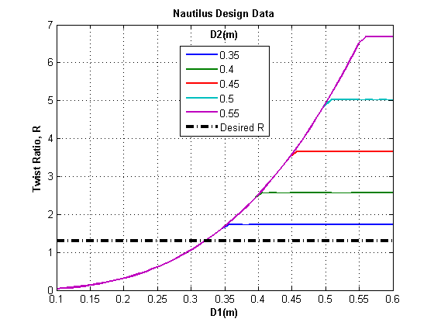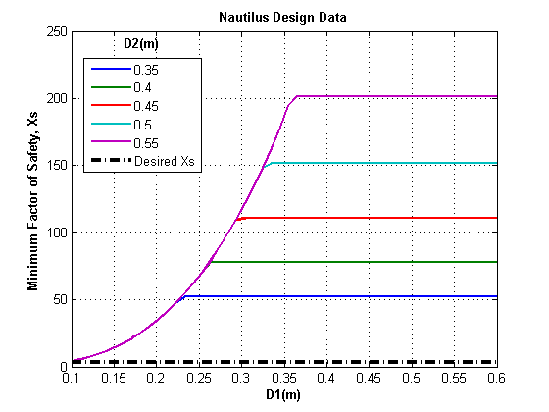**Results**

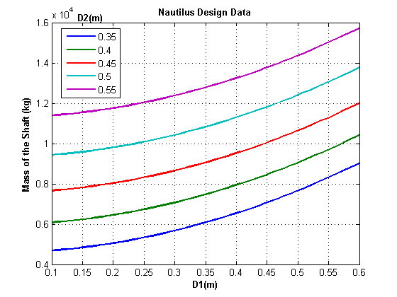**Appendix**

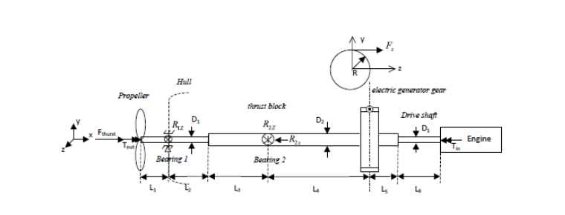Eq 1. Bending Moment written in singularity functions:

$$M(z) = R1z{〈x-L1〉}^{1} + R2z{〈x-(L1+L2+L3)〉}^{1} + Fz{〈x-(L1+L2+L3+L4)〉}^{1}$$

Eq 2. Stress due to bending for a circular cross section:

$$σ_{x,B}=σ_{a}={32∙M(x)}/{π∙{D(x)}^{3}}$$

Eq 3. Mean Stress due to axial loading:

$$σ_{m}={F_{x}}/{π{(\frac{D}{2})}^{2}}$$

Eq 4. Angle of twist due to a torque:

$ϕ= {T\left(x\right)∙x}/{J∙G}$

Eq 5. S-N equations for maximum alternating stress:

$$σ_{ac}=A∙{N_{f}}^{B}$$

$σ_{a1}=0.9∙σ_{u}$; $N_{f1}=10,000 cycles$

$σ_{a2}=0.5∙σ_{u}$; $N_{f2}=1,000,000 cycles$

$B= \frac{\log{{σ_{a1}}/{σ_{a2}}}}{\log{{N_{f1}}/{N_{f2}}}}$

$$A= {σ_{a1}}/{{N_{f1}}^{B}}$$

Eq 6. Modifed Goodman theory:

$$σ_{ar}=\frac{σ_{a}}{1-\frac{σ_{m}}{σ_{u}}}$$

Eq 7. Factor of Safety with respect to stress:

$$X_{s}= {σ_{ac}}/{σ_{ar}}$$

Eq 8. Critical angle of twist for a circular shaft in radians:

$$ϕ_{crit}={0.0175∙x}/{20∙D}$$

Eq 9. Twist ratio for a circular shaft

$$R= \frac{ϕ_{crit}}{ϕ}$$

Eq 10. Volume of the Drive Shaft

$$V= π∙\left[\left({\left(\frac{D_{1}}{2}\right)}^{2}∙(L_{1}+L_{2}+L_{6})\right)+ \left({\left(\frac{D_{2}}{2}\right)}^{2}∙(L_{3}+L_{4}+L_{5})\right)\right]$$

Eq 11. Mass of the Drive Shaft

$$m= ρ∙V$$