**Introduction**:

Additive manufacturing (AM) is a generic term used to describe the technologies that build 3d Objects [1]. ASTM International defines Additive Manufacturing as the “process of joining materials to make objects from 3D model data, usually layer upon layer, as opposed to subtractive manufacturing methodologies.” [2]. 3D Printing is one of the technologies encompassed by AM [3].3D Printing is a manufacturing method wherein materials like plastic, polymer or metal, are deposited on one another in layers to produce a three dimensional object[4].

3D Printing is a 3-step process (see Figure 1) which includes creating a virtual design of the object (either by using designing software or through 3d scanners), slicing the 3d model before it can be printedfollowed by printing the object, and final step is the finishing process in which the printed object is cleaned up, polished / sanded, painted to complete it as intended. The material chosen to print the object determines the underlying technology for the actual printing process,to name a few, if the material chosen is plastic then Fused Deposition Modeling (FDM) technology is used, for photo sensitive resin material the technology named photopolymerisation is used, whereas SLS (Selective Laser Sintering) is the technology used if print material is powder (Alumide).Photopolymerisationis a technique that involves the use of UV light to solidify the photosensitive material. This technique is used by different 3d printing processes like Stereolithography (SLA), Digital Light Processing (DLP) and MultiJet printers. MultiJet printersbegin by spraying the tiny droplets of photopolymer in the shape of the first layer followed by crosslinking the polymer by using the UV light from the lamp attached to the print head thus locking the shape of the layer in place [5].

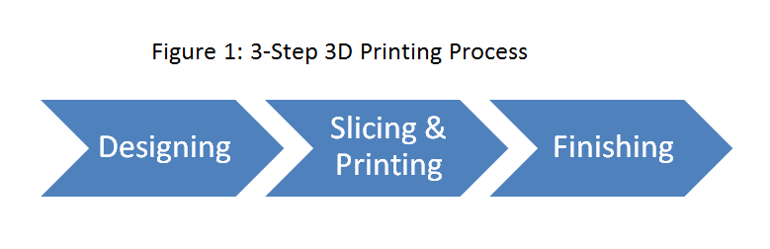

The step 2 of the 3d Printing process involves the use of a software/s which enables conversion of the input (i.e. virtual design) to a form which is understood by the print machine. Cuttlefishis a powerful print driver, which enables to perform the transformation of the digital geometric representation of the design into machine-specific code/representation that eventually drives the 3D printer.Cuttlefish supports high-resolution multi-material printers and allows printing large sized multiple objects[6].High-resolution multi-material prints consists of huge amount(easily up to 10^12 as today’s printers allow to combine 7 materials in a single print) of voxels- a*voxel* is3D equivalent of 2Dpixel [7]. To reproduce the shape and attributes of the 3d model with high precision,Cuttlefish performs material assignment at voxel level.To do so large amount of computational effort is needed which cannot be achievedefficiently by a single processing entity for higher number of objects. Moreover, cuttlefish processes the input in serial fashion leading to increased amount of computational time for multiple objects.

To achieve a reasonable performance for large computations, distributed computing can be used [8][9]. Distributed computing is concept where in multiple machines of a distributed system work together on a single problem domain [10].A distributed system can be defined as the group / cluster of autonomous computers which are connected via network and communicate primarily through message passing [11]. The ultimate goal of distributed computing is to maximize performance by enhancing resource utilization in a cost effective, transparent and reliable manner.

**Problem Statement:**

The state of the art multi-jet 3D printers allow printing high resolution large sized multiple print objects at the same time. To efficiently exploit the offered functionality of these printers, appropriate digital fabrication software needs to be developed. Through this master thesis, I have implemented a distributed version of cuttlefish 3dPrinting pipeline by applying the various concepts of distributed computing. The pre-processing task of the large sized multipleobjects can be distributed among the nodes of the distributed system so as to utilize the processing power of each node in order to increase the efficiency by limiting the computational effort and time for each node. Distribution of the tasks among the nodes of the distributed system parallelizes the pre-processing of the input thereby reducing the waiting time for each object to be processed.

1. Progress in Additive Manufacturing and Rapid Prototyping
2. Standard Terminology for Additive Manufacturing Technologies, ASTM F2792-10, June 2010
3. Making sense of 3-D printing: Creating a map of additive manufacturing products and services
4. Innovations in 3D printing: a 3D overview from optics to organs
5. <https://www.sculpteo.com/en/3d-printing/3d-printing-technologies/>
6. <https://www.cuttlefish.de/>
7. 3DString: A Feature String Kernel for 3D Object Classification on Voxelized Data
8. Godfrey, Bill (2002). "A primer on distributed computing"
9. N. Desai, R. Bradshaw, E. Lusk and R. Butler, "Component-based cluster systems software architecture a case study," Cluster Computing, 2004 IEEE International Conference on, San Diego, CA, 2004, pp. 319-326. DOI: 10.1109/CLUSTR.2004.1392629
10. <http://whatis.techtarget.com/definition/distributed-computing>
11. George Coulouris, Jean Dollimore, Tim Kindberg, and Gordon Blair. 2011. Distributed Systems: Concepts and Design (5th Ed.). Addison-Wesley Publishing Company, USA.
12. Voxel-based fabrication through material property mapping: A design method for bitmap printing