WEEK 13

1.OBJECTIVE

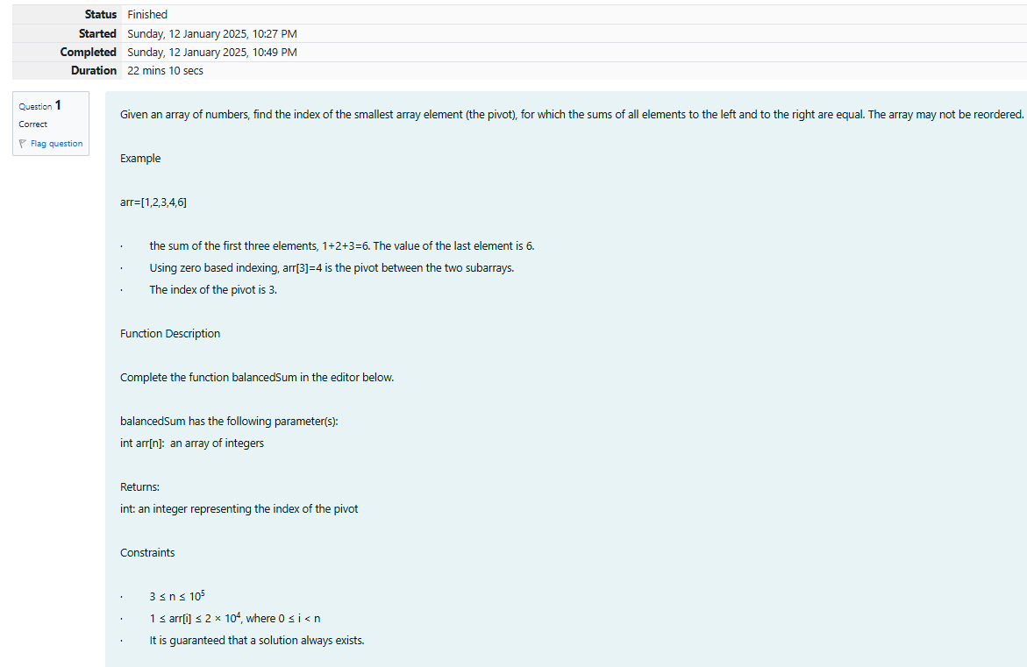

CODE

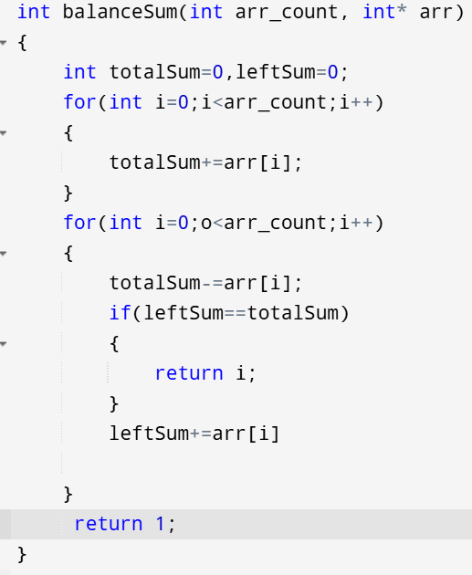

OUTPUT

Test expected got

Int arr[]= {1,2,3,3}; 2 2

Printf(“%d” , balancedSum(4,arr))

2.OBJECTIVE

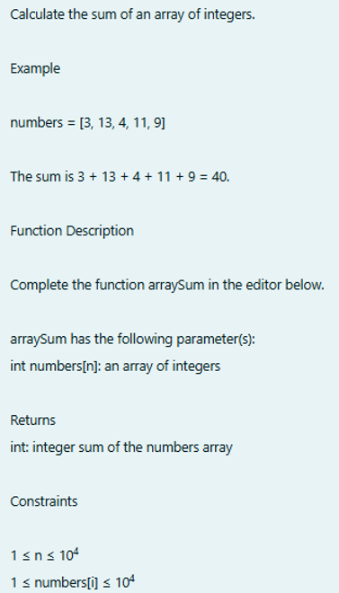

CODE

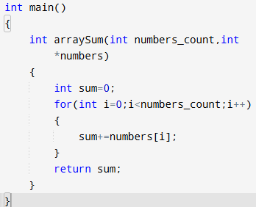

OUTPUT

TEST EXPECTED GOT

Int arr[]={1,2,3,4,5}; 15 15

Printf(“%d”,arraySum(5,arr))

3.OBJECTIVE

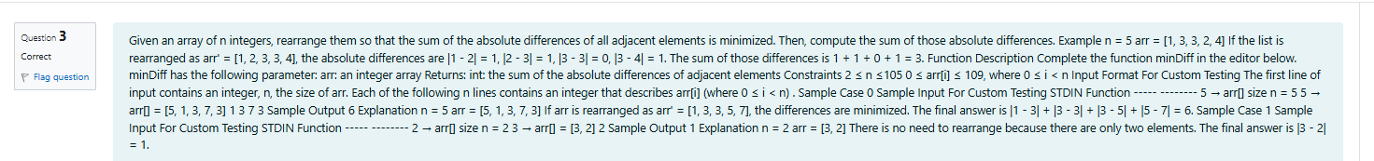

CODE

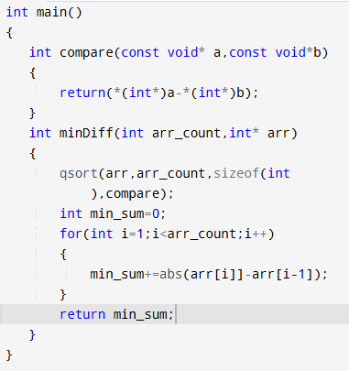

OUTPUT

TEST EXPECTED GOT

int arr[]={5,1,3,7,3}; 6 6

printf(“%d”,minDiff(5,arr))