1. **Why does the below code return false?**

Code:

package package1;

// Java program to illustrate If statement

class IfDemo {

public static void main(String args[])

{

Sample2333 SampleObj23 = new Sample2333();

// System.out.println(SampleObj23.add() );

// System.out.println(SampleObj23.add(1,2) );

System.out.println(SampleObj23.add("Ramana SAI") );

}

}

class Sample2333

{

int a=90;

byte b= 89;

String name = "Rachana";

//non praprmeter

int add(){

//comment

String name = "sdfkgsdf";

int c= 23+23;

System.out.println("I am a non paramtereted and with rtetuurn value function");

return c;

}

int add(int a, int b){

//comment

int c= a+b;

System.out.println("I am parametered nd with rtetuurn value function");

return c;

}

boolean add(String str){

//comment

System.out.println("Hellow " +str +"can you hear me ?");

return false;

}

}

From the main method , SampleObj23.add("Ramana SAI") is called. As you can see the method name is “add” and there is one argument passed and the argument passed is a string . So, the method called from the class Sample2333 is add(String str);

This method has a Boolean return type and it return false.

1. **Difference between constructor and method?**

|  |  |
| --- | --- |
| Constructors | Methods |
| A Constructor is a block of code that initializes a newly created object. | A Method is a collection of statements which returns a value upon its execution. |
| A Constructor can be used to initialize an object. | A Method consists of Java code to be executed. |
| A Constructor is invoked implicitly by the system. | A Method is invoked by the programmer. |
| A Constructor is invoked when an object is created using the keyword new. | A Method is invoked through method calls. |
| A Constructor doesn’t have a return type. | A Method must have a return type. |
| A Constructor initializes an object that doesn’t exist. | A Method does operations on an already created object. |
| A Constructor’s name must be same as the name of the class. | A Method’s name can be anything. |
| A class can have many Constructors but must not have the same parameters. | A class can have many methods but must not have the same parameters. |
| A Constructor cannot be inherited by subclasses. | A Method can be inherited by subclasses. |

1. **Who gives default constructor?**

The compiler automatically provides a no-argument, default constructor for any class without constructors.

1. **What are other responsibilities of JVM?**

The JVM has two primary functions: to allow Java programs to run on any device or operating system (known as the "Write once, run anywhere" principle), and to manage and optimize program memory

1. **Is java call by reference or call by value?**

Java Uses call by value. The modification done to the parameter passed does not reflect in the caller's scope.Call By Reference is less Secure.

1. **Who is providing the extra functions is java?**

Built in functions in java are methods that are present in different API of JDK.

1. **What happens if a final keyword is applied on class and function?**

If we declare a class as final, we restrict the other classes to inherit or extend it.

If we declare a method as final, then it cannot be overridden by any subclasses.

1. **What happens if final keyword is applied on variable, class and method?**

we declare a variable with the final keyword, we can’t change its value again.

If we declare a class as final, we restrict the other classes to inherit or extend it.

If we declare a method as final, then it cannot be overridden by any subclasses.

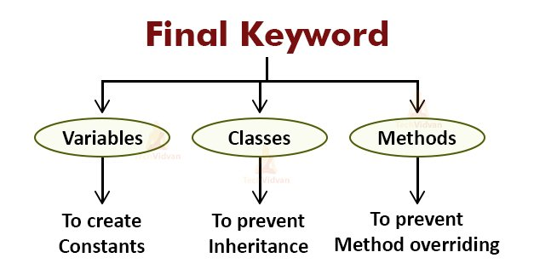

1. **Why string is passed in main method?**

String parameter in main contains the command-line arguments passed to the Java program upon invocation

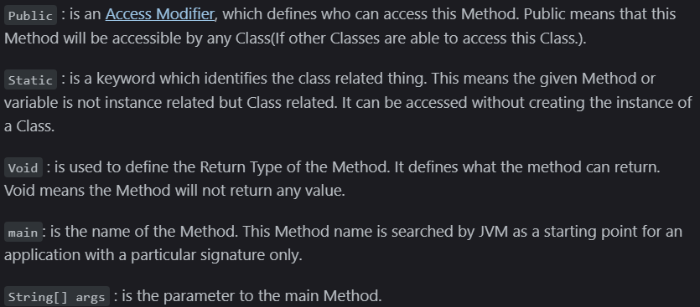

1. **Why only JVM gives default constructor?**

In case, programmer does not provide any constructor in class definition – JVM provides a default constructor to the class in runtime.

1. **Difference b/w java 8 and java7**

|  |  |
| --- | --- |
| Java 7 | Java 8 |
| Java SE 7 was codenamed Dolphin. | Code name for Java SE 8 is Spider. |
| Java 7 is supported on Win XP. | Java 8 is not officially supported on Win XP. |
| Java 7 brings JVM support for dynamically-typed languages plus Type Interference for Generic Instance creation. | Java 8 brings the most anticipated feature for the programming language called Lambda Expressions, a new language feature which allows users to code local functions as method arguments. |
| Users can catch multiple exception types in one catch block which could be impossible before JDK 7. | Java 8 brings its own new specialized API for Date and Time manipulation. |
| Small language enhancements were brought to simplify common programming tasks such as automatic resource management, string object in switch, better exception handling, etc. | New and improved JavaScript engine, Nashorn which allows developers to run the script on a JVM. The idea was to implement a lightweight JavaScript runtime in the programming language with a native JVM. |

1. **When and Why collections were added?**

The collection framework was introduced in Java2 or 1.2.

The Collection framework allows storage and manipulation of a group of elements. It gives a flexible and amazing set of APIs to work on the elements. They allow the developer to insert, remove, search, and sort

1. **Difference b/w collection and collections**

The Collection is an interface whereas Collections is a utility class in Java. The Set, List, and Queue are some of the sub interfaces of Collection interface, a Map interface is also part of the Collections Framework, but it doesn't inherit Collection interface.