Motivation for SQL

All finance Data ..all Domain related projects let it be API development or Data Science all begins with Data ..

Data is the new OIL
Data needs to be cleaned and stored in DB (on prem or cloud ) and same is raw material so your working on processing the raw material

Tasks
Check how many DataBase types are and have to understand all ..more than Nosql now document object ..and even cloud has some may be different
Some code queries on Special operators IN, Between, IS NULL, LIKE and tricky questions

Work on point how to monitor and get alerts for performance from DataBase servers and what features parameters and tools to use to get real time monitoring and API hit stats
Work on some interview and more critical situations for Date in Database

During API calls and with Javascript mandatory to convert Date to string ..check what and how

Check other all different constrains which are developed at database level and at Different database like nosql and documents object how constrains are applied there and which all constraints are there

Unique constraints applied on column and ID mostly is unique what are other domain related things which are kept unique
Statement - whenever we are creating unique the oracle server creates B tree internally ..why and what are other more things happen this way ..check for same type of scenarios

=-========================
Conceptual - is design side ..making sketch
Physical is actual DB Data in Hard disk

DDL - Data Definition Language –

Create, alter,modify, Drop,Truncate,Rename

Modify – to change the Datatype of column

Desc – will give all column details like datatype ,is it Null etc
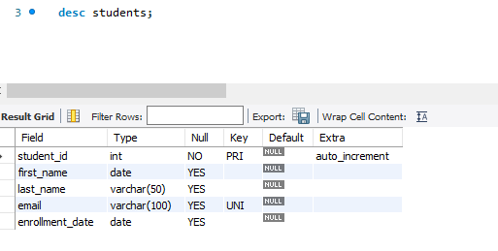

DROP

Drop table students
This will remove the table from DataBase and probably keep in new versions of all Database in recycle Bin ..we can extract from there just like deleted folders in windows

Drop all columns at once from the table

Alter table students DROP column(col1,col3..all)

Also dropping or deleting columns will happen only if no dependencies are with the same deleting table

Drop is used only to remove table but can also be used to remove other objects and views
Drop table table_name
Drop Object Object_name
Drop View view_name

Truncate
Its used to delete all the rows from the table

Rename
Used to rename a Table

DML - Data Manipulation Language

Insert, update, delete , merge

Delete is deleting rows and data for specific person whos last name is DOE

delete from students
where last_name ="Doe";
select * from students

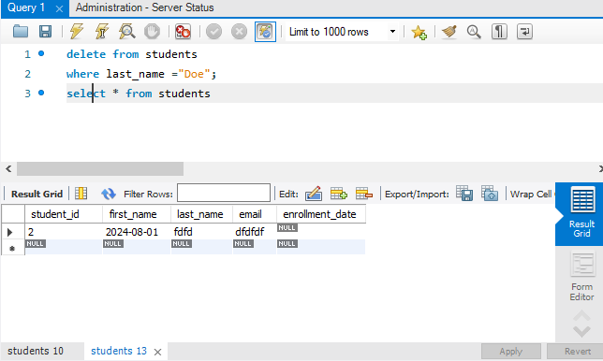

Creating a new Table from existing also copies the Data ..constrains ,, primary and foreign Keys are also copied ..like dependencies

Note : If do not want to copy the data and only the table structure then we habbe benutzen diese unten abfrage
Wenn Sie eine Tabelle erstellen möchten und die Daten nicht kopieren wollen, verwenden Sie die folgende Abfrage

Create Table Table_name where 1==2;

Falsche Bedingung Tabelle erstellt, aber ohne Daten

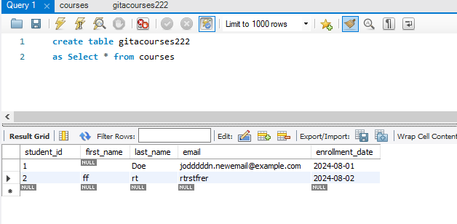

Operators in SQL
Special operators IN, Between, IS NULL, LIKE
Practice above queries from above section to get hands on for special operators

NV() or NV2() –
Select ename, salary , salary*12..some time some rows if it has no values updated or null then whole answer will be null ..above query will return null and not any answer
So query shall be Select ename,salary, salary+NV1(comm,0) from …

NV will have two options parameters and NV2 wil have 3 option parameters

Date () examples and queries
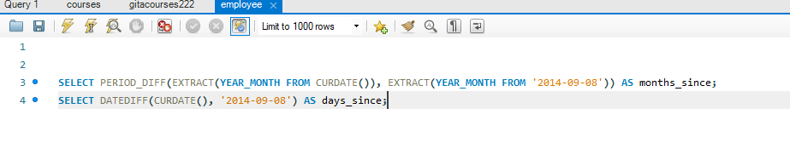
Work on some interview and more critical situations for Date in Database

Functions
Functions are of two types ..pre define and user defined
abs() – get the absolute value – change from negative to positive
min()
max()
avg()
count()

GroupBy
It makes the aggregate and removes duplicate count

Select department,count()
From Employee
Group By department

Order By

The result will be arranged in Ascending or descending order

Roll UP and Cube Function –

Rool up is like directly in result after the grouping in done give total for each group adding an extra row as total

Cube is aggregate of all the group in the very down section which will give aggregate total of all groups

Joins

Inner Join ..give only matching Data from both the tables
Self join – try to understand this and with more examples
Outer Join – all rows ..also we have left outer join , right outer join
Natural join – same as self but little faster

—-------------
Constrains

Its added on table and column level to project wrong Data entry or missing Data entry

Not null – cannot insert null or keep it empty
Unique - data insertion must be unique (at column level examples ID cannot be duplicate )
Primary Key – one for table and does not accept the null or duplicate
Foreign Key – this is to connect to other table with primaryKey only ..foreign key can have duplicate and null but primary Key cannot
On delete cascade option - when master table data is getting deleted then oracle will not allow as child table also has the Data and child table has to be deleted first ..so in case we want to delete the master without constraints of first deleting the child and directly master data ..then delete cascade option is enabled while creating the table
Create Table Employee(Empname str , empid int references OtherTable (PrimaryKey ) on delete cascade )

Cascade – this option is like to prevent asking is any child is also there and ignore same ..
Truncate table master_table cascade;

Check – logical conditions applied while creating table and these conditions can be business specific …
Example – Create Table table_name(EmployeeID int, Employe_salary check(salary > 45000))

We can use command to get the column and their specific constrains and check acting upon them ..they are actually stored in temp tables at oracle server default level or some default table maintained by server

Creating and altering Constrains

—-------------

Transaction Control Language

Commit , RollBack ,Save Point

—----------

Data Control Language (DCL)

DDL - Data definition language
Create the table
Create table table1(Sno number(5),Name varchar(10));

Desc - desc is to view only the single table structure …only the header of table

Alter –
To alter the columns in table ..like change delete column, change data type of colum

Drop ..drop can be used on table

Truncate Table — its used to delete all rows from the table

Create Table First as Select * from emp

Select * from first

Truncate table First .

The above will remove all rows from the Table

Joins …inner ..left outer..right outer..outer

Views
Materialized views
Fast Refresh Materialized Views

Triggers –
Statement Level triggers
Row level triggers ..after each row added/edited/deleted this code is triggered

Privileges

Roles

Object Level and schema level and Table level …privileges and Roles

Cache – simple like RAM ..which is in build in oracle server ..

Locks – table level locks and row level locks
..in row level too we have shared locks and exclusive locks

Index— indexing improves the query and performance of the query …fetch and

Normalization forms
1 NF
2NF
3NF
BCNF
4NF

SQL Nearly completed

Queries Questions only
Write a query to get the name,salary and annual salary from the employee Table

