PRACTICAL-1
NAMEB.SURYA PRAKASH REDDY
ROLL.NO2520030145
SEC7
C file program
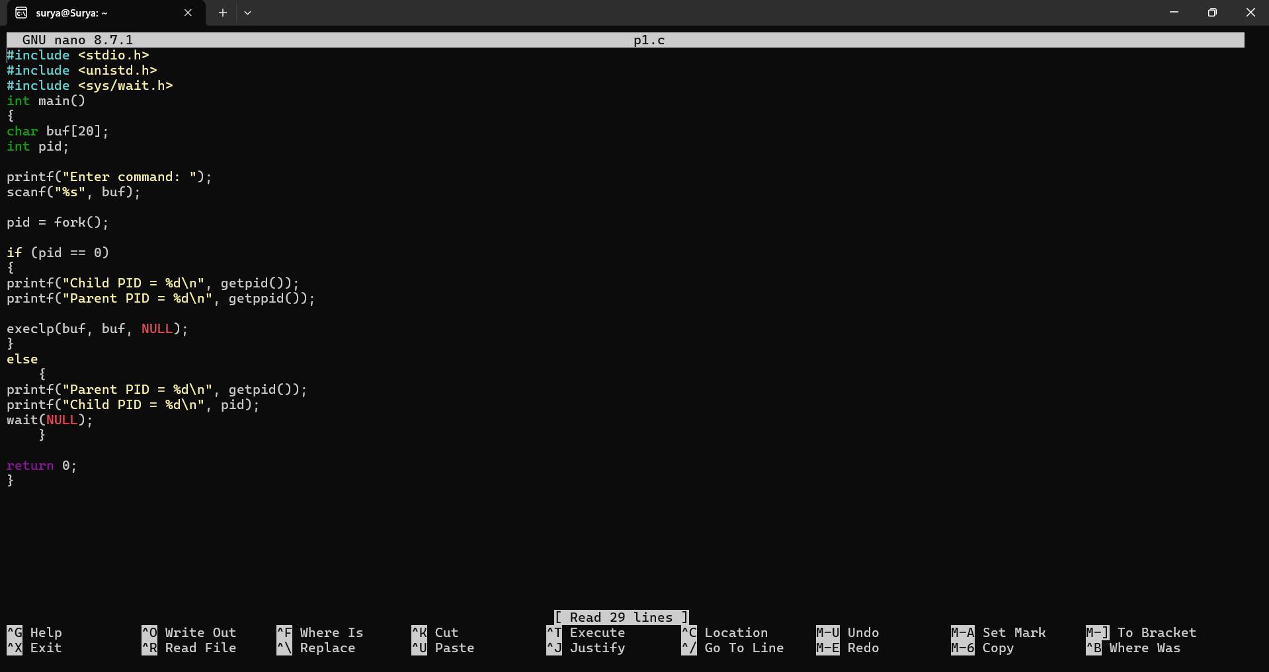
Output:-
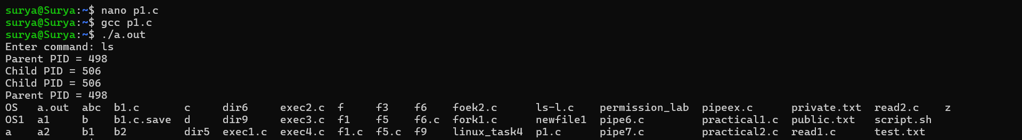
lscpu:-
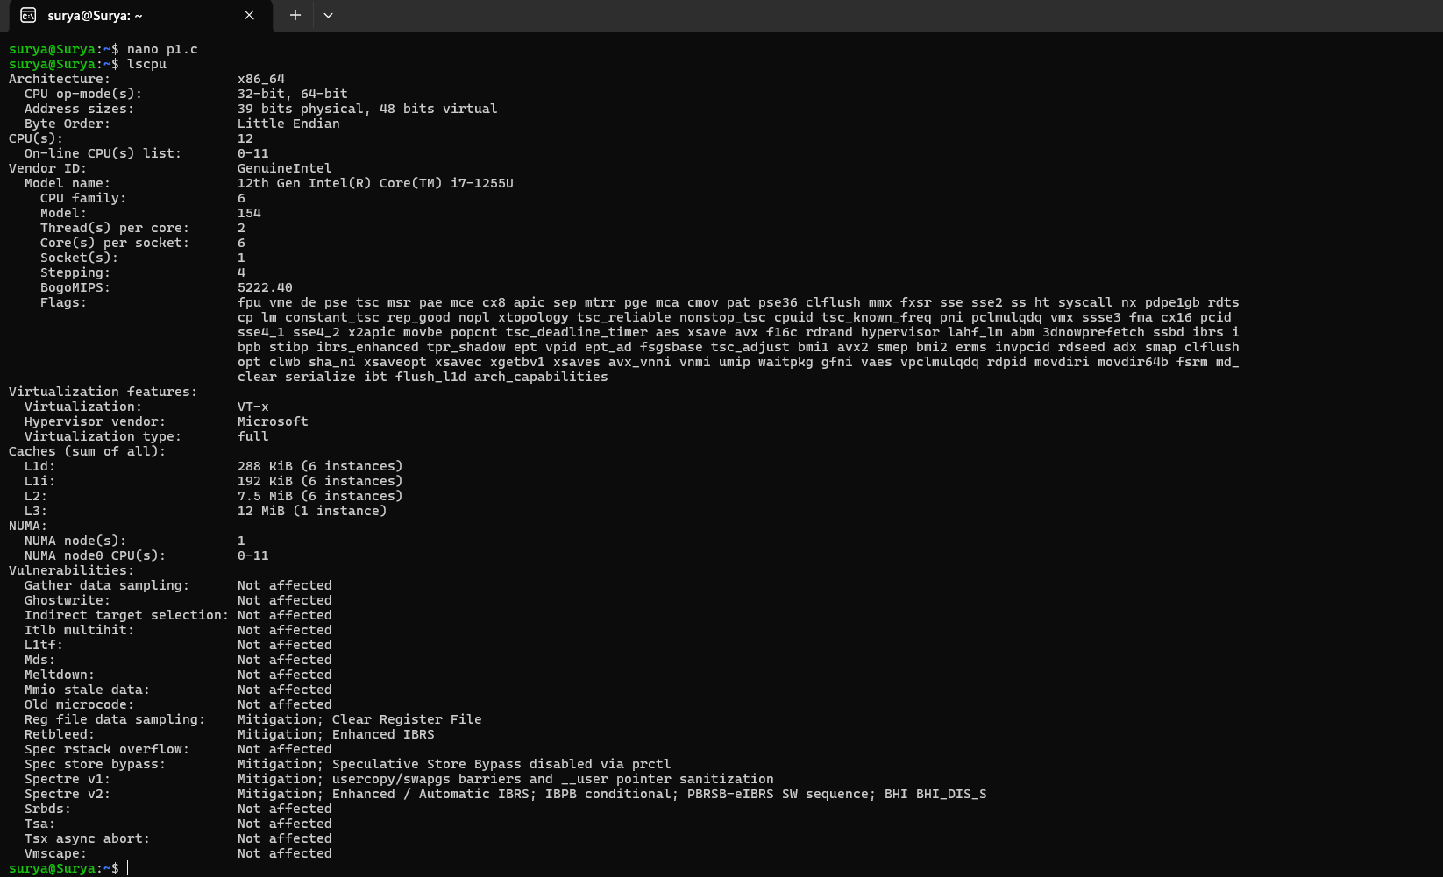
lsblk:-
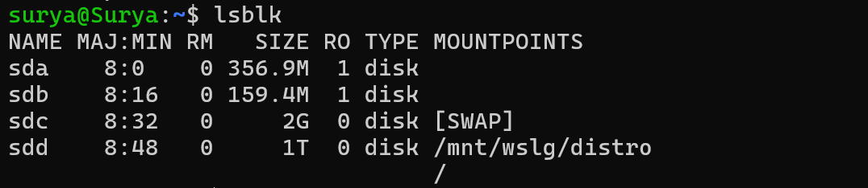
ps:-
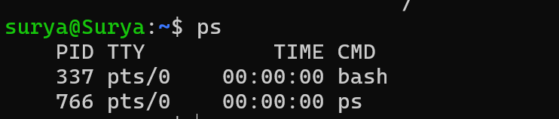
top:-
