Practical – 4
2520030145
B. Surya Prakash Reddy
S – 7

C File for the wait program
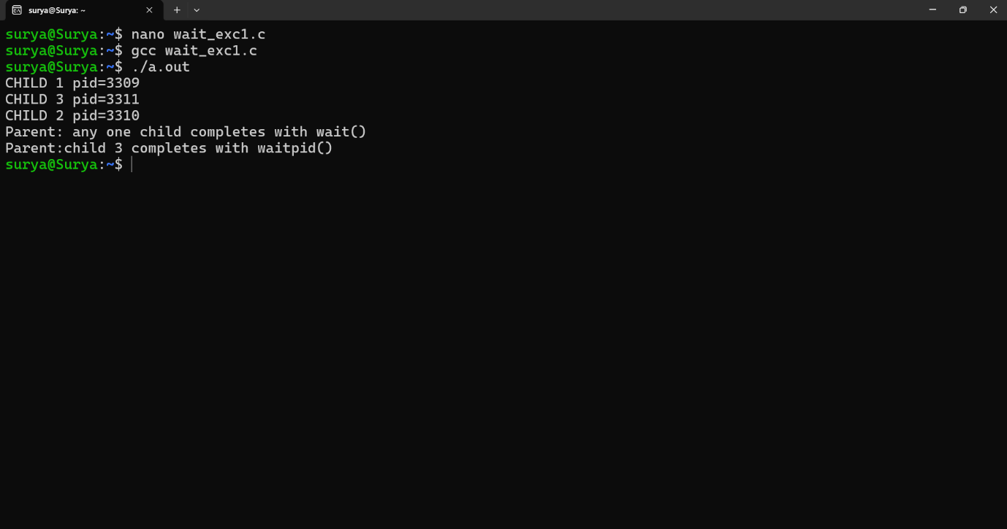

Output for the Zombie process experiment:
