PRACTICAL-3
NAMEB.SURYA PRAKASH REDDY

ROLL.NO2520030145

SEC7

C file(the program):

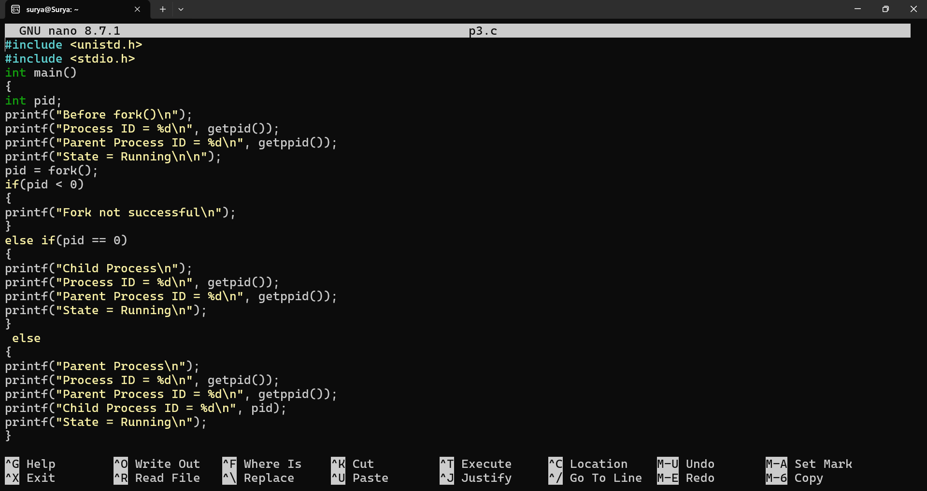

Output:

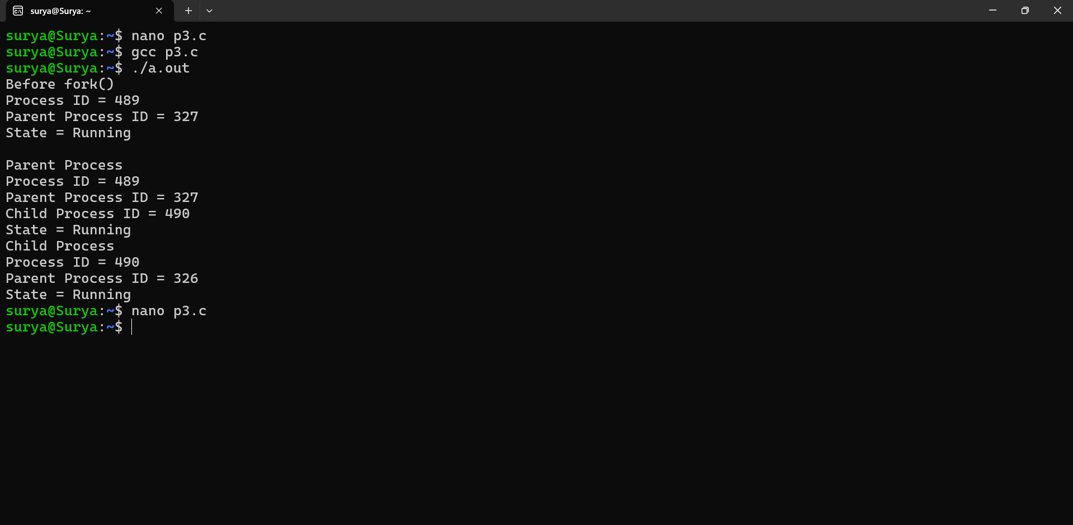

Ps (we got 327 as the pid and it is show here)
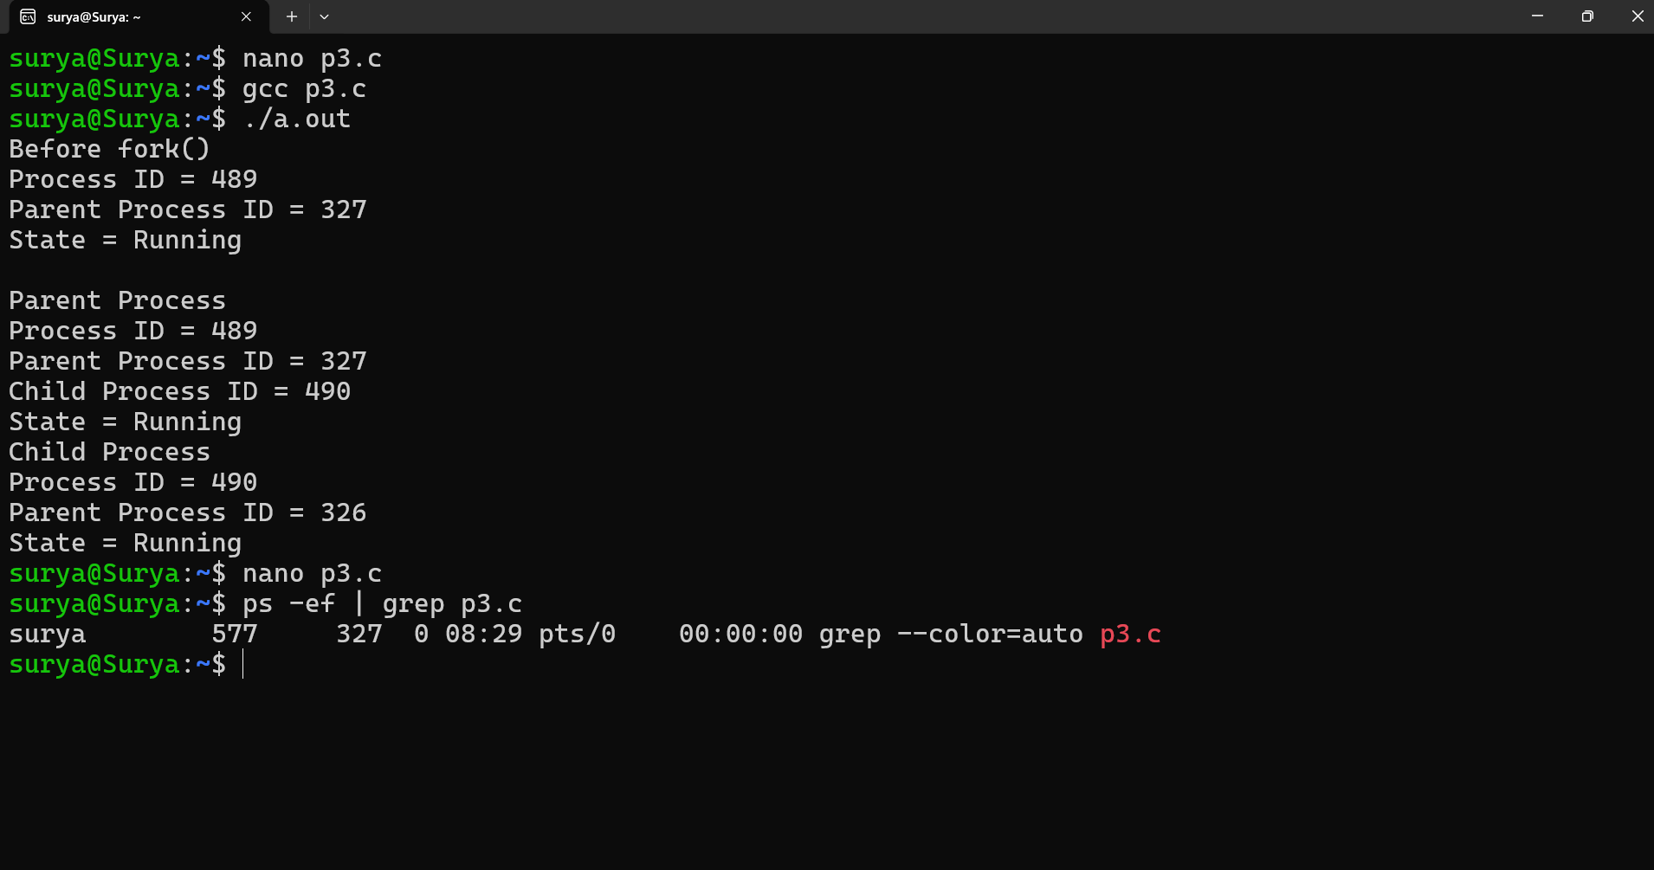

Top command using the 327 pid

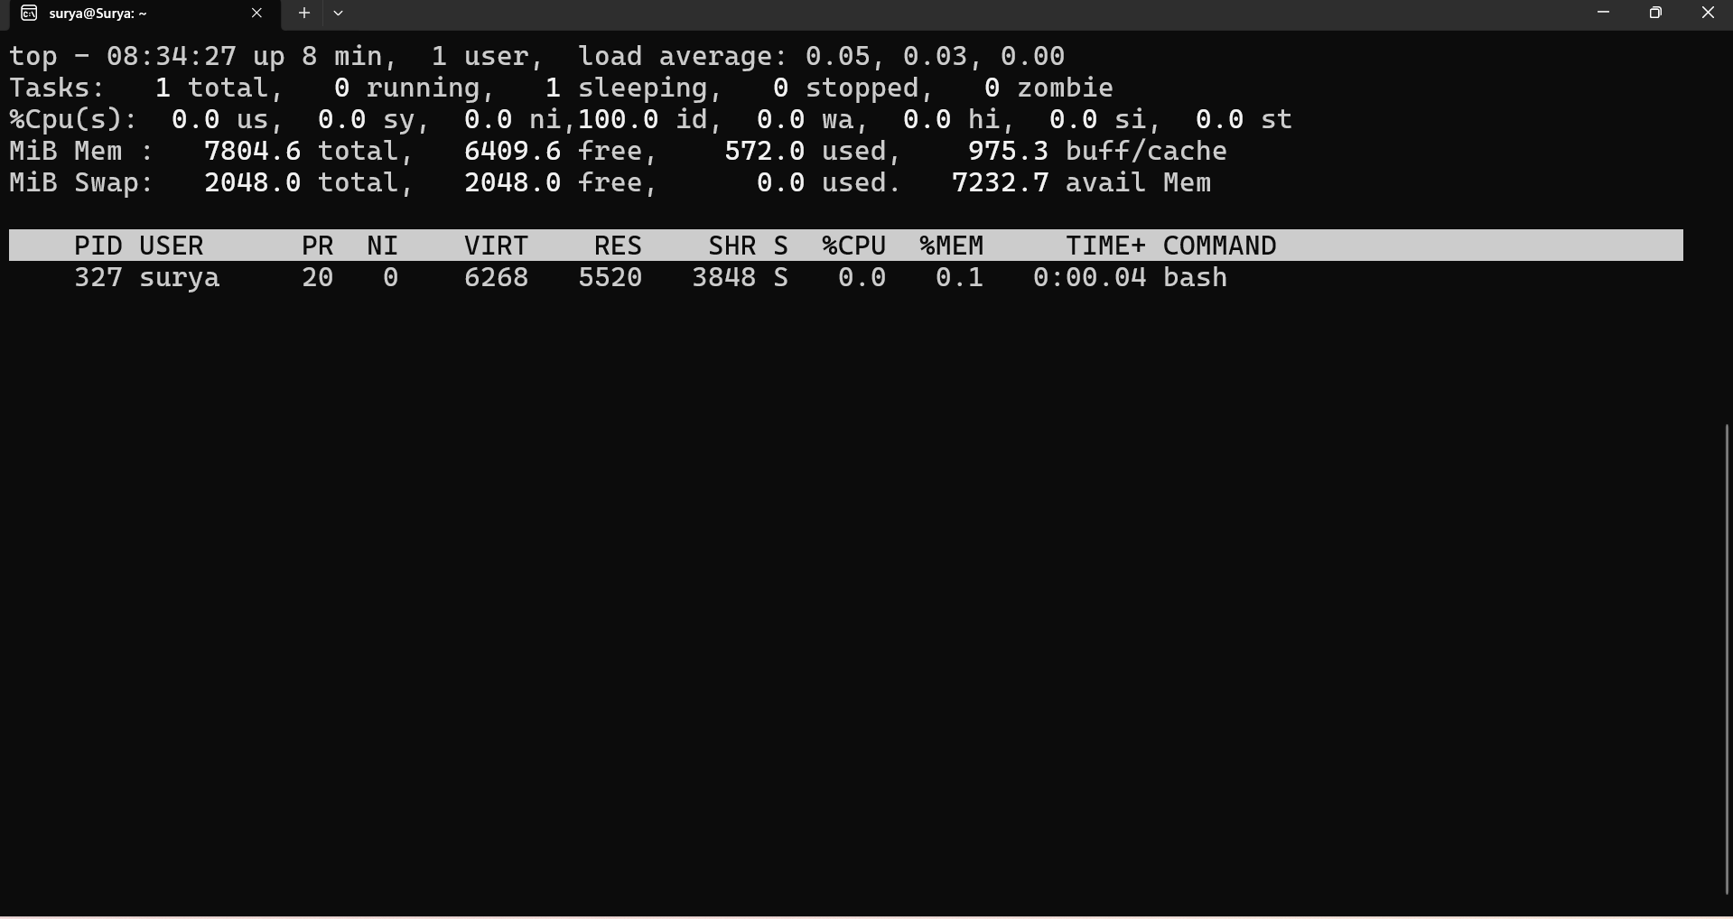

/proc command:

