


BERMUDA CRUISE

ALL MHS ALUMNI ARE INVITED TO ATTEND

At the request of those who can remember (!?!?!?) celebrating our "Class of '72 Turns 50" cruise, May 2004, your hardworking reunion committee is at it once again! Balmy breezes, sun, sand, scantily clad woman and ripped bar boys. Who can resist?
Join us on a Bermuda cruise second to none in October 2009. This is not a misprint. Your committee is arranging a once in a lifetime opportunity to leave your everyday stress behind and relax in Bermuda!
Royal Caribbean's luxury liner the "Explorer of the Seas" will be hosting Montville High School's best class reunion ever. We plan on leaving Saturday/Oct 10th 2009 from Cape Liberty, Bayonne NJ. We will be returning on Thursday Oct. 15th• Don't let the cost dissuade you from participating!
The cost is from $744 per person (inside cabin, no window), $794 per person (inside promenade with window); $1004 per person (Balcony Cabin) all prices include fees and taxes. Tips not included.
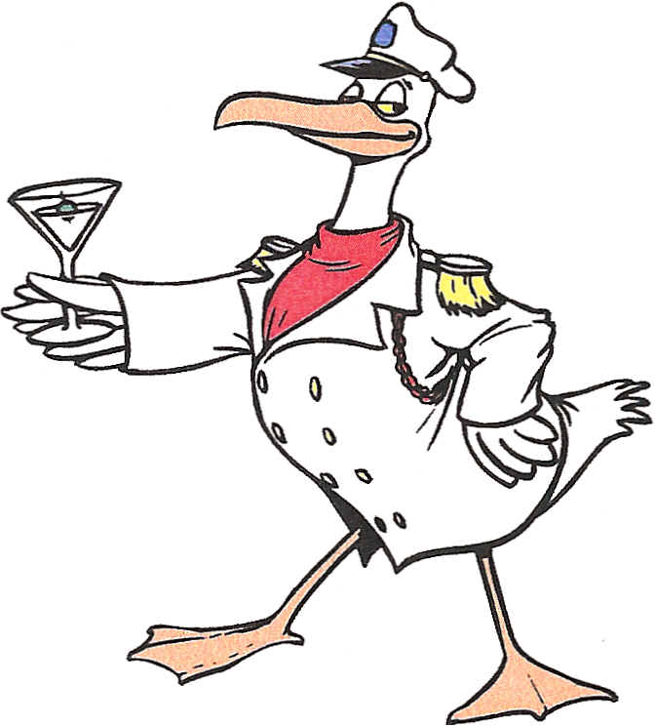
So, leave your worries behind and let's see just how much liquor we can consume, blackjack we can win, and trouble we can cause on the boat!!
Time to be had by all PRICELESS!!!! !
Minimum deposit of $250.00 due ASAP
2nd deposit of $200 due June 12th
Final payment due August 1st
For more details and to book your cruise contact:
Inger at King Travel, 310 Salem Turnpike Norwich, CT 06360 860-886-1901
Hope to see you there!
Sandy Zawacki Vanase (860-537-1266) e-mail: svanase@comcast.net
Shari Lee Orbe Puckett (860-376-9539 e-mail: shari.puckett@genesishcc.com
Fred Lathrop (860-848-9505) e-mail: fijfc@ct.metrocast.net


