Montville High School Alumni Association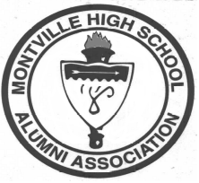
P.O. Box 133 Telephone: (860) 848-9208
Uncasville, CT 06382 Fax: (860) 848-3872

Membership Application

Name: (Maiden)
Address: Alumnus/YOG
Friend
Home Phone: Parent of Alumnus
Employer’s Name: Faculty
Address: Parent of Current Student
Name(s) of Student(s):
Business Phone: YOG
Check here if any information is new YOG
Committee Participation:
Board of Directors Legal
Communications- Newsletter Social- Fall Kickoff Classic
Communications- Media Social-Band/Drama
Financial Social- Sports Teams
School Relations

Membership Levels: (Make Checks Payable to “MHS Alumni Association”
$50.00 Gold Indian (Window Decal No Yes)
$25.00 Silver Indian (Window Decal No Yes)
$10.00 Basic Membership (Window Decal No Yes)
$5.00 Patron (Window Decal No Yes)
Additional designated for Scholarship

Merchandise:
$10.00 T-shirt x $10.00 =
$20.00 Golf Shirt x $20.00 =
$27.00 Sweat Shirt x $27.00 =

Please return completed form to the above address.

