* **PART 1:**
* **Training set error over number of epochs:**

for epoch # 0

Train Error:

0.002668761095225525

for epoch # 1

Train Error:

0.0

for epoch # 2

Train Error:

0.0

for epoch # 3

Train Error:

0.0

for epoch # 4

Train Error:

0.0

for epoch # 5

Train Error:

0.0

for epoch # 6

Train Error:

0.0

for epoch # 7

Train Error:

0.0

for epoch # 8

Train Error:

0.0

for epoch # 9

Train Error:

0.0

for epoch # 10

Train Error:

0.0

for epoch # 11

Train Error:

0.0

for epoch # 12

Train Error:

0.0

for epoch # 13

Train Error:

0.0

for epoch # 14

Train Error:

0.0

**Train Accuracy** :: 100.0 %

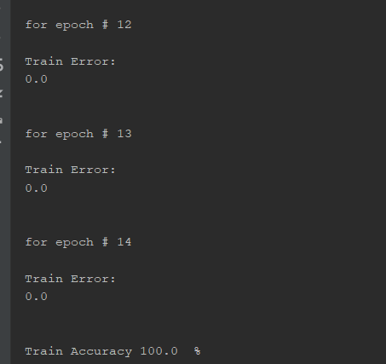

* **Test set error over number of epochs:**

epoch: 0 test error:: 0.13004502899507095

epoch: 1 test error:: 0.13004502899507095

epoch: 2 test error:: 0.13004502899507095

epoch: 3 test error:: 0.13004502899507095

epoch: 4 test error:: 0.13004502899507095

epoch: 5 test error:: 0.13004502899507095

epoch: 6 test error:: 0.13004502899507095

epoch: 7 test error:: 0.13004502899507095

epoch: 8 test error:: 0.13004502899507095

epoch: 9 test error:: 0.13004502899507095

epoch: 10 test error:: 0.13004502899507095

epoch: 11 test error:: 0.13004502899507095

epoch: 12 test error:: 0.13004502899507095

epoch: 13 test error:: 0.13004502899507095

epoch: 14 test error:: 0.13004502899507095

* **Final Test set accuracy:**

**Test** **accuracy** :: 86.9954971004929 %

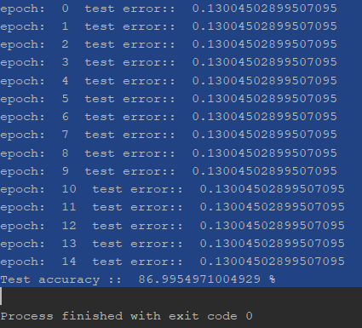

* **PART 2 :**
* **Training set error over number of epochs:**

after epoch: 1 train error--- 0.5766912346551406

after epoch: 2 train error--- 0.5720259337264455

after epoch: 3 train error--- 0.4064771132006119

after epoch: 4 train error--- 0.22960791617303897

after epoch: 5 train error--- 0.2361212820105808

after epoch: 6 train error--- 0.23599518508126877

after epoch: 7 train error--- 0.25394070386770884

after epoch: 8 train error--- 0.24296316337530055

after epoch: 9 train error--- 0.23882115724646868

after epoch: 10 train error--- 0.23522980189595277

after epoch: 11 train error--- 0.2312125301884199

after epoch: 12 train error--- 0.2307893215655949

after epoch: 13 train error--- 0.23351665211474026

after epoch: 14 train error--- 0.22795571328354236

after epoch: 15 train error--- 0.23098456508562445

**Train** **accuracy**:: 76.90154349143755 %

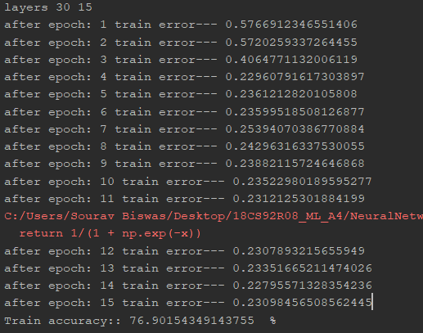

* **Test error over number of epochs:**

After epoch: 1 test error: 0.5618897925278062

After epoch: 2 test error: 0.5428628228098078

After epoch: 3 test error: 0.22205826578629742

After epoch: 4 test error: 0.2140650032798368

After epoch: 5 test error: 0.2299526127339579

After epoch: 6 test error: 0.23822457879965908

After epoch: 7 test error: 0.24559919083149365

After epoch: 8 test error: 0.23950566554218045

After epoch: 9 test error: 0.2528042514925054

After epoch: 10 test error: 0.2462061901498092

After epoch: 11 test error: 0.233175483222757

After epoch: 12 test error: 0.2364616498522636

After epoch: 13 test error: 0.23084315445559497

After epoch: 14 test error: 0.22941014132576254

After epoch: 15 test error: 0.23920922690915503

* **Final Test set accuracy:**

**Test accuracy ::** 76.0790773090845 %

