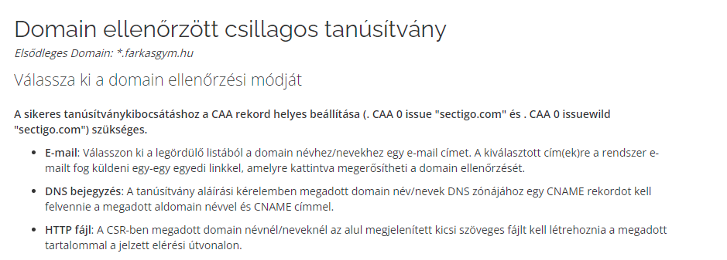

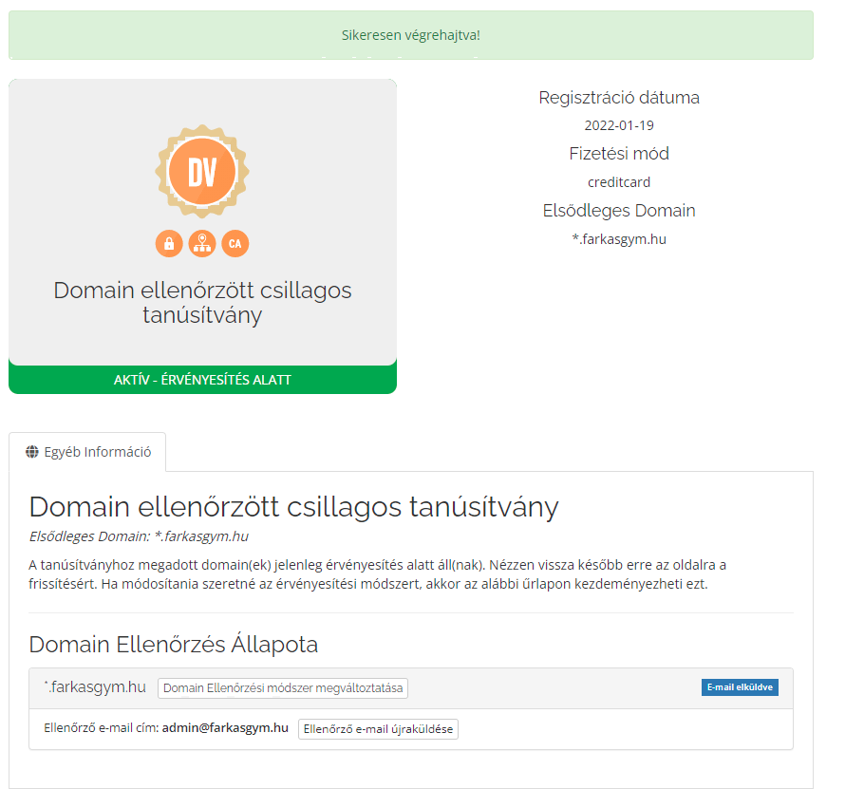

admin@farkasgym.hu

ism3RyZbAsSGXd9

ism3RyZbAsSGXd9

**ORDER #744597683 - Domain Control Validation for \*.farkasgym.hu (reference #35715)**

**T4GGqRqM\*DsHLswHG\*RAxWVySe8p16R7**

