Pawn Broker App

Please refer the below requirement document for this application requirements.
Stack: Next.js 13 + TypeScript + Prisma + SQLite + Vitest, nodeJs

How to run
Open command prompt
Go to the repo where placed ->
- cd d:\projects\pawn-broker
- npm install
- npx prisma migrate dev
- npm run db:seed
- npm run dev
Then open http://localhost:3000

Sample demo flow
- Create a loan (e.g. ₹10,000 at 2% monthly)
- Open loan details — check interest till date
- Record a partial payment
- Record another payment to close the loan
- Open Day Book — verify debit/credit entries

Loan List
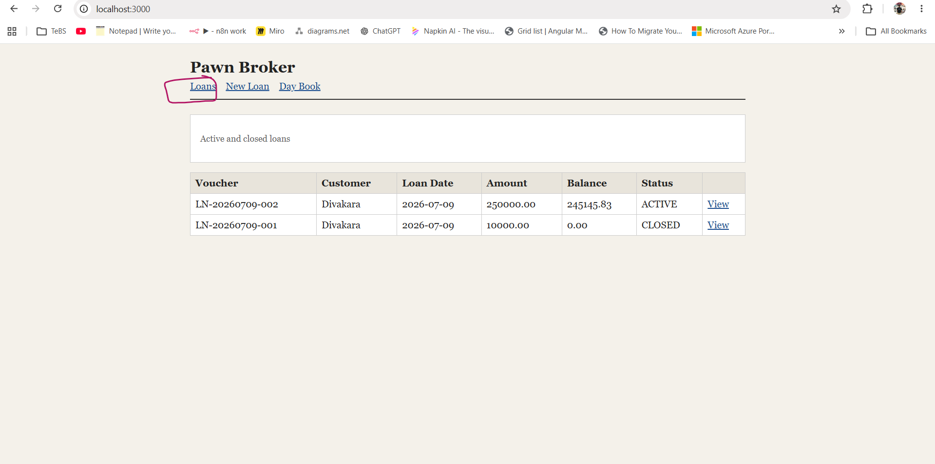

New Loan
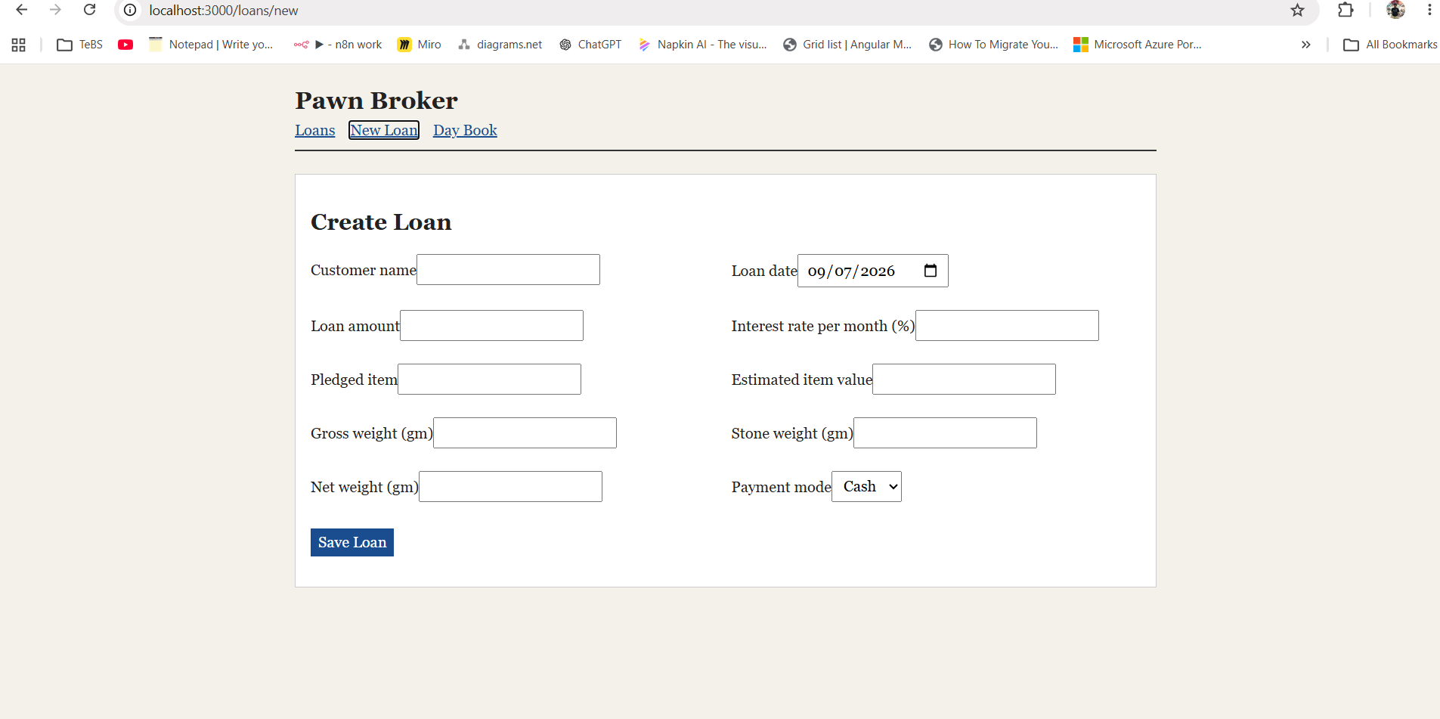

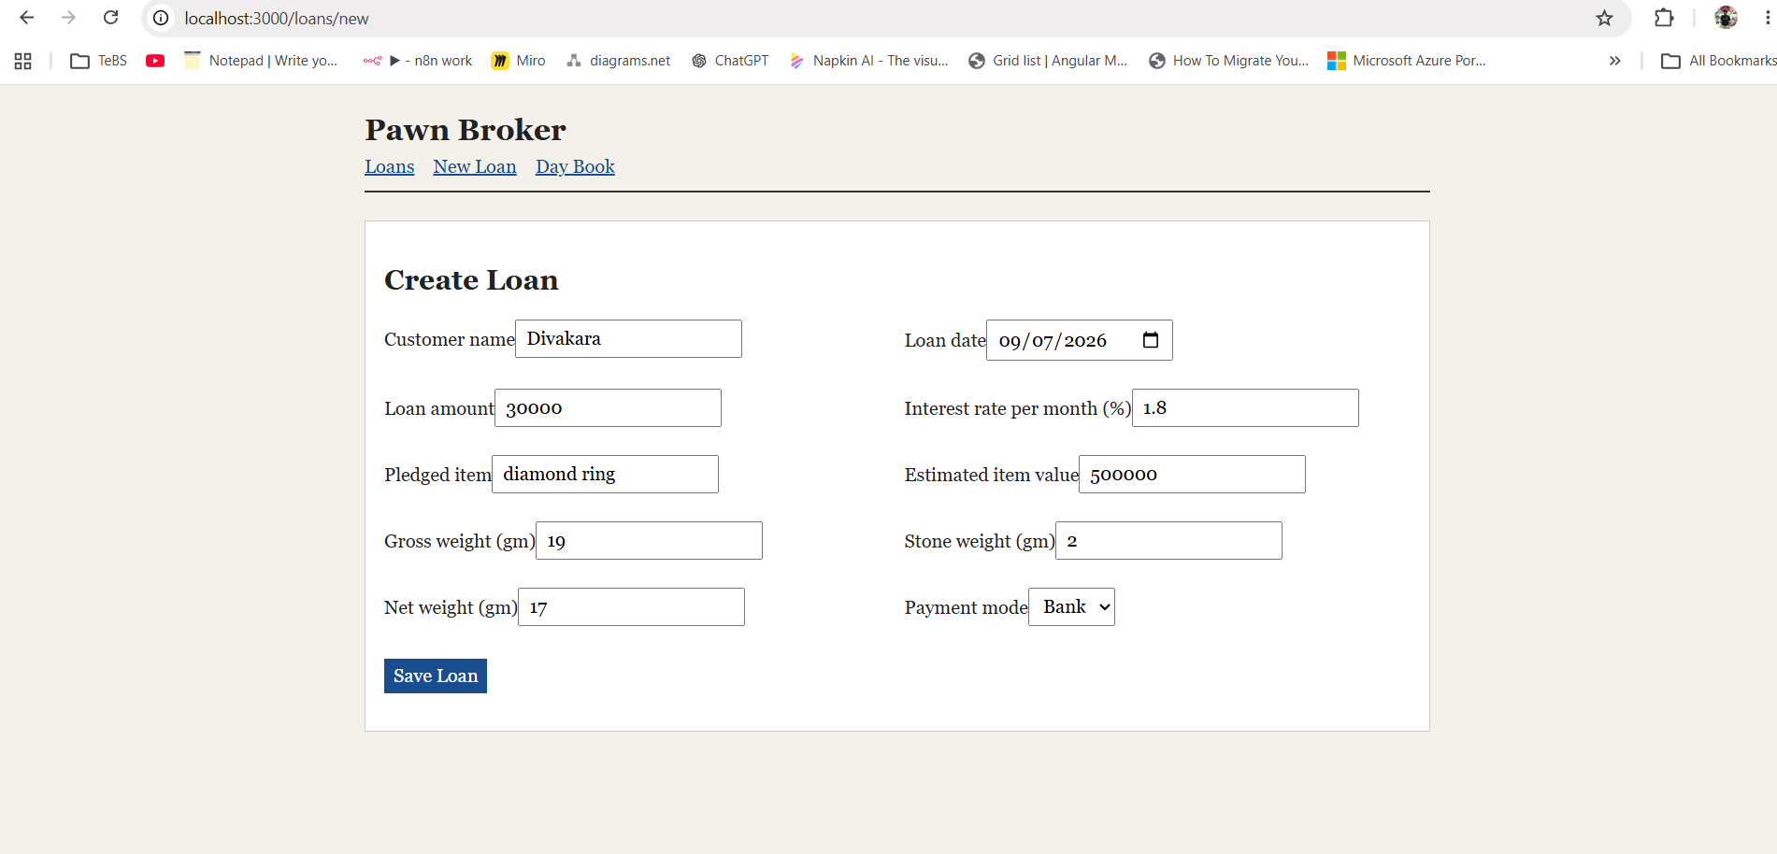
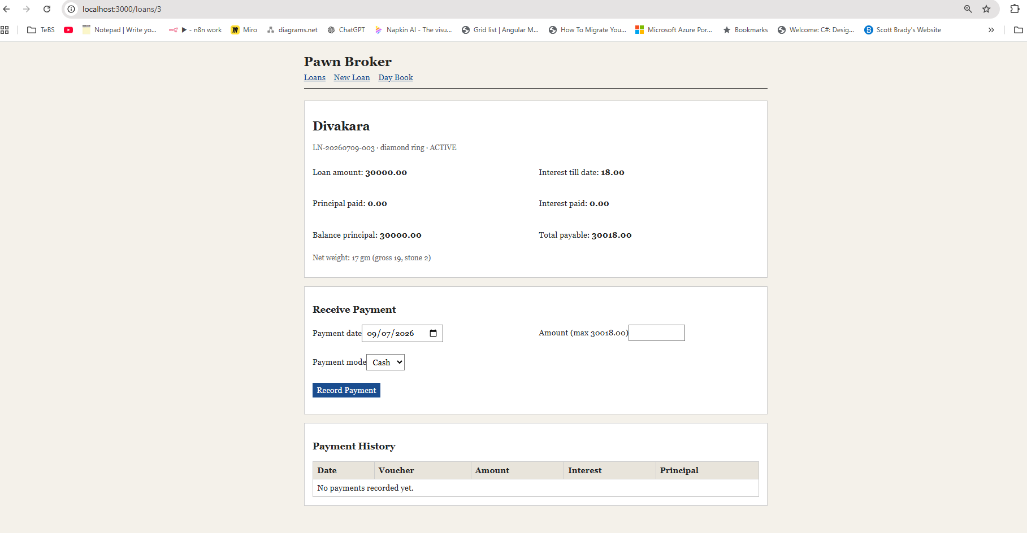

Record partial payment
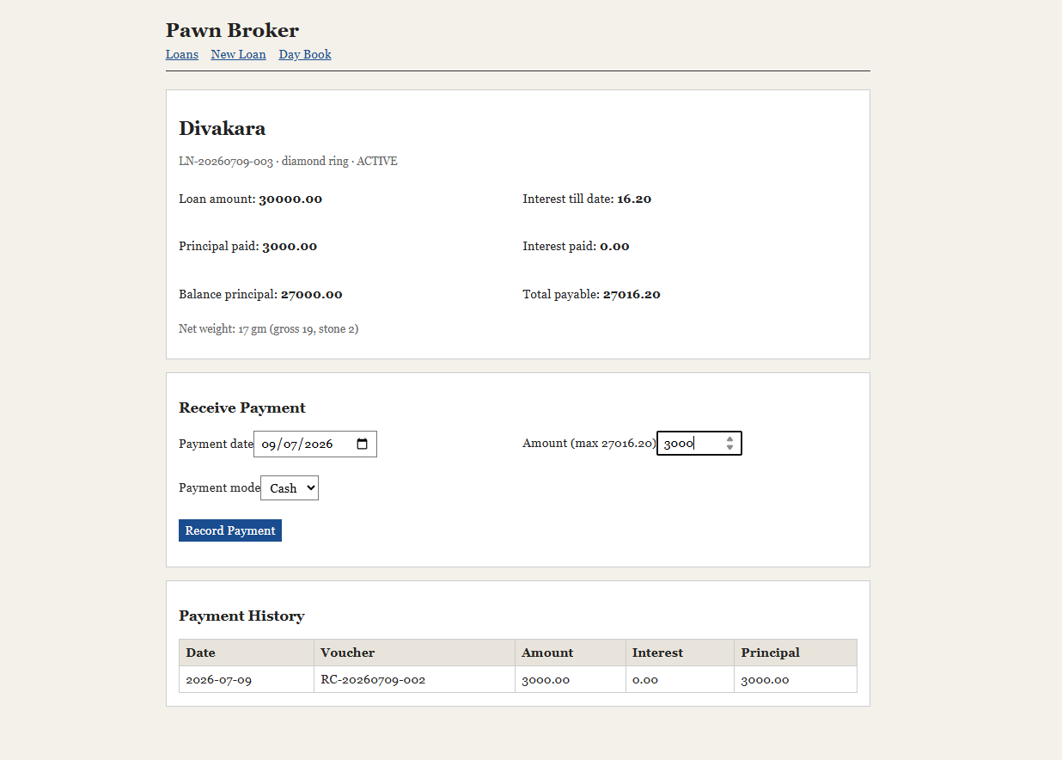

Day Book
