電通二甲微處理器實驗 實驗結報

實驗名稱 | Lab06(音樂教室)
組別 | 04 | 組員 | 羅振中、劉皓暐

- 實驗目的
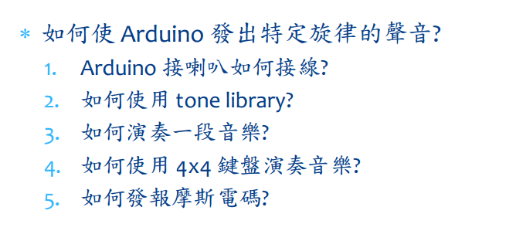
- 實驗步驟

- 程式碼
#define NOTE_C3 131
#define NOTE_CS3 139
#define NOTE_D3 147
#define NOTE_DS3 156
#define NOTE_E3 165
#define NOTE_F3 175
#define NOTE_FS3 185
#define NOTE_G3 196
#define NOTE_GS3 208
#define NOTE_A3 220
#define NOTE_AS3 233
#define NOTE_B3 247
#define NOTE_C4 262
#define NOTE_CS4 277
#define NOTE_D4 294
#define NOTE_DS4 311
#define NOTE_E4 330
#define NOTE_F4 349
#define NOTE_FS4 370
#define NOTE_G4 392
#define NOTE_GS4 415
#define NOTE_A4 440
#define NOTE_AS4 466
#define NOTE_B4 494
#define WHOLE 1 //全分符
#define HALF 0.5 //半分符
#define QUARTER 0.25
#define EIGHTH 0.125
#define SIXTEENTH 0.0625
int tune[] = { NOTE_C4, NOTE_C4, NOTE_C4,
NOTE_C4, NOTE_C4, NOTE_B3, NOTE_G3,
NOTE_A3, NOTE_C4, NOTE_C4, NOTE_G3,
NOTE_G3, NOTE_F3, NOTE_F3, NOTE_G3,
NOTE_F3, NOTE_E3, NOTE_G3, NOTE_C4,
NOTE_C4, NOTE_C4, NOTE_C4, NOTE_A3,
NOTE_B3, NOTE_C4, NOTE_D4};
float duration[] = { EIGHTH,
QUARTER+EIGHTH, SIXTEENTH, QUARTER,
QUARTER, HALF, HALF, HALF, QUARTER,
QUARTER, HALF+QUARTER, QUARTER,
QUARTER, QUARTER, QUARTER+EIGHTH,
EIGHTH, QUARTER, QUARTER, QUARTER,
EIGHTH, EIGHTH, QUARTER, QUARTER,
QUARTER, QUARTER, HALF+QUARTER};
void setup() {
pinMode(8, OUTPUT);
length = sizeof(tune) /
sizeof(tune[0]);
}
void loop() {
for (int x=0; x<length; x++) {
tone(8, tune[x]);
delay(2500 *duration[x]);
noTone(8);
}
delay(5000);
}

- 實驗結果及分析
實驗1中能成功演奏出一首曲子，實驗2中成功將4x4鍵盤變成樂器，實驗3中讓arduino輸出摩斯密碼。

- 心得討論
這次的實驗是做【音樂教室】，利用喇叭接上Aaduino板，使其發出聲音，並利用音頻的差別，彈奏出一首歌的曲子，而我們這組彈奏的是【瑪莉有隻小綿羊】。
第二個實驗，利用喇叭接上Arduino板以及4X4的鍵盤，使我們輸入的數字，能夠順利發出想要的聲音。
第三個實驗，利用喇叭接上Arduino板，完成摩斯密碼的輸出聲音，每個字母間隔0.3秒，空白鍵間隔0.7秒。

真得很有趣，第一次做有關於機器發出聲音的實驗，希望下一次能夠有機會可以再做類似的實驗!!!
- 修正電路圖

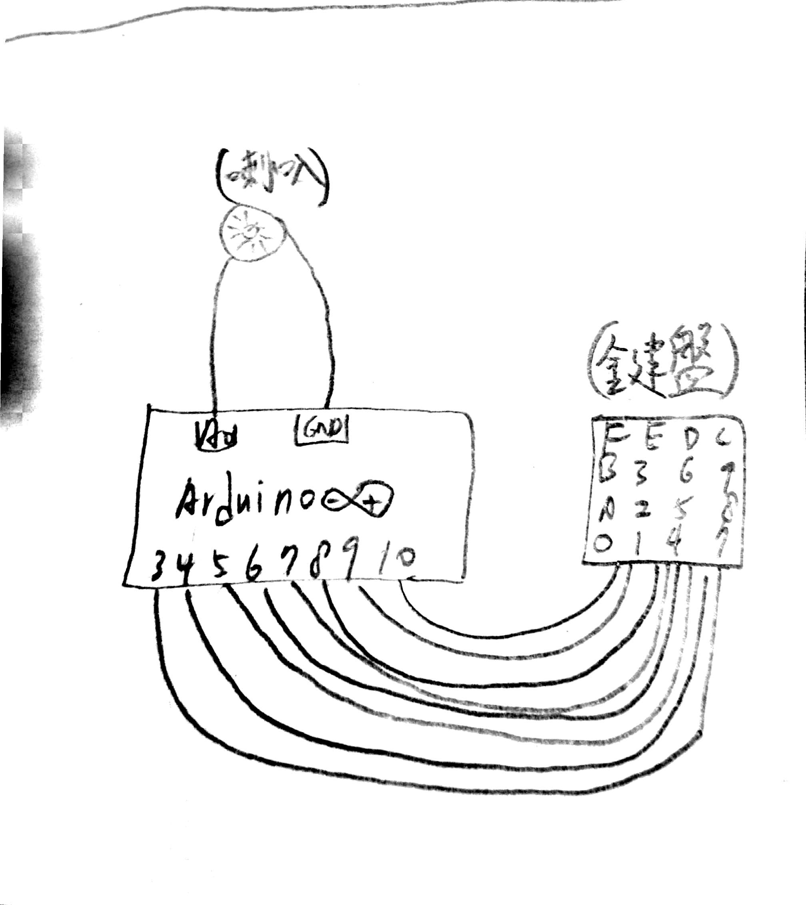
- 修正程式碼
(1)
#define NOTE_C3 131
#define NOTE_CS3 139
#define NOTE_D3 147
#define NOTE_DS3 156
#define NOTE_E3 165
#define NOTE_F3 175
#define NOTE_FS3 185
#define NOTE_G3 196
#define NOTE_GS3 208
#define NOTE_A3 220
#define NOTE_AS3 233
#define NOTE_B3 247
#define NOTE_C4 262
#define NOTE_CS4 277
#define NOTE_D4 294
#define NOTE_DS4 311
#define NOTE_E4 330
#define NOTE_F4 349
#define NOTE_FS4 370
#define NOTE_G4 392
#define NOTE_GS4 415
#define NOTE_A4 440
#define NOTE_AS4 466
#define NOTE_B4 494
#define WHOLE 1 //全分符
#define HALF 0.5 //半分符
#define QUARTER 0.25
#define EIGHTH 0.125
#define SIXTEENTH 0.0625

int tune[] = {NOTE_B3,NOTE_A3,NOTE_G3,NOTE_A3,NOTE_B3,NOTE_B3,NOTE_B3,
NOTE_A3,NOTE_A3,NOTE_A3,NOTE_B3,NOTE_B3,NOTE_B3,NOTE_B3,NOTE_A3,NOTE_G3,NOTE_A3,NOTE_B3,NOTE_B3,NOTE_B3,
NOTE_A3,NOTE_A3,NOTE_B3,NOTE_A3,NOTE_G3};

float duration[] = {QUARTER+EIGHTH,EIGHTH,QUARTER,QUARTER,
QUARTER,QUARTER,HALF,
QUARTER,QUARTER,HALF,
QUARTER,QUARTER,HALF,
QUARTER+EIGHTH,EIGHTH,QUARTER,QUARTER,
QUARTER,QUARTER,HALF,
QUARTER,QUARTER,QUARTER,QUARTER,
HALF+HALF};

int length = sizeof(tune);

void setup()
{
pinMode(A0, OUTPUT);
}

void loop()
{
for (int x=0;x<length;x++)
{
tone(A0, tune[x]);
delay(2500 *duration[x]);
noTone(A0
);
}
delay(5000);
}

(2)
#include <Keypad.h>
const byte ROWS = 4;
const byte COLS = 4;

char keys[ROWS][COLS] =
{
{'7','8','9','C'},
{'4','5','6','D'},
{'1','2','3','E'},
{'0','A','B','F'}
};
byte rowPins[ROWS] = {6,5,4,3};
byte colPins[COLS] = {10,9,8,7};
Keypad keypad = Keypad( makeKeymap(keys), rowPins, colPins, ROWS, COLS );

#define NOTE_C3 131
#define NOTE_CS3 139
#define NOTE_D3 147
#define NOTE_DS3 156
#define NOTE_E3 165
#define NOTE_F3 175
#define NOTE_FS3 185
#define NOTE_G3 196
#define NOTE_GS3 349
#define NOTE_A3 392
#define NOTE_AS3 440
#define NOTE_B3 493
#define NOTE_C4 523
#define NOTE_CS4 587
#define NOTE_D4 659
#define NOTE_DS4 698
#define NOTE_E4 784
#define NOTE_F4 880
#define NOTE_FS4 988
#define NOTE_G4 1046
#define NOTE_GS4 1175
#define NOTE_A4 1318
#define NOTE_AS4 1397
#define NOTE_B4 1568
#define WHOLE 1 //全分符
#define HALF 0.5 //半分符
#define QUARTER 0.25
#define EIGHTH 0.125
#define SIXTEENTH 0.0625

int tune[] = {NOTE_GS3,NOTE_A3,NOTE_AS3,NOTE_B3,NOTE_C4,NOTE_CS4,
NOTE_D4,NOTE_DS4,NOTE_E4,NOTE_F4,NOTE_FS4,NOTE_G4,NOTE_GS4,NOTE_A4,
NOTE_AS4,NOTE_B4};

void setup()
{
pinMode(A0, OUTPUT);
}
void loop()
{
char key = keypad.getKey();
if (key != NO_KEY)
{
if(key >= '0' && key <= '9')
{
tone(A0, tune[key-48]);
delay(100);
noTone(A0);
}
if(key >= 'A' && key <= 'F')
{
tone(A0, tune[key-65+10]);
delay(100);
noTone(A0);
}

}
}
(3)
char*morse[]={"01","1000","1010","100",
"0","0010","110","0000",
"00","0111","101","0100",
"11","10","111","0110",
"1101","010","000","1",
"001","0001","11","1001",
"1011","1100"};
const byte Buzzer =10;
char chr,index;
char*ptr;

void setup()
{
pinMode(Buzzer,OUTPUT);
Serial.begin(9600);
}
void loop()
{
if(Serial.available())
{
chr = Serial.read();
Serial.println(chr);
if((chr-'A')>=0 && (chr-'Z')<=0)
{
index = chr-'A';
ptr = morse[index];
while(*ptr!='\0')
{
if(*ptr=='0')
{
tone(Buzzer,440,100);
delay(100);
}
else
{
tone(Buzzer,440,300);
delay(300);
}
ptr++;
delay(100);
}
delay(300);
}
}
}
}

