電通二甲微處理器實驗 實驗預報

實驗名稱 | Lab06(音樂教室)
組別 | 04 | 組員 | 羅振中、劉皓暐

- 實驗目的
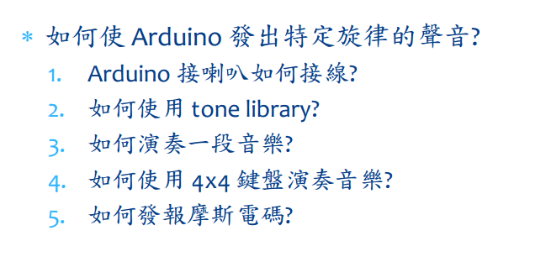

- 實驗步驟\


- 程式碼
#define NOTE_C3 131
#define NOTE_CS3 139
#define NOTE_D3 147
#define NOTE_DS3 156
#define NOTE_E3 165
#define NOTE_F3 175
#define NOTE_FS3 185
#define NOTE_G3 196
#define NOTE_GS3 208
#define NOTE_A3 220
#define NOTE_AS3 233
#define NOTE_B3 247
#define NOTE_C4 262
#define NOTE_CS4 277
#define NOTE_D4 294
#define NOTE_DS4 311
#define NOTE_E4 330
#define NOTE_F4 349
#define NOTE_FS4 370
#define NOTE_G4 392
#define NOTE_GS4 415
#define NOTE_A4 440
#define NOTE_AS4 466
#define NOTE_B4 494
#define WHOLE 1 //全分符
#define HALF 0.5 //半分符
#define QUARTER 0.25
#define EIGHTH 0.125
#define SIXTEENTH 0.0625
int tune[] = { NOTE_C4, NOTE_C4, NOTE_C4,
NOTE_C4, NOTE_C4, NOTE_B3, NOTE_G3,
NOTE_A3, NOTE_C4, NOTE_C4, NOTE_G3,
NOTE_G3, NOTE_F3, NOTE_F3, NOTE_G3,
NOTE_F3, NOTE_E3, NOTE_G3, NOTE_C4,
NOTE_C4, NOTE_C4, NOTE_C4, NOTE_A3,
NOTE_B3, NOTE_C4, NOTE_D4};
float duration[] = { EIGHTH,
QUARTER+EIGHTH, SIXTEENTH, QUARTER,
QUARTER, HALF, HALF, HALF, QUARTER,
QUARTER, HALF+QUARTER, QUARTER,
QUARTER, QUARTER, QUARTER+EIGHTH,
EIGHTH, QUARTER, QUARTER, QUARTER,
EIGHTH, EIGHTH, QUARTER, QUARTER,
QUARTER, QUARTER, HALF+QUARTER};
void setup() {
pinMode(8, OUTPUT);
length = sizeof(tune) /
sizeof(tune[0]);
}
void loop() {
for (int x=0; x<length; x++) {
tone(8, tune[x]);
delay(2500 *duration[x]);
noTone(8);
}
delay(5000);
}

- 電路圖
