**TD 6**

**Web Service REST**

**What Done**

Follow all steps of Unit 1.

Follow to step 14 of Unit 2.

**What Working**

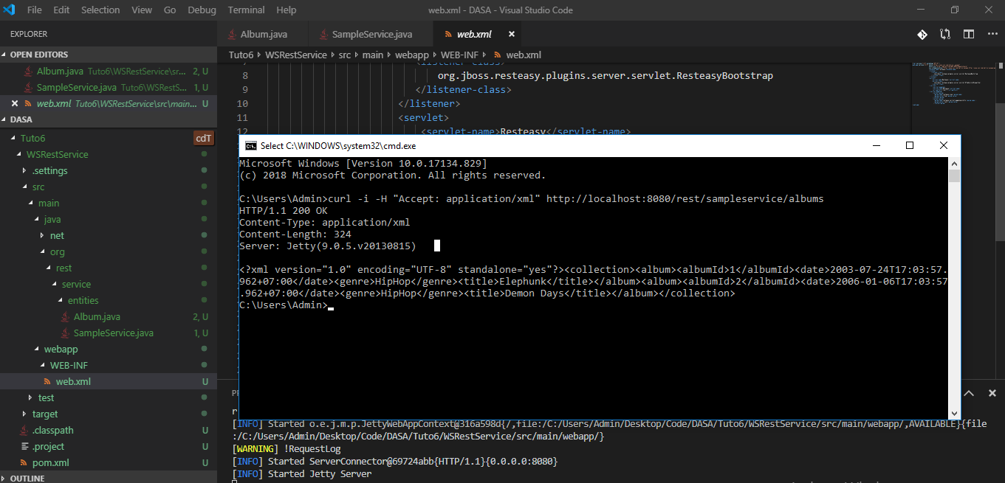

**What Not Working**

Unit 2 – Step 13: Did not get the message.

**How it works**