BACKGROUND
Sepsis and its heterogeneous host immune response.
Approximately 13% of U.S. hospital costs are attributed to a single condition: Sepsis. Alarmingly, despite more than 38 billion USD in hospitalization expenses annually, the estimated mortality of the disorder ranges from 28 to 50%¹. To put it into perspective, the number of U.S. deaths from sepsis is higher than prostate cancer, breast cancer, and AIDS combined ². One evident issue that influences the high mortality is the lack of interventions available to clinicians when caring for septic patients. Although there have been many promising preclinical studies, more than 100 clinical trials have failed to improve sepsis survival rates³. Consequently, the disease has no FDA-approved therapies. The prevalent hypothesis for this persistent failure to develop therapeutic options is that septic patients have been treated as a homogenous cohort when, in fact, they exhibit clinical and biological heterogeneity.
The 5th Toronto Sepsis Roundtable⁴ reinforced the concept of sepsis not as a single disease entity but as a heterogeneous process. Breaking down this process is challenging due to several limitations, including the labor-intensive and costly logistics of conducting large, prospective multi-omics clinical studies, the scarcity of longitudinal transcriptomic data, the need for accessible, well-curated multi-omics datasets, and the lack of diversity in research cohorts. These challenges have significantly hindered the evaluation of effective therapies for sepsis. Yet, the confluence of multiple data modalities (e.g., physiological, omics) — aided by cutting-edge artificial intelligence (AI) techniques (e.g., unsupervised learning algorithms), systematic data curation processes, and broader involvement of the research community — promises to reveal homogeneous, clinically actionable phenotypes in septic patients⁵.
Opportunities and challenges of immune phenotypes of sepsis patients
In the last few years, several methodologies have been developed to uncover the inherent heterogeneity of the host response syndrome in septic patients, in search of a treatable trait: a specific physiologic derangement characterized by immune phenotypes (or biomarkers) that may signal a predictable response to a particular therapy or intervention⁶. In the specific case of sepsis, as the immune response to infection leads to a “storm” of pro- and anti-inflammatory cytokines being expressed at the same time⁷, the transcriptome has become one of the most viable sources of information on the host response, as it precedes the alterations at the protein levels and can be sequenced on a scale^{8,9}.
Several transcriptomic-based immune phenotypes of septic patients have been recently developed and validated in individual studies, establishing a foundation for a precision medicine approach in sepsis¹⁰⁻¹⁵. These studies have shown that gene expression patterns can stratify patients into immune phenotypes with distinct survival patterns, offering the potential for developing targeted treatments and improving patient outcomes. These results bring the promise that precision medicine could soon become a reality in sepsis. However, the reproducibility of these studies is limited by variability in platforms (e.g., microarray, bulk RNA sequencing, or NanoString) and methodologies (e.g., whole blood or peripheral blood leukocyte-derived RNA)¹⁶. Furthermore, the quality and integrity of RNA samples, and the disparate technologies, techniques, and materials used to analyze gene expression at the transcriptomic level without effective batch correction to mitigate dataset-specific noise, are frequent technical challenges in translating transcriptomic research^{17,18}. In addition, even with the establishment of consensus frameworks¹⁹, many transparency issues still impact the reproducibility of scientific research, such as the majority use of private datasets and the undermining of public datasets by a lack of standardization and sharing of data harmonization methods and code in their entirety. Unsurprisingly, a recent study assessing the concordance of immune phenotypes in critically ill patients could not identify a comparable patient population across the studied phenotypes ¹⁸. This highlights that, despite promising findings, these phenotyping tools will rarely be deployed in clinical practice because they are not reproducible and lack technical transparency, raising concerns about the exacerbation of equity issues in access to and delivery of care.
While discovery platforms such as DataMed^{ref} have eased the issues above by making biomedical data searchable, this is only the first step of the research process. Integrating and harmonizing the diverse platforms, methodologies, and technologies for analysis constitutes the bulk of the effort required for reproducible research. When trying to overcome the remaining barriers, researchers often find: (1) the fragmentation of sepsis biomedical data across different formats, which demands a high level of technical expertise to integrate, harmonize, and analyze and therefore hinders reproducibility and continuity of research (2) the lack of open-source methodologies that systematically uncovers immune phenotypes in sepsis in a manner that is attainable to the overall scientific community including researchers with limited digital literacy, hindering data democratization, subject diversity, and the equitable and overall development of a transparent research field. Therefore, this program aims to develop an open-source discovery and integration hub for biomedical data, accelerating massive open research collaborations that will enable more transparent and inclusive research, expanding and promoting multi-omics research, and potentially leading to new discoveries and interventions in sepsis.

RECENT PROGRESS
Our research group has recently made significant advancements in the field of sepsis, positioning us strategically to achieve our goals ^{20.} A key milestone was the establishment of collaborations that grant us access to two novel, de-identified, longitudinal, paired clinical-transcriptomics datasets from the USA, Canada, and Brazil, derived from the Stratifying Patient Immune Endotypes in Sepsis (SPIES) network²¹ and Endpoint Health, Inc. The SPIES network, an ongoing NIH-funded multicenter study, has enrolled 438 critically ill adults (sepsis and non-sepsis) since February 2021. Meanwhile, Endpoint Health, Inc. conducted a multicentric observational study of 500 adults with septic shock from Brazil, Canada, and the USA (July 2021–August 2022) — a study designed, led, and conducted by our group. These datasets are unique, as they feature a diverse population with sepsis and rich multi-omics (i.e., proteomics, transcriptomics, metabolomics) data at varying time points for each patient, offering unprecedented opportunities for integrative analysis.
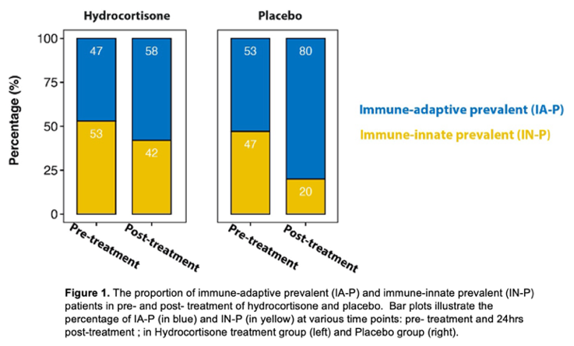
We have also developed significant experience and infrastructure for managing and analyzing complex clinical transcriptomics datasets, as evidenced by two recent publications exploring gene expression derived from microarray and RNA-seq to classify immune phenotypes in patients with sepsis and guide hydrocortisone treatment ¹⁵. Using transcriptomic data and unsupervised learning, we uncovered two sepsis immune phenotypes: Immune-Adaptive Prevalent (IA-P) and Immune-Innate Prevalent (IN-P) in patients with sepsis. The Immune-Adaptive Prevalent (IA-P) phenotype was characterized by lower indices of inflammation, organ failures, severity of illness scores, and lower mortality and was represented by higher expression of genes related to adaptive immunity, such as T cell activation. The Immune Innate Prevalent (IN-P) phenotype was characterized by a lack of adaptive immune activity with lower lymphocyte counts and a higher expression of genes associated with inflammation regulated by myeloid cell-mediated immune activity. These phenotypes may have a different response to steroid therapy as demonstrated in a secondary analysis¹⁵ of a subgroup of patients from the Effect of Early Vasopressin vs. Norepinephrine on Kidney Failure in Patients with Septic Shock (VANISH) trial²². In the analyses, IA-P patients treated with hydrocortisone had a statistically significant increase in 28-day mortality. In contrast, IN-prevalent patients showed the reverse trend¹⁵. This finding was subsequently validated in a re-analysis of the largest trial to date on the use of hydrocortisone in patients with septic shock (ref), which confirmed that sepsis immune phenotypes might help tailor therapies, offering insights into immunopathology and treatment effects in sepsis (Figure 1).
One of the proposed projects in this application is a web resource that the industry characterizes as Software as a Service (SaaS); as such, the successful completion of this proposal also relies on the capacity to build one. In recent endeavors relevant to acquiring this expertise, I led the creation of a multi-platform digital scheduling software system²³ to manage multidisciplinary clinical shifts. The primary goal was to alleviate the burden on healthcare practitioners by enabling seamless shift exchanges and providing a clear visual overview of on-call schedule coverage. To bring this to life, I direct a team of human interface designers, software developers, and data professionals in materializing this SaaS solution. The software Escala (www.escala.app) now serves over 130,000 users across hundreds of hospitals in Brazil and has successfully managed over 3.2 million clinical shifts. (Figure 2). Additionally, our lead software developer consultant for this proposal brings over 15 years of full-stack experience, having built and scaled complex digital health platforms, including a HIPAA-compliant application that reached thousands of users.
Lastly, during my postdoctoral fellowship, I contributed to the development of the eICU Collaborative Research Database (eICU-CRD)^{24,} hosted on PhysioNet²⁵. This publicly available dataset, created by the MIT Laboratory for Computational Physiology, contains detailed, de-identified patient data from over 200 intensive care units (ICUs) across the United States. The eICU-CRD has become a vital resource for research in critical care, machine learning, and healthcare analytics. The research community has widely utilized its comprehensive and granular data. As of 2025, the database has been accessed by over 5,400 researchers and has supported more than 1,000 published academic papers, demonstrating its impact on advancing critical care research. We also organized and mentored on multiple datathons and workshops internationally, with the goal of bringing together local experts from multiple social and professional backgrounds to get familiarized with tools used in the analysis of information, aiming to create a community that can collaborate towards progressing the field of data science in healthcare²⁶⁻²⁸. Our progress underscores the team’s expertise and readiness to address the challenges inherent in creating publicly available resources and fostering collaborative research, further strengthening the scientific foundation of our R35 proposal.

OVERVIEW OF FUTURE RESEARCH
Future research needs to tackle the fragmentation of sepsis biomedical data across different repositories and formats, and the lack of open-source methodologies that systematically uncover immune phenotypes in sepsis. The successful completion of this program will address these challenges, which are critical for ensuring that life-changing discoveries can be made more precisely, equitably, and faster through the democratization of access to data and tools necessary for biomedical research.

Project 1: Developing a Discovery and Integration Hub for Biomedical Data (BiomedHub)
Significance
Sepsis research is severely constrained not merely by the fragmentation of data, but by the loss of semantic context that occurs when datasets are moved between repositories. Currently, researchers rely on index platforms like DataMed²⁹ to locate datasets across sources such as GEO³⁰, ArrayExpress³¹, or PhysioNet²⁵. However, once a dataset is downloaded, the critical metadata regarding its provenance, clinical inclusion criteria, and original processing methods are often detached or lost, creating insurmountable barriers to reproducibility and harmonization. This collapse of contextual information forces non-computational scientists to rely on manual, error-prone integration processes that lack transparency, ultimately slowing the translation of precision medicine. There is no existing solution that assists researchers through the entire study lifecycle while preserving context, from discovery to harmonization to analysis. Therefore, a new platform that does not simply aggregate data but also orchestrates semantic continuity is needed. By offering a framework that incorporates detailed metadata from these source datasets to automate their mapping into high-fidelity interoperability standards, this platform would allow researchers to document analytic choices and share reproducible methodologies transparently. Ultimately, this platform would democratize access to high-quality, harmonized data, laying the necessary technical foundation for rigorous, transparent discovery across the community.
Innovation
BiomedHub represents a paradigm shift from static data repositories to a dynamic orchestration engine. The innovation lies in its capability to unify clinical and multi-omics datasets through an architecture that integrates emerging interoperability standards into a single coherent graph. Unlike traditional analytical platforms that require data users to have data already harmonized, BiomedHub automates the technical interoperability of the research object: it utilizes public resources such as DataMed for discovery, the Medical Event Data Standard (MEDS) ^{ref} for data harmonization, Croissant^{ref} for machine-learning-ready metadata, and Fast Health Care Interoperability Resource (FHIR)^{ref} for study definition and information exchange. Crucially, the platform distinguishes between format adherence and scientific process. While BiomedHub’s architecture ensures that every project technically adheres to these standards (e.g., exporting a valid FHIR resource or a containerized pipeline), it does not enforce a specific scientific workflow. Instead, it acts as the provenance enabler, automating the generation of the metadata and dependency graphs. This flexibility allows the platform to support the full spectrum of research projects, from rapid prototyping to high-integrity clinical validation, establishing a framework that captures the full lineage of the scientific process.
Approach
We will validate the engineering of BiomedHub by processing and harmonizing public datasets that include paired clinical and transcriptomic data from adult and pediatric sepsis patients, as well as two private, fully de-identified datasets our team has developed. This ensures the feasibility of our proposal, as the scope is within our team's expertise and includes the most commonly used modalities in current sepsis immune phenotyping research. However, whenever feasible, we will incorporate additional technologies, such as single-cell RNA-seq, metabolomics, epigenetics, microbiome analysis, and other data modalities (e.g., images or waveforms). The platform’s core functionality is organized into three integrated layers: discovery, harmonization, and analysis (Figure 3).
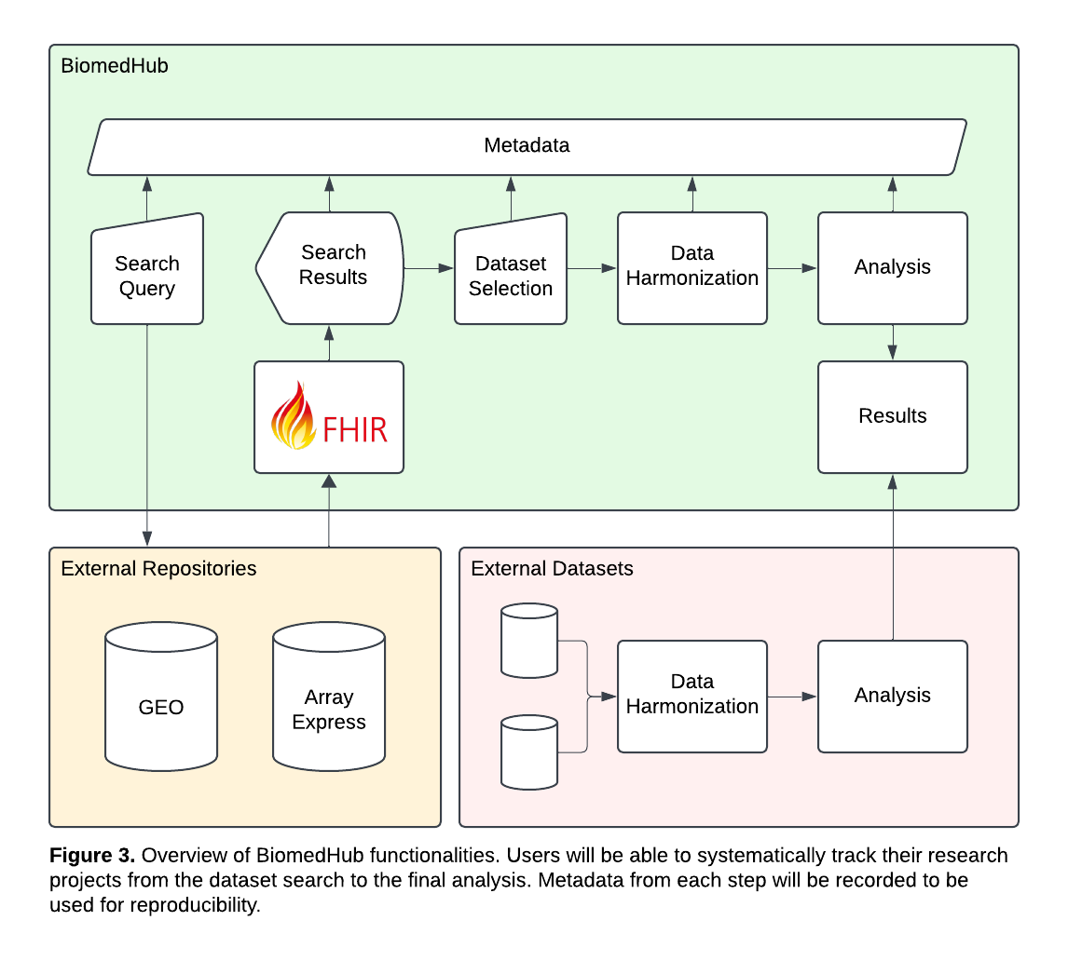
In the discovery and harmonization layers, the platform serves as an intelligent assistant for study design. When a researcher initiates a sepsis immune phenotyping research project, the platform will automatically suggest datasets that include critically ill patients, provide inclusion and exclusion criteria to select septic patients within each dataset, and mappings of relevant data fields (e.g., race, Sequential Organ Failure Assessment score) to standard concept vocabularies. Crucially, this process will not be a “black box”. Each suggestion will be flagged for human review with the evidence supporting it, such as the publicly available code it used, to suggest how to select septic patients within a dataset. This “human-in-the-loop” architecture ensures that the process remains transparent and progressively improves as the community reviews suggestions during their projects. After the user selects the datasets and reviews their mappings, the platform will compile the final cohort in Medical Event Data Standard (MEDS) format. Subsequently, in the Analysis layer, BiomedHub will provide prebuilt, containerized workflows powered by Nextflow. To balance accessibility with flexibility, users will be able to interact with these pipelines both programmatically and through a browser-based interface that abstracts the complexity of command-line tools. Importantly, every modification is captured programmatically. This enables us to provide flexibility without hindering reproducibility, as the platform automatically generates and stores granular metadata for every component, including specific dataset versions and cohort splits using croissant, analytical parameters using the Nextflow DSL, and clinical logic and information using FHIR. All metadata will be exposed via RESTful APIs, ensuring that external tools and agents can query the project’s full provenance information.
We will support researchers at all levels of expertise through three interfaces: a web-based UI with guided workflows for non-computational users, Python libraries for data scientists, and a Model Context Protocol (MCP) layer that enables AI agents to interact with the platform’s structured metadata. Finally, BiomedHub will also employ a three-tier data access model that balances collaboration with privacy protection. The public tier provides open-access datasets (e.g., GEO, ArrayExpress) in harmonized, analysis-ready form for exploratory research. The restricted tier indexes private datasets (e.g., Endpoint Health) but defers access control to the owner’s compliance structure (e.g., Institutional Review Boards and Data Use Agreements), maintaining workflow consistency while aligning with the desired data stewardship. The federated tier enables institutions to run the standardized workflows locally, sharing only metadata and aggregate results to preserve data sovereignty. This model supports ethical collaboration across public and private datasets, employing privacy-preserving methods, such as differential privacy and secure computation, to protect participants. All access will be logged to ensure transparency and regulatory compliance. The codebase for the version of BiomedHub delivered by this proposal will be publicly available, allowing for iterative testing and user feedback. Success will be evaluated through user engagement, reproducibility of analyses, and demonstrated ability to integrate multi-repository datasets into cohesive sepsis cohorts.
Evaluation Metrics, Community Engagement and Sustainability
The success of BiomedHub will be evaluated through several interrelated indicators. User experience will be tracked using a Net Promoter Score (NPS ≥50 by Year 3) and a System Usability Scale (SUS ≥70), indicating strong satisfaction and above-average usability. At least 80% of users are expected to complete harmonization workflows independently. Scientific impact will be measured through user adoption, dataset harmonization volume, and downstream outputs such as publications and collaborations. Sustainability metrics will include user retention, community-contributed tools, and interoperability with NIH data ecosystems (e.g., dbGaP, BioData Catalyst). Together, these metrics will guide iterative development and demonstrate measurable progress toward a scalable, user-centered platform that enhances biomedical data discovery and reuse. The community engagement will be promoted through online forums and social media, GitHub contributions, and training workshops, with the expectation that at least half of the pilot users will contribute methods, tools, or documentation back to the resource. Sustained participation will be encouraged by establishing mechanisms for contributor recognition and providing clear governance structures, including an advisory board and contributor guidelines, to support ongoing refinement. Partnerships with existing initiatives such as PhysioNet will ensure BiomedHub’s sustainability, positioning it as a lasting community-driven infrastructure.
Project 2: Massive Open Collaborative Research (MOCR): A Pilot Study in Sepsis Immune Phenotyping
Significance
Sepsis research requires integration of large, diverse datasets to address the heterogeneity issue. Yet current approaches remain constrained by siloed data, single-center biases, proprietary datasets, and variability in analytic approaches that limit reproducibility and progress. These technical challenges are compounded by an academic reward system that prioritizes individual achievements over team-based contributions, creating powerful disincentives for the interdisciplinary collaboration critical to addressing complex scientific challenges. Researchers who openly share data risk being scooped, those who prioritize reproducibility publish less frequently, and architects of collaborative platforms receive less credit than those who use them. It is unreasonable to believe that research conducted on siloed data within systems that actively discourage collaboration can ever be truly effective. This aim addresses fundamental gaps by establishing the first Massive Open Collaborative Research (MOCR) initiative in biomedicine: an open, community-driven framework in which contributions to datasets, methodologies, and analytic outputs are systematically compiled. By implementing protocols that make research contributions visible, traceable, and incremental across the entire research lifecycle, we enable critical appraisal and collaborative refinement while demonstrating a viable path toward reforming how we conduct and evaluate collaborative science. In this aim, we will develop a transcriptomic-based immune phenotyping study in sepsis and will employ the MOCR framework to perform a comprehensive evaluation of the contributions that constitute the project.
Innovation
Although the tools to increase the depth of academic evaluation already exist in interoperability (e.g., FHIR, Croissant), collaboration (e.g., version control systems), and attribution (e.g., CRediT, DOI, ORCID) mechanisms, they mostly operate in isolation. MOCR acts as the unifying framework that orchestrates these disconnected components into a coherent system. For example, in a MOCR-compliant study, inclusion criteria are required to exist not merely as a sentence in the manuscript, but as computable FHIR resource with a unique DOI. Because MOCR also requires objects to be version controlled, every modification is automatically logged, allowing the system to identify every contributor to that specific object version and programmatically assign them the appropriate CRediT role within the overall project. The result is an audit trail that turns the static concept of authorship into a dynamic record of specific actions, allowing us to quantify the impact of a data curator who harmonized some information or a methodologist who optimized an analytical parameter. Consequently, these contributions become visible, verifiable, and citable components of the scientific record, providing a mechanism to reward the essential infrastructure work that traditional bibliometrics ignore.
Approach
MOCR is a new scientific protocol designed to recognize contributions and quantify research impact. While BiomedHub builds the technical engine to generate detailed metadata, MOCR governs what metadata is necessary and how to use it to construct dependency-based collaboration networks that reveal the underlying structure of scientific teamwork. These networks allow us to trace the lineage of standardized objects, thereby formalizing critical but often invisible roles. Beyond direct contributions, this highlights the value of bridging disconnected nodes. A prime example is a researcher who serves as the single connection point tying a project network to a separate community, such as social workers; as the only pathway between these two groups, they play a quantifiable role in recruiting necessary expertise. By ensuring these roles receive permanent recognition, MOCR democratizes the scientific reward system and sets a new precedent for open, community-driven discovery. We will develop and validate the MOCR protocol by executing a reference implementation focusing on transcriptomic-based immune phenotyping of adult and pediatric sepsis. This pilot will demonstrate that adherence to the MOCR protocol generates a higher standard of reproducibility and transparency than traditional methods, defined by MOCR compliance. This compliance is a quantifiable status determined by three computational metrics that redefine how scientific impact and quality are measured.
The first metric assesses the novelty of the study hypothesis, the Semantic Innovation Index (SII). Since identifying similar research manually is infeasible, the SII queries public biomedical corpora (e.g., PubMed, bioRxiv) using an LLM-driven vector search. The system generates a high-dimensional vector embedding of the proposed study’s abstract and documentation, then retrieves existing studies that are most semantically similar in their hypothesis. A large vector distance indicates a genuinely novel study, while a small distance identifies the study as a potential replication or extension. Critically, this list of similar studies is passed downstream to the second metric, the Provenance Integrity Score (PIS), which acts as an automated audit to prevent process plagiarism or lack of methodological reporting. The PIS first performs an internal scan of the metadata, ensuring that every computational tool used (e.g., Salmon, ComBat-seq) is formally mentioned. Simultaneously, it cross-references the studies identified by the SII against the study’s bibliography to audit the analytical provenance, lowering the score when it detects a high degree of methodological similarity, such as identical pipeline architectures or parameter settings, with a prior study that is absent from the citation list. This coupled approach distinguishes between valid replication (high integrity) and unattributed copying (low integrity), ensuring that the original architects of methodologies receive proper credit.
Finally, we replace subjective quality assessments with the Representative Quality Score (RQS), a composite metric that uses the detailed metadata to evaluate real-world applicability. This score quantifies two aspects of representativeness: it calculates appropriateness of the author list, ensuring domain specialists (e.g., clinicians) are present and have experience with the study population (e.g., have practiced in the country where the cohort was enrolled); and it audits the final patient group against epidemiological baselines to penalize unrepresentative sampling. Researchers have been trying to develop alternative scores to evaluate research participation^{ref}, but none assess the entirety of the research process as SII, PIS, and RQs aim to do. The final products of a MOCR-compliant study are three-fold: a collaboration network that details every contribution that made the research project possible; metrics that truly describe the novelty, integrity, and quality of the study; and a trail of metadata and objects that can be used to compare studies and feed incremental research without losing context or authorship attribution. The latter is what constitutes the true essence of MOCR, as the wide adoption of the protocol would generate a vast trail of metadata that could be compiled to attribute status, progress rate, and major contributors to research fields. When adopted by academic reward systems, such products can also help address the lack of incentives for some burdensome aspects of biomedical research, specifically time-consuming tasks such as data curation. The final deliverable will be a comprehensive, version-controlled Sepsis Immune MOCR study that serves as the blueprint for future MOCR initiatives.
Evaluation Metrics, Community Engagement, and Sustainability
Success will be assessed through platform adoption metrics, including 20 unique participants during the pilot phase and contributed datasets representing 3,000 patients by year three and 5,000 by year five, with one-third of initial contributors remaining active after 12 months. Scientific impact includes validated immune phenotypes with cross-cohort reproducibility, 15 peer-reviewed publications by year five, and reuse of datasets and tools by external investigators. Community engagement occurs through quarterly online seminars, annual online workshops, and working groups with inclusive governance via a diverse steering committee with rotating membership. BiomedHub provides transparent contribution tracking through CRediT taxonomy and version-controlled code, ensuring full reproducibility. We prioritize equity by accommodating varying infrastructure, including offline documentation, providing cloud computing credits and data harmonization services, and developing accessible interfaces for clinical researchers without computational expertise. Visible recognition through contributor badges and authorship attribution provides tangible rewards, while dependency tracking makes contributions legible to institutions.
Sustainability operates through self-reinforcing mechanisms where researchers contribute to access curated datasets and tools while receiving recognition for their work. The rotating steering committee ensures governance reflects active contributors, and transparent policies enable both consortium authorship for platform studies and investigator-initiated projects. As the network expands, researchers outside it become isolated from collaborative opportunities, creating natural adoption incentives that transform evaluation from a barrier to an enabler of genuine collaboration.
TIMELINE
Project 1 will be performed over the 5 years, with a focus on the platform launch with internal validation sepsis immune phenotype project in years 1 to 3, and the focus on community growth and platform maturity (platform governance, maintenance, self-sustaining community contributions, and partnership sustainability) in years 4 to 5
Project 2 will begin in the second half of year 1 and will be conducted throughout year 2.
ALTERNATIVE APPROACHES
Given the innovative nature of these approaches and their dependence on Project 1, we have outlined alternative solutions to mitigate risks in the event Project 1 encounters challenges. To reduce the likelihood of failure in Project 1, in the event that the project faces unforeseen challenges, we can narrow its scope to include only our two private and publicly available datasets from GEO and ArrayExpress, explicitly focusing on datasets with sepsis and paired clinical and transcriptomic data. Public datasets typically include a limited number of clinical variables, which minimizes the burden on the data harmonization process.
We expect many of the frameworks incorporated by BiomedHub components to offer a means to make both data and metadata interoperable. For example, we can use FHIR not only to make patient measurements available, but also to document how some dataset was mapped to it (i.e., using the StructureMap and ConceptMap resources) and which selection criteria was applied to the study datasets to achieve the final cohort (i.e., using the EvidenceVariable, Group, and ResearchStudy resources). If we encounter a component that is not entirely covered by the current release of the applicable interoperability standard, we will work with the entity responsible for extending it. If necessary to mitigate possible delays in our project, we will implement our own version of the proposed extension and update it accordingly as the official implementation progresses.
If the emerging standards (e.g., CROISSANT, MEDS) prove unsuitable for clinical data harmonization, we will adopt other alternatives, such as the OMOP common data model. Should this also prove unsuccessful, we will resort to manual harmonization. In such a scenario, Project 2 will remain unaffected, and the MOCR will still be published as an open resource, a freely accessible protocol that is not dependent on the methodologies used within a project, but on the metadata research projects need to generate to ensure compliance.

