**Software Engineering Principles and Techniques (2178)**

**CMIS 330 6380**

**University of Maryland University College**

**15-Oct 2017**

**Software Development Plan (SDP) – Assignment #4**

**To**

**Pro. Dave Gabello**

**By**

**Bisrat W Tadesse**

**John & Jane Reservation System Project**

**Software Development Plan For**

**John & Jane Project**

**October 15, 2017**

**University of Maryland**

**University College, Maryland**

Preface

This document is a formal deliverable. The customers, John and Jane, reserve the right to request change within 30 days of the initial submittal. This document was last revised on October 15, 2017. It documents the current software development methodology, planning, and management that Bisrat Tadesse followed to develop the reservation system. Any future changes in the software development process will result in an update to this document and resubmittal to John and Jane.

Future changes to this document shall be made by document change notice, and any future changes must be reviewed and approved by John and Jane.

This document is under Bisrat Tadesse’s control and any question and proposed changes should be addresses to:

Bisrat Tadesse

Maryland, United States.

Table of content

1. Overview
   1. project summary
      1. purpose, scope, objectives
      2. Assumptions and constraints
      3. Project deliverables
2. References
3. Delimitations
4. Project Organization
   1. External interface
   2. Internal structure
      1. Software Quality Assurance (SQA)
      2. Software Configuration Management (SCM)
   3. Roles and responsibilities
5. Managerial process plan
   1. Omitted
   2. Work plan
      1. work activities
      2. Schedule allocation
      3. Resource allocation
      4. Omitted
   3. Omitted
   4. Risk management
6. Technical process plan
   1. Process Model
   2. Methods, tools, and techniques
7. Overview
   1. Project summary

This software development plan (SDP) is a required deliverable for the B&B system that would be developed to John and Jane bed and breakfast business.

* + 1. Purpose, Scope, and Objective

This SDP outlines the steps by which the development of the John and Jane Bed Room reservation system software will be completed, and the management’s approach to the software development. This SDP document addresses software processes, products, methods, organizational responsibilities, tools, configuration management, and software quality.

This SDP describes the process to be used to develop and document the John and Jane bed room reservation system software development.

* + 1. Assumptions and constraints

It is assumed that John and Jane have the necessary budget for the project. The platform that the system software shall be run is a PC running on windows 10. There are no budget and time constraints.

* + 1. Project deliverables

Three B&B system software versions shall be delivered to John and Jane. The delivery of all releases or versions of the B&B system software shall be on customer site where initial integration and configuration shall be made to test the system for proper operation. The second and the third deliverables shall follow after the initial test and the customers’ feedback. The delivery dates and quantities required to satisfy the terms of the project agreement are summarized in table 1.1.

|  |  |  |  |
| --- | --- | --- | --- |
| Release version | Delivery date | Quantity | Comment |
| 1.0 | Jan, 2019 | 1 | Initial release |
| 2.0 | App, 2019 | 1 | Intermediate release |
| 3.0 | Aug, 2019 | 1 | Final product |

Table 1.1 Summary of deliverables.

1. References

This SDP follows the IEEE standard for Software Project management Plans: IEEE Std, 1058-1980.

1. Definitions

The definitions listed here establish meaning within the context of this SDP document.

* 1. Customers: John and Jane that own the B&B reservation system, who specify the requirements for and accepts delivery of a new or modified software product and its documentation.
  2. Project deliverable: a work product to be delivered to the customer. The deliverable may include operational requirements, functional specifications, design documentations, source code, installation instructions, test results, training aids, user manuals, product development tools, and maintenance documentation.
  3. Work activity: a collection of work task spanning a fixed duration within a schedule of the B&B system software development cycle.

1. Project Organizations

This section includes the B&B system project organization. It describes the software development process using table 4.1, and internal and external interfaces.

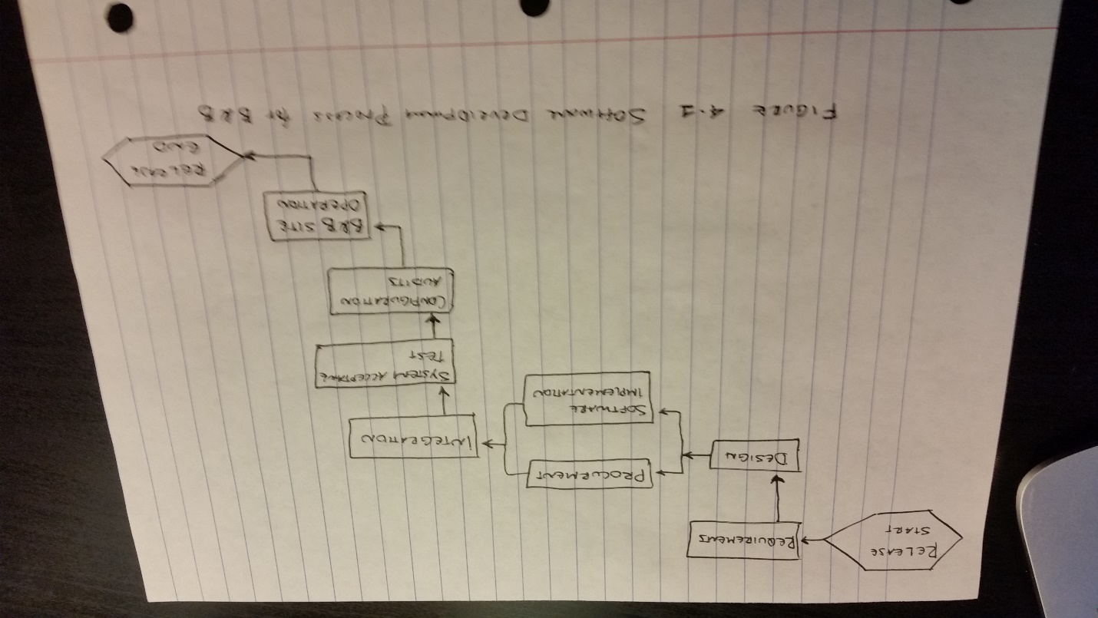

* 1. External interface

The external interface can best be described using the SDS where all the boundaries of the B&B system are depicted using the architectural context diagram (ACD). In addition, the SRS document for the B&B system must be consulted for any boundary related implementation.

* 1. Internal structure
     1. Software Quality Assurance (SQA)

All members of the B&B system software development team will take active role in SQA activities. The quality assurance engineer performs product evaluation using software reviews, and software measurements in accordance with the IEEE Std, 730-1998.

* + 1. Configuration management

This section includes the methods used to manage changes to the B&B system software. The software configuration items that will be controlled include the card object, system objects like check-in, check-out, Reservation, and the main driver that aggregate all the system objects.

Git will be used for version and change management and control.

Configuration audits shall be conducted by the software configuration management personnel to verify that: the change process has identified all affected system configuration items (SCIs), no unanticipated change has surfaced, and authorized changes have been completely and consistently implemented.

1. Managerial process plan
   1. Omitted
   2. Work plan

This section of the document includes the work activities, the schedule allocation, the resource allocation, and the risk management plan to be used for the B&B system software development.

* + 1. Work Activities

The work activities are all the necessary work or activities that has to be performed to deliver the finished B&B system software. The work activity breakdown is as shown below:

Requirement Analysis Task

1. Requirement gathering
2. Requirement analysis

Design Analysis

1. Data design sub-task
2. UI design sub-task
3. UML design sub-task

Code

1. Creating classes sub-task
2. Developing methods sub-task
3. Creating main or drivers sub-task

Tests

1. Unit testing sub-task
2. Integration testing sub-tsk
   * 1. Schedule allocation

The figure shown below indicates the schedule allocation of the major task for the B&B system software development project. The waterfall model is used, and some tasks might overlap. From the calculated results of the resource allocation section, the B&B system software development project is estimated to take 18 months of work day. Thus, the schedule allocation is based on that figure. Figure 5.1 shows the schedule allocation for B&B

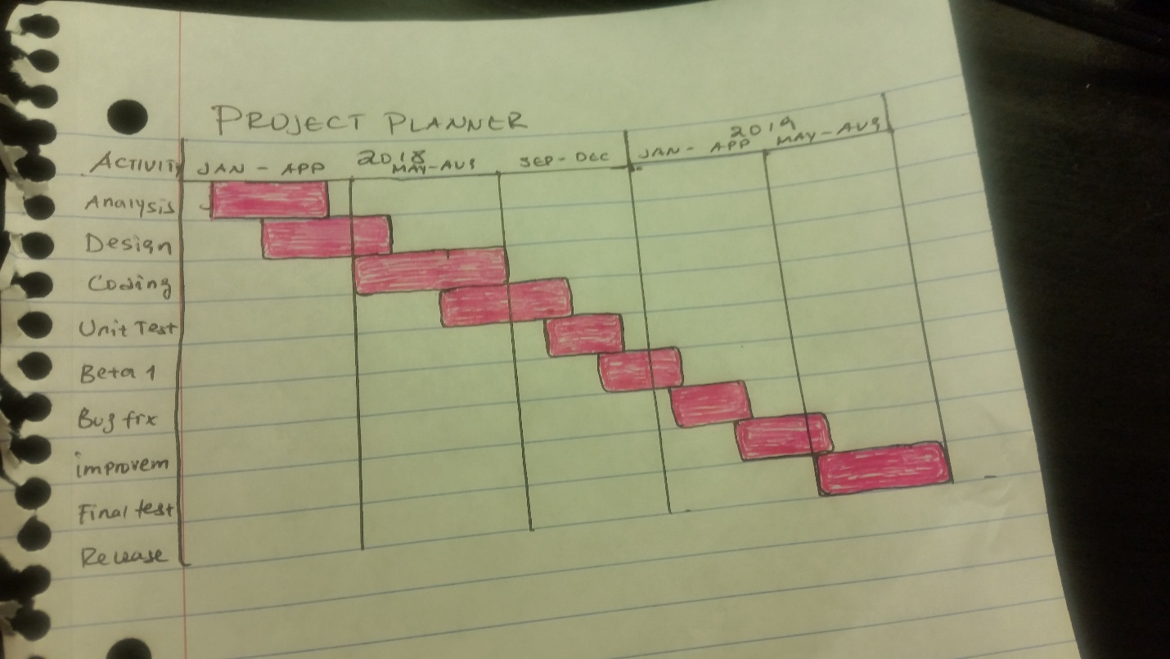

Figure 5.1 The Schedule Allocation for B&B Project

* + 1. Resource Allocation

For this section, I used function point (FP) method to estimate the sis of the B&B system software product. The architectural context diagram (ACD) of the B&B SDS document is consulted for the function point (FP) analysis.

The external inputs are:

1. Key
2. Bill

The external out puts are

1. Receipt
2. Confirmation number
3. Bill
4. Cost-profit analysis page

The external inquiries are

1. Button
2. Requests

The internal logical files are:

1. System configuration file

The external interface file can be defined as:

1. Store’s database

For the B&B reservation system project, I assumed the weight factors as it can be seen in table 5.1, which are based on scale of 1 to 10 and are grouped into three categories: less complex, average, and more complex.

Table 5.1

Weight factors based on level of complexity

|  |  |  |  |
| --- | --- | --- | --- |
| Domain Value | Less complex | Average | More complex |
| External input | 3 | 5 | 9 |
| External output | 2 | 4 | 7 |
| External inquire | 3 | 5 | 8 |
| Internal logical files | 4 | 7 | 10 |
| External interface file | 3 | 6 | 8 |

Figure 5.2 shows unadjusted function point (FP) computation for the B&B system software development to estimate the program size.

Table 5.2

Unadjusted function point complexity for B&B system

|  |  |  |  |
| --- | --- | --- | --- |
| Information domain  value | count | Complexity weight  factor | total |
| External input | 2 | 3 | 6 |
| External output | 4 | 4 | 16 |
| External inquire | 2 | 3 | 6 |
| Internal logical files | 1 | 4 | 4 |
| External interface file | 1 | 6 | 6 |

The next step of function based metrics is to determine the value adjustment factor (VAF), which is based on the general characteristics of the system that is most likely to influence the application. Table 5.3 summarizes the 14-possible system characteristics that need to be considered in determining the VAF for the B&B system project, according to the general software project standard.

Table 5.3

A total Grade Rating for the B&B system Characters

|  |  |  |
| --- | --- | --- |
| Number | System Characters | Grade rating |
| 1 | Data communication | 3 |
| 2 | Distributed data processing | 4 |
| 3 | Performance | 4 |
| 4 | Hardware configuration | 4 |
| 5 | Transaction rate | 2 |
| 6 | Online data entry | 0 |
| 7 | End user efficiency | 5 |
| 8 | Online update | 0 |
| 9 | Complex process | 4 |
| 10 | Reusability | 2 |
| 11 | Installation | 1 |
| 12 | Operations | 3 |
| 13 | Multiple sites | 1 |
| 14 | Facilitate change | 3 |
| Total |  | 36 |

The following relationship is used to compute the function point (FP):

FP = unadjusted-FP * [[0.65 + + 0.01] * Summation of Fi]

Where Fi represents the VAF or total degree of influence. Therefore,

FP = [38 * [0.65 + 0.01] * 36]

FP = 1, 368

The FP value is the software product size.

The basic human effort (E) is calculated using COCOMO:

E = a * (Size)b, for Organic model a= 2.4, b= 1.05, accordingly

E = 2.4 * (1, 368)1.05 = 1, 962. 86

Again, using the COCOMO of Organic model, the B&B project development in staff month can be computed as:

TDEV = a * (E)b months.

TDEV = 2.5 * (1, 962.86)0.38 for Organic mode.

TDEV = 18 months.

From this, the average staff size (SS) can be calculated using:

SS = E/TDEV = 1, 968.86/18 = 110 staffs.

6 Technical process models

6.1 Process model

The B&B system software development follows Linear-sequential (waterfall) models

* 1. Methods, Tools, and Techniques

Linear-sequential (waterfall) model is used. The language used to develop the software is Java SE, and Git is used for software version control.