**Software Engineering Principles and Techniques (2178)**

**CMIS 330 6380**

**University of Maryland University College**

**17-Sep 2017**

**Analysis Model for John & Jane B&B Reservation System -- Assignment #1­­­­­­­­­­­­­­­­­­­­­**

**To**

**Pro. Dave Gabello**

**By**

**Bisrat W Tadesse**

Table of content

1. Introduction
   1. purpose
   2. Scope
   3. Definitions, abbreviations
   4. References
   5. Overview
2. Overall description
   1. Product perspective
   2. Product functions
   3. User characteristics
   4. Constraints
   5. Assumptions and dependencies
3. Specific requirements
   1. External Interface Requirements
      1. User Interfaces
      2. Hardware Interfaces
      3. Software Interfaces
      4. Communication Interfaces
   2. Classes/Objects
   3. Functional Requirements
   4. Performance Requirement
   5. Design Constraints
   6. Software System Attributes
   7. Other Requirements

Introduction

* 1. purpose

To specify the software requirements of developing the John and Jane B&B reservation system and give a basis for the software development team that takes over the software design analysis and other phases of the software development.

* 1. Scope

The application generates profit and expenses report, and shall be used for bed room reservation. The product shall enable John and Jane or any employee to make bed room reservation, generate expenses and profit report, generate reservation confirmation number, generate bill for customers, print receipt, check availability of bed rooms based on a calendar day, verify and process debit and credit cards, process cash payment, make guaranteed and unguaranteed reservations. The product shall automatically drop unguaranteed reservation, if the reservation is not guaranteed by that day. The product shall not have any interface for customers. It shall not have web application Interface. This product shall be used by John and Jane B&B business to monitor their profit and expenses, and help them avoid reservation overlaps and other bed room reservation issues.

* 1. Definitions, abbreviations
  2. References
  3. Overview

The rest of this document contains an Object-Oriented Analysis of the John and Jane B&B reservation system. The requirements are organized by objects.

1. Overall description
   1. Product perspective

The B&B Reservation Management System should work as a component of a large system that as shown in Figure 2.1.

Figure 2.1

Context Diagram for John and Jane B&B Reservation Management System

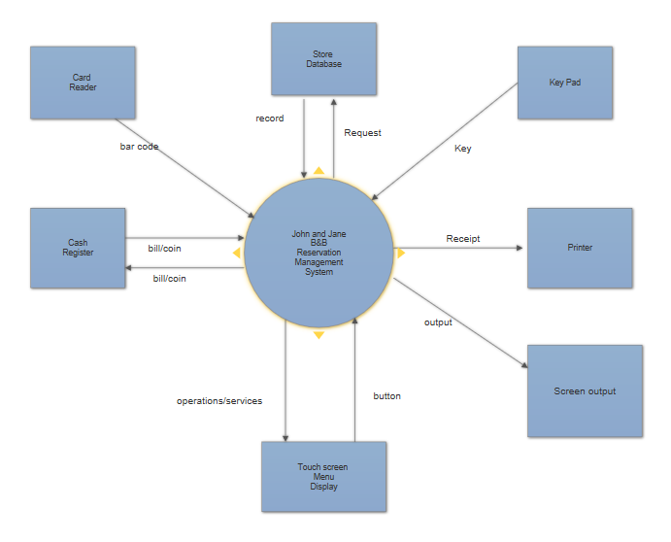

* 1. Product Functions

The product shall enable users to manage reservation, generate profits and expenses report, check-in and check-out customers, generate bill for customers, print receipt, and verify and process debit and credit card payments. Figure 2.2 shows the level-1 DFD of the system.

Figure 2.2 Level-1 Data Flow Diagram

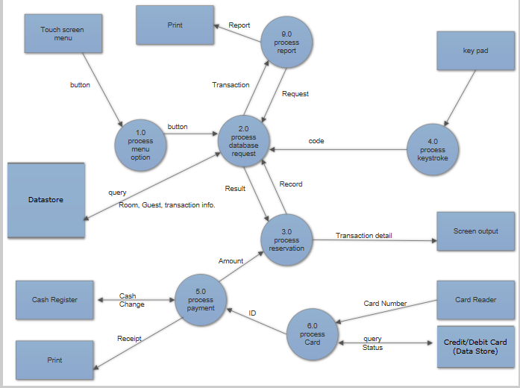

Table 2.1

Use Case to Launch the software product

|  |
| --- |
| **Use Case 1.0**: Start/Launch the product  John or Jane, or any employee, who has taken the training to use the product starts the program when a customer calls to reserve a room, or checks in, or checks out, or when a report must be generated.  **Precondition:** The Reservation Management System/ or the product needs to be configured properly, and have access to the local area network and the store database. The system needs to be ready to perform a new transaction.  **Postcondition:** The system is ready to start a new transaction.  **Actor profile:** John or Jane, or any employee, who has been trained to use the application.  **Sequences of events**:   1. User launches or starts the product 2. User enters his/her employee ID and password 3. User click the “login” button. |

Figure 2.3

Use Case diagram for start the program

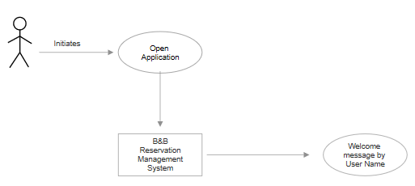

Table 2.2

User Scenarios for Starting the Program Use Case

|  |
| --- |
| User Scenario 1: Start the Application/Program   1. User opens the application 2. System displays a login Form 3. User enters user ID and password 4. System displays a success of a failure message |

Table 2.3

Use Case for making New Room Reservation

|  |
| --- |
| 2.0 Make Reservation  Customer call to reserve a room, the users (John or Jane, any other employee) uses the product or application to make the reservation.  Precondition: The application needs to be running properly and ready to start new reservation  Postcondition: The system is ready to start a new reservation.  Actor profile: John or Jane or any employee, who has been trained to use the software product.  Sequences of events:   1. Customer calls to reserve a room 2. User logs in to the system 3. User selects the “make reservation” button from the displayed menu option. |

Figure 2.4

Use Case diagram for making new Room Reservation

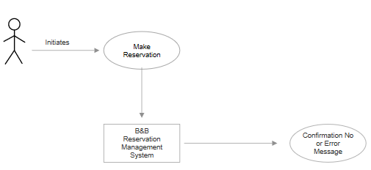

Table 2.4

User Scenarios for Making New Room Reservation Use Case

|  |
| --- |
| User Scenario 1: Check room availability   1. User either clicks or touches “check-vacancy” button on the Touch screen menu display 2. System displays detail information for each room based on calendar day, and a “Reserve-Room” button, if a room is available   User Scenario 2: Reserve room   1. User clicks or touches the “Reserve-room” button. 2. System returns a Form to register customer   User Scenario 3: Submit form   1. User fills all the required information and hit the submit button. 2. System displays a success or failure message, after processing the data 3. User clicks the “OK” button on the message box. 4. System responds either by displaying a confirmation number for the reservation, or an empty Form, if the message was an error message. |

Figure 2.5

State Transition Diagram for the Reservation Management System

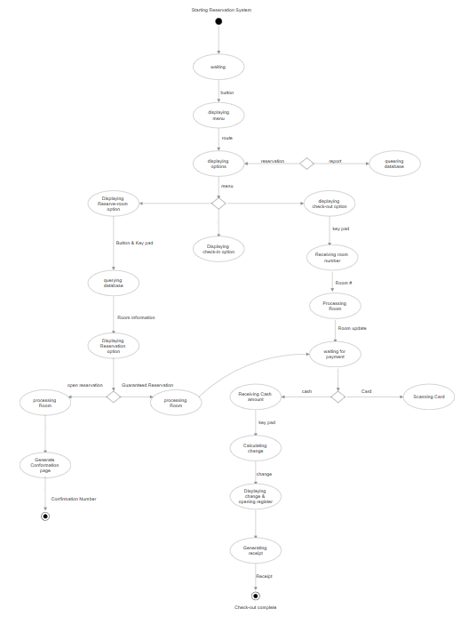

* 1. User Characteristic

The intended users of this product are John and Jane, or any employee, who has basic computer literacy, and who understands English language.

* 1. Constraints

The limited amount of budget from the customers restrict other feature developments like forecasting and workday analysis. The system is restricted to make single transaction at a time, due to availability of additional hardware and software products. The system is restricted for desktop application only, as the available network is LAN.

* 1. Assumptions and Dependencies

The application is assumed to run on windows 10, and use MYSQL as the main data definition and processing tool. The other components in the system, like the printer, card reader, and cash register are assumed to have the necessary drivers to function and integrate with the software application without problem.

1. Specific Requirements
   1. External Interface Requirement

3.1.1 User Interface

The application displays menu options on a full-screen GUI. Each menu is a button that invokes a certain procedure that generates a result on a screen display or printout. The buttons are given descriptive names to help users to easily adopt to the application. The touch screen menu shall include the following operations: check-in, check-out, reserve-bed, check-vacancy, print-receipt, generate-bill, and generate-report. Any individual with a basic understanding and experience of computer usage can use the interface with 1 and half hours of training.

* + 1. Hardware Interfaces

The device or platform that the application runs must support integration of a printer, a cash register, and a card reader, and provide a full-screen support.

* + 1. Software Interfaces

Data Management System: Microsoft Access, Acess2016Ink.

Operating System: Windows10, Microsoft Office 2016

* + 1. Communication Interface

Local Area Network: can be wired or wireless. The network must connect all the hardware interfaces stated earlier.

* 1. Classes/Objects

Figure 3.1

Class Diagram for John and Jane B&B Reservation Management System

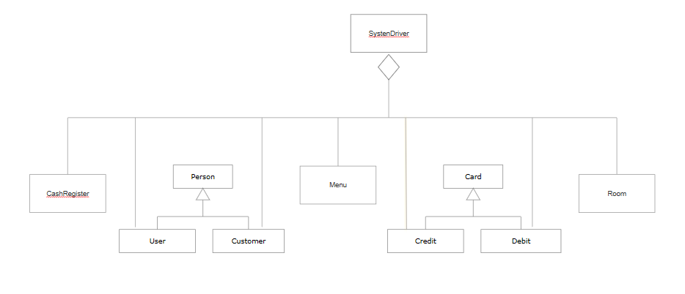

* 1. Functional requirements

Table 3.1

Requirement for starting/opening the application

|  |
| --- |
| Requirement 1.0: start/open application   * 1. The system shall display a login or registration option      1. The system shall require admin login, if the register option is selected      2. The system shall display a registration form, if the admin login is valid      3. The system shall display a success message, if the registration is successful.   1.1.2 The system shall display a login page, if the login option is selected.  1.1.2.1 The system shall display if the login is successful.  1.1.2.2 The system shall display an error message if the login information is invalid. |

Table 3.2

Requirement for making new Room Reservation

|  |
| --- |
| Requirement 2.0: Reserve a Room   * 1. The system shall display available room for the requested dates   2. The system shall display options to choose from available rooms   3. The system shall display a customer form, if a room is selected.   4. The system shall validate information entered   5. The system shall display success or failure message based on the form validation.   6. The system shall display reservation options: guaranteed or open reservation   7. The system shall display payment processing option, if guaranteed reservation is selected.   8. The system shall generate reservation confirmation page with a confirmation number. |

Table 3.3

Requirement for check-in

|  |
| --- |
| Requirement 3.0: check-in   * 1. The system shall display a check-in button   3.2The system shall display a form to enter guest’s driver’s license or last name  3.3 The system shall display reservation detail  3.4The system shall display message for no prior reservation  3.5 The system shall offer option to enter customer information for no prior reservation   * 1. The system shall generate check-in confirmation page |

Table 3.4

Requirement for check-out

|  |
| --- |
| Requirement 4.0: check-out   * 1. The system shall display a check-out button   2. The system shall display a check-out form   3. The system shall calculate total charges including taxes   4. The system shall generate bill   5. The system shall display payment options   6. The system shall process card or cash payments   7. The system shall generate and print receipt. |

Table 3.5

Requirements for Generating Report

|  |
| --- |
| Requirement 5.0: Generate Report  5.1 The system shall offer a Generate-Report button  5.1.1 The system shall display a menu for daily, weekly, and monthly report options  5.2 The system shall process profits and expenses  5.3 The system shall generate and display a summary of daily, weekly, and monthly transactions based on the selected operation.  5.4 The system displays a page with a weekly and monthly profits and expenses detail |

3.4 Performance Requirement

3.3.1 Static Requirements

Only one terminal is supported. The product shall support only one user at

A time, and handles payment and personal information.

3.3.2 Dynamic Requirements

Only one transaction and process shall be handled by the product at a time,

and all the transaction should not take more than 2 minutes to process.

* 1. Design Constraint

The 8GB Memory of the product platform allows significant amount of data to be processed under any condition, so hardware limitation for this application is irrelevant.

.