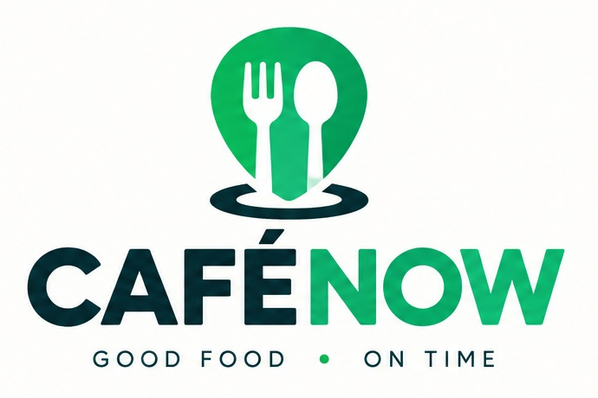
SOLUTION PROPOSAL
CaféNow
Smart Cafeteria Ordering System on ServiceNow
Proposed by
NowServing Solutions
October 2026

1. Executive Summary
NowServing Solutions proposes CaféNow, a ServiceNow-based cafeteria ordering application that enables employees to order meals in advance, select scheduled pickup times, and collect food without unnecessary waiting. CaféNow connects employees and multiple cafeteria vendors through a centralized ordering and tracking system.
Core Problem: Employees should not have to spend their limited lunch breaks waiting in queues, and vendors should not have to manage peak-hour demand without advance visibility of incoming orders.

2. Business Problem
In large organizations, cafeterias often have multiple food vendors serving employees during scheduled lunch and break periods. Since many employees take their breaks around the same time, cafeterias experience sudden increases in demand, resulting in long queues, crowded pickup counters, delayed orders, and inefficient service.

2.1 Long Queues and Wasted Employee Break Time
Employees spend a significant portion of their limited lunch breaks reviewing menus, placing orders, making payments, and waiting for food. This reduces the time available for eating and relaxing before returning to work. Employees with short or fixed break periods may not have enough time to finish their meals.

2.2 Unpredictable Demand During Peak Hours
Vendors often receive large numbers of orders within a short period without knowing the exact demand in advance. This makes it difficult to estimate food quantities, staffing requirements, and popular menu items. Consequently, some orders are delayed, while other food items may be overprepared or run out.

2.3 Inefficient Order Management
When orders are managed through physical queues, verbal communication, paper slips, or separate vendor systems, tracking becomes difficult. Vendors may struggle to prioritize orders and monitor preparation progress, leading to missed orders, incorrect meals, duplicate requests, and confusion at pickup counters.

2.4 Lack of Order Visibility and Communication
Employees often have no reliable way to determine when their food will be ready. They may need to wait near the counter or repeatedly ask vendors for updates. Vendors also lack an efficient way to communicate order completion, delays, or unavailable menu items.

2.5 Poor Coordination Between Multiple Vendors
Employees may need to visit different counters, wait in separate queues, and follow different ordering procedures. Since vendors often manage orders independently, cafeteria administrators may struggle to monitor overall demand, coordinate pickup periods, and maintain a consistent employee experience.

2.6 Limited Operational Insights
Without centralized order records and reporting, management may lack accurate information about peak ordering periods, popular meals, preparation times, cancellations, missed pickups, and vendor performance. This limits their ability to identify bottlenecks and improve operations.

Overall Business Impact
These challenges result in wasted employee time, lower satisfaction, unpredictable food preparation, operational inefficiencies, and potentially increased food waste and staffing costs.

3. Proposed Solution
CaféNow delivers five core capabilities on the ServiceNow platform.

3.1 Employee Ordering Portal
- Browse menus, prices, and availability across multiple vendors.
- Select meals, quantities, and special instructions.
- Place orders in advance and receive a unique order number.
Business Benefit: Employees can order conveniently without standing in line.

3.2 Scheduled Pickup Slots
- Allow employees to choose convenient pickup times.
- Set order capacity limits for each time slot.
- Validate slot availability before confirming orders.
Business Benefit: Reduces overcrowding and distributes orders more evenly throughout the lunch period.

3.3 Automated Order Processing
- Use ServiceNow Flow Designer to validate and route orders.
- Send order confirmations and update order statuses.
- Notify employees when meals are ready or delayed.
Business Benefit: Reduces manual work, improves communication, and streamlines order processing.

3.4 Vendor Dashboard
- Display orders grouped by pickup time.
- Show meal quantities, preparation status, and pending orders.
- Help vendors prepare meals in advance based on confirmed demand.
Business Benefit: Improves preparation planning, order accuracy, and service efficiency.

3.5 Administration and Reporting
- Manage vendors, menus, prices, and pickup capacities.
- Control access through roles and Access Control Lists (ACLs).
- Track order volumes, waiting times, preparation performance, and cancellations through reports and dashboards.
Business Benefit: Gives management better visibility into cafeteria operations and opportunities for improvement.

4. How CaféNow Works
Step | What Happens
1. Browse | The employee selects a vendor and chooses meals.
2. Schedule | The employee selects an available pickup time.
3. Confirm | ServiceNow validates the order and records it in the system.
4. Prepare | The vendor receives the order in a scheduled preparation queue and prepares the meal.
5. Notify | The employee receives a notification when the meal is ready.
6. Collect | The employee picks up the meal, and the order is marked as completed.

5. ServiceNow Technologies
CaféNow is built entirely with native ServiceNow capabilities, keeping the solution maintainable, secure, and aligned with the platform roadmap.
ServiceNow Technology | Purpose
Employee Center / Service Portal | Provides the employee ordering interface
UI Builder | Creates customized employee and vendor dashboards
Custom Tables | Store vendor, menu, order, and pickup-slot information
Flow Designer | Automates order processing and notifications
ACLs and Roles | Manage secure access for employees, vendors, and administrators
Reports and Dashboards | Monitor cafeteria performance and demand

6. Expected Business Outcomes
CaféNow aims to achieve the following outcomes:
- Reduced Waiting Times: Minimize queues and unnecessary delays during lunch breaks.
- Improved Employee Experience: Make ordering and collecting meals easier and more convenient.
- Better Vendor Planning: Enable vendors to prepare meals based on confirmed orders.
- Improved Order Accuracy: Centralize order details and track preparation progress.
- Efficient Operations: Reduce manual order management and improve coordination between vendors.
- Data-Driven Decisions: Use reports to identify peak periods, popular meals, and operational bottlenecks.
Success can be measured by comparing average pickup waiting times, on-time order readiness, order accuracy, and employee feedback before and after implementation.

7. Project Vision
CaféNow connects employees and cafeteria vendors through a smart, scheduled ordering system that makes meal pickup faster, easier, and more efficient.
Good Food · On Time

