**Difference between css position absolute versus relative**

I spent some time understanding the difference between absolute positioning and relative positioning. It was a confusing topic to me and I decide to illustrate their differences with pictures.

Before going further, we should know the default behavior of position when we do not specify any position property.

**position: static**

*By default, position an element based on its current position in the flow. The top, right, bottom, left and z-indexproperties do not apply. — source MDN*

**position: relative**

*Position an element based on its current position without changing layout.*

**position: absolute**

*Position an element based on its closest positioned ancestor position.*

**Take an example**

To start with, create a parent container with 4 boxes side by side.

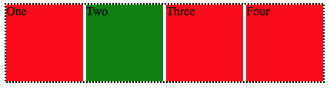

position: static

**index.html**

<div class=”parent”>  
 <div class=”box” id=”one”>One</div>  
 <div class=”box” id=”two”>Two</div>  
 <div class=”box” id=”three”>Three</div>  
 <div class=”box” id=”four”>Four</div>  
</div>

**style.css**

.parent {  
 border: 2px black dotted;  
 display inline-block;  
}

.box {  
 display: inline-block;  
 background: red;  
 width: 100px;  
 height: 100px;  
}

#two {  
 background: green;  
}

*By default, position is set to static. It positions based on the layout in the flow.*

**What happens when we want to move the GreenBox but do not want to affect the layout around it?**

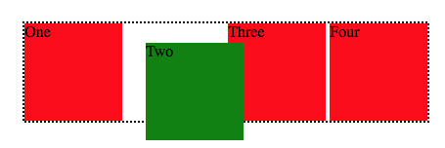

position: relative

This is where position relative comes in. Move the green box relative to its current position to 20px from the left and top without changing the layout around it. Thus, **leaving a gap**for the green box where it would have been had it not been position.

#two {  
 top: 20px;  
 left: 20px;  
 background: green;  
 position: relative;  
}

Live code: [JsBin](https://jsbin.com/nohoyiq/edit?html,css,output)

**Position: absolute is the opposite.**

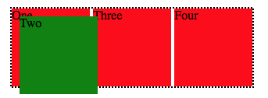

position: absolute

By applying position: absolute to the GreenBox, it will **not** leave any gap where it would have been. The position of the GreenBox is based on its parent position (the dotted border). Thus, moving 20px to the left and bottom from the top-left origin of the dotted border.

#two {  
 top: 20px;  
 left: 20px;  
 background: green;  
 position: absolute;  
}

**In a nutshell …**

position: relative places an element relative to its current position without changing the layout around it, whereas position: absolute places an element relative to its parent’s position and changing the layout around it.

