**ADDTEQ Website Redevelopment Assessment**

Addteq specializes in software configuration, build automation and release management. They firmly believe that automation is essential for successful software releases. They can be found at [https://addteq.com/](https://addteq.com/display/WEB/Addteq+software+release+management). They develop products that automate the software configuration management process from creation of a project to the build and deployment phases.

The assessment will be based on a SWOT analysis and wireframe of their existing website that needs to be redeveloped.

1. **SWOT ANALYSIS**

In order to improve Addteq website, strengths, weaknesses, opportunities, and threats are be defined as follows:

**External**

**Internal**

**Positive**

**Negative**

**Suggestions:**

After reviewing the site and considering ways to improve it in order to better present the services that Addteq provides to its client, to better retarget its audience, to be available in any browser, and for better and easy site maintenance, the following recommendations have been provided:

1. Make the website compatible throughout the entire browser.
2. Improve the font size or typographic or the site to make it more appealing to users.
3. Even though they have their pages that can adapt their content or appearance depending on the situation or specific request, the big banner need to be review and re-implement, as well as the graphics used on it.
4. Remove the drop-down menu when redesigning the site
5. With the highly develop technology services market, the website needs to be compelling to the user and stand out.
6. Fill up page or bring up footer information up to fill the unnecessary white space.
7. Re-evaluate the footer to make it less cluster.
8. Re-size graphics and headings to make it more appealing and less overwhelming in the eyes.
9. Even though pages on the site don’t change content or layout with every request to the web server, the footer has to be consistent with every page.
10. Redesign the site to stand out and improve the brand.
11. Build the site with users’ interests in mind.
12. Improve header
13. Make sure that most of the important information is located in the top part of the site by following the “Golden Ratio”.
14. **WIREFRAME MOCKUPS**

The mockups of Addteq following the SWOT and the suggestions will be on their home and the about us pages. To show consistence, appealing, customer-oriented, better general appearance of the site to boost and improve the company branding, while increasing profit and acquire more client. The colors that have been used to redesign the site are either part of the current site or have been meticulously chosen to go together with the rest of the page. The color codes used are at follow:

* Gray (border, etc): e8e8e8
* Text (dark grey): 818182, 686868
* Blue is : 1455a7
* Heading blue is : 0b72c0
* Navigation links: 22a1e0
* Divider green: 99af3e
* Darker blue: 003366
* Light blue: 9ed6f2
* Green line: 8CC63F
* Highlighted heading (red): D30F22
* **The Mockup “Home” Page**

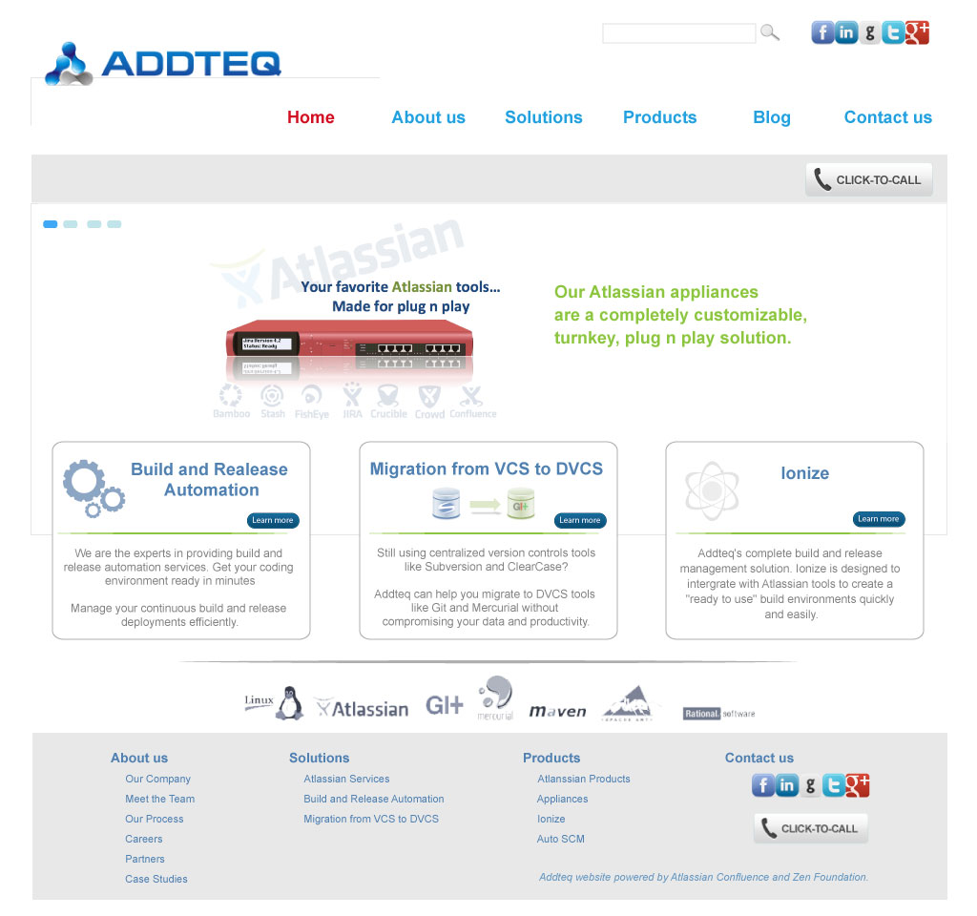

* **The Mockup “About us” Page**

