Visual Kivy (lite)

A. Introduction

Visual Kivy (lite) is a small application for non experience programming users interested on creating and learn how main kivy widgets work. Through the different examples provided as well as the possibility of designing basic smartphone interfaces, Visual kivy (lite) users will deep into kivy basics. The complete interface can be dragged and resized in order to adapt it to different devices screens as smartphones, tablets or computers.
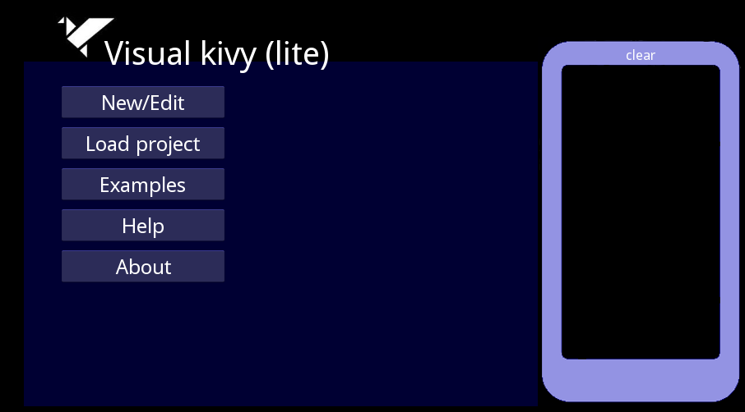
main interface

Visual Kivy (lite) is not an application intended for interfaces/program development but for teaching some of the kivy basics.

New/Edit button: New and old projects can be created or edited. Once selected, several kivy widgets will appear available if interface option is choosen. Each widget displays its properties when clicked, allowing the user to settle the object into the interface.

Load project button: File browser is open to import and edit created projects. Loaded projects can be edited through New/Edit button.

Examples button: Set of projects to show the user all the different widgets provided and the source code associated.

Help button: Displays a short description of visual kivy (lite) and the widgets available. Further description is provided within the current document.

B. Widgets and their properties
Twelve widgets have been selected to show non experienced users the basics of kivy programming: Label, Button, TextInput, CheckBox, Popup, Image, FileChooser, Spinner, Slider, ProgressBar, Switch and VideoPlayer.

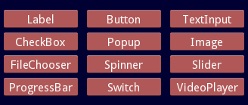
Visual kivy widgets

- Label: Displays one or more lines of text in the same style. Font size, type and position are some of the properties that can be defined.

- Button: The Button is a label with associated actions triggered when pressed or released. Size, font type and position are some of the properties available.

- TextInput: The TextInput widget provides an editable box containing plain text. Multiline, selection and clipboard features are supported.

- CheckBox: The CheckBox widget is a two-state button that can be either checked or unchecked. When a group is defined, the CheckBox becomes a Radio button.

- TogleButton: This button widget acts like a checkbox. When you touch/click it, the state toggles between ‘normal’ and ‘down’ (as opposed to a Button that is only ‘down’ as long as it is pressed). Toggle buttons can also be grouped to make radio buttons

- Image: The Image widget displays images within the screen.
source should contain the path to the image file. width and heigh define the image size to display.

- FileChooser: This widget displays the directory tree so folders and files can be selected. This widget offers two ways of browsing:

- ListView. Displays file browser in list mode.
- IconView. Displays file browser in icon mode.

''type'' only admits ''ListView'' and ''IconView'' as parameters. width and height will define the size of the FileChooser widget.

- Spinner: This widget provides a quick way to select one value from a set. By default it shows its current selected value. Touching the Spinner, displays a dropdown menu with all other values from which the user can select a new one.

Three values appear defined within the Spinner widget by default (home, file, edit). Size relates to widget's width and height.

- Slider: The Slider widget looks like a scrollbar, supporting vertical and horizontal orientation.
Depending on the orientation, width or height should be left as ''0''. Orient only admits ''vertical'' and ''horizontal'', by default, the slider allways is displayed in vertical.

- ProgressBar: This widget is used to visualize the progress of some tasks. Only the horizontal mode is supported.
width defines the ProgressBar size, max refers to the maximum value gven to the ProgressBar scale and value shows the rank covered.

- Switch: The Switch widget consists on a dual mode button that is active or inactive. Switch mode can be changed just by clicking on it. By default it appears as "off" (inactive).
width and height properties relate to the size of the Switch widget and pos define the coordinates where the widget will be displayed.

- VideoPlayer: This widget can be used to play video and let the user control the play/pausing, volume and position.
Through the properties, the widgets can be modified so the user easily visualizes the changes applied. The source field must contain the path to the video file, width and height define the size of the VideoPlayer widget and pos is related to the coordinates.

Properties associated to each widget will appear below the widegts panel and should look as follows:
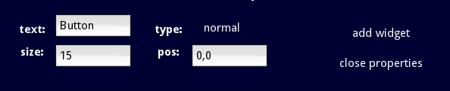
note: Depending on the widget selected the properties may vary.

C. Work with Visual Kivy (lite)
By default, the first template contains the following code:

from kivy.app import App
from kivy.uix.widget import Widget
class MyApp(App):
def build(self):
win = Widget()
return win
if __name__ == '__main__':
MyApp().run()

The following steps provided explain how to use the application for adding widgets and obtain the kivy code associated to each action:
1. Press the New/Edit button.
2. Among the three options available (Interface, View Code and Save), select "Interface".
3. Twelve widgets will be displayed. Click on one of them to display the properties.
4. After configuring the properties associated to the desired widget, select "Add widget" so it appears within the smartphone field.
5. If properties are closed without "undoing" the action, the code associated to the widget displayed will be added to the project code.
6. Click on "close properties" followed by "close" at the widget panel so you can get the code by selecting "View Code". Source code display allows the user to get a basic idea about how widgets are created in Kivy.
7. The “clear” button available on the top of the smartphone graph will restore all settings. This action will delete all previous steps performed.
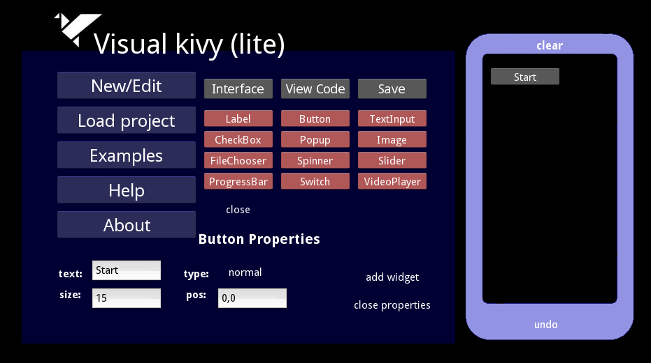
Adding a button showing the text 'Start' will create the following code:
from kivy.app import App
from kivy.uix.widget import Widget
from kivy.uix.button import Button
class MyApp(App):
def build(self):
win = Widget()
btn=Button(text='Start',font_size=15,pos=(670,370))
win.add_widget(btn)
return win
if __name__ == '__main__':
MyApp().run()

Thus, through the code generated, users can easily learn or teach some of the Kivy basics.

D. Some Important notes
- As commented before in the current document, "clear" button restores all settings and actions taken.

- While creating or editing an existing project, other options available within the application as "Load project", "Examples" or "Help", will not be accessible unless you save the current project or restore the settings with "clear".

