Created by LDT on 13/04/2022

---------------------------------------

This is a guide on how to visualise the .vtk time series (generated using PlotModel.py).

There are two different types of data in the .vtk files: meshes and contours. This is reflected in the filenames.

# **PART 1: Meshes**

* To open the files : File>Open> Mesh you are interested in.
* Paraview automatically groups the time series, that will be visualised with a small triangle on the File>Open window

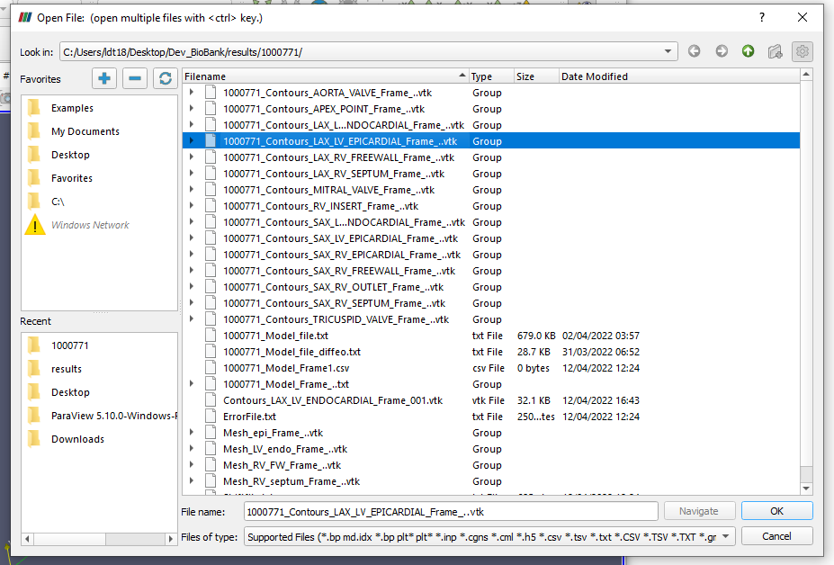

* Once the series has been opened, click Apply

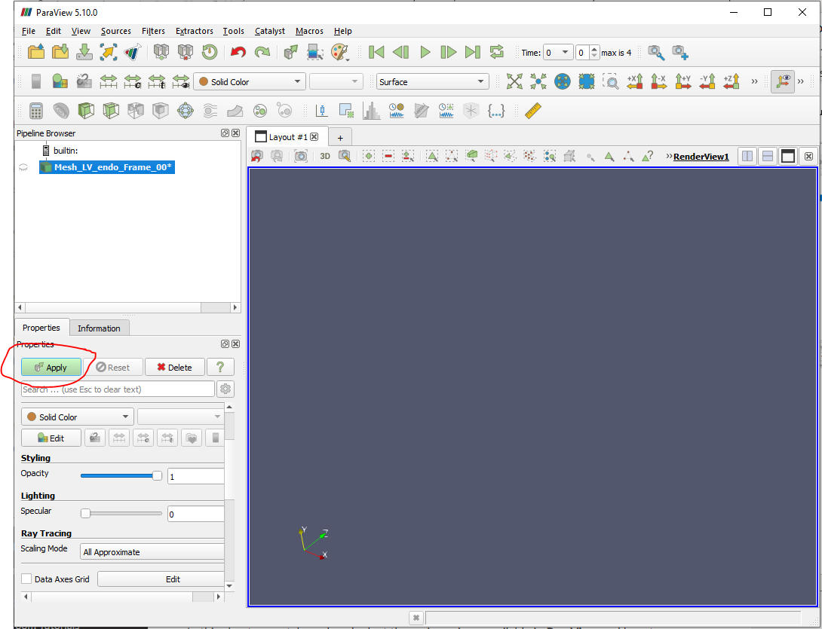

* The mesh will now appear
* To animate through time click on “Play”

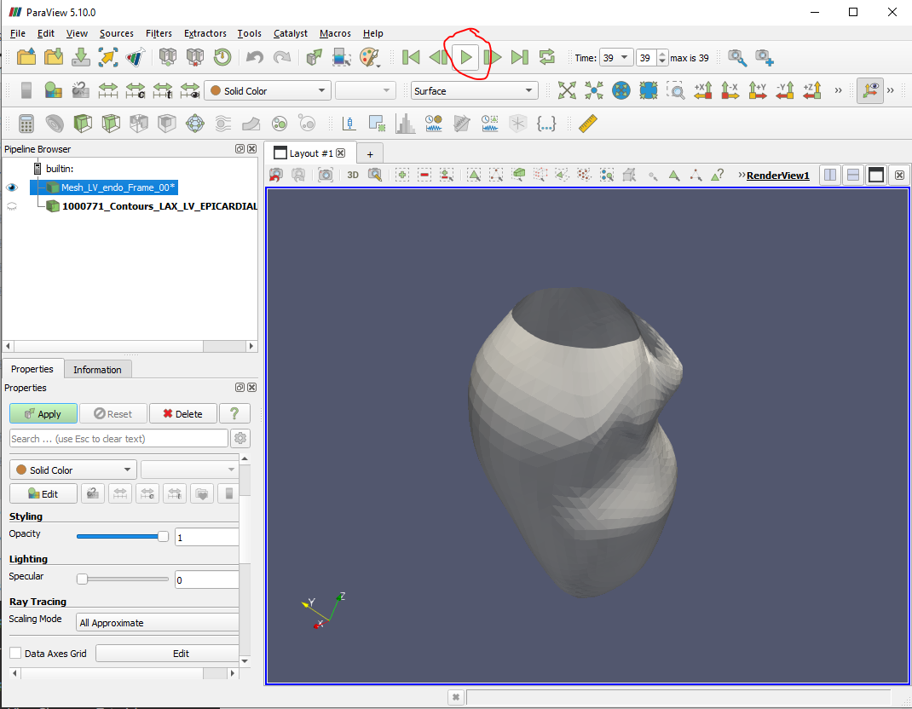

# **PART 2: Contours**

* Import data using File> Open and click on the time series
* Click on “ apply” button
* Select Representation-> Point Gaussian

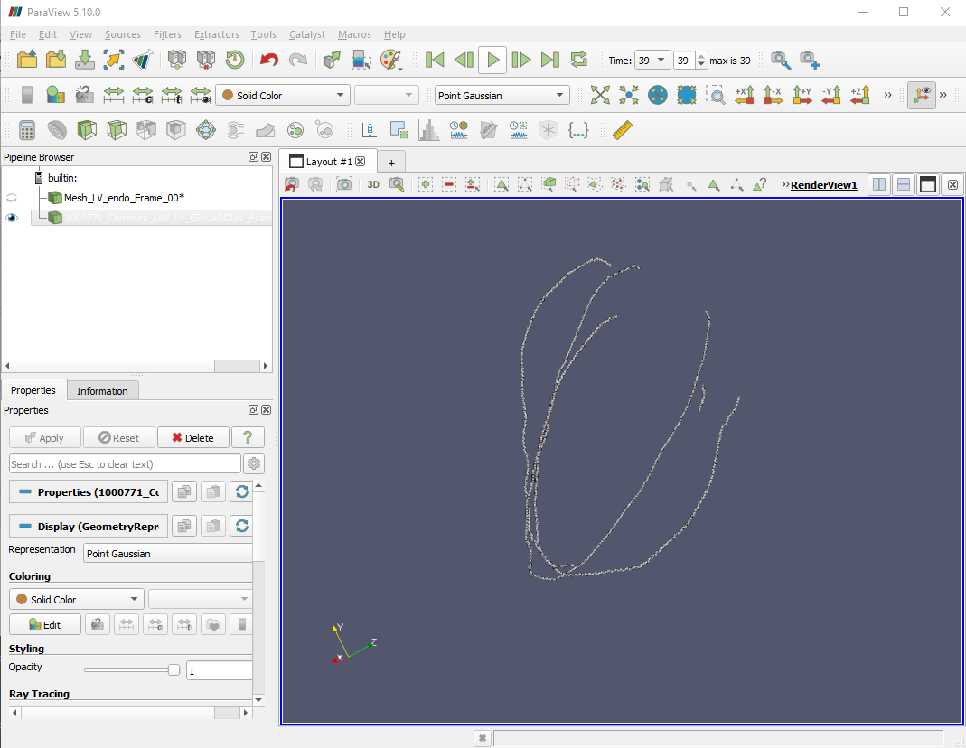

* Optional: Convert to point cloud by choosing Filters> Convert to point cloud
* Animate through time by clicking on the green play button