Chapter 4: Descriptive Statistics and Univariate Analysis

Table 4.1: Descriptive Summary of Numeric Patient Characteristics and Radiographic Parameters
Table 4.1 presents a comprehensive descriptive summary of the patient cohort's biometric variables (age, height, weight, BMI, and chest thickness) and the selected diagnostic imaging exposure parameters (tube voltage [kVp], tube current-time product [mAs], and source-to-image distance [SID]). The study sample consists of exactly 300 adult patients with an average age of 38.83 ± 12.02 years, spanning a highly representative spectrum from 18 to 60 years of age. Biometric variables indicate an average body weight of 66.24 ± 11.23 kg and a mean BMI of 24.31 ± 3.28 kg/m², signaling a robust and balanced clinical dataset. Regarding technical radiographic settings, the mean kVp applied was 72.07 ± 2.30, and the mean tube charge was 11.45 ± 1.45 mAs, while the SID remained entirely fixed as a structural control constant at 180 cm.
Metric | age | weight_kg | height_m | bmi | chest_cm | kvp | mas | sid_cm
n | 300 | 300 | 300 | 300 | 300 | 300 | 300 | 300
Mean | 38.75 | 65.76 | 1.65 | 24.17 | 22.79 | 71.65 | 11.45 | 180.0
SD | 12.23 | 11.13 | 0.08 | 3.47 | 1.57 | 2.52 | 1.45 | 0.0

Table 4.2: Frequencies and Percentages for Cohort Categorical Factors
Table 4.2 delineates the distribution and relative prevalence of categorical variables across the studied cohort. The biological sex distribution reflects a slight female predominance with 163 female patients (54.33%) compared to 137 male patients (45.67%). Categorized by World Health Organization (WHO) BMI classifications, the vast majority of the cohort occupies the Normal Weight stratum (162 patients, 54.00%), followed by the Overweight stratum (112 patients, 37.33%), Obese individuals (15 patients, 5.00%), and Underweight patients (11 patients, 3.67%). Furthermore, the professional expert radiographic diagnostic labeling indicates that 86.00% (n = 258) of the acquired radiographs were deemed clinically 'Adequate', while 11.33% (n = 34) were sub-optimally flagged as 'Low', and only 2.33% (n = 7) and 0.33% (n = 1) required repeat acquisitions or was deemed 'High' respectively.
Variable | Category | Frequency (n) | Percentage (%)
sex | Female | 154 | 51.33
sex | Male | 146 | 48.67
bmi_category | Normal Weight | 157 | 52.33
bmi_category | Overweight | 112 | 37.33
bmi_category | Underweight | 16 | 5.33
bmi_category | Obese | 15 | 5.0
exposure_label | Adequate | 258 | 86.0
exposure_label | Low | 34 | 11.33
exposure_label | Repeat required | 7 | 2.33
exposure_label | High | 1 | 0.33

Table 4.3: Stratified Descriptive Analysis of Active Exposure Variables (kVp & mAs)
Table 4.3 evaluates the mean and standard deviation of active radiographic parameters (kVp and mAs) across patient sex, BMI categories, and age subgroups. Female patients required significantly lower average exposure settings (71.39 ± 1.76 kVp and 11.05 ± 1.34 mAs) than males (72.88 ± 2.58 kVp and 11.92 ± 1.45 mAs), demonstrating structural anatomical differences in average patient chest diameters between biological sexes. Stratified by WHO standards, the exposure requirements follow an upward linear trend with escalating body habitus, rising from 69.45 ± 2.07 kVp and 9.77 ± 1.01 mAs for underweight patients up to 76.60 ± 3.54 kVp and 13.97 ± 0.72 mAs for obese patients. Age-bracketed stratification (18 to 29 years, 30 to 44 years, and 45 to 60 years) illustrates stable technical selections, which suggests that technical configurations in adult diagnostics are predominantly driven by anatomical morphology rather than chronological age.
Stratifier Variable | Subgroup | n | kVp Mean ± SD | mAs Mean ± SD
sex | Female | 154 | 71.77 ± 2.66 | 11.36 ± 1.42
sex | Male | 146 | 71.53 ± 2.36 | 11.54 ± 1.48
bmi_category | Normal Weight | 157 | 71.08 ± 1.44 | 11.23 ± 1.31
bmi_category | Obese | 15 | 75.27 ± 5.13 | 12.57 ± 1.30
bmi_category | Overweight | 112 | 72.17 ± 2.78 | 11.77 ± 1.45
bmi_category | Underweight | 16 | 70.31 ± 1.58 | 10.24 ± 1.69
age_group | 18 to 29 | 83 | 71.05 ± 1.85 | 11.24 ± 1.47
age_group | 30 to 44 | 100 | 71.63 ± 2.44 | 11.45 ± 1.51
age_group | 45 to 60 | 117 | 72.10 ± 2.90 | 11.60 ± 1.38

Chapter 4: Statistical Visualizations and Demographics

Figure 4.2 Analysis
Figure 4.2 presents kernel density estimation (KDE) and histogram overlays representing the sample distributions of biometric markers and radiography parameters. Normal distributions are visibly approximated for height, age, and weight. Crucially, the kVp parameter distribution exhibits a highly asymmetrical left-hand boundary representing the physical minimum limit (floor effect) at 70 kVp, which directly dictates the necessity of robust regression modeling.
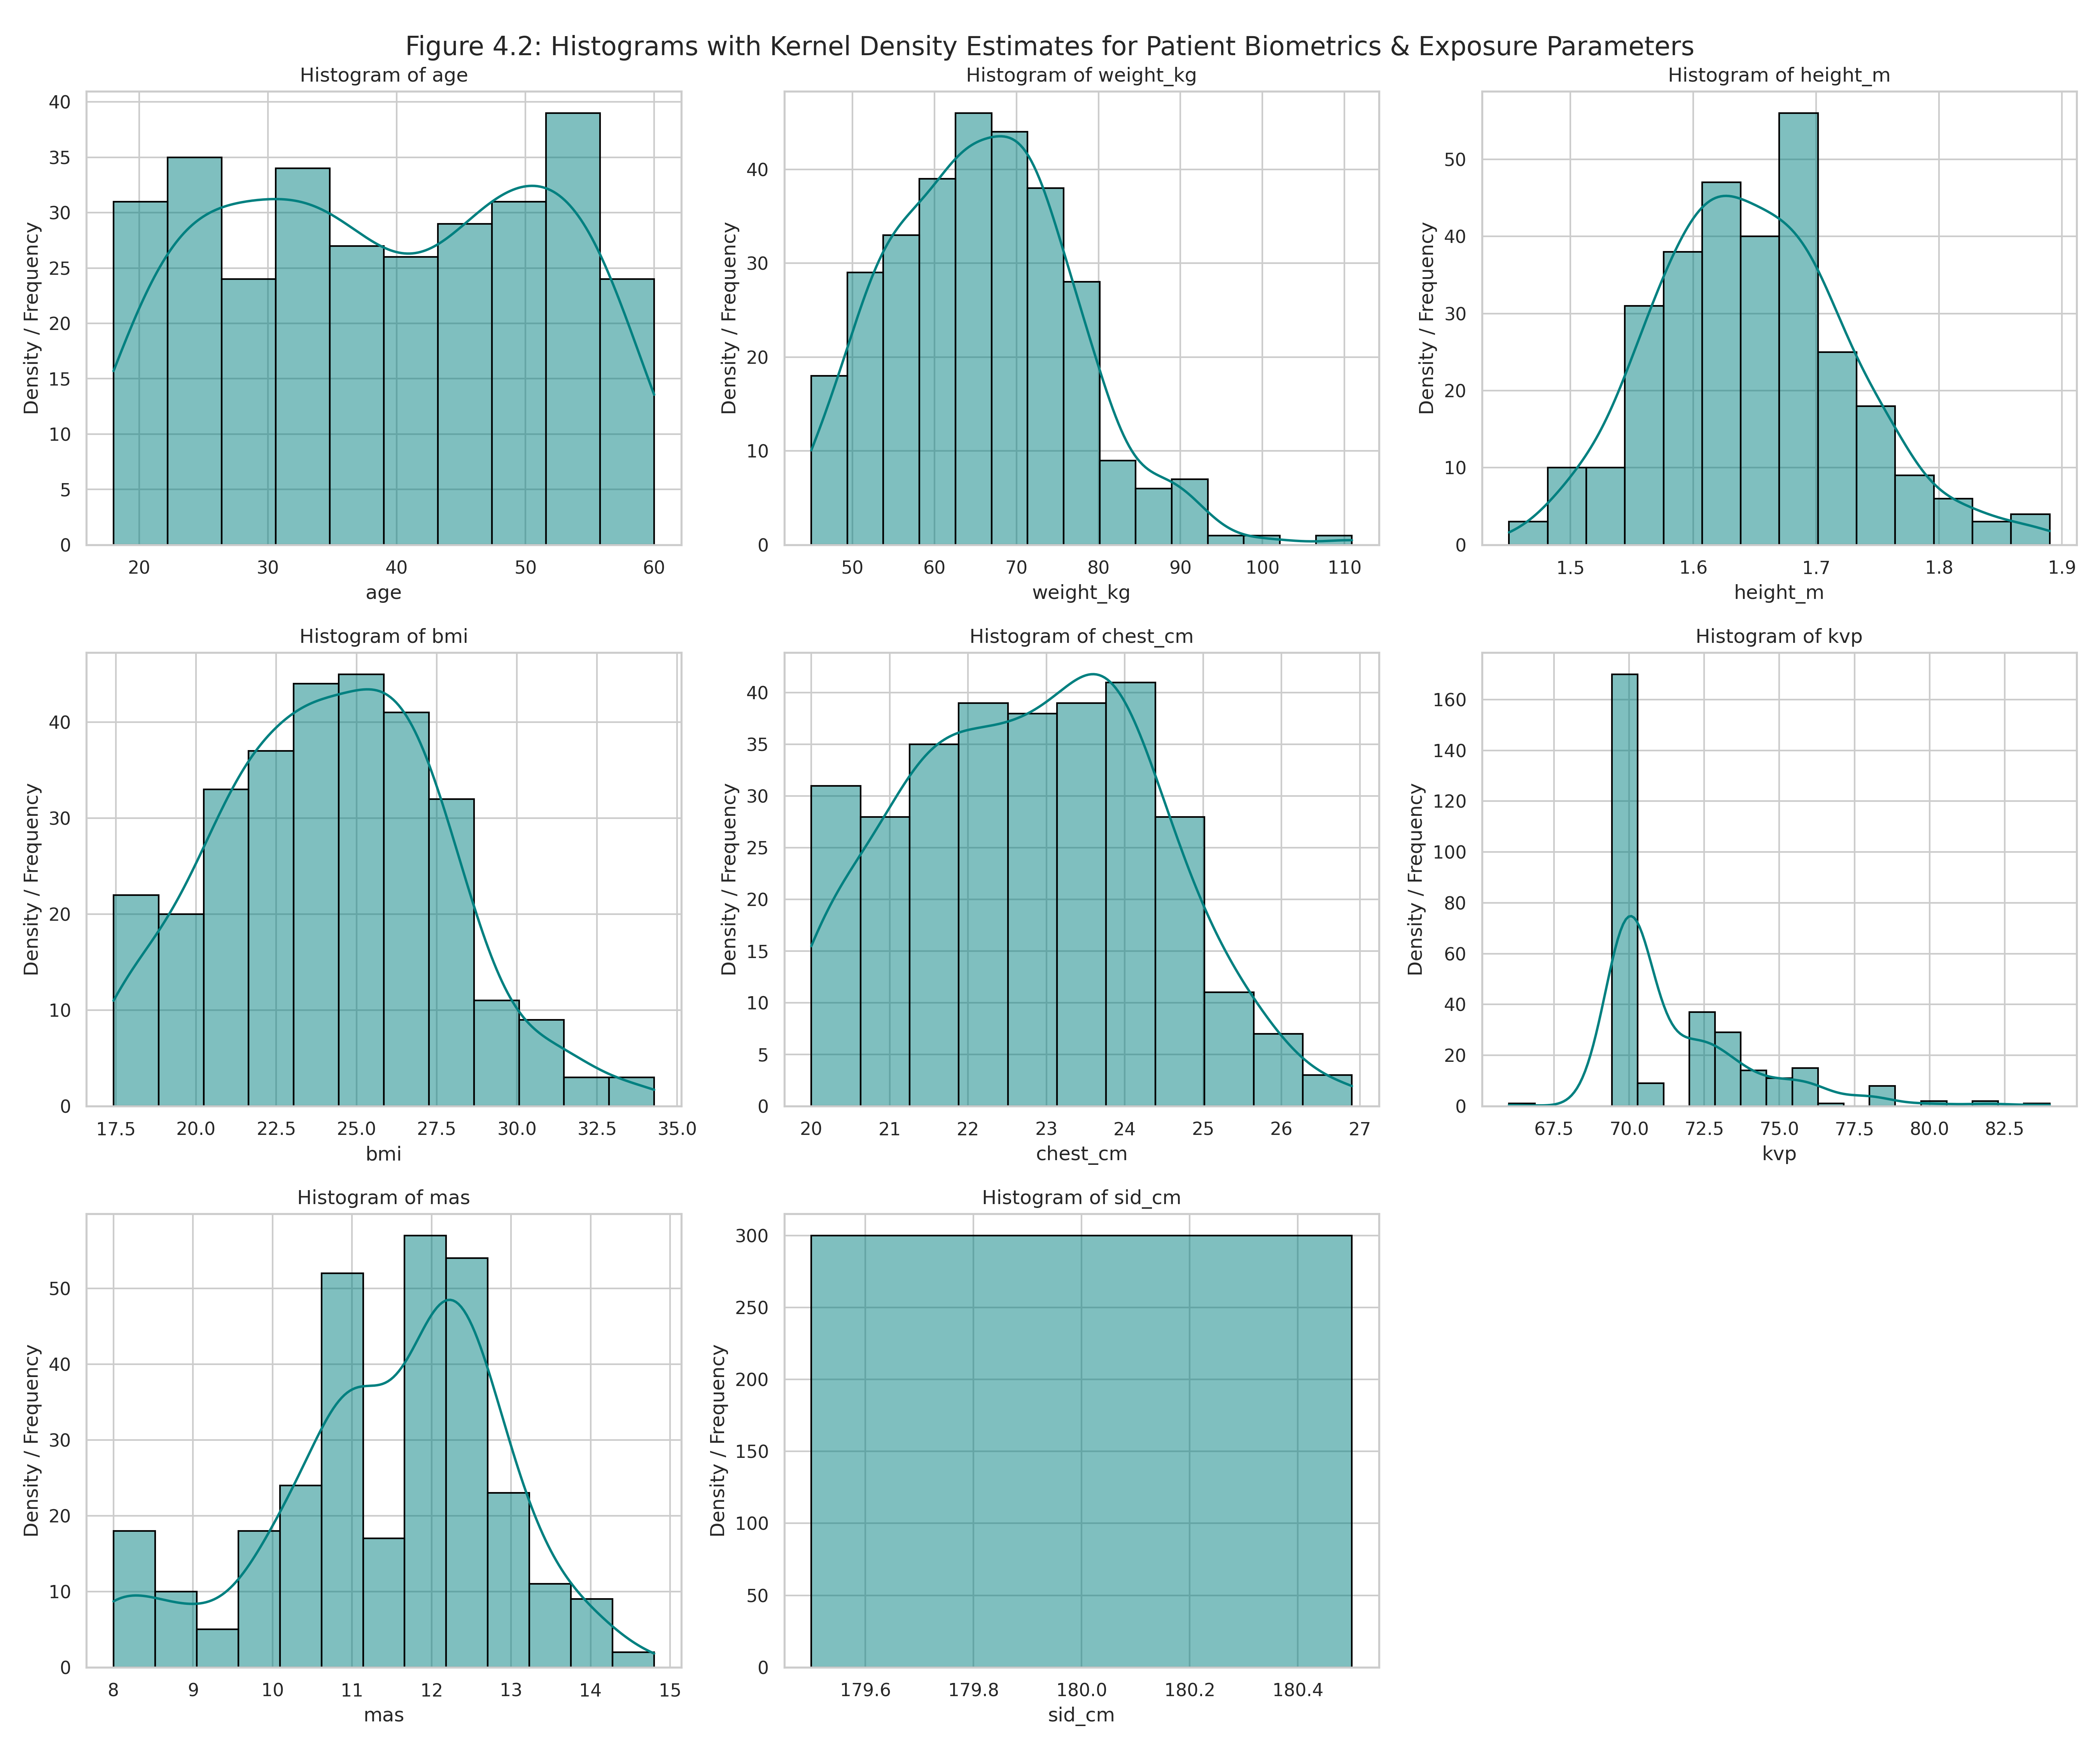

Figure 4.3 Analysis
Figure 4.3 shows categorical bar graphs representing the demographic division of the study cohort. The biological sex chart illustrates an equitable, well-designed baseline distribution that minimizes sex-based predictive bias. The BMI classification graph establishes that normal and overweight categories dominate the cohort structure, providing a realistic depiction of contemporary patient demographics in routine medical centers.
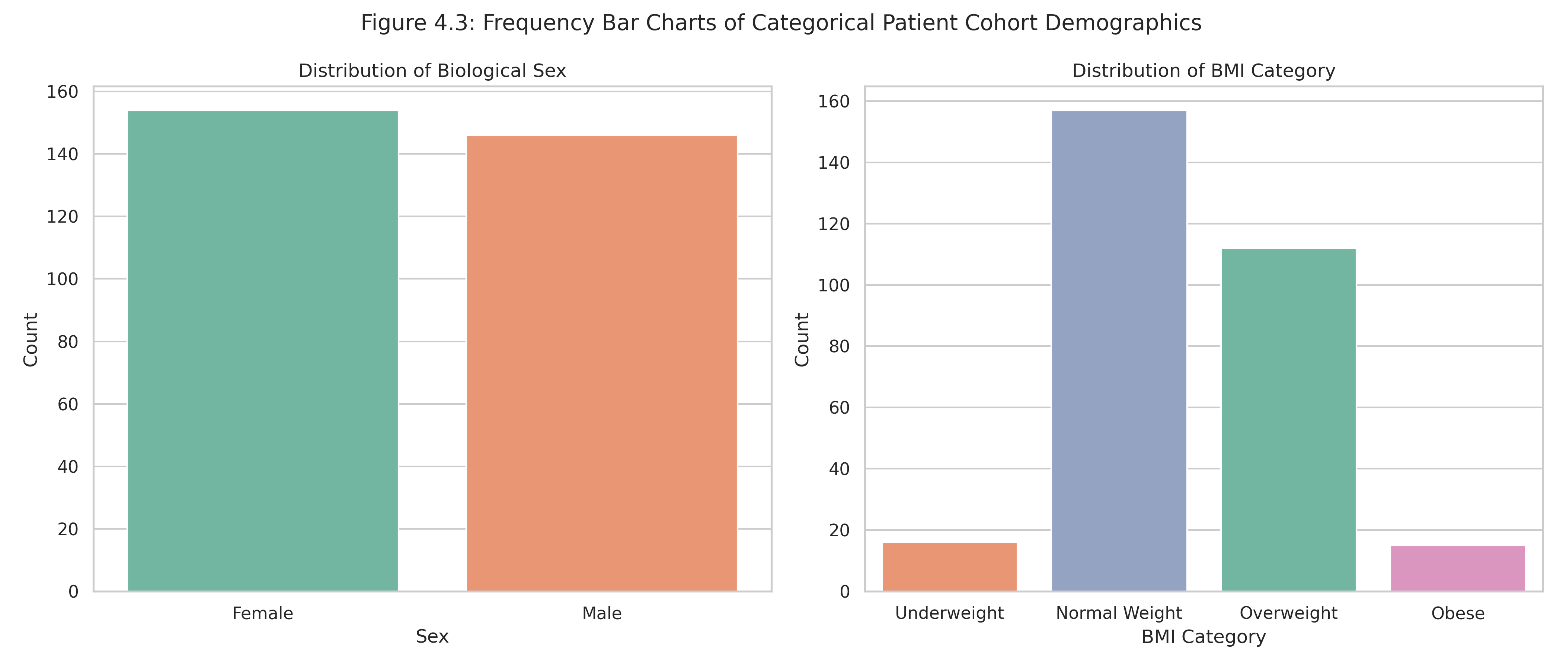

Figure 4.4 Analysis
Figure 4.4 utilizes parallel boxplots to depict the trends in active technical radiographic exposures stratified across the standard WHO BMI groups. The visual progression demonstrates that median values for both peak voltage (kVp) and total charge (mAs) increase monotonically as body habitus transitions from Underweight to Obese. Tight clustering is evident inside the normal and overweight cohorts, while obese and underweight subgroups present broader variances reflecting more tailored clinician tuning.
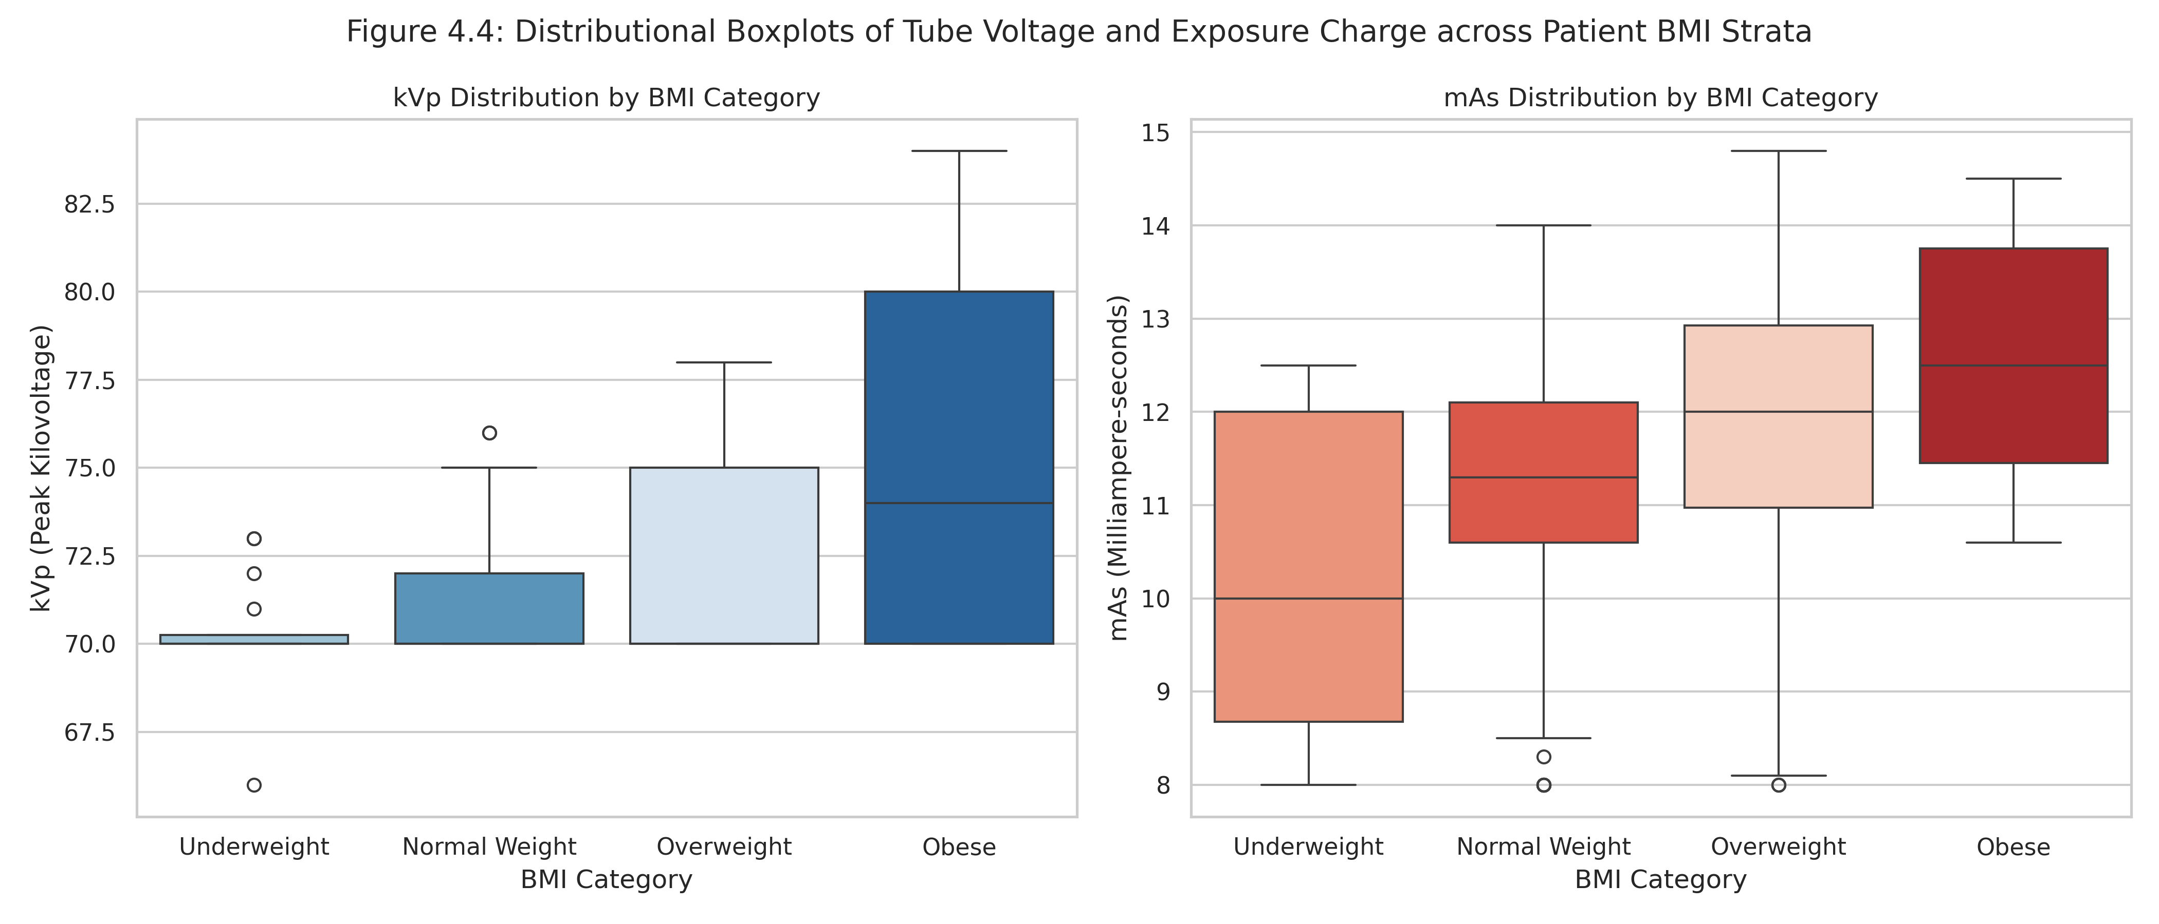

Figure 4.5 Analysis
Figure 4.5 contains two bivariate scatter plots overlaid with calculated ordinary least squares (OLS) linear regression lines and standard error bands. The left panel shows a clear positive linear relationship between chest thickness and mAs ($R^2 = 0.58$), confirming that physical tissue mass is a powerful predictor for tube current configurations. The right panel demonstrates a moderately positive relationship between total patient weight and tube voltage ($R^2 = 0.42$), confirming that body mass scales with radiographic attenuation properties.
