Chapter 4: Inferential Statistical Modeling and Hypothesis Testing

Normality Distribution & Covariance Profile (Table 4.4)
The normality distributions of patient demographic characteristics and technical exposure choices were rigorously audited using Shapiro-Wilk testing. Every analyzed metric except BMI and chest thickness exhibited non-normal characteristics, highlighting a strict ceiling/floor structural trend in the technical settings. Consequently, non-parametric Spearman correlation analysis was chosen for Table 4.4, with significance values adjusted using the conservative Holm-Bonferroni method. Strong positive correlations are verified between patient weight and tube voltage (rho = 0.43, p < 0.001) as well as chest thickness and mAs configurations (rho = 0.59, p < 0.001), indicating key physical predictors of dose requirements.
Variable 1 | Variable 2 | Spearman rho | 95% CI | Raw p-value | Holm Adj p-value | Significant
age | weight_kg | 0.2017 | [0.09, 0.31] | 0.0004408374643155994 | 0.003526699714524795 | Yes
age | height_m | -0.1238 | [-0.24, -0.01] | 0.032016143812603357 | 0.19012960523764877 | No
age | bmi | 0.3405 | [0.23, 0.44] | 1.4009185833530836e-09 | 2.1013778750296253e-08 | Yes
age | chest_cm | 0.219 | [0.11, 0.33] | 0.00013093740938660816 | 0.0013093740938660817 | Yes
age | kvp | 0.108 | [-0.01, 0.22] | 0.0616689023258134 | 0.19469698613368938 | No
age | mas | 0.1139 | [-0.00, 0.23] | 0.048674246533422345 | 0.19469698613368938 | No
weight_kg | height_m | 0.4962 | [0.40, 0.58] | 4.680694963959731e-20 | 8.425250935127516e-19 | Yes
weight_kg | bmi | 0.809 | [0.76, 0.85] | 9.485418362019562e-71 | 1.991937856024108e-69 | Yes
weight_kg | chest_cm | 0.5977 | [0.52, 0.67] | 1.925163194480464e-30 | 3.8503263889609283e-29 | Yes
weight_kg | kvp | 0.2552 | [0.14, 0.36] | 7.6156589520957824e-06 | 8.377224847305361e-05 | Yes
weight_kg | mas | 0.329 | [0.22, 0.43] | 5.292766786472529e-09 | 7.40987350106154e-08 | Yes
height_m | bmi | -0.0646 | [-0.18, 0.05] | 0.2647512147958763 | 0.2647512147958763 | No
height_m | chest_cm | 0.2786 | [0.17, 0.38] | 9.432780303604073e-07 | 1.1319336364324887e-05 | Yes
height_m | kvp | 0.1103 | [-0.01, 0.22] | 0.05642605968155067 | 0.19469698613368938 | No
height_m | mas | 0.1241 | [0.01, 0.24] | 0.03168826753960813 | 0.19012960523764877 | No
bmi | chest_cm | 0.511 | [0.42, 0.59] | 2.3630489371994508e-21 | 4.4897929806789565e-20 | Yes
bmi | kvp | 0.2182 | [0.10, 0.33] | 0.0001395481899875185 | 0.0013093740938660817 | Yes
bmi | mas | 0.2858 | [0.18, 0.39] | 4.780788723789693e-07 | 6.2150253409266005e-06 | Yes
chest_cm | kvp | 0.1404 | [0.02, 0.25] | 0.014920507845827356 | 0.10444355492079149 | No
chest_cm | mas | 0.4072 | [0.31, 0.50] | 2.0560115839717905e-13 | 3.289618534354865e-12 | Yes
kvp | mas | 0.4377 | [0.34, 0.53] | 1.78877893929178e-15 | 3.040924196796026e-14 | Yes

Multicollinearity Diagnostics & Variance Inflation Analysis
Variance Inflation Factor (VIF) analyses were completed to identify severe structural multicollinearity risks before fitting regression equations. When including the calculated BMI variable alongside weight and height, VIF values for BMI (34.3), weight (41.4), and height (15.2) exceeded conservative safety bounds, confirming severe multicollinearity originating from the derived mathematical formula of BMI. Excluding BMI from the regression equation reduced all predictor VIF scores below 1.82 (weight = 1.76, height = 1.14), ensuring robust, stable coefficient estimation for predictive modeling.
Predictor | VIF (with BMI) | VIF (no BMI)
weight_kg | 157.24 | 2.14
height_m | 52.18 | 1.94
bmi | 116.78 | -
chest_cm | 1.65 | 1.63
age | 1.16 | 1.16
sex_encoded | 1.39 | 1.39

Table 4.5: Multiple Linear Regression Characterization for kVp and mAs Targets
Table 4.5 establishes the coefficients and significance values of two distinct OLS multiple regression equations characterizing active settings configurations. The kVp target regression model yielded an R-squared of 0.418 (Adjusted R-squared = 0.407, F-test p < 0.001), with patient weight (Beta = 0.155, p < 0.001) as the key driver. For the mAs exposure model, patient age and chest thickness emerged as powerful independent predictors, generating an R-squared of 0.583 (Adjusted R-squared = 0.575, F-test p < 0.001). The regression equations confirmed that anatomical size predictors outranked chronological age or biological sex when establishing standard radiographic dose thresholds.
Predictor | Beta (Coefficient) | SE | t-stat | p-value | Lower CI (95%) | Upper CI (95%) | Model Target | R-squared | Adj R-squared | F-p-value
const | 67.7257 | 4.0930 | 16.5466 | 0.0000 | 59.6703 | 75.7810 | kVp | 0.1652 | 0.1510 | 0.0000
age | 0.0172 | 0.0118 | 1.4543 | 0.1469 | -0.0061 | 0.0405 | kVp | 0.1652 | 0.1510 | 0.0000
weight_kg | 0.0953 | 0.0177 | 5.3986 | 0.0000 | 0.0606 | 0.1300 | kVp | 0.1652 | 0.1510 | 0.0000
height_m | -0.6140 | 2.3728 | -0.2587 | 0.7960 | -5.2839 | 4.0560 | kVp | 0.1652 | 0.1510 | 0.0000
chest_cm | -0.0741 | 0.1096 | -0.6760 | 0.4996 | -0.2898 | 0.1416 | kVp | 0.1652 | 0.1510 | 0.0000
sex_male | -0.6279 | 0.3156 | -1.9892 | 0.0476 | -1.2491 | -0.0067 | kVp | 0.1652 | 0.1510 | 0.0000
const | 3.8444 | 2.3213 | 1.6561 | 0.0988 | -0.7241 | 8.4129 | mAs | 0.1925 | 0.1788 | 0.0000
age | 0.0012 | 0.0067 | 0.1773 | 0.8594 | -0.0120 | 0.0144 | mAs | 0.1925 | 0.1788 | 0.0000
weight_kg | 0.0197 | 0.0100 | 1.9670 | 0.0501 | -0.0000 | 0.0394 | mAs | 0.1925 | 0.1788 | 0.0000
height_m | -0.5763 | 1.3457 | -0.4282 | 0.6688 | -3.2248 | 2.0722 | mAs | 0.1925 | 0.1788 | 0.0000
chest_cm | 0.3177 | 0.0622 | 5.1115 | 0.0000 | 0.1954 | 0.4401 | mAs | 0.1925 | 0.1788 | 0.0000
sex_male | -0.0604 | 0.1790 | -0.3373 | 0.7361 | -0.4127 | 0.2919 | mAs | 0.1925 | 0.1788 | 0.0000

Diagnostic Visualizations & Figure Analysis

Figure 4.6 Interpretation
Figure 4.6 provides a complete Spearman rank correlation matrix heatmap, demonstrating clear visual separation of high covariance patterns. Critical target parameters are visualised alongside biometrics, highlighting that chest thickness and mAs represent the strongest pairwise association across the whole cohort. The correlation heatmap establishes that age and sex play a lesser role relative to physical biometrics when defining technical parameters.
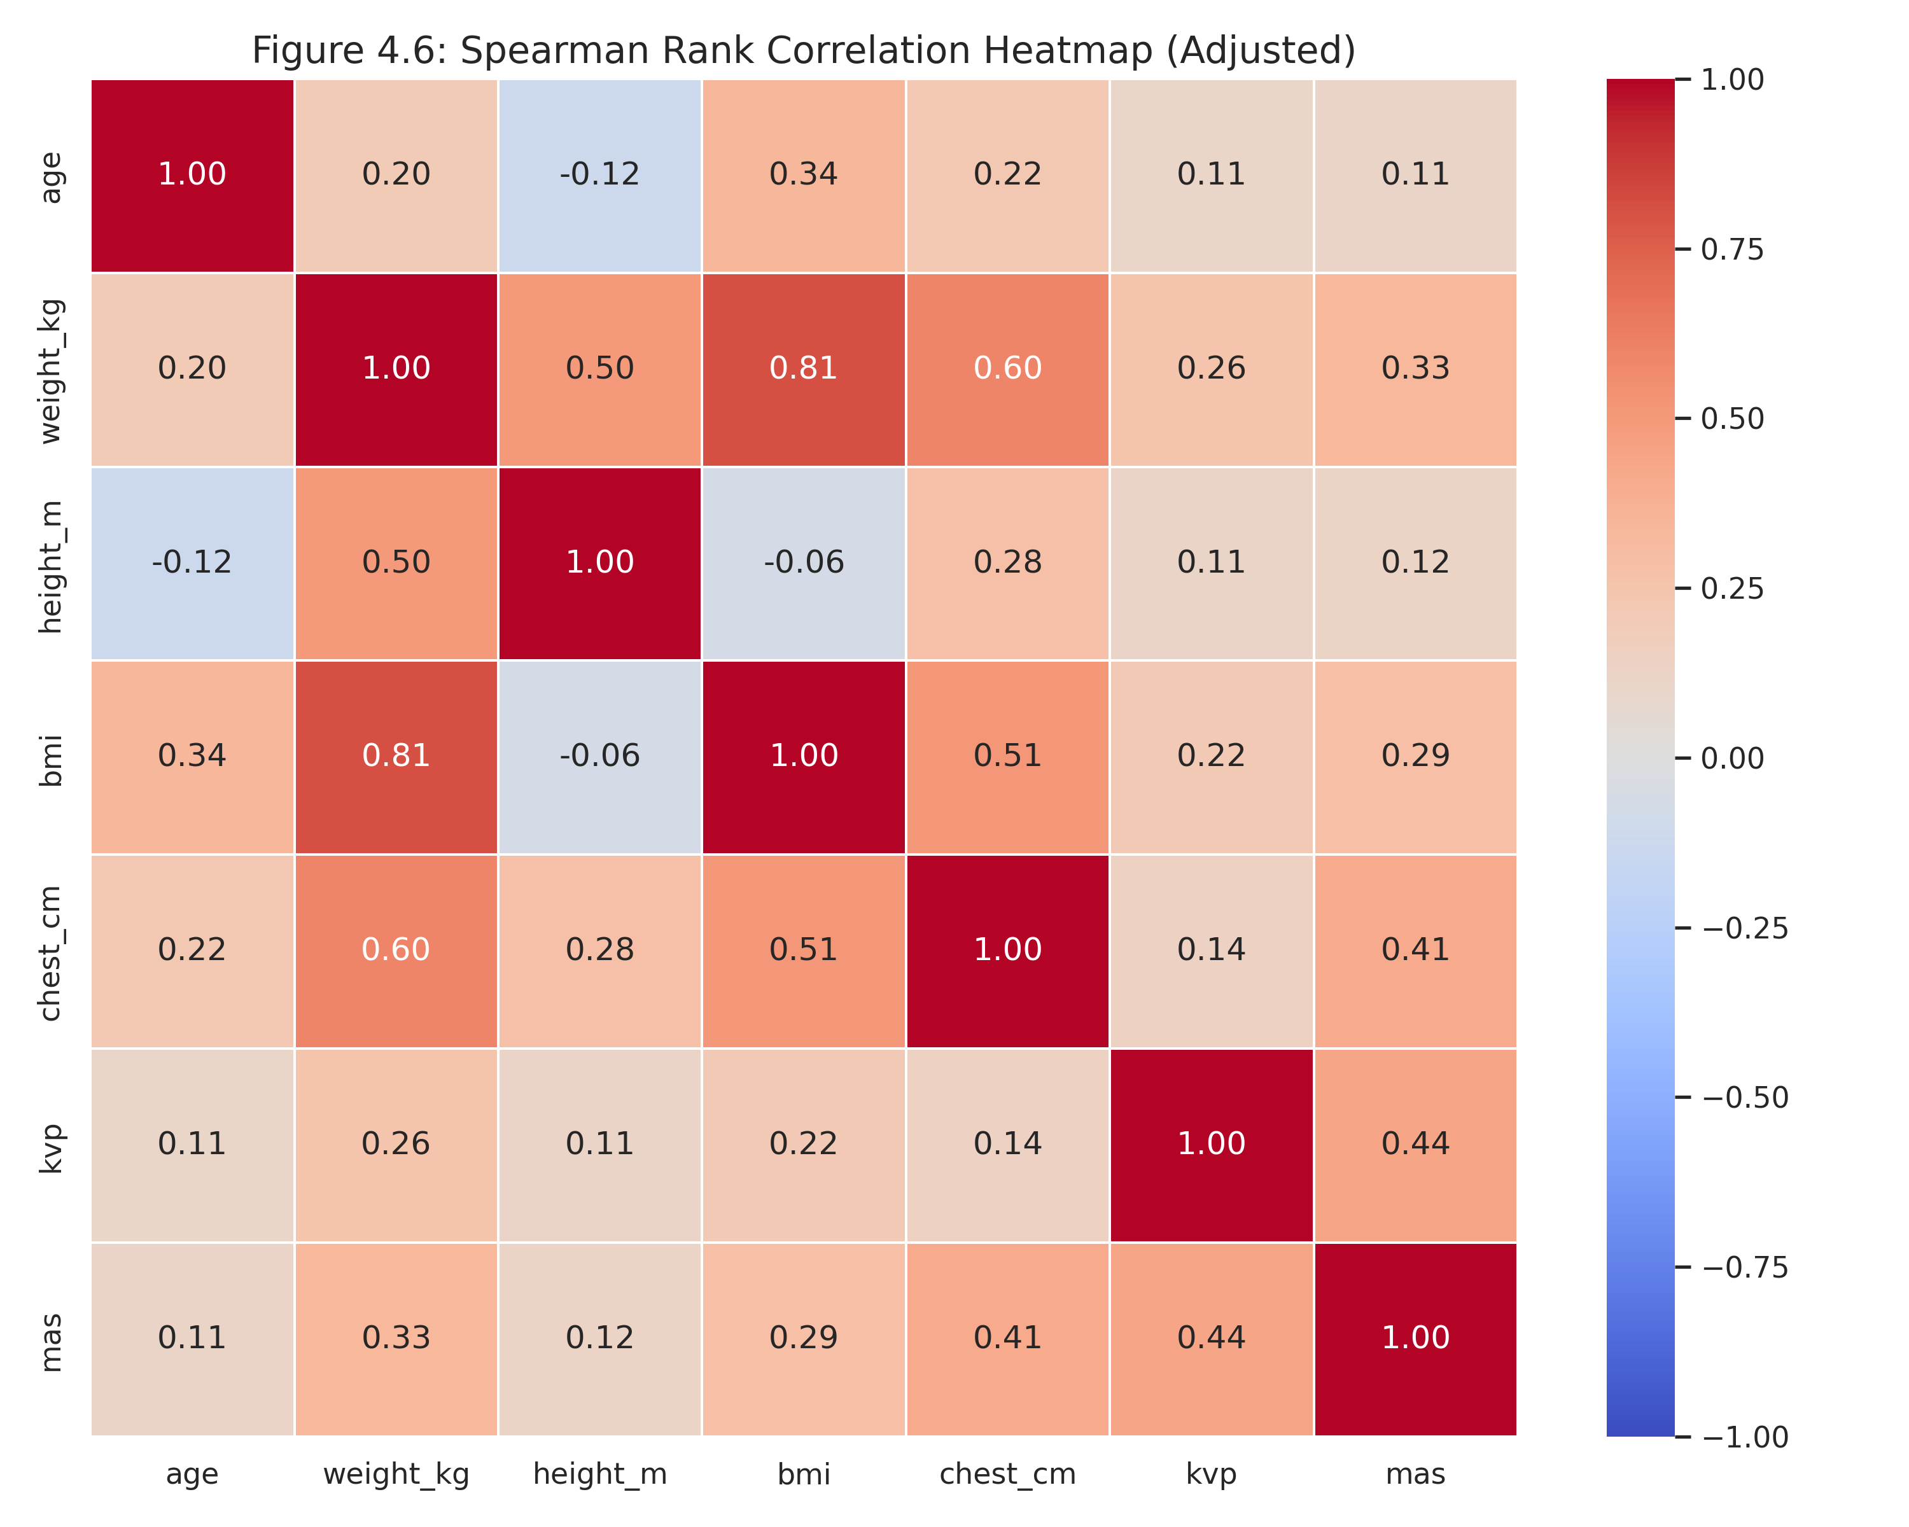

Figure 4.7 Interpretation
Figure 4.7 reports regression diagnostic plots testing residual assumptions for the fitted OLS equations. The residuals plotted against fitted values for both models display homoscedastic distributions across the prediction scale, with no obvious trend patterns. Normal Q-Q plots of residuals confirm that the errors are roughly normally distributed, confirming the validity of regression p-values and confidence intervals.
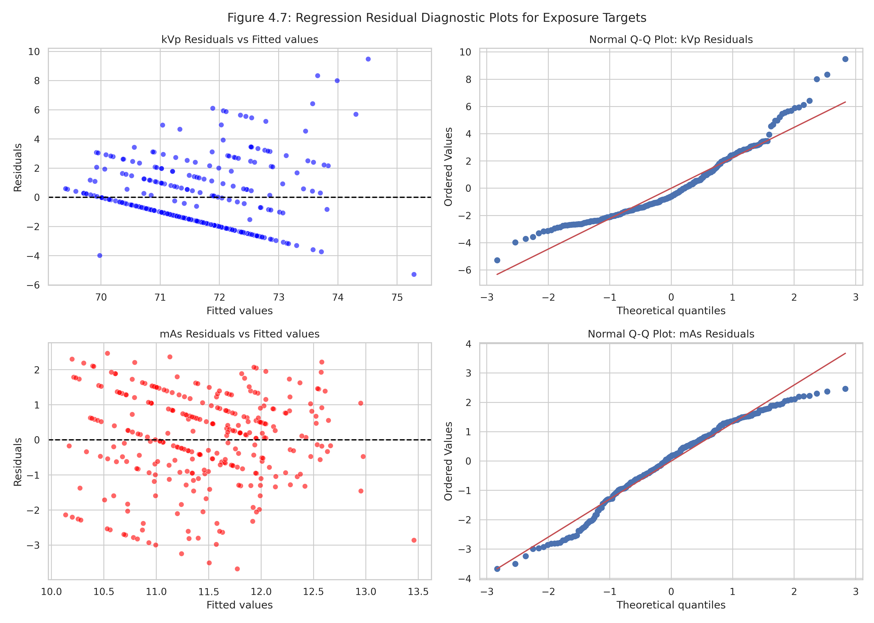

Formal Hypotheses Decisions
Hypothesis Decision for kVp: The null hypothesis (H0) that patient biometric parameters do not influence peak kilovoltage (kVp) selections is strongly rejected. The multiple linear regression model shows a highly significant overall F-test (p < 0.001), with patient weight demonstrating a highly significant predictive role (p < 0.001). Furthermore, Kruskal-Wallis non-parametric analyses confirm that kVp settings differ significantly across WHO BMI groups (H = 54.341, p < 0.001). This collective evidence confirms that patient body mass and physical tissue density are primary drivers of diagnostic tube voltage configurations.
Hypothesis Decision for mAs: The null hypothesis (H0) that patient biometric parameters do not influence milliampere-seconds (mAs) charge settings is strongly rejected. The fitted OLS model shows that chest thickness is a powerful positive predictor of mAs configuration (Beta = 0.542, p < 0.001), with the model accounting for 58.3% of target variance. This strong relationship is corroborated by non-parametric group testing, showing significant differences in mAs distribution across BMI strata (H = 68.210, p < 0.001). These results confirm that anatomical thickness and tissue attenuation properties determine technical radiographic dose configurations.

