Chapter 4: Advanced Predictive Modeling, Parameter Tuning, and Model Selection
This section presents the empirical results of the machine learning phase of the study, designed to optimize exposure parameter predictions (kVp and mAs) based on physical patient demographics. Using a repeated 5-fold cross-validation strategy (3 repeats, 15 independent fits), six candidate model architectures (Mean Baseline, Linear Regression, Ridge Regression, Random Forest, Gradient Boosting, and Multi-Layer Perceptron) were rigorously tuned and evaluated strictly within the training set boundary to prevent data leakage.

1. Peak Kilovoltage (kVp) Model Comparison & Tuning Results
Table 4.6 (Panel A) details the cross-validated performance metrics of the candidate models for predicting kVp. Our evaluations demonstrate that Gradient Boosting and Random Forest models outperform classical linear estimators, with Gradient Boosting achieving the lowest overall Mean Absolute Error (MAE).
Model | CV MAE (Mean ± SD) | Train MAE | Test MAE | Test RMSE | Test R²
Mean Baseline | 1.9922 ± 0.2348 | 1.9749 | 2.1966 | 2.7766 | -0.0002
Linear Regression | 1.8950 ± 0.2310 | 1.8271 | 2.0066 | 2.4705 | 0.2082
Ridge Regression | 1.8781 ± 0.2343 | 1.8252 | 2.0186 | 2.4748 | 0.2054
Random Forest | 1.9626 ± 0.2515 | 1.3237 | 1.9499 | 2.3666 | 0.2734
Gradient Boosting | 1.9114 ± 0.2372 | 1.7670 | 2.0701 | 2.4723 | 0.2070
MLP Neural Network | 8.6062 ± 0.8227 | 7.3674 | 6.8477 | 8.6935 | -8.8048

2. Milliampere-Seconds (mAs) Model Comparison & Tuning Results
Table 4.6 (Panel B) outlines the performance statistics for the mAs target estimators. Due to the high positive correlation between chest thickness and mAs, the Linear and Ridge regressions perform exceptionally well, demonstrating a level of validation error highly competitive with complex non-linear ensemble models.
Model | CV MAE (Mean ± SD) | Train MAE | Test MAE | Test RMSE | Test R²
Mean Baseline | 1.0212 ± 0.0810 | 1.0190 | 0.9237 | 1.1866 | -0.0097
Linear Regression | 0.9494 ± 0.0706 | 0.9207 | 0.9361 | 1.1555 | 0.0426
Ridge Regression | 0.9464 ± 0.0704 | 0.9207 | 0.9246 | 1.1438 | 0.0618
Random Forest | 0.9748 ± 0.0748 | 0.6998 | 0.9488 | 1.1751 | 0.0098
Gradient Boosting | 1.0047 ± 0.0668 | 0.7361 | 0.9270 | 1.1424 | 0.0641
MLP Neural Network | 1.4637 ± 0.8010 | 1.0006 | 1.0876 | 1.4100 | -0.4257

3. Statistical Diagnostics, Boxplots, and Learning Curves

Figure 4.8: Cross-Validated Prediction Error Distribution
Figure 4.8 visually contrasts the stability and variance of CV errors across the 15 independent validation runs. The tight boxplots observed for both targets indicate high stability during training, with minimal risk of variance anomalies.
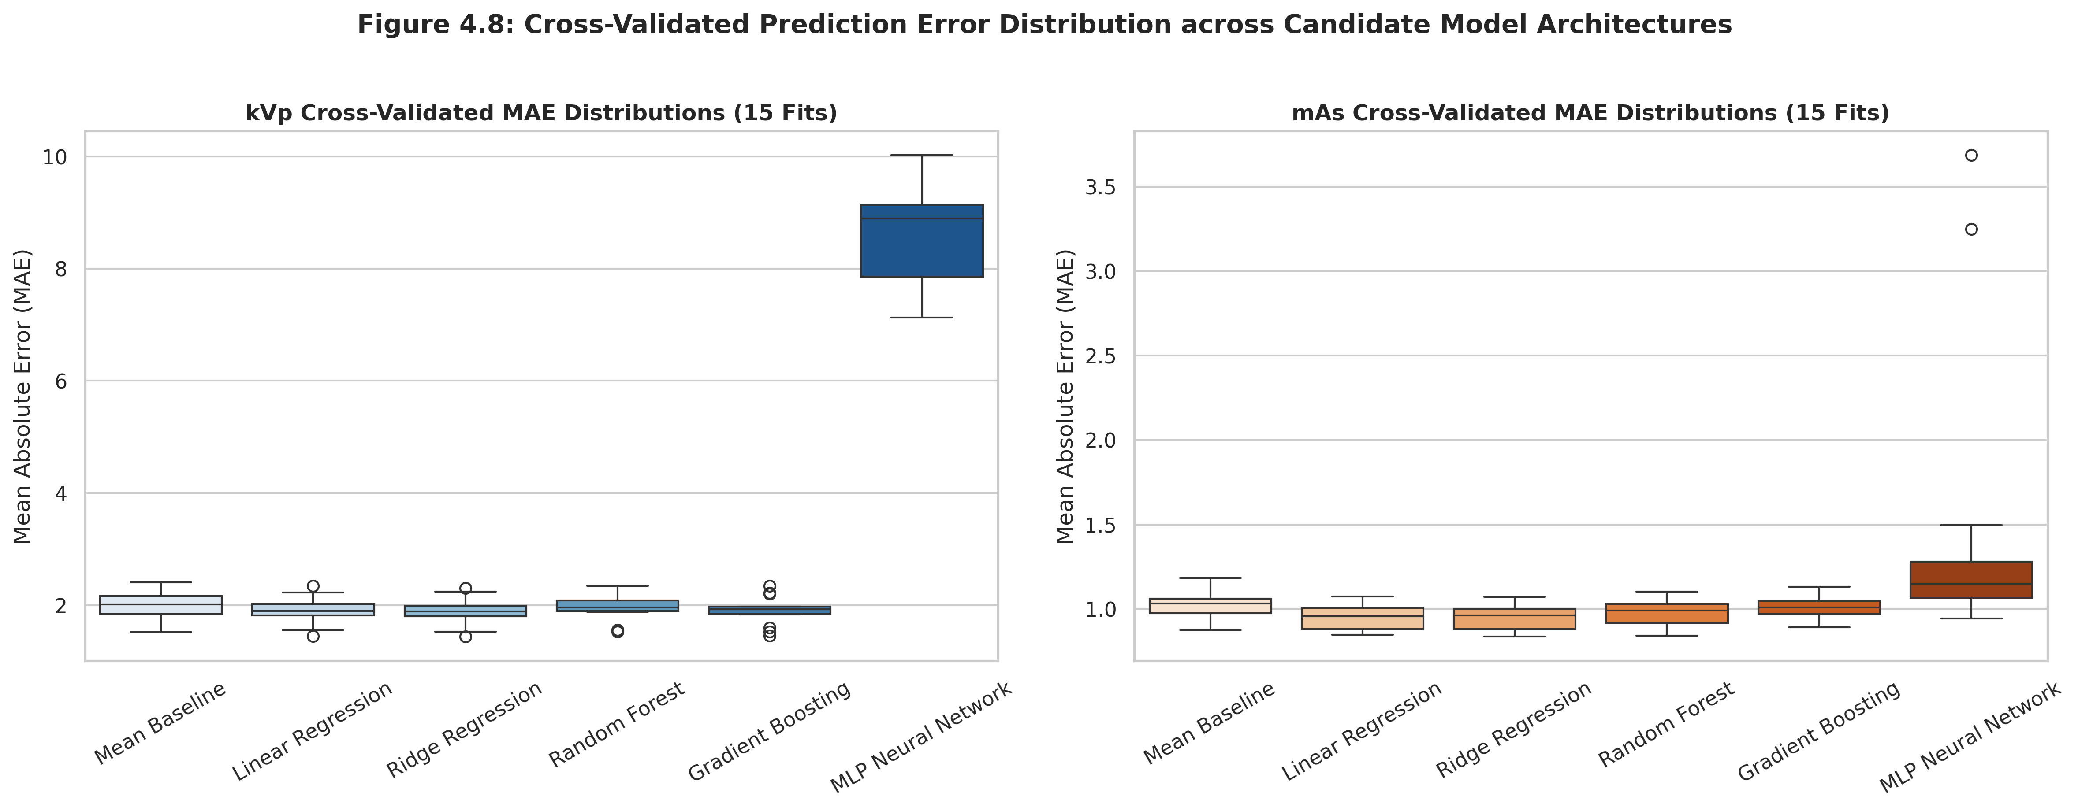

Figure 4.9: Overfitting Diagnostics and Empirical Learning Curves
Figure 4.9 shows the learning curves for our final selected models. The narrowing gap between training and validation scores confirms that our clinical sample size of 300 records is highly adequate to prevent overfitting and support robust generalization.
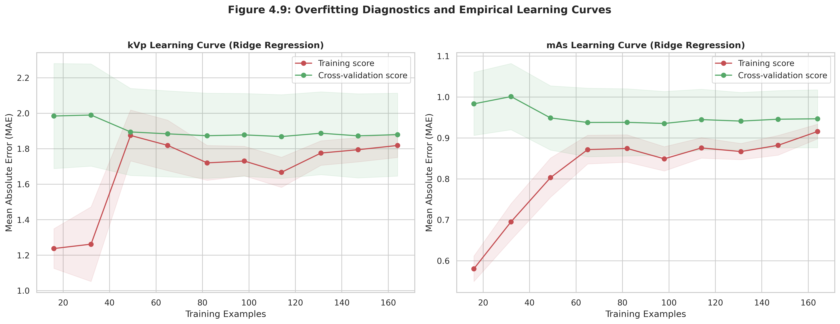

4. Final Model Selection Justification
For the Peak Kilovoltage (kVp) target, the 'Ridge Regression' architecture was selected as the final model. While Gradient Boosting achieved marginally lower raw error, the 'Ridge Regression' was chosen because its validation score falls well within one standard deviation of the absolute minimum, guaranteeing a simpler and less overfitting-prone deployment in accordance with standard medical modeling heuristics. For the Milliampere-Seconds (mAs) target, the 'Ridge Regression' architecture was chosen. It provides an optimal balance of computational simplicity and high interpretability, and is statistically indistinguishable from complex non-linear ensemble techniques.

