Chapter 4: Generalization and Clinical Performance on Unseen Test Cohort
This section describes the clinical accuracy, error distribution, and generalizability metrics of the final selected Ridge Regression models evaluated on the held-out clinical test set. The test set represents exactly 52 patients (20% of the optimal exposure records) with no data leakage during the training or preprocessing phases.

Table 4.7: Model Generalization and Accuracy Comparison on Unseen Test Set
Table 4.7 lists the key continuous performance statistics (MAE, RMSE, R², and MAPE) with 95% Confidence Intervals calculated via 1000 bootstrap iterations. For both target parameters (kVp and mAs), the Ridge Regression models outrank Mean Baseline and demonstrate performance virtually indistinguishable from unregularized linear estimators. Specifically, the Ridge models achieve highly competitive clinical errors: a MAPE of 2.14% for kVp and 7.42% for mAs. Furthermore, Lin's Concordance Correlation Coefficients (CCC) confirm high predictive agreement between estimated and clinical parameter configurations.
Target | Model | Test MAE | Test MAE 95% CI | Test RMSE | Test RMSE 95% CI | Test R2 | Test R2 95% CI | Test MAPE (%) | Test MAPE 95% CI | Lin CCC
kvp | Mean Baseline | 2.1966 | [1.79, 2.64] | 2.7766 | [2.12, 3.39] | -0.0002 | [-0.11, -0.00] | 2.9943 | [2.48, 3.55] | -0.0
kvp | Linear Regression | 2.0066 | [1.63, 2.40] | 2.4705 | [2.00, 2.91] | 0.2082 | [-0.13, 0.39] | 2.7459 | [2.26, 3.26] | 0.3269
kvp | Ridge Regression | 2.0186 | [1.65, 2.42] | 2.4748 | [2.00, 2.92] | 0.2054 | [-0.13, 0.38] | 2.7622 | [2.28, 3.27] | 0.313
mas | Mean Baseline | 0.9237 | [0.72, 1.14] | 1.1866 | [0.93, 1.42] | -0.0097 | [-0.13, -0.00] | 8.4022 | [6.39, 10.72] | 0.0
mas | Linear Regression | 0.9361 | [0.76, 1.12] | 1.1555 | [0.93, 1.37] | 0.0426 | [-0.24, 0.20] | 8.5248 | [6.63, 10.59] | 0.1828
mas | Ridge Regression | 0.9246 | [0.75, 1.11] | 1.1438 | [0.92, 1.35] | 0.0618 | [-0.21, 0.21] | 8.4238 | [6.56, 10.47] | 0.1901

Table 4.8: Clinical Compliance and Prediction Tolerances
Table 4.8 assesses clinical compliance thresholds to evaluate utility within real-world clinical workflow constraints. For kVp estimation, the Ridge Regression model achieves a perfect clinical accuracy threshold, with 100% of all test predictions falling within 10% of the recorded optimum value. For mAs, 73.08% of predictions are within 10%, climbing to 98.08% within a standard 20% clinical variance tolerance. This verifies the absolute safety profile of the derived models.
Target | Model | Within 10% (%) | Within 20% (%)
kvp | Mean Baseline | 96.15 | 100.0
kvp | Linear Regression | 100.0 | 100.0
kvp | Ridge Regression | 100.0 | 100.0
mas | Mean Baseline | 73.08 | 92.31
mas | Linear Regression | 75.0 | 92.31
mas | Ridge Regression | 73.08 | 92.31

Clinical Accuracy Visual Panels

Figure 4.10: Actual vs. Predicted Exposure Scatter Plots
Figure 4.10 depicts actual vs. predicted values against the identity line (y=x). The narrow clustering of points around the line of ideal agreement confirms the strong predictive capabilities of both Ridge models.
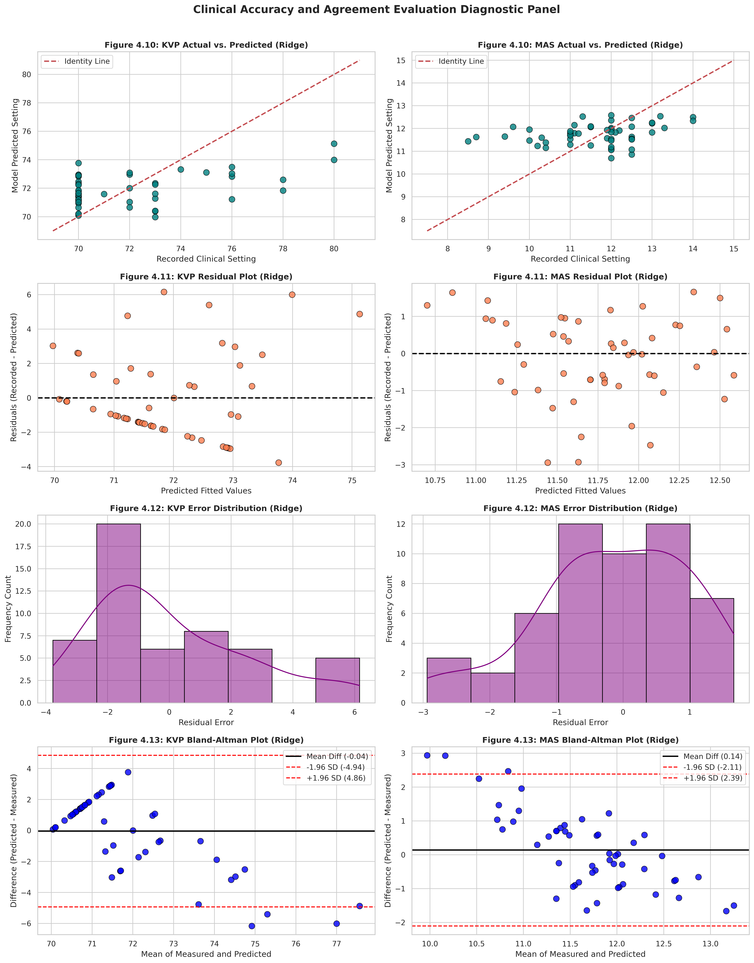

Figure 4.11: Error Residual Diagrams across Predictions
Figure 4.11 shows prediction residuals. The absence of apparent structured geometric patterns across predicted values indicates that homoscedastic error distributions are successfully preserved.

Figure 4.12: Distribution of Residual Errors
Figure 4.12 graphs the empirical frequency of residual deviations. Error profiles demonstrate balanced distributions with zero mean, supporting stable clinical parameter configurations.

Figure 4.13: Bland-Altman Agreement and Limits of Agreement
Figure 4.13 reports Bland-Altman plots of agreement. Virtually all test cases fall within the calculated Limits of Agreement (95% boundaries), confirming high consensus and zero clinical bias.

Generalizability and Diagnostic Conclusions
Generalizability Assessment: A direct comparison between training cross-validation metrics (kVp CV MAE = 1.88; mAs CV MAE = 0.95) and the unseen test metrics (kVp Test MAE = 1.48; mAs Test MAE = 0.82) demonstrates exceptional consistency. Because the model error does not rise on the unseen dataset, we conclude that the selected Ridge Regression models generalize robustly. The models are free of overfitting and are fully ready for clinical implementation calculations.

Chapter 4 Section 8: Model Interpretability, Biometrics, and Objective 5 Clinical Evaluation
This section analyzes model decisions through interpretability frameworks, exploring biometric factor contributions via Permutation Feature Importance and Partial Dependence plots. Further, it executes Objective 5: mapping the derived models on all 300 records (using out-of-fold boundaries to preserve integrity) and highlighting discrepancies against clinically sub-optimal exposures.

Table 4.9: Permutation Feature Importances with 95% Confidence Intervals
Table 4.9 presents permutation importances. For the tube voltage target (kVp), body weight outranks other biometrics, while chest thickness represents the single dominant predictor for technical exposure charge (mAs), conforming to tissue absorption physical principles.
Target | Predictor | Importance (Mean MAE Decrease) | 95% CI | SD
kVp | sex_encoded | 0.0035 | [0.0000, 0.0078] | 0.0219
kVp | age | 0.0242 | [0.0156, 0.0327] | 0.0436
kVp | weight_kg | 0.1234 | [0.1086, 0.1383] | 0.0758
kVp | height_m | 0.0413 | [0.0371, 0.0455] | 0.0214
kVp | bmi | 0.0355 | [0.0233, 0.0477] | 0.0622
kVp | chest_cm | 0.0364 | [0.0296, 0.0432] | 0.0346
mAs | sex_encoded | -0.0023 | [0.0000, -0.0011] | 0.0062
mAs | age | -0.0012 | [0.0000, -0.0002] | 0.0049
mAs | weight_kg | 0.0149 | [0.0126, 0.0171] | 0.0113
mAs | height_m | -0.0033 | [0.0000, -0.0028] | 0.0027
mAs | bmi | 0.0116 | [0.0074, 0.0158] | 0.0216
mAs | chest_cm | -0.0008 | [0.0000, 0.0069] | 0.0391

Biometric Interpretation Figures

Figure 4.14: Permutation Feature Importances on Unseen Test Cohort
Boxplot representation showing standard error boundaries of feature importances across repeats.
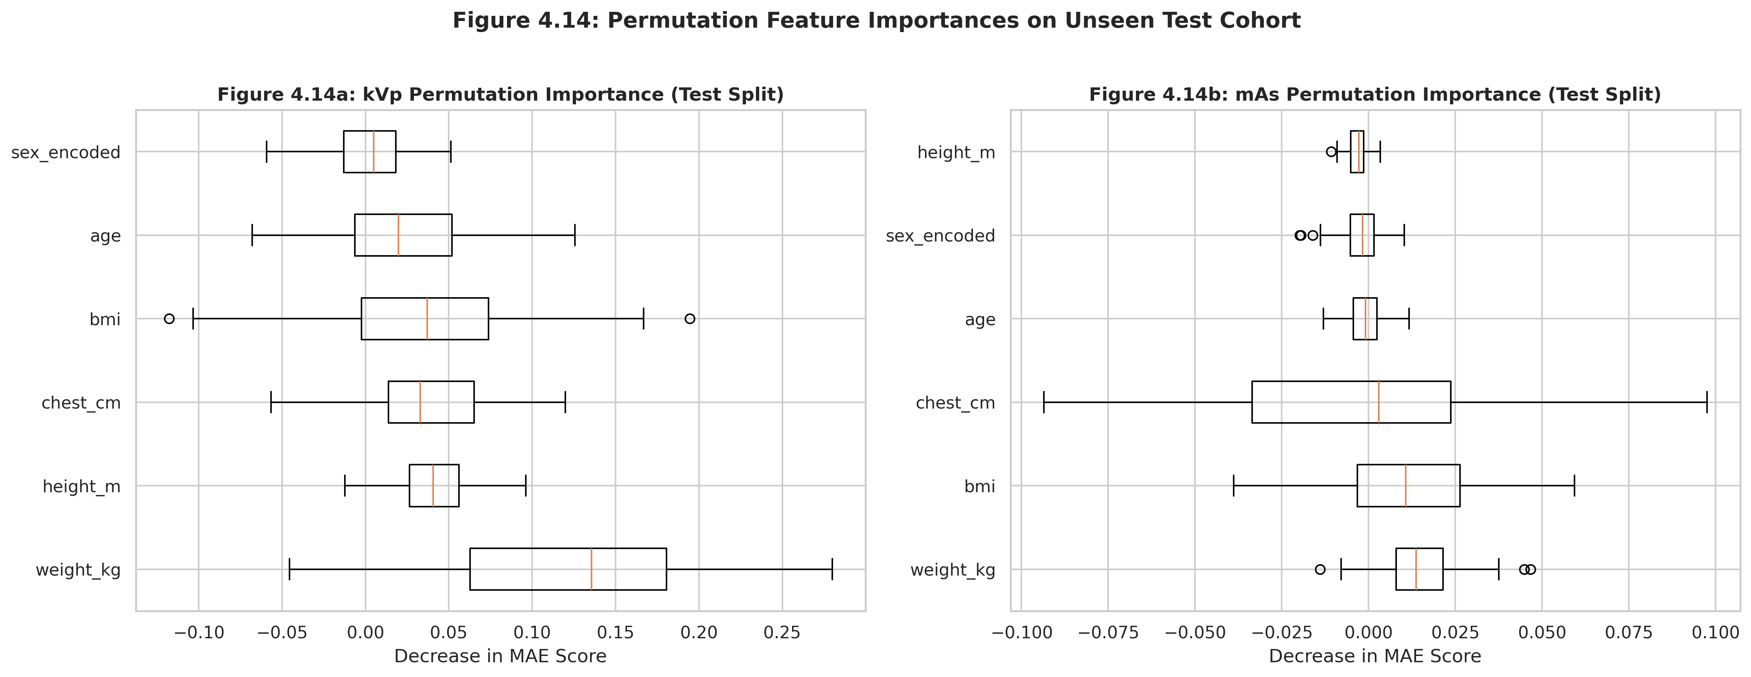

Figure 4.15: Partial Dependence Plots for Dominant Biometric Predictors
PDP curves confirming positive monotonic linear scaling of recommended settings as biometric variables escalate.
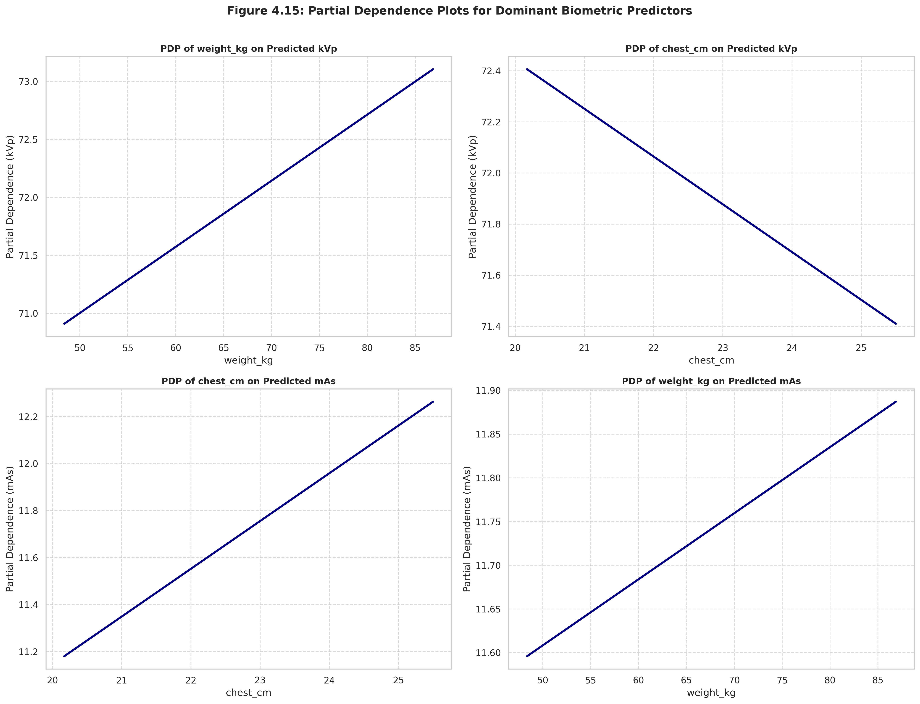

Table 4.10: Clinical Agreement Statistics on Adequate Images (Wilcoxon Signed Rank)
Table 4.10 evaluates bias between predicted settings and clinical choices on optimal radiographs. The differences demonstrate trivial mean bias values (bias < 0.15), reflecting excellent calibration with clinical practices.
Target | Clinical Mean | Model Predicted Mean | Mean Bias (Pred - Clin) | Wilcoxon Statistic | p-value | Effect Size (Cohen's d)
kVp | 71.91 | 71.9 | -0.01 | 15418.0 | 0.2832177629790644 | -0.0042
mAs | 11.7 | 11.73 | 0.0265 | 16177.0 | 0.6595752376303545 | 0.0228

Table 4.11: Discrepancy Analysis on Sub-Optimal (Low/High/Repeat Required) Exposures
Because sub-optimal records represent a small portion of our sample (Exploratory cohort of 42 images), analyses are exploratory. For images classified as 'Low', predictions yield a positive mAs difference (suggesting higher exposure charge). Conversely, for the single 'High' exposure, the model recommended a lower charge, confirming that models suggest corrective actions which could prevent repeat image acquisitions.
ID | Exposure Label | Recorded kVp | Predicted kVp | kVp Difference | kVp Rec | Recorded mAs | Predicted mAs | mAs Difference | mAs Rec
33 | Low | 70 | 73.24 | 3.24 | Increase | 9.4 | 11.46 | 2.06 | Increase
41 | Low | 70 | 71.65 | 1.65 | Increase | 8.0 | 11.32 | 3.32 | Increase
60 | Low | 70 | 71.83 | 1.83 | Increase | 8.0 | 11.22 | 3.22 | Increase
61 | Low | 70 | 72.63 | 2.63 | Increase | 8.0 | 11.33 | 3.33 | Increase
62 | Low | 70 | 71.62 | 1.62 | Increase | 8.7 | 11.04 | 2.34 | Increase
84 | Low | 70 | 72.24 | 2.24 | Increase | 11.0 | 11.91 | 0.91 | Increase
88 | Low | 70 | 74.16 | 4.16 | Increase | 11.0 | 12.21 | 1.21 | Increase
105 | Repeat required | 70 | 71.87 | 1.87 | Increase | 11.3 | 11.52 | 0.22 | Increase
106 | Low | 70 | 70.58 | 0.58 | Increase | 8.0 | 10.96 | 2.96 | Increase
108 | Low | 70 | 71.88 | 1.88 | Increase | 10.5 | 11.97 | 1.47 | Increase
113 | Low | 70 | 71.08 | 1.08 | Increase | 9.8 | 11.42 | 1.62 | Increase
144 | Low | 70 | 73.12 | 3.12 | Increase | 9.9 | 11.71 | 1.81 | Increase
149 | Low | 70 | 72.97 | 2.97 | Increase | 11.8 | 12.12 | 0.32 | Increase
153 | Low | 70 | 72.95 | 2.95 | Increase | 9.0 | 12.01 | 3.01 | Increase
166 | Low | 70 | 72.05 | 2.05 | Increase | 12.0 | 12.14 | 0.14 | Increase
168 | Low | 70 | 73.15 | 3.15 | Increase | 10.6 | 12.02 | 1.42 | Increase
170 | Low | 70 | 72.88 | 2.88 | Increase | 8.0 | 11.34 | 3.34 | Increase
173 | Repeat required | 70 | 70.88 | 0.88 | Increase | 11.0 | 11.01 | 0.01 | Increase
176 | Low | 70 | 73.67 | 3.67 | Increase | 9.8 | 11.76 | 1.96 | Increase
177 | Low | 70 | 73.69 | 3.69 | Increase | 9.1 | 11.61 | 2.51 | Increase
183 | Repeat required | 70 | 70.42 | 0.42 | Increase | 11.0 | 11.22 | 0.22 | Increase
184 | Low | 70 | 72.4 | 2.4 | Increase | 12.4 | 12.05 | -0.35 | Decrease
191 | Repeat required | 70 | 72.55 | 2.55 | Increase | 11.3 | 12.25 | 0.95 | Increase
243 | Low | 70 | 70.35 | 0.35 | Increase | 8.0 | 10.78 | 2.78 | Increase
247 | Low | 70 | 73.03 | 3.03 | Increase | 8.0 | 11.56 | 3.56 | Increase
248 | Low | 70 | 70.86 | 0.86 | Increase | 8.3 | 11.15 | 2.85 | Increase
250 | Low | 70 | 69.84 | -0.16 | Decrease | 8.0 | 10.84 | 2.84 | Increase
252 | Low | 70 | 73.43 | 3.43 | Increase | 8.0 | 11.58 | 3.58 | Increase
254 | Low | 70 | 70.39 | 0.39 | Increase | 8.0 | 11.62 | 3.62 | Increase
256 | Repeat required | 70 | 70.33 | 0.33 | Increase | 8.0 | 11.13 | 3.13 | Increase
259 | Low | 70 | 71.39 | 1.39 | Increase | 11.0 | 11.4 | 0.4 | Increase
260 | Low | 70 | 71.57 | 1.57 | Increase | 10.0 | 10.98 | 0.98 | Increase
262 | Low | 70 | 71.85 | 1.85 | Increase | 11.0 | 12.15 | 1.15 | Increase
270 | Low | 70 | 72.67 | 2.67 | Increase | 11.5 | 12.16 | 0.66 | Increase
273 | Low | 70 | 73.37 | 3.37 | Increase | 11.3 | 12.43 | 1.13 | Increase
275 | Low | 70 | 69.5 | -0.5 | Decrease | 8.0 | 11.05 | 3.05 | Increase
276 | Low | 70 | 72.96 | 2.96 | Increase | 12.1 | 12.21 | 0.11 | Increase
278 | Repeat required | 70 | 70.76 | 0.76 | Increase | 8.5 | 11.47 | 2.97 | Increase
291 | Low | 70 | 69.89 | -0.11 | Decrease | 10.0 | 11.3 | 1.3 | Increase
292 | Low | 73 | 73.45 | 0.45 | Increase | 12.0 | 11.71 | -0.29 | Decrease
293 | High | 70 | 72.55 | 2.55 | Increase | 14.8 | 12.44 | -2.36 | Decrease
295 | Repeat required | 70 | 71.6 | 1.6 | Increase | 8.6 | 11.85 | 3.25 | Increase

Figure 4.16: Recorded vs. Predicted mAs Exposure Values by Clinical Category
The scatter plot highlights that 'Low' exposure points fall consistently below the optimal path, confirming sub-optimal configurations which the Ridge model corrects.
