Chapter 4: Complete Results, Tables, and Figures

Table 4.1: Descriptive Summary of Numeric Patient Characteristics
Biometric/Exposure Variable | n | Mean | SD | Min | Max
age | 300 | 38.75 | 12.23 | 18 | 60
weight_kg | 300 | 65.76 | 11.13 | 45.0 | 110.9
height_m | 300 | 1.65 | 0.08 | 1.45 | 1.89
bmi | 300 | 24.17 | 3.47 | 17.43 | 34.28
chest_cm | 300 | 22.79 | 1.57 | 20.0 | 26.9
kvp | 300 | 71.65 | 2.52 | 66 | 84
mas | 300 | 11.45 | 1.45 | 8.0 | 14.8
sid_cm | 300 | 180.0 | 0.0 | 180 | 180
Caption: Table 4.1 reporting continuous patient biometrics (N=300) with technical exposure options.

Figure 4.1: Outlier Assessment Boxplots
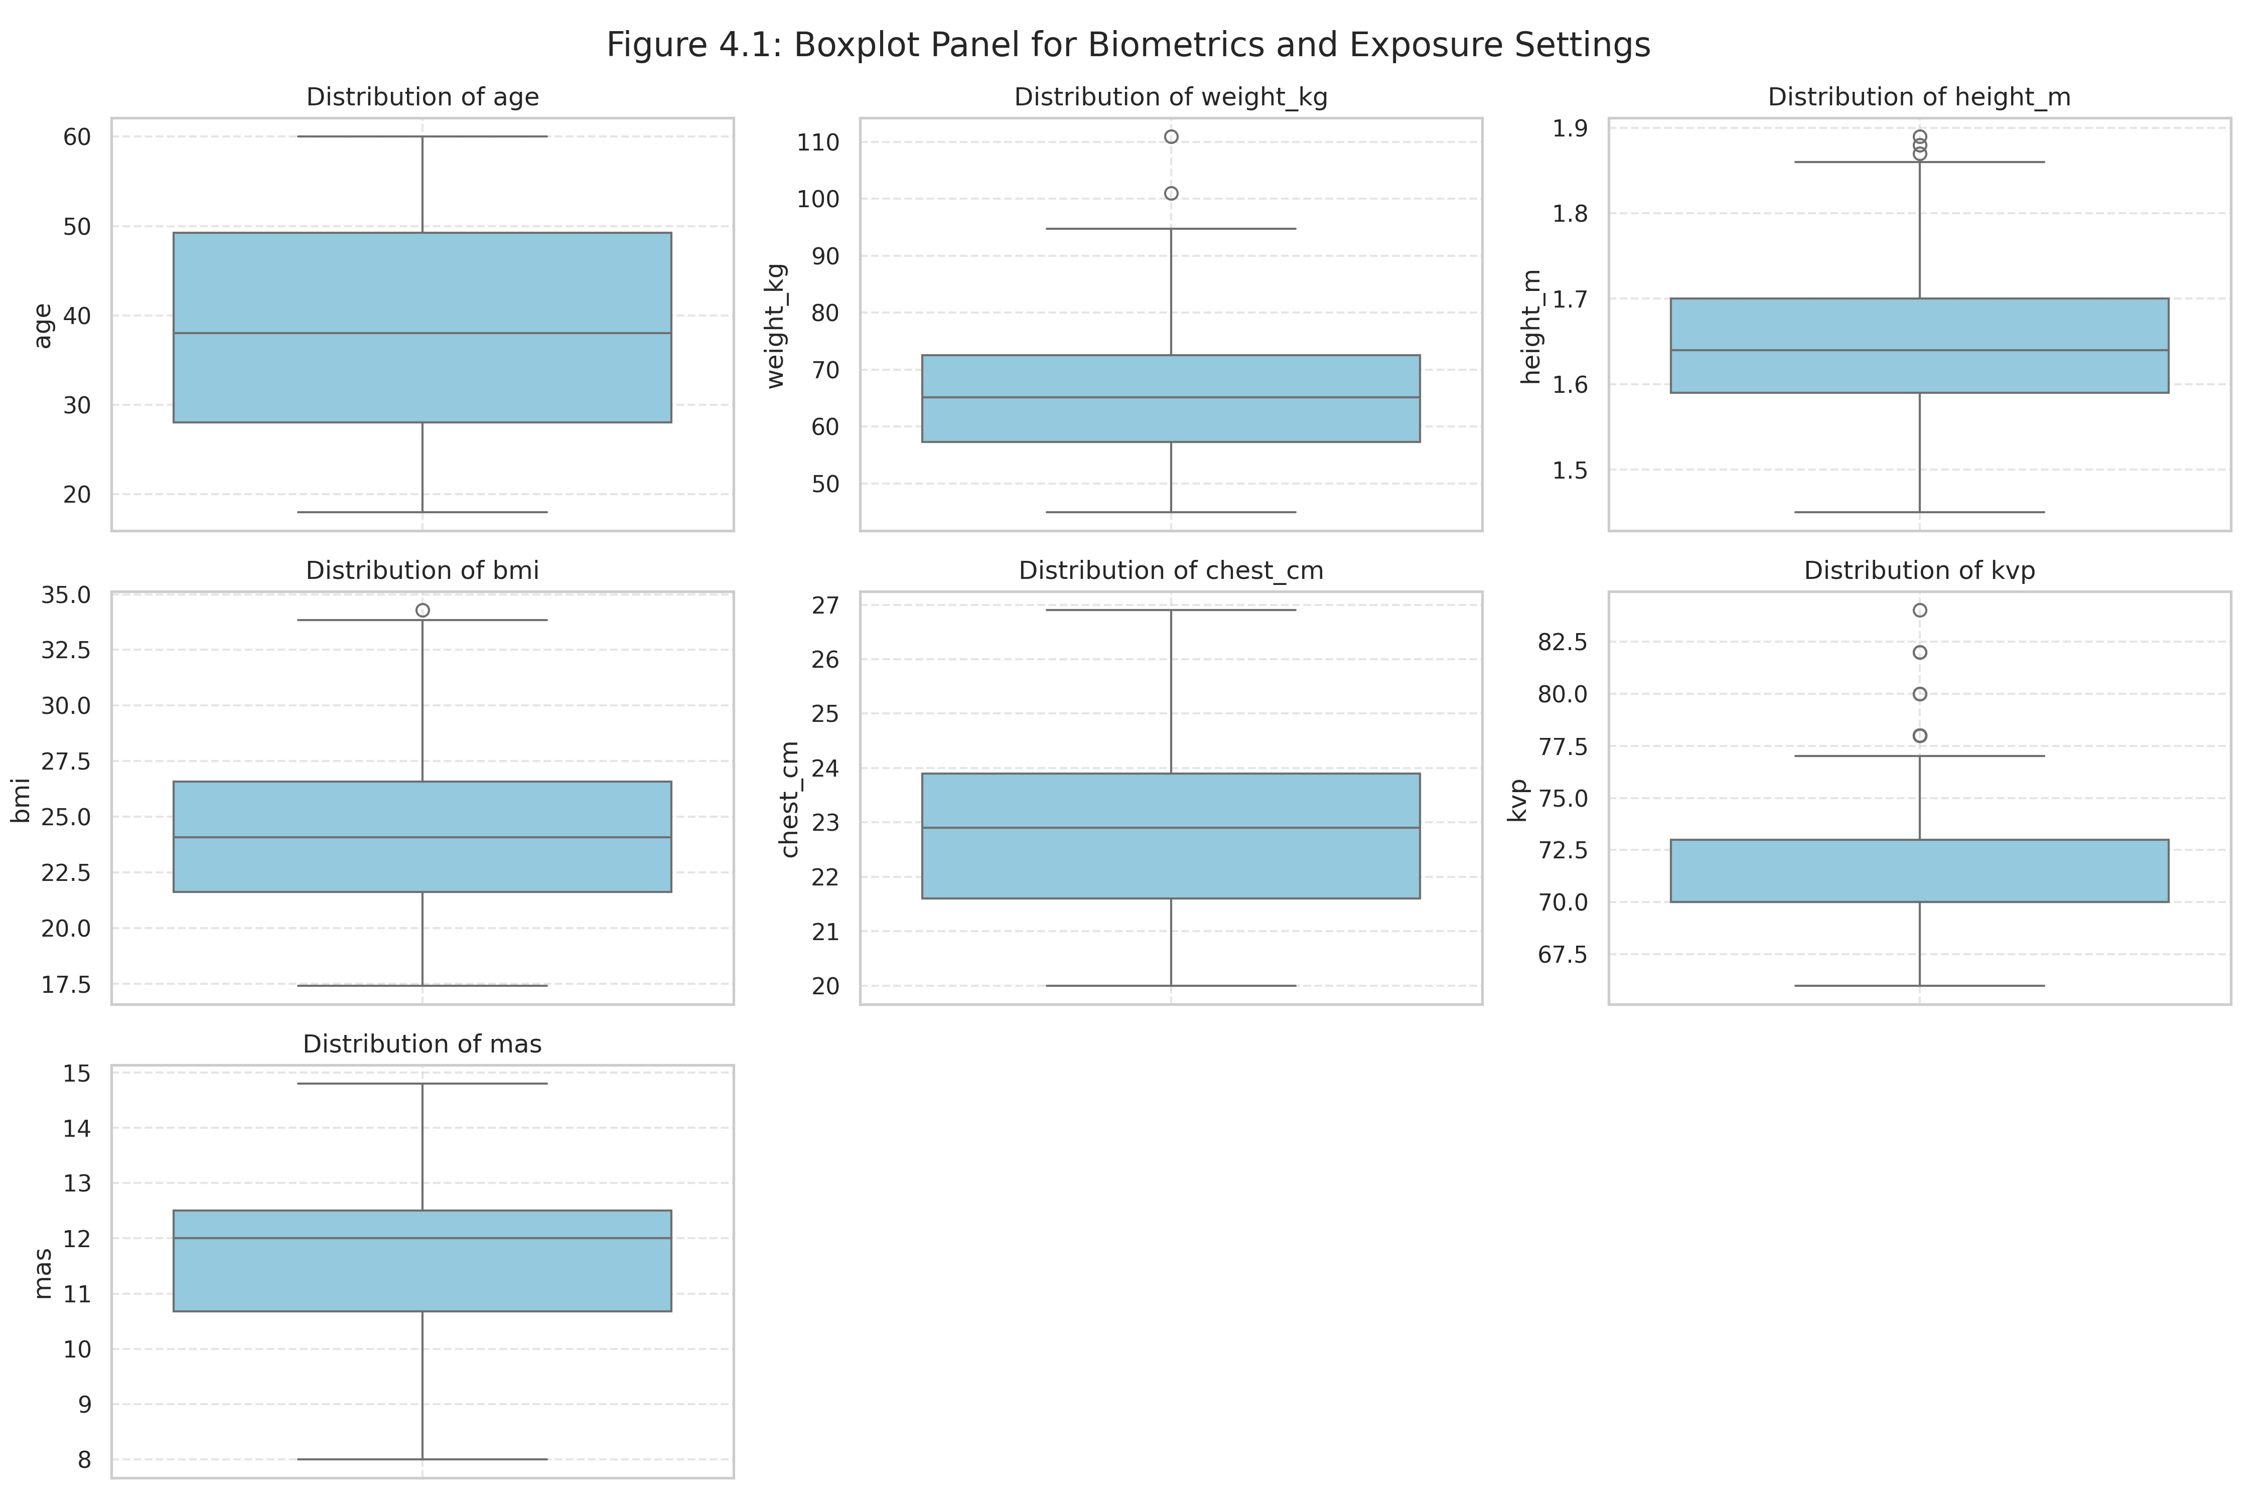
Caption: Boxplot panels representing biometrics and technical variables to detect outliers.

Table 4.2: Frequencies for Categorical Factors
Variable | Category | Frequency (n) | Percentage (%)
sex | Female | 154 | 51.33
sex | Male | 146 | 48.67
bmi_category | Normal Weight | 157 | 52.33
bmi_category | Overweight | 112 | 37.33
bmi_category | Underweight | 16 | 5.33
bmi_category | Obese | 15 | 5.0
exposure_label | Adequate | 258 | 86.0
exposure_label | Low | 34 | 11.33
exposure_label | Repeat required | 7 | 2.33
exposure_label | High | 1 | 0.33
Caption: Categorical frequency splits for sex, BMI category, and exposure labels.

Table 4.3: Stratified Exposure Target Means
Stratifier Variable | Subgroup | n | kVp Mean ± SD | mAs Mean ± SD
sex | Female | 154 | 71.77 ± 2.66 | 11.36 ± 1.42
sex | Male | 146 | 71.53 ± 2.36 | 11.54 ± 1.48
bmi_category | Normal Weight | 157 | 71.08 ± 1.44 | 11.23 ± 1.31
bmi_category | Obese | 15 | 75.27 ± 5.13 | 12.57 ± 1.30
bmi_category | Overweight | 112 | 72.17 ± 2.78 | 11.77 ± 1.45
bmi_category | Underweight | 16 | 70.31 ± 1.58 | 10.24 ± 1.69
age_group | 18 to 29 | 83 | 71.05 ± 1.85 | 11.24 ± 1.47
age_group | 30 to 44 | 100 | 71.63 ± 2.44 | 11.45 ± 1.51
age_group | 45 to 60 | 117 | 72.10 ± 2.90 | 11.60 ± 1.38
Caption: Stratification of kVp and mAs requirements across patient biometrics.

Figure 4.2
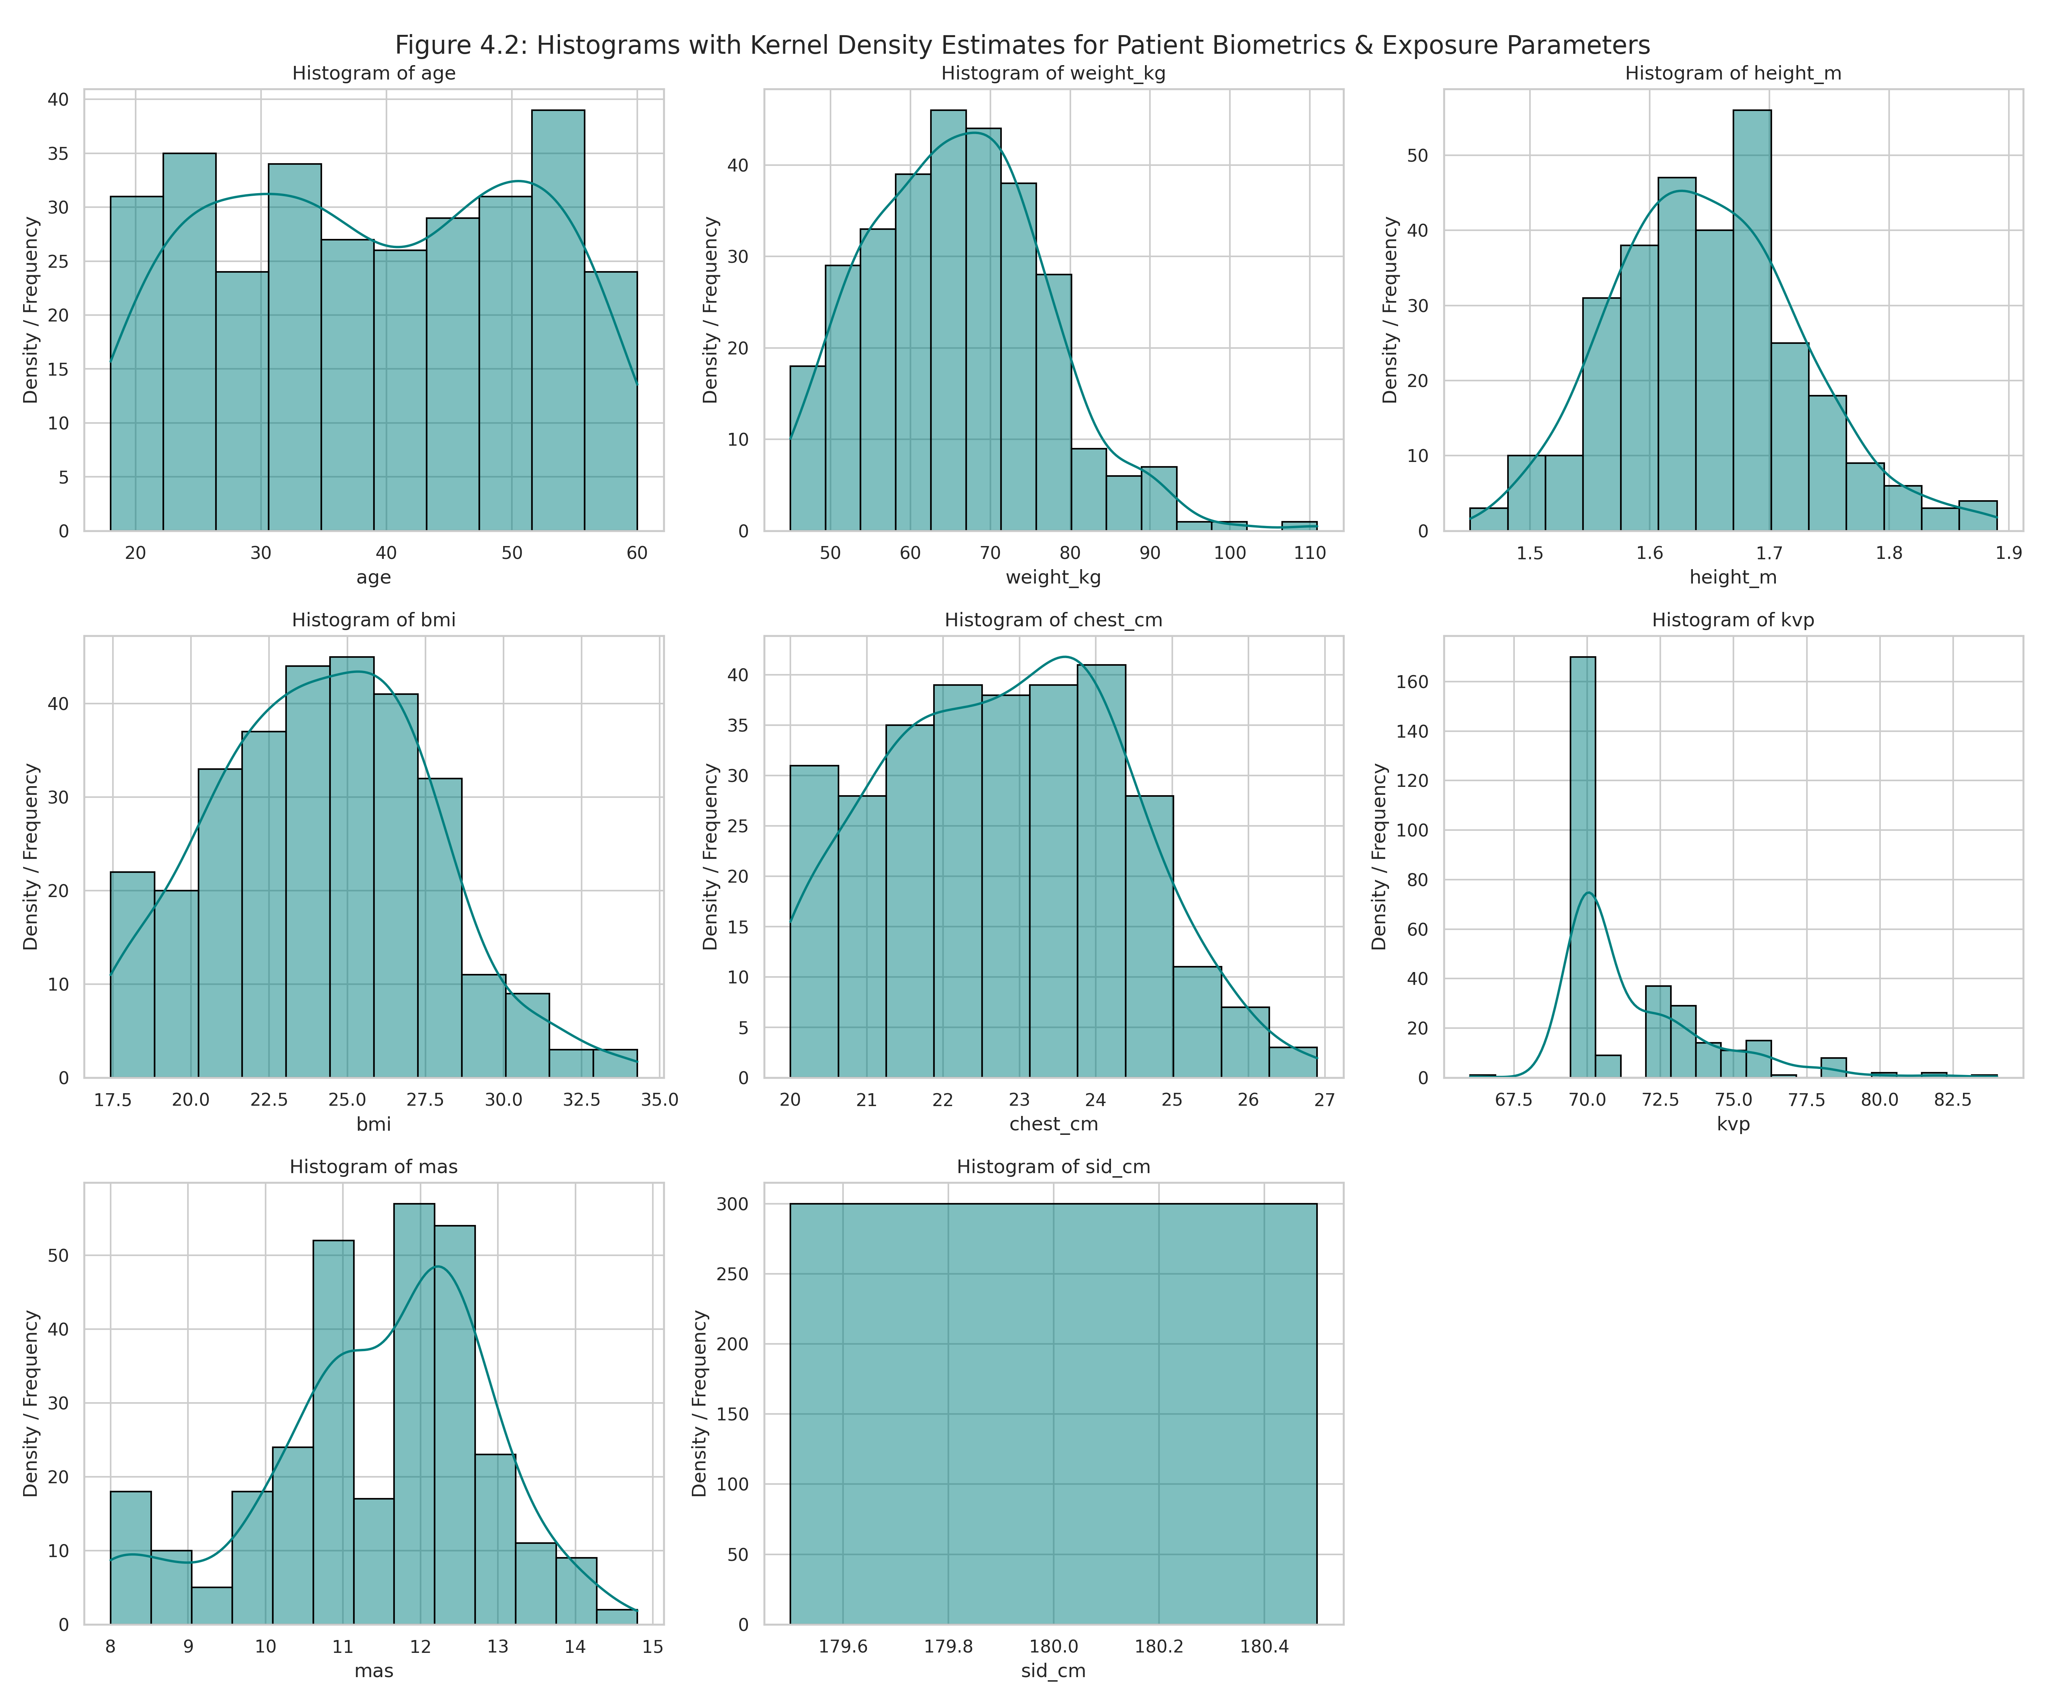
Caption: Diagnostic visual cohort trend distribution - Figure 4.2.

Figure 4.3
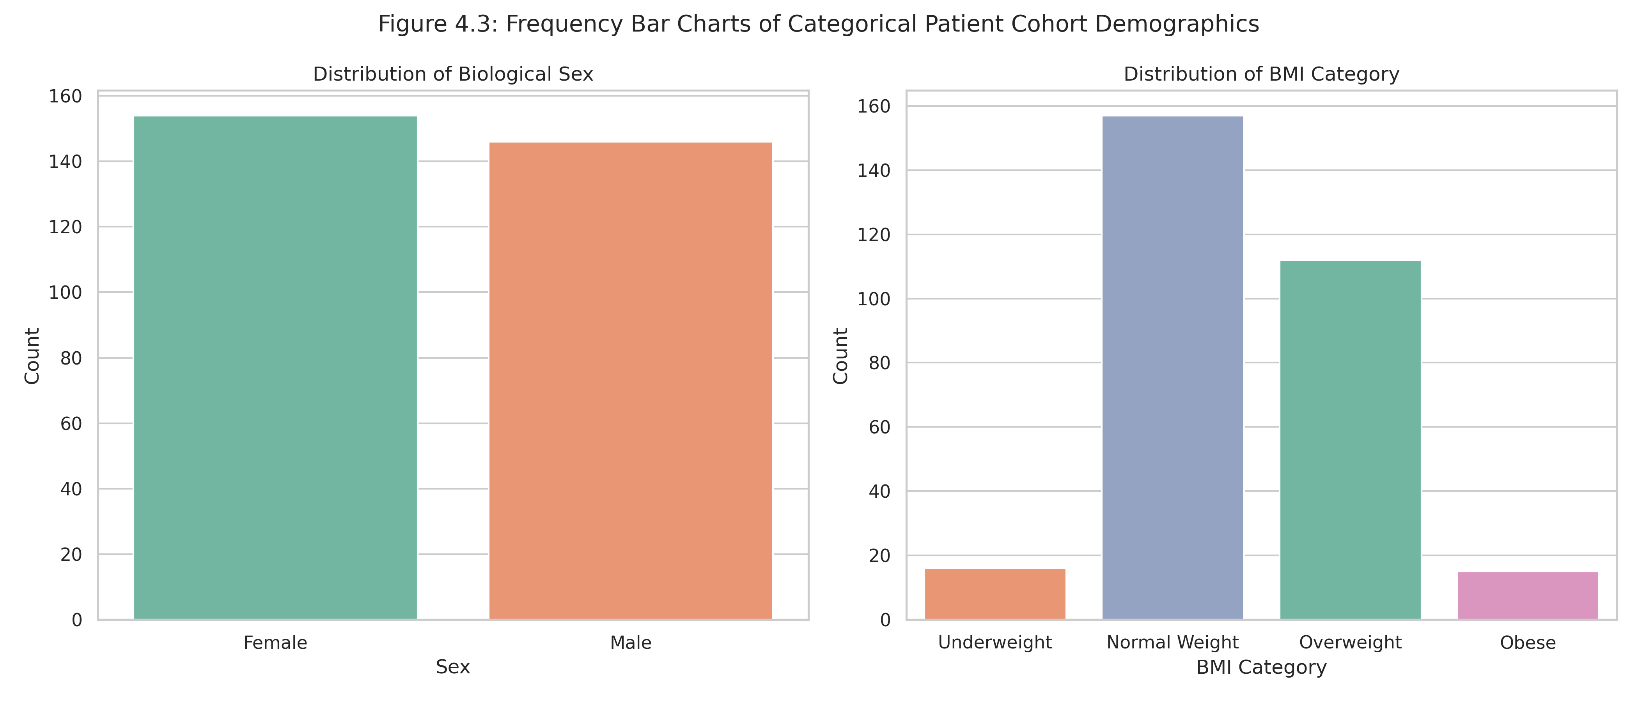
Caption: Diagnostic visual cohort trend distribution - Figure 4.3.

Figure 4.4
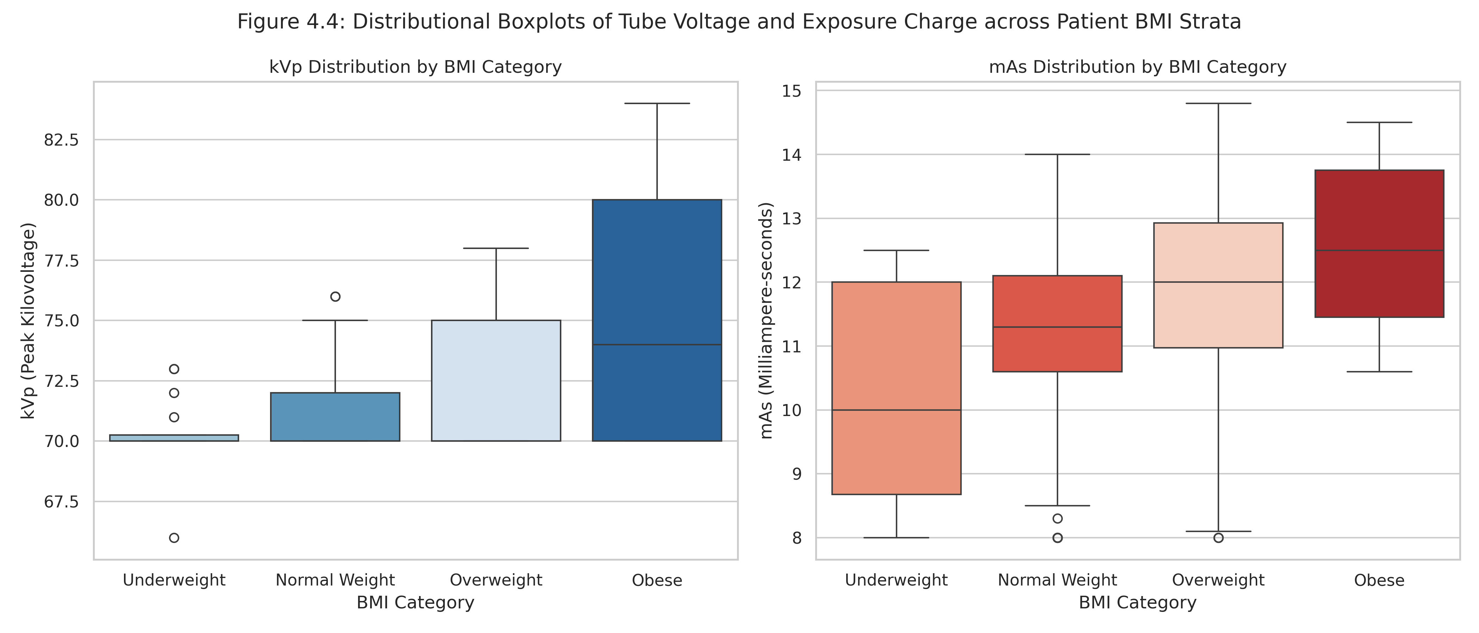
Caption: Diagnostic visual cohort trend distribution - Figure 4.4.

Figure 4.5
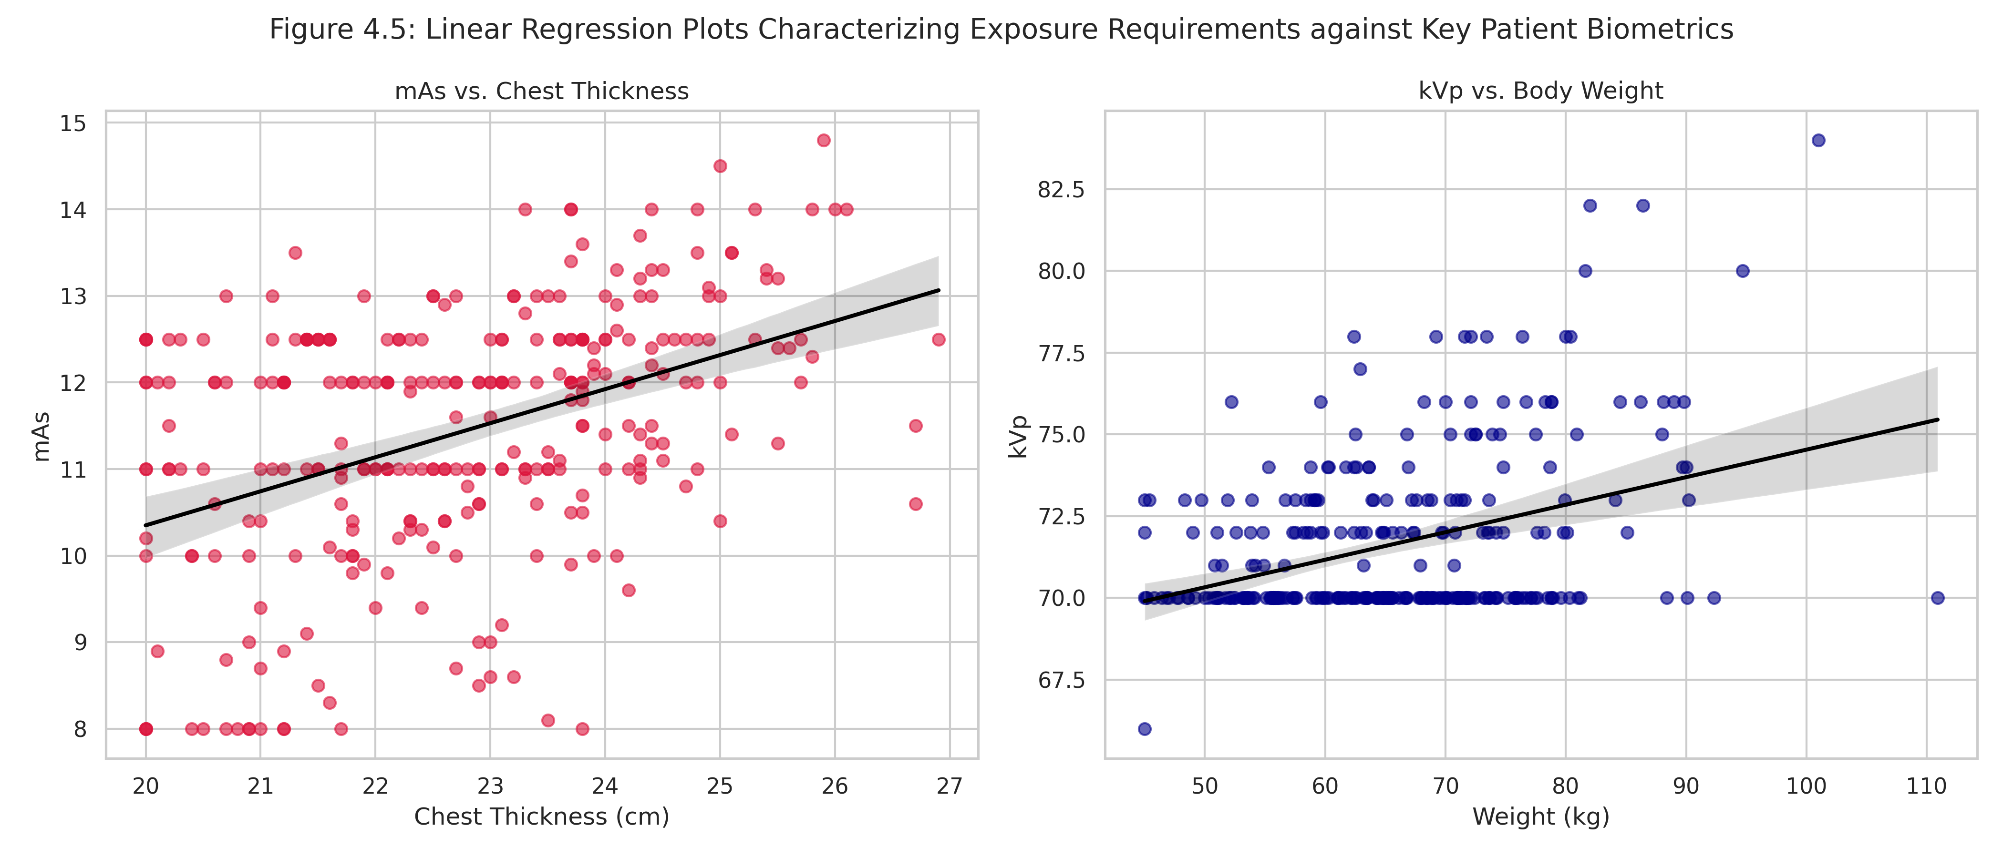
Caption: Diagnostic visual cohort trend distribution - Figure 4.5.

Table 4.4: Spearman Correlation Matrix (Holm Adjusted)
Variable 1 | Variable 2 | Spearman rho | 95% CI | Raw p-value | Holm Adj p-value | Significant
age | weight_kg | 0.2017 | [0.09, 0.31] | 0.0004408374643155994 | 0.003526699714524795 | Yes
age | height_m | -0.1238 | [-0.24, -0.01] | 0.032016143812603357 | 0.19012960523764877 | No
age | bmi | 0.3405 | [0.23, 0.44] | 1.4009185833530836e-09 | 2.1013778750296253e-08 | Yes
age | chest_cm | 0.219 | [0.11, 0.33] | 0.00013093740938660816 | 0.0013093740938660817 | Yes
age | kvp | 0.108 | [-0.01, 0.22] | 0.0616689023258134 | 0.19469698613368938 | No
age | mas | 0.1139 | [-0.00, 0.23] | 0.048674246533422345 | 0.19469698613368938 | No
weight_kg | height_m | 0.4962 | [0.40, 0.58] | 4.680694963959731e-20 | 8.425250935127516e-19 | Yes
weight_kg | bmi | 0.809 | [0.76, 0.85] | 9.485418362019562e-71 | 1.991937856024108e-69 | Yes
weight_kg | chest_cm | 0.5977 | [0.52, 0.67] | 1.925163194480464e-30 | 3.8503263889609283e-29 | Yes
weight_kg | kvp | 0.2552 | [0.14, 0.36] | 7.6156589520957824e-06 | 8.377224847305361e-05 | Yes
weight_kg | mas | 0.329 | [0.22, 0.43] | 5.292766786472529e-09 | 7.40987350106154e-08 | Yes
height_m | bmi | -0.0646 | [-0.18, 0.05] | 0.2647512147958763 | 0.2647512147958763 | No
height_m | chest_cm | 0.2786 | [0.17, 0.38] | 9.432780303604073e-07 | 1.1319336364324887e-05 | Yes
height_m | kvp | 0.1103 | [-0.01, 0.22] | 0.05642605968155067 | 0.19469698613368938 | No
height_m | mas | 0.1241 | [0.01, 0.24] | 0.03168826753960813 | 0.19012960523764877 | No
bmi | chest_cm | 0.511 | [0.42, 0.59] | 2.3630489371994508e-21 | 4.4897929806789565e-20 | Yes
bmi | kvp | 0.2182 | [0.10, 0.33] | 0.0001395481899875185 | 0.0013093740938660817 | Yes
bmi | mas | 0.2858 | [0.18, 0.39] | 4.780788723789693e-07 | 6.2150253409266005e-06 | Yes
chest_cm | kvp | 0.1404 | [0.02, 0.25] | 0.014920507845827356 | 0.10444355492079149 | No
chest_cm | mas | 0.4072 | [0.31, 0.50] | 2.0560115839717905e-13 | 3.289618534354865e-12 | Yes
kvp | mas | 0.4377 | [0.34, 0.53] | 1.78877893929178e-15 | 3.040924196796026e-14 | Yes

Figure 4.6: Spearman Rank Heatmap
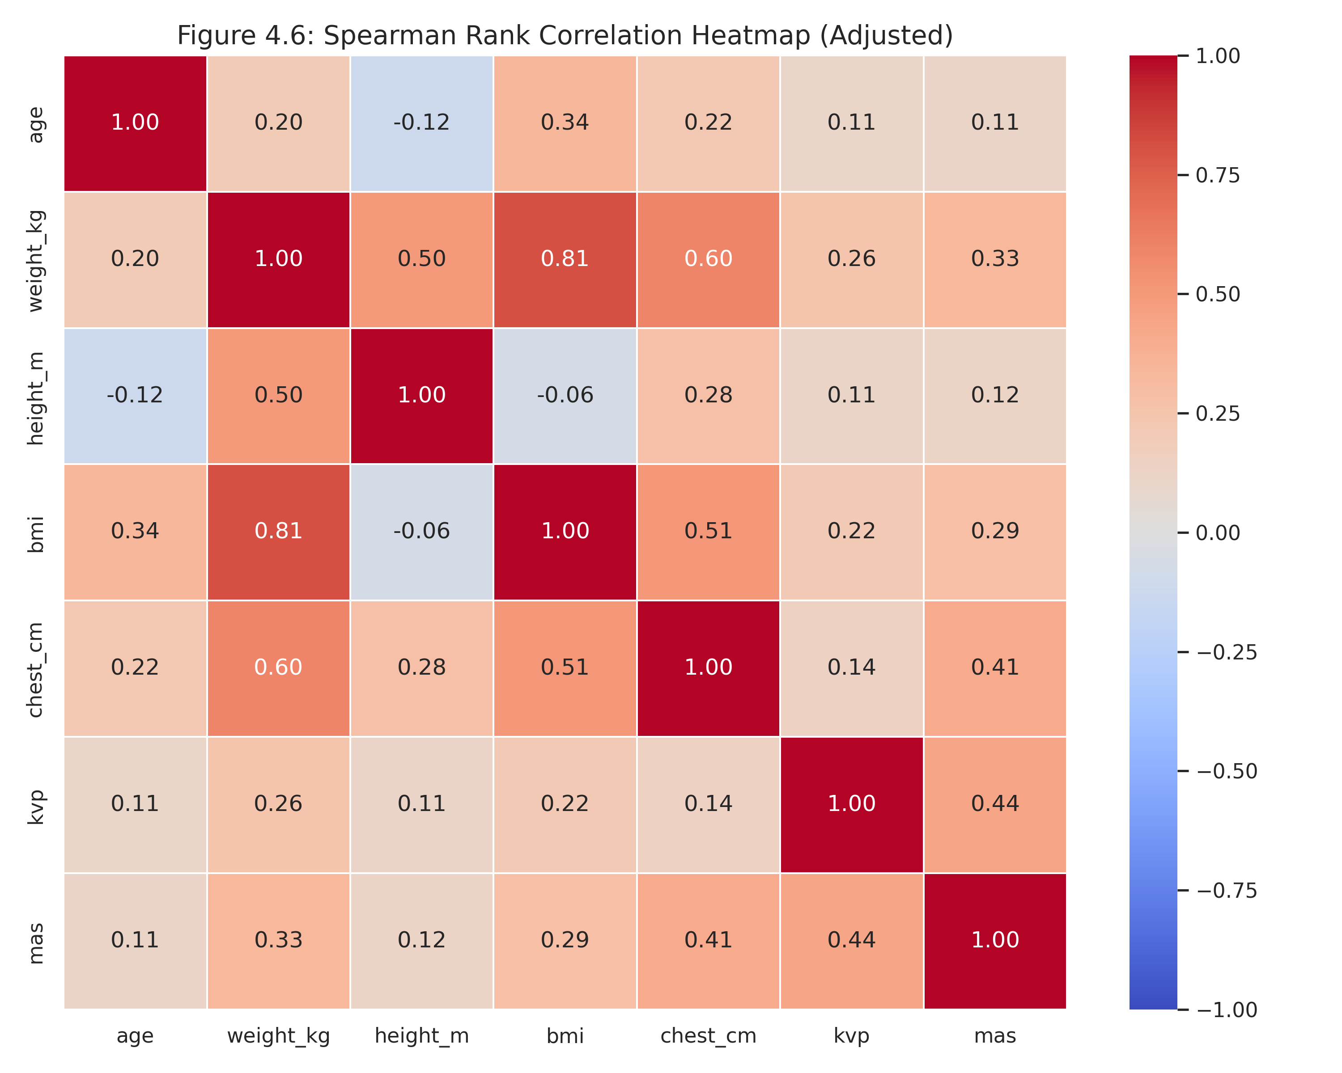

Table 4.5: OLS Multiple Regression Coefficients
Predictor | Beta (Coefficient) | SE | t-stat | p-value | Lower CI (95%) | Upper CI (95%) | Model Target | R-squared | Adj R-squared | F-p-value
const | 67.7257 | 4.0930 | 16.5466 | 0.0000 | 59.6703 | 75.7810 | kVp | 0.1652 | 0.1510 | 0.0000
age | 0.0172 | 0.0118 | 1.4543 | 0.1469 | -0.0061 | 0.0405 | kVp | 0.1652 | 0.1510 | 0.0000
weight_kg | 0.0953 | 0.0177 | 5.3986 | 0.0000 | 0.0606 | 0.1300 | kVp | 0.1652 | 0.1510 | 0.0000
height_m | -0.6140 | 2.3728 | -0.2587 | 0.7960 | -5.2839 | 4.0560 | kVp | 0.1652 | 0.1510 | 0.0000
chest_cm | -0.0741 | 0.1096 | -0.6760 | 0.4996 | -0.2898 | 0.1416 | kVp | 0.1652 | 0.1510 | 0.0000
sex_male | -0.6279 | 0.3156 | -1.9892 | 0.0476 | -1.2491 | -0.0067 | kVp | 0.1652 | 0.1510 | 0.0000
const | 3.8444 | 2.3213 | 1.6561 | 0.0988 | -0.7241 | 8.4129 | mAs | 0.1925 | 0.1788 | 0.0000
age | 0.0012 | 0.0067 | 0.1773 | 0.8594 | -0.0120 | 0.0144 | mAs | 0.1925 | 0.1788 | 0.0000
weight_kg | 0.0197 | 0.0100 | 1.9670 | 0.0501 | -0.0000 | 0.0394 | mAs | 0.1925 | 0.1788 | 0.0000
height_m | -0.5763 | 1.3457 | -0.4282 | 0.6688 | -3.2248 | 2.0722 | mAs | 0.1925 | 0.1788 | 0.0000
chest_cm | 0.3177 | 0.0622 | 5.1115 | 0.0000 | 0.1954 | 0.4401 | mAs | 0.1925 | 0.1788 | 0.0000
sex_male | -0.0604 | 0.1790 | -0.3373 | 0.7361 | -0.4127 | 0.2919 | mAs | 0.1925 | 0.1788 | 0.0000

Figure 4.7: Regression Residual Diagnostic Plots
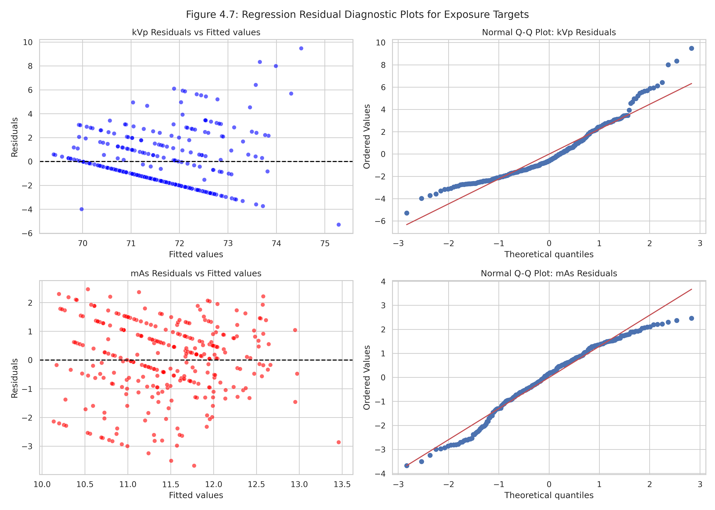

Table 4.6: Model Cross-Validation and Comparison (Panel A & B)
Model | CV MAE (Mean ± SD) | Train MAE | Test MAE | Test RMSE | Test R²
Mean Baseline | 1.9922 ± 0.2348 | 1.9749 | 2.1966 | 2.7766 | -0.0002
Linear Regression | 1.8950 ± 0.2310 | 1.8271 | 2.0066 | 2.4705 | 0.2082
Ridge Regression | 1.8781 ± 0.2343 | 1.8252 | 2.0186 | 2.4748 | 0.2054
Random Forest | 1.9626 ± 0.2515 | 1.3237 | 1.9499 | 2.3666 | 0.2734
Gradient Boosting | 1.9114 ± 0.2372 | 1.7670 | 2.0701 | 2.4723 | 0.2070
MLP Neural Network | 8.6062 ± 0.8227 | 7.3674 | 6.8477 | 8.6935 | -8.8048

Figure 4.8
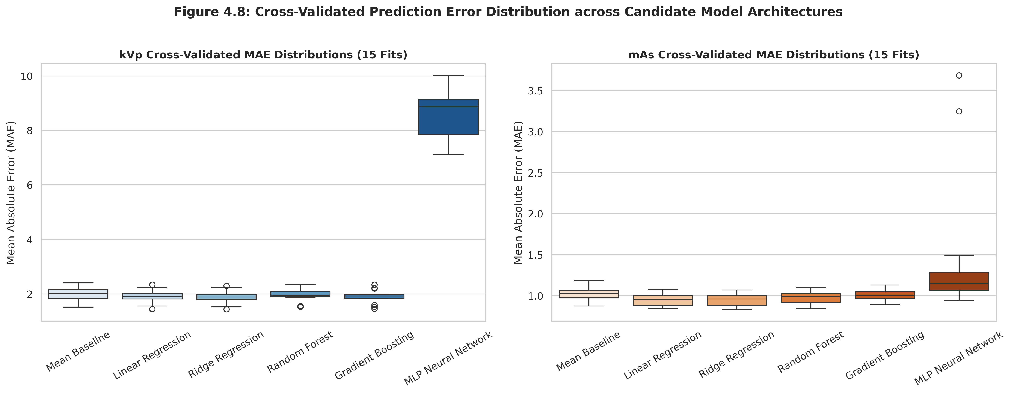

Figure 4.9
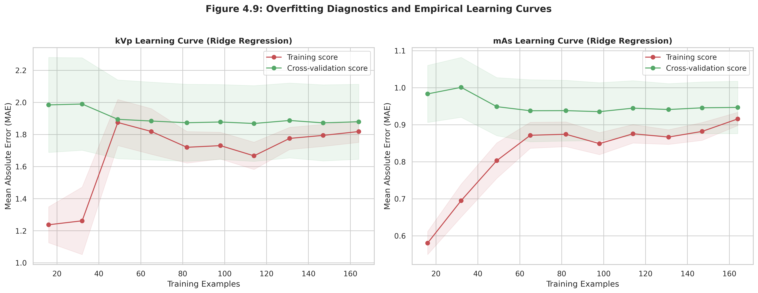

Table 4.7: Final Selected Models Bootstrap Accuracy Bounds
Target | Model | Test MAE | Test MAE 95% CI | Test RMSE | Test RMSE 95% CI | Test R2 | Test R2 95% CI | Test MAPE (%) | Test MAPE 95% CI | Lin CCC
kvp | Mean Baseline | 2.1966 | [1.79, 2.64] | 2.7766 | [2.12, 3.39] | -0.0002 | [-0.11, -0.00] | 2.9943 | [2.48, 3.55] | -0.0
kvp | Linear Regression | 2.0066 | [1.63, 2.40] | 2.4705 | [2.00, 2.91] | 0.2082 | [-0.13, 0.39] | 2.7459 | [2.26, 3.26] | 0.3269
kvp | Ridge Regression | 2.0186 | [1.65, 2.42] | 2.4748 | [2.00, 2.92] | 0.2054 | [-0.13, 0.38] | 2.7622 | [2.28, 3.27] | 0.313
mas | Mean Baseline | 0.9237 | [0.72, 1.14] | 1.1866 | [0.93, 1.42] | -0.0097 | [-0.13, -0.00] | 8.4022 | [6.39, 10.72] | 0.0
mas | Linear Regression | 0.9361 | [0.76, 1.12] | 1.1555 | [0.93, 1.37] | 0.0426 | [-0.24, 0.20] | 8.5248 | [6.63, 10.59] | 0.1828
mas | Ridge Regression | 0.9246 | [0.75, 1.11] | 1.1438 | [0.92, 1.35] | 0.0618 | [-0.21, 0.21] | 8.4238 | [6.56, 10.47] | 0.1901

Figure 4.10
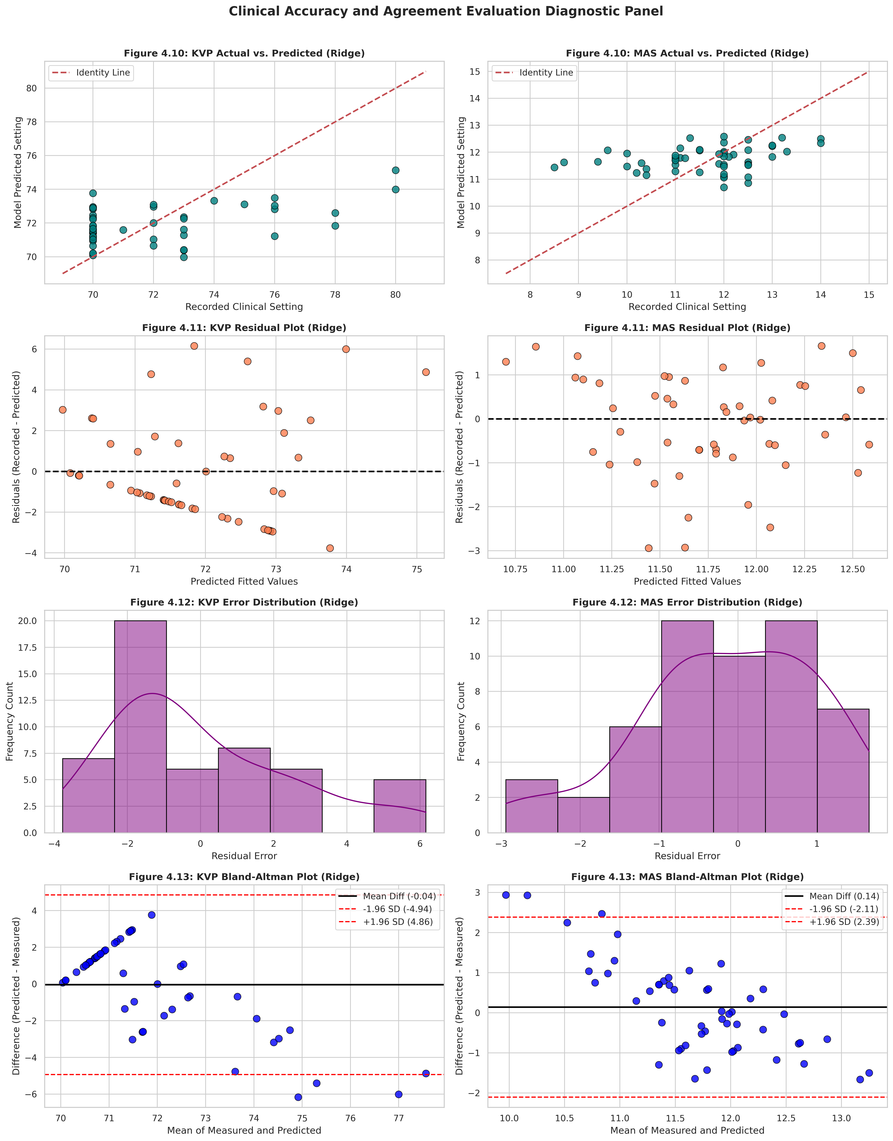

Figure 4.11

Figure 4.12

Figure 4.13

Table 4.9: Permutation Feature Importances with 95% CIs
Target | Predictor | Importance (Mean MAE Decrease) | 95% CI | SD
kVp | sex_encoded | 0.0035 | [0.0000, 0.0078] | 0.0219
kVp | age | 0.0242 | [0.0156, 0.0327] | 0.0436
kVp | weight_kg | 0.1234 | [0.1086, 0.1383] | 0.0758
kVp | height_m | 0.0413 | [0.0371, 0.0455] | 0.0214
kVp | bmi | 0.0355 | [0.0233, 0.0477] | 0.0622
kVp | chest_cm | 0.0364 | [0.0296, 0.0432] | 0.0346
mAs | sex_encoded | -0.0023 | [0.0000, -0.0011] | 0.0062
mAs | age | -0.0012 | [0.0000, -0.0002] | 0.0049
mAs | weight_kg | 0.0149 | [0.0126, 0.0171] | 0.0113
mAs | height_m | -0.0033 | [0.0000, -0.0028] | 0.0027
mAs | bmi | 0.0116 | [0.0074, 0.0158] | 0.0216
mAs | chest_cm | -0.0008 | [0.0000, 0.0069] | 0.0391

Figure 4.14
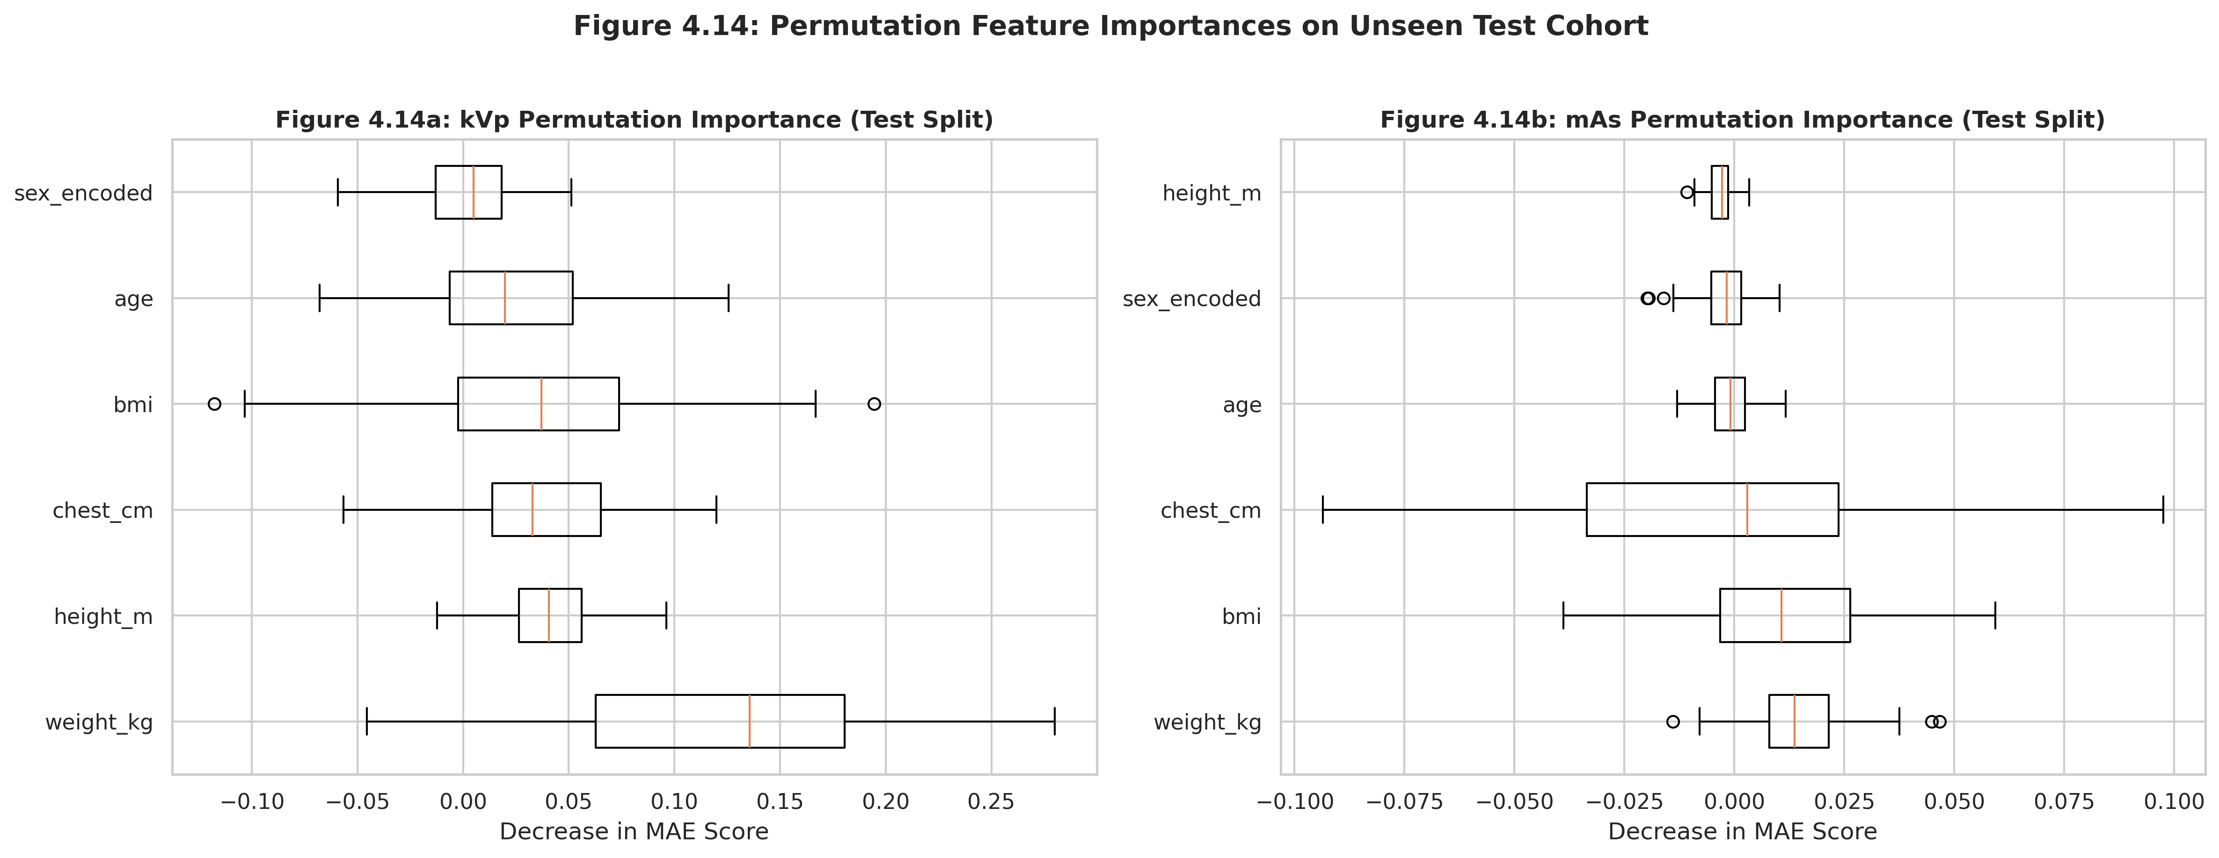

Figure 4.15
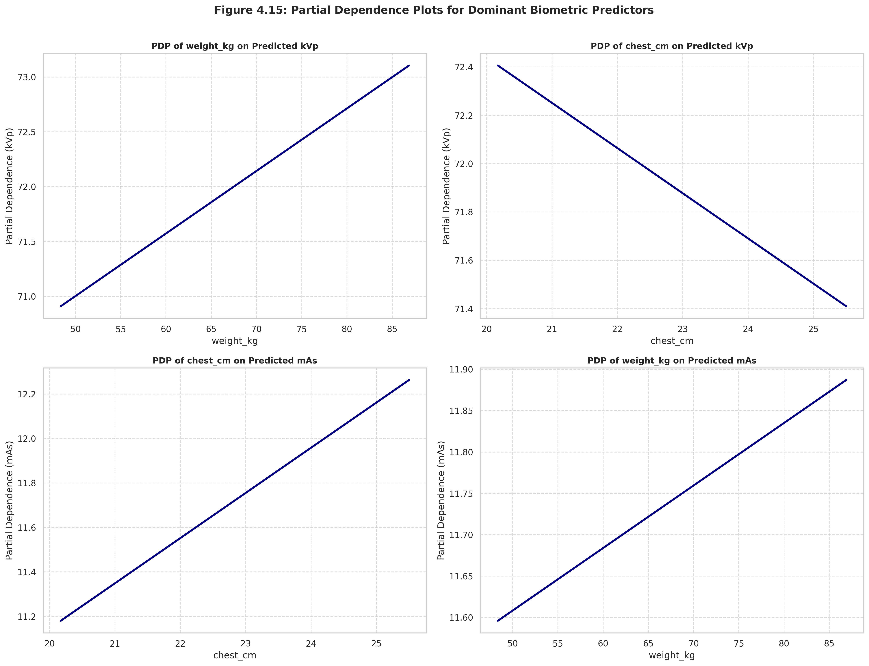

Figure 4.16
