

EÖTVÖS LORÁND UNIVERSITY
FACULTY OF INFORMATICS
DEPARTMENT OF PROGRAMMING LANGUAGES AND COMPILERS

SAGE
(Sales, Availability and Growth/Insights Engine)

Supervisor:
Morse Gregory Reynolds
Lecturer

Author:
Tekerek Ahmet Baybars
Computer Science BSc

CONTENTS
Contents
CONTENTS 1
1 INTRODUCTION 2
1.1 Project Objectives 3
1.2 Background and Motivation 3
1.3 Contributions 4
1.4 Outline 4
2 USER DOCUMENTATION 6
2.1 System Overview 7
2.1.1 Target Users 7
2.1.2 High-Level Workflow 8
2.2 System Requirements 9
2.2.1 Hardware Requirements 9
2.2.2 Software Requirements 10
2.3 Configuration and Installation 11
2.3.1 Environment Configuration 11
2.3.2 Installation Steps 11
3 DEVELOPER DOCUMENTATION 12
3.1 Design 13
3.1.1 Design Overview 13
3.1.2 Design Principles 13
3.1.3 Functional Requirements 13
3.1.4 Non-Functional Requirements 21
3.1.5 System Architecture 21
3.1.6 Behavioral Models 23
3.1.7 Data Design 26
3.1.8 Core Functionality Design 27
3.1.9 UI Architecture and Wireframes 30

INTRODUCTION
The modern retail ecosystem is built on the continuous, high-velocity exchange of transactional data across a broad set of operational domains. Effective retail management requires that sales operations, inventory control, cost accounting, and strategic analytics all share a consistent and up-to-date view of the business state. In current industrial practice, however, these responsibilities are typically delegated to a fragmented collection of independent platforms — a Point of Sale (POS) system, an Inventory Management System (IMS), and separate analytical reporting suites — each maintaining its own isolated data store.
The dominant paradigm underlying these systems is the "Current-State" or CRUD (Create, Read, Update, Delete) model, in which a relational database stores only the most recent value of any given domain object. When an inventory count changes, the previous value is overwritten. When a price is updated, the historical price is lost. This destructive write model treats the lifecycle of a product as a disconnected sequence of snapshots rather than a continuous, traceable flow of events. While adequate for basic record-keeping, this approach has a fundamental structural limitation: it cannot support the deterministic reconstruction of past system states. There is no reliable mechanism to answer the question of exactly what the inventory level was at a specific moment in the past, or which supplier delivery was responsible for the current cost-layer composition of a SKU.
This architectural fragmentation introduces what may be termed as an "informational inconsistency gap." Because isolated platforms do not derive their state from a unified data foundation, transactional data processed at the POS is not immediately reconciled against back-end inventory layers or supplier-specific cost structures. This "data lag" prevents management from observing, in real time, how price fluctuations or hidden logistics overheads affect profit margins as they occur. Furthermore, the absence of a shared event history makes it impossible to perform an auditable investigation of discrepancies between financial KPIs and their source documents.
To address these structural deficiencies, this thesis presents SAGE (Sales, Availability and Growth/Insights Engine), an integrated retail management platform constructed upon an Event-Sourced Architecture. Rather than performing destructive updates, SAGE encodes every operational change — every sale, every stock adjustment, every price modification — as an immutable event appended to a canonical event log. This log serves as the singular, authoritative source of truth for the entire system, from which all other views of the business state are derived through incremental projection.
The platform integrates three tightly coupled operational domains: a high-concurrency Point-of-Sale interface, an AI-driven logistics and invoice processing pipeline, and a strategic analytics and optimization layer. The analytical layer applies Mixed-Integer Linear Programming (MILP) to live inventory signals, producing mathematically optimized replenishment recommendations that minimize the risk of stockouts while constraining the capital tied up in surplus inventory. Together, these components form a unified platform that replaces fragmented software subscriptions with a single, traceable, and analytically powerful system.

Project Objectives
The primary objective of this thesis is to design and implement SAGE as a fully integrated, event-sourced retail management platform. The system is intended to unify the currently fragmented landscape of point-of-sale processing, inventory valuation, logistics automation, and strategic analytics into a single, coherent environment in which all state transitions are derivative of an underlying, immutable event stream.
The specific technical objectives are organized around the four conceptual pillars encoded in the project's name:
- Sales — To design a high-concurrency transactional interface that ensures every retail operation is immediately encoded into the canonical event stream without data loss or latency. This interface must support atomic cart operations, role-differentiated access, and real-time session recovery.
- Availability — To implement a layered inventory valuation engine that maintains the explicit relationship between specific stock intake batches and subsequent sales outflows, thereby enabling near-real-time Cost of Goods Sold (COGS) computation using First-In-First-Out (FIFO) and weighted-average costing methodologies.
- Growth and Insights — To provide a strategic intelligence layer that transforms live inventory consumption signals into actionable purchasing recommendations through the application of a Mixed-Integer Linear Programming (MILP) optimization model, subject to practical business constraints such as minimum order quantities, budget ceilings, and supplier lead times.
- Engine — To construct a robust and supplier-agnostic invoice understanding pipeline that automates inventory intake through a machine-learning-based document parsing component, incorporating confidence scoring and a human-in-the-loop review workflow to maintain data reliability at the point of entry into the event log.

Background and Motivation
The motivation for SAGE originates from a close examination of the limitations inherent to the traditional Current-State database paradigm that underpins most commercial retail software. In standard CRUD-based systems, a database record represents only the current state of a domain object. Any prior state is irreversibly overwritten the moment an update is committed. This architecture is fundamentally incompatible with several requirements that are critical to modern retail operations.
First, the inability to deterministically replay past states makes auditable historical KPI regeneration impossible. A manager who needs to understand why the reported gross margin on a particular day differed from expectations cannot trace the discrepancy back to individual transactions or specific cost layers, because the intermediate states that produced those results no longer exist in the database. Second, the siloed nature of traditional architectures means that inventory costs as recorded in the IMS are typically not synchronized with the costs used to compute margins in the reporting suite, creating a structural inconsistency that persists for as long as these systems remain disconnected.
Event Sourcing addresses these limitations by treating an append-only event log as the primary data source. System state is never stored directly; instead, it is computed on demand by replaying the sequence of events that produced it. This preserves the complete operational history of the system, supports point-in-time state reconstruction, and yields a natural audit trail with no additional engineering effort. The pattern was selected for SAGE because it aligns precisely with the auditability, traceability, and real-time synchronization requirements of the target domain.
A secondary motivation concerns the logistics workflow. Supplier invoice processing in traditional retail is a labor-intensive, error-prone manual task: an operator reads an invoice, transcribes product names, quantities, and unit costs into the IMS, and reconciles the results against a purchase order. Errors propagate directly into inventory valuations and margin calculations. A document understanding component capable of extracting structured data from diverse invoice formats is therefore a data integrity requirement, not an optional convenience. The event-sourced architecture depends on clean, accurate data at its point of entry.
Finally, the replenishment problem in retail has a well-established mathematical structure. Inventory managers must weigh the cost of understocking — lost sales, customer dissatisfaction — against the cost of overstocking — capital lockup, waste, storage overhead. Simple reorder-point rules break down when multiple SKUs, variable lead times, and budget constraints must be considered at once. Mixed-Integer Linear Programming offers a rigorous framework for this problem and embedding it in a live data platform turns it from a periodic planning exercise into a continuously updated decision aid.

Contributions
This thesis makes the following principal contributions:
- An Event-Sourced Retail Architecture: The design and implementation of a canonical event stream as the sole source of truth for a retail management system, enabling deterministic state reconstruction, historical KPI regeneration, and a complete, unalterable audit trail of all operational changes.
- A Layered Inventory Valuation Engine: A non-destructive costing mechanism that maintains an explicit and traceable link between individual inventory intake batches and their subsequent consumption through sales, supporting both FIFO and weighted-average valuation methods and producing near-real-time COGS and gross margin metrics.
- An Intelligent Invoice Processing Pipeline: A multi-stage document understanding component that applies machine-learning-based layout analysis and OCR to extract structured data from diverse supplier invoice formats, augmented by a confidence-scored human-in-the-loop review workflow to handle uncertain cases and preserve data integrity.
- A MILP-Based Replenishment Optimization Module: The formulation and integration of a Mixed-Integer Linear Programming model that consumes live inventory consumption and stock-level signals to produce mathematically optimized order quantity recommendations, subject to constraints on budget, minimum order quantities, and supplier lead times.

Outline
The remainder of this thesis is structured as follows:
- Chapter 2: User Documentation serves as a functional guide to the SAGE platform. It defines the target user personas, hardware and software prerequisites, and provides a comprehensive walkthrough of the system’s dual environments. This chapter focuses on the operation flow of the POS interface and the Management Dashboard without delving into the underlying technical mechanics.
- Chapter 3: Developer Documentation constitutes the core technical and architectural specification of the project. It is divided into two primary segments:
  - The Design Phase: A strictly conceptual analysis of the system architecture, including Object-Oriented Modeling (OOM) with four types of UML diagrams, the Object-Oriented Design (OOD) patterns, the relational database schema (ERD), and the mathematical formulation of the MILP replenishment and AI extraction modules.
  - The Implementation Phase: A detailed description of the concrete realization of the platform, detailing the choice of programming languages, the structure of the canonical event store, and the deployment of incremental view maintenance logic.
- Chapter 4: Testing and Validation presents the methodologies utilized to verify the system. This includes testing the deterministic replay capabilities of the event store, the accuracy of the FIFO valuation engine, and the precision of the AI-driven invoice parsing pipeline.
- Chapter 5: Conclusion summarizes the development results, reflects on the challenges of implementing an event-sourced architecture in a retail context, and suggest future research directions.

USER DOCUMENTATION
This chapter provides a comprehensive functional reference for the SAGE platform, addressed to individuals who will interact with the system daily. It describes the target user population, the conceptual workflow that governs the system’s operation, the hardware and software environment required to deploy it, and a detailed walkthrough of each user-facing interface.

System Overview
SAGE (Sales, Availability and Growth/Insights Engine) is an integrated retail management platform designed to consolidate the three operational domains that most retail businesses currently manage through separate, unconnected software tools: sales transaction processing, inventory control and cost accounting, and strategic analysis and replenishment planning. Rather than synchronizing these domains through periodic batch exports or manual reconciliation, SAGE unifies them through a single canonical event stream, ensuring that every operational system — a completed sale, an approved supplier delivery or a price adjustment — is immediately reflected across all views of the system.
From a user perspective, SAGE is organized around three core concepts:
- Events: Every atomic action in the business is recorded as an immutable event. This includes completed sales, stock intake from supplier deliveries, manual stock adjustments, and price overrides. The event log is the permanent record of everything that has happened in the system; no information is ever overwritten or deleted. This eliminates the reconciliation effort that arises when separate systems hold conflicting versions of the same data.
- Inventory Layers: When a supplier delivery is recorded, the system creates a cost layer that associates a specific quantity of a product with its exact acquisition cost at that moment in time. When a sale occurs, the system deducts stock from the oldest available layers first, following the First-In-First-Out Principle. This approach ensures that the cost figure used to compute profit margins always reflects the actual acquisition cost of the specific items sold, rather than a generic average.
- Insights: The platform continuously analyzes the event stream to produce actionable business intelligence. This includes real-time profit margin tracking that updates with every sale, stock aging alerts that flag inventory at risk of expiration, and mathematically optimized replenishment recommendations that tell the manager precisely how much of each product to order and when.

Target Users
The SAGE platform is designed to serve three distinct user populations, each with a different operational context and a different set of system privileges.
- Floor Staff (Operations Personnel): Employees who are responsible for front-end sales operations. Their primary interaction with the system is through the Point-of-Sale interface, where they process customer transactions. They do not require access to financial data, inventory cost information, or the management dashboard. Their accounts are provided with read access to the product catalog and write access to the sales event stream only.
- Managers and Business Owners: Decision-makers who are responsible for the strategic and financial health of the business. They interact primarily with the Management Dashboard to review real-time KPIs, approve or reject AI-processed supplier invoices, monitor inventory aging and waste risk, and execute replenishment strategies. They require full read access across all system projections and write access to the invoice approval and replenishment modules.
- System Administrators: Technical users responsible for the operational health of the platform itself. They configure AI thresholds, manage user accounts and role assignments, oversee the integrity of the event store and projection tables, and monitor system performance. They hold unrestricted access to all system modules, including diagnostic and configuration interfaces that are not visible to other user roles.

High-Level Workflow
The end-to-end workflow of SAGE is designed to convert raw operational actions into continuous business intelligence through five sequential stages:
- Transaction Processing: Floor staff record customer sales through the POS interface. Each completed transaction is atomized and appended to the canonical event stream as a SaleEvent. This event immediately triggers updates to the stock-level projection and the financial summary projection, ensuring that the management dashboard reflects the state of the business near-real-time.
- Logistics Automation and Invoice Ingestion. When a supplier delivery arrives, the manager uploads the corresponding invoice document through the Management Dashboard. The AI-driven processing pipeline parses the document, identifies product names, quantities, and unit costs, and presents the results in a structured review interface. This eliminates the need for manual data entry, and the transcription errors it introduces.
- Financial Update and Cost Layer Creation. Once the manager approves the extracted invoice data, the system appends an InventoryIntakeEvent to the event stream. This event creates a new cost layer in the inventory valuation engine, recording the specific quantity and unit cost of the delivery. From this point forward, outgoing sales will be matched against this layer (and earlier layers, in FIFO order), enabling precise COGS computation for every transaction.
- Demand Analysis and Replenishment Optimization. The system continuously monitors consumption rates derived from the event stream. As stock levels approach configurable reorder thresholds, the optimization engine formulates a replenishment problem and solves it using Mixed-Integer Linear Programming, producing a set of recommended order quantities that balance stockout risk against the cost of holding excess inventory.
- Review and Strategic Decision Making. The manager reviews automated reorder suggestions, current profitability metrics, and stock aging alerts through the unified dashboard. The system shifts the manager's role from reactive trouble-shooting — responding to stockouts after they occur — to proactive planning, supported by a complete and accurate view of the business state.

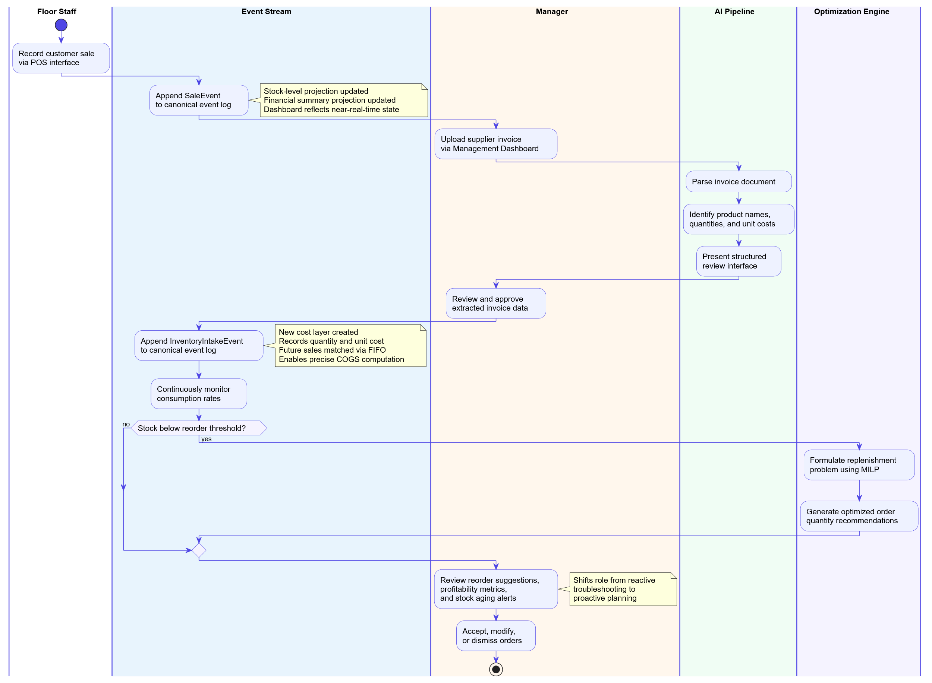
Figure 2-1: High-Level Workflow Diagram — five-stage operational flow from transaction processing through logistics automation, cost layer creation, and replenishment optimization to strategic decision-making.

System Requirements
SAGE is a distributed web application whose components -the backend API, the relational database, the AI invoice processing pipeline, and the frontend interface- may be deployed on a single host machine or distributed across separate servers depending on the expected transaction volume. The requirements specified in this section describe a single-host deployment suitable for a small to medium-sized retail operation.

Hardware Requirements
The following hardware specifications are necessary to support the concurrent execution of all system components with acceptable latency.
- Processor: Minimum 4 cores at 2.0 GHz; recommended 8 cores at 3.0 GHz or higher. The AI invoice pipeline executes OCR and ML-based layout analysis concurrently with the backend API, making this the most CPU-bound workload in the system. Higher core counts directly reduce pipeline latency during invoice processing.
- Memory: Minimum 8 GB; recommended 16 GB or more. The MILP solver holds the full inventory signal dataset in working memory while formulating the replenishment problem, and the AI pipeline maintains intermediate OCR buffers simultaneously. Both components are resident in memory concurrently during peak operation.
- Storage type: Minimum HDD at 7200 RPM; recommended NVMe SSD. The event store's access pattern is dominated by sequential appends and indexed range reads, both of which are sensitive to random-access latency. SSD significantly reduces projection rebuild time following a failure.
- Storage capacity: Minimum 20 GB; recommended 50 GB or more. Event log growth is linear with transaction volume — a retail environment processing approximately one thousand transactions per day can expect 50–100 MB of growth per month depending on average line items per transaction.
- Network: Minimum 100 Mbps LAN; recommended Gigabit LAN. The WebSocket hub maintains persistent real-time connections to all active Dashboard and POS clients simultaneously, meaning sustained bidirectional traffic scales with the number of concurrent sessions.

Software Requirements
The system is designed to be cross-platform at the operating system level. The following software components must be installed and properly configured on the host machine before the platform can be deployed:
- Operating system: Windows 10/11, macOS Monterey or later, or Ubuntu 22.04 LTS. Linux is recommended for production deployments due to its superior process isolation and service management, which aligns with the multi-component deployment model where the API, projection engine, and AI pipeline run as independent processes.
- Runtime environment: Python 3.0 or higher. Both the backend API and the AI invoice pipeline require Python, which was selected at the design stage for its mature ecosystem of OCR, document processing, and optimization libraries that are direct dependencies of the pipeline and MILP solver components.
- Database system: PostgreSQL. The event store requires JSONB payload indexing for efficient event-type filtering and temporal range queries against the payload column, which is a native capability of PostgreSQL and a direct structural requirement of the Projection Engine's checkpoint-based resumption mechanism.
- OCR engine: Tesseract OCR v5.0 or higher, invoked as an external process by the AI pipeline for invoice documents that lack a parseable digital text layer. Version 5.0 is the minimum because earlier versions lack the LSTM-based recognition engine that the pipeline's field-level confidence scoring model depends on.
- Web browser: Chrome 90+, Firefox 88+, or Safari 15+, with ES6+ and WebSocket support required. These constraints follow directly from the Notification Hub's real-time projection update delivery mechanism, which maintains persistent server-to-client push connections to all active Dashboard sessions.

Configuration and Installation
Deploying SAGE requires the sequential completion of four configuration steps: environment variable setup, database initialization, dependency installation, and service startup. Each step is described below.

Environment Configuration
All sensitive and environment-specific parameters are managed through a .env file located in the root of the application directory. This file must be created and populated before any other installation step is performed. The following parameters are required:
- DATABASE_URL: The full connection string for the PostgreSQL instance, including hostname, port, database name, and authentication credentials. The application uses this parameter to establish all connections to the event store and projection tables.
- AI_CONFIDENCE_THRESHOLD: A decimal value between 0.0 and 1.0 (for example, 0.85) that defines the minimum confidence level the invoice parsing pipeline must assign to an extracted value before accepting it automatically. Extracted values below this threshold are flagged and routed to the manager's review queue for manual verification.
- OCR_ENGINE_PATH: The absolute file path to the Tesseract OCR executable on the host machine. This parameter is used by the AI pipeline to invoke the OCR engine for invoice documents that cannot be parsed directly from their digital text layer.
- SECRET_KEY: A cryptographically random string used by the authentication module to sign and verify session tokens. This value must be kept confidential and rotated periodically in production deployments.

Installation Steps
Once the environment file has been configured, the system can be installed and started through the following sequence of steps:
- Database Initialization: Create a new PostgreSQL database and run the provided schema migration scripts. These scripts create the Event Store table, the Projection tables for products, inventory layers, and financial summaries, and the user account and role tables required by the authentication module.
- Backend Dependency Installation: Install the required backend libraries using the provided requirements file. This installs the web API framework, the database access layer, the optimization solver, and all supporting utilities needed by the AI pipeline.
- Frontend Dependency Installation: Navigate to the frontend application directory and install the required frontend packages using the Node package manager. This prepares the React-based user interface for compilation.
- Service Startup: Start the backend API server and the frontend development or production server. On successful startup, the system will begin accepting connections and is ready to process its first event.

DEVELOPER DOCUMENTATION
This chapter presents the complete technical specification of the SAGE platform from the developer’s perspective. It is organized into two primary sections: Design, which establishes the architectural and conceptual foundations of the system through object-oriented models, functional and non-functional requirements, and subsystem design specifications; and Implementation, which describes the concrete realization of each design component in code, covering the technology stack, backend services, frontend architecture, and the event store and the projection engine.

Design

Design Overview
This section examines the architectural and conceptual design of the SAGE platform. It covers the structural principles that guided the design, a formal specification of both functional and non-functional requirements, the object-oriented class and component architecture, the behavioral models expressed as UML sequence and state-machine diagrams, and the design of the three core technical subsystems: the FIFO inventory valuation engine, the AI invoice processing pipeline, and the MILP replenishment optimization model.

Design Principles
- Immutability as the primary invariant: No domain object is ever overwritten. Every change to business state is expressed as an immutable event appended to the Event Store. This principle eliminates the possibility of silent data loss, enables complete audit trails without additional engineering, and provides a reliable foundation for historical KPI reconstruction.
- Separation of write consistency from read performance: Command handlers write only to the Event Store, a narrow append operation that can be made highly consistent. Queries read only from Projection Tables, which are denormalized and pre-aggregated for the specific read pattern of each interface. The two paths share no data access layer.
- Early validation: Domain invariants are enforced inside aggregate objects before any event is raised. A FinalizeSale command is rejected by the DraftSale aggregate if the cart is empty, an InventoryIntakeEvent is rejected if the referenced product does not exist. No invalid state reaches the Event Store.
- Deterministic reconstructibility: Any derived view of the system – a stock level, a daily revenue figure, a cost layer composition – can be reconstructed from scratch by replaying the event stream from sequence number zero. This means that a corrupted or outdated projection is never a data loss event; it is a reprocessing task.

Functional Requirements
Functional requirements define the user-facing capabilities of the SAGE platform. This section specifies the system actors, their responsibilities and access levels, the complete set of use cases grouped by actor context, the corresponding user stories, and sequence diagrams that illustrate the interaction flows for each actor group.

System Actors
Three primary actors interact with the SAGE system, each with a distinct operational scope and privilege level. The System Administrator inherits all Manager use cases through a generalization relationship, so the descriptions below indicate only the additional capabilities exclusive to each role.

Actor | Responsibilities and Access Level
Floor Staff / Operational Personnel | Processes customer transactions through the POS interface. Read access to the product catalogue; write access to the sales event stream only. No visibility of financial data, cost information, or the management dashboard.
Manager / Business Owner | Monitors live KPIs and gross margin through the Management Dashboard. Reviews and approves AI-extracted supplier invoices. Executes replenishment strategies from MILP suggestions. Full read access across all projection tables; write access to the invoice approval and replenishment modules.
System Administrator | Manages user accounts and role assignments. Configures AI confidence thresholds, replenishment budget ceilings, and costing strategy. Unrestricted access to all modules including diagnostic and configuration interfaces not available to other roles. Inherits all Manager capabilities.

Use Cases
The system encompasses twelve use cases distributed across three interaction contexts: the POS context (Floor Staff), the Dashboard context (Manager), and the Administration context (System Administrator). Each use case is described below under its corresponding actor, specifying the main interaction flow, preconditions, postconditions, and any exception or extension paths.
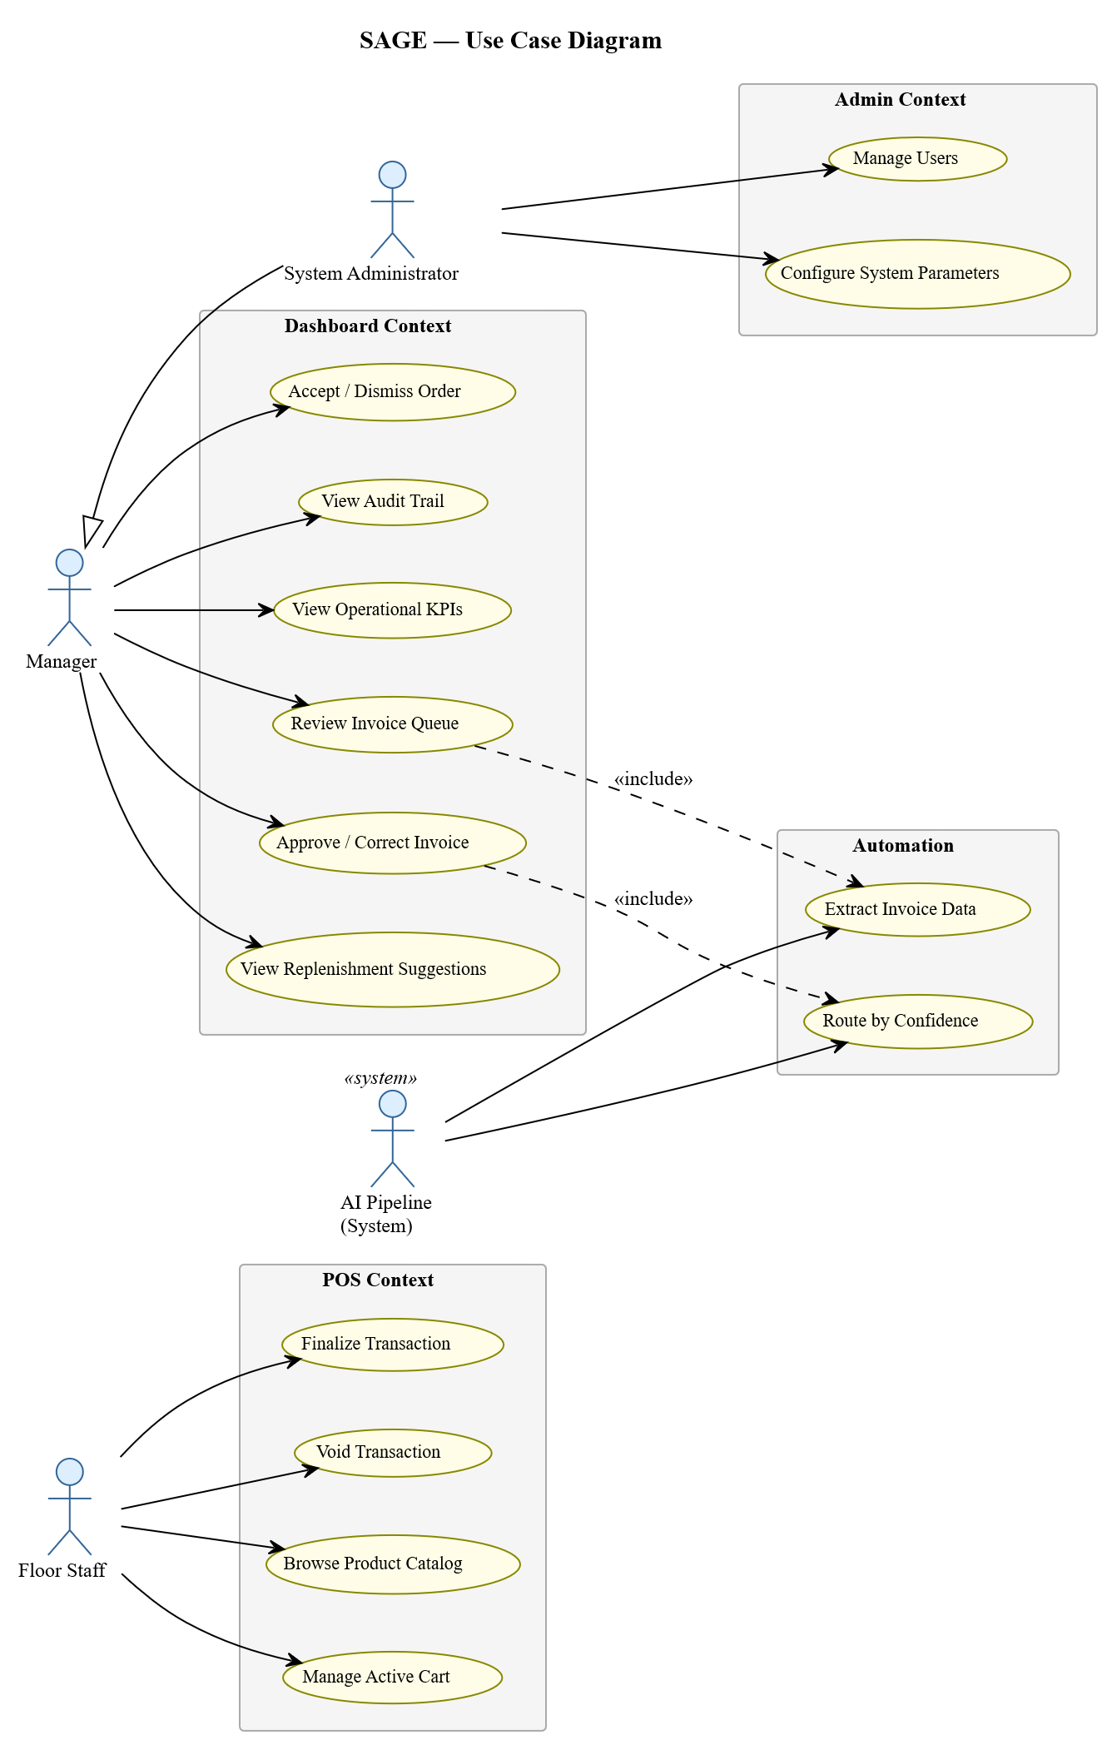
Figure 3-1:UML Use Case Diagram — system actors and their interactions across the POS, Dashboard, and Admin contexts.

Floor Staff – POS Context
Floor Staff are the front-line operations personnel responsible for processing customer transactions through the Point-of-Sale interface. They have read access to the product catalogue and write access to the sales event stream only, with no visibility of financial data, cost information, or the Management Dashboard. Four use cases are available to this role:
UC-01: Browse Product Catalogue. The actor navigates the hierarchical product catalogue via the POS interface. A stack-based breadcrumb trail records each navigation step, enabling O(1) back navigation. Precondition: an authenticated Floor Staff session is active. Postcondition: a product has been identified for inclusion in the active cart. Extension: products with zero available stock across all inventory layers are displayed with a “No stock available” indicator and cannot be added to the cart.
UC-02: Manage Active Cart. The actor adds, updates, and removes line items from the active DraftSale aggregate. Each command emits a cart event to the in-session projection, recalculating the total in real time without a server round-trip. Precondition: an active DraftSale aggregate exists in the Empty or Active state. Postcondition: the cart reflects the updated line-item composition and running total. Invariant: no AddItem command may cause the requested quantity to exceed the total available stock across all cost layers for that product.
UC-03: Finalise Transaction. The actor selects a payment method and submits a FinalizeSale command. The system validates that the cart is non-empty, appends a SaleEvent atomically to the Event Store via the Unit of Work, depletes FIFO inventory cost layers, updates the financial summary projection, and pushes a real-time update signal to all connected Dashboard clients via the Notification Hub. Precondition: the DraftSale aggregate is in the Active state with at least one line item. Postcondition: a SaleEvent is committed, the DraftSale transitions to the Finalized terminal state, and stock and revenue projections are updated. Exception: a concurrent StockDepletionException triggers an atomic rollback of the Unit of Work; the operator must adjust the cart before retrying.
UC-04: Void Transaction. The actor cancels an in-progress transaction before payment is taken by issuing a VoidTransaction command. A VoidEvent is appended atomically to the Event Store and a new DraftSale aggregate is initialised for the next transaction. No inventory depletion or financial update is triggered. Precondition: the DraftSale is in the Empty or Active state. Postcondition: a VoidEvent is committed and the terminal Voided state is reached. Constraint: finalised transactions cannot be voided through this use case; returns and corrections require a separate administrative corrective event.

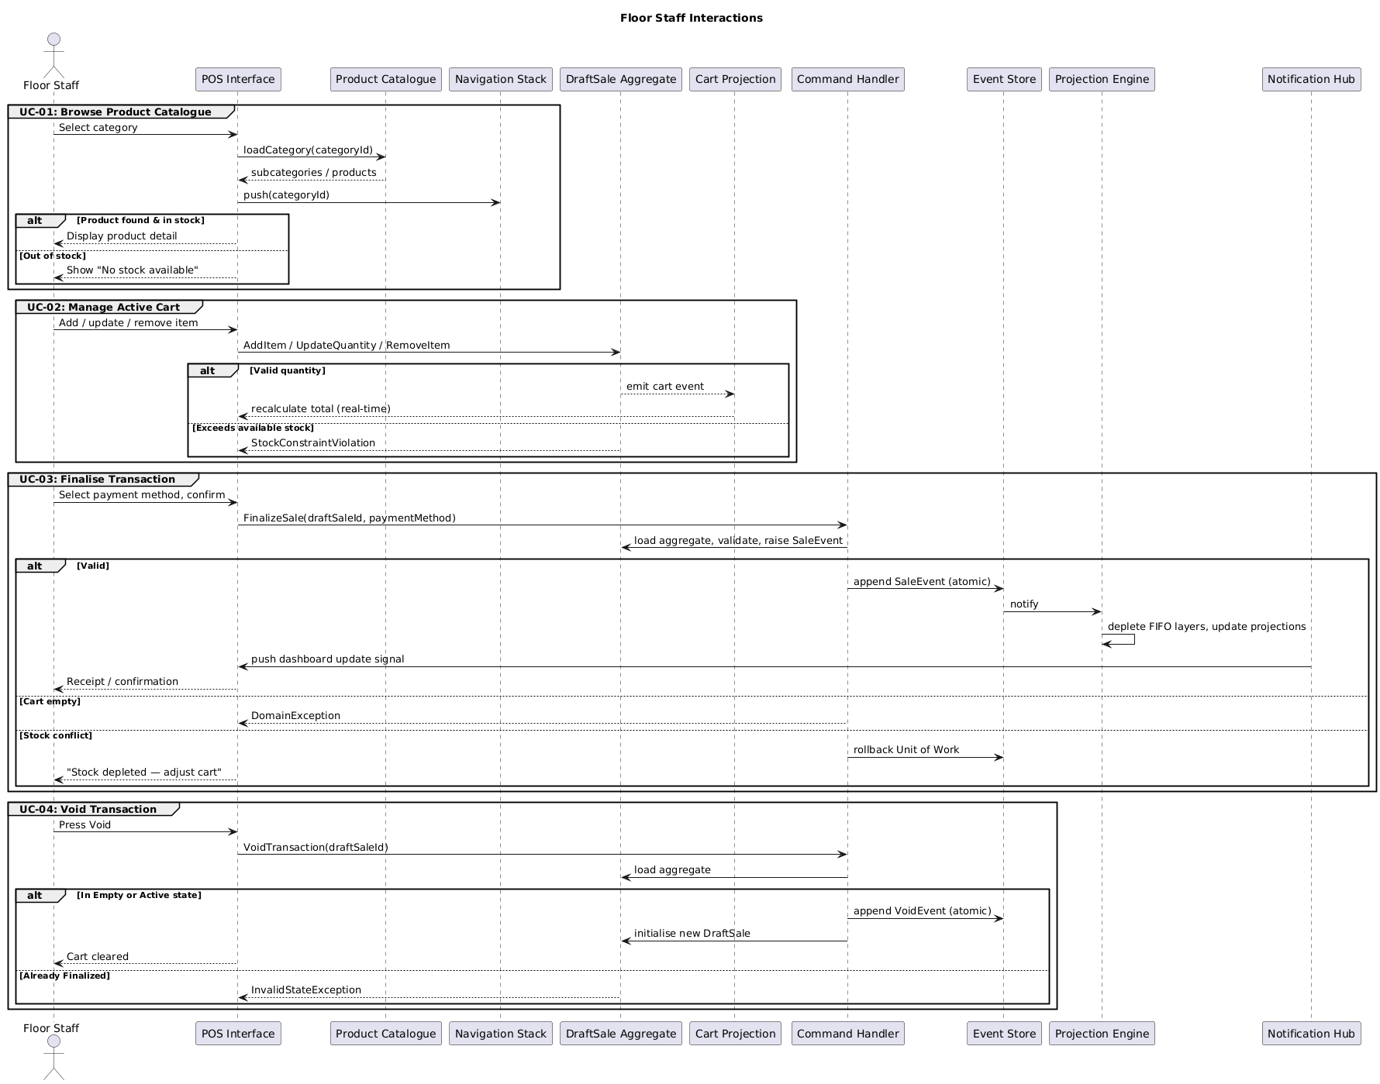
Figure 3-2: UML Sequence Diagram — Floor Staff POS context interactions covering transaction browsing, cart management, sale finalisation, and void operations (UC-01 to UC-04).

Manager / Business Owner — Dashboard Context
Managers and Business Owners are the primary decision-makers responsible for the financial health and operational strategy of the business. They interact with SAGE principally through the Management Dashboard and hold full read access across all system projections, write access to the invoice approval module, and write access to the replenishment module. Six use cases are available to this role:
UC-05: View Operational KPIs. The actor opens the Management Dashboard to observe reactive KPI cards — today’s revenue, gross margin percentage, total units sold, and transaction count — alongside a per-SKU cost-layer-adjusted margin breakdown table. Each card subscribes independently to a specific projection and updates only when the Notification Hub delivers a new signal, ensuring that a high-volume sales period triggers targeted refreshes rather than a full-page reload. Precondition: the actor is authenticated with the Manager role. Postcondition: the Dashboard reflects the current state of all projection tables.
UC-06: Review Invoice Queue. The actor uploads a supplier invoice document through the Dashboard’s logistics module. The AI Pipeline processes the document through three sequential stages: layout analysis identifies the header, line-item table, and footer regions; the ML/LLM extraction component extracts structured fields (product name, quantity, unit, unit price, line total) with per-field confidence scores; and constraint-based validation cross-checks numeric types, line totals against quantity multiplied by unit price, and the sum of line totals against the footer total. Precondition: the actor holds the Manager role and a valid invoice document has been uploaded. Postcondition: an extraction preview is displayed with auto-accepted fields highlighted and uncertain or invalid fields flagged for review.
UC-07: Approve or Correct Invoice. Following the review produced by UC-06, the actor edits flagged fields, removes invalid line items, and submits an ApproveInvoice command. An InventoryIntakeEvent is appended atomically to the Event Store; the Inventory Projector creates one cost layer per approved line item, recording the product identifier, intake quantity, and exact unit cost. Precondition: the invoice review interface is open with at least one valid line item. Postcondition: an InventoryIntakeEvent is committed, new cost layers are created in the inventory layers projection, and stock levels on the KPI Dashboard are updated. Alert: if any new layer’s unit cost differs materially from its predecessor for the same product, a CostLayerTransitionAlert is delivered to the Dashboard via the Notification Hub.
UC-08: View Replenishment Suggestions. The actor opens the Replenishment module. The MILP optimisation engine reads current stock levels from the inventory layers projection, derives projected daily demand from a rolling average of recent SaleEvents, and solves an integer programming model to produce a table of optimal order quantities ranked by ascending remaining days of stock. Precondition: the actor holds the Manager role. Postcondition: the replenishment table is populated with the current optimisation output. Fallback: when the budget constraint renders a full feasible solution impossible, a two-phase priority heuristic iteratively builds a partial solution ordered by stockout urgency.
UC-09: Accept or Dismiss Replenishment Order. Following the output of UC-08, the actor accepts, modifies the quantity of, or dismisses each suggested order row individually. Accepted and modified orders are persisted as PurchaseOrderEvents; dismissals are logged as DismissedReplenishmentEvents. Both record the actor’s identity, timestamp, and the optimisation snapshot that justified the suggestion. Precondition: the replenishment suggestion table contains at least one row. Postcondition: every actioned suggestion is reflected in the Event Store with a complete decision record, making the full purchasing rationale auditable.
UC-10: View Audit Trail. The actor accesses the append-only Event Store log through a filterable interface supporting event type, date range, and user identity. Each entry displays the event type, aggregate identity, triggering user, and occurrence timestamp. Selecting a row reveals the full event payload. Precondition: the actor holds the Manager role. Postcondition: the audit trail is displayed and can be filtered to isolate any event of interest. Guarantee: because the Event Store is append-only and no event is ever modified or deleted, this view provides a deterministic and unalterable record of every state transition in the system.

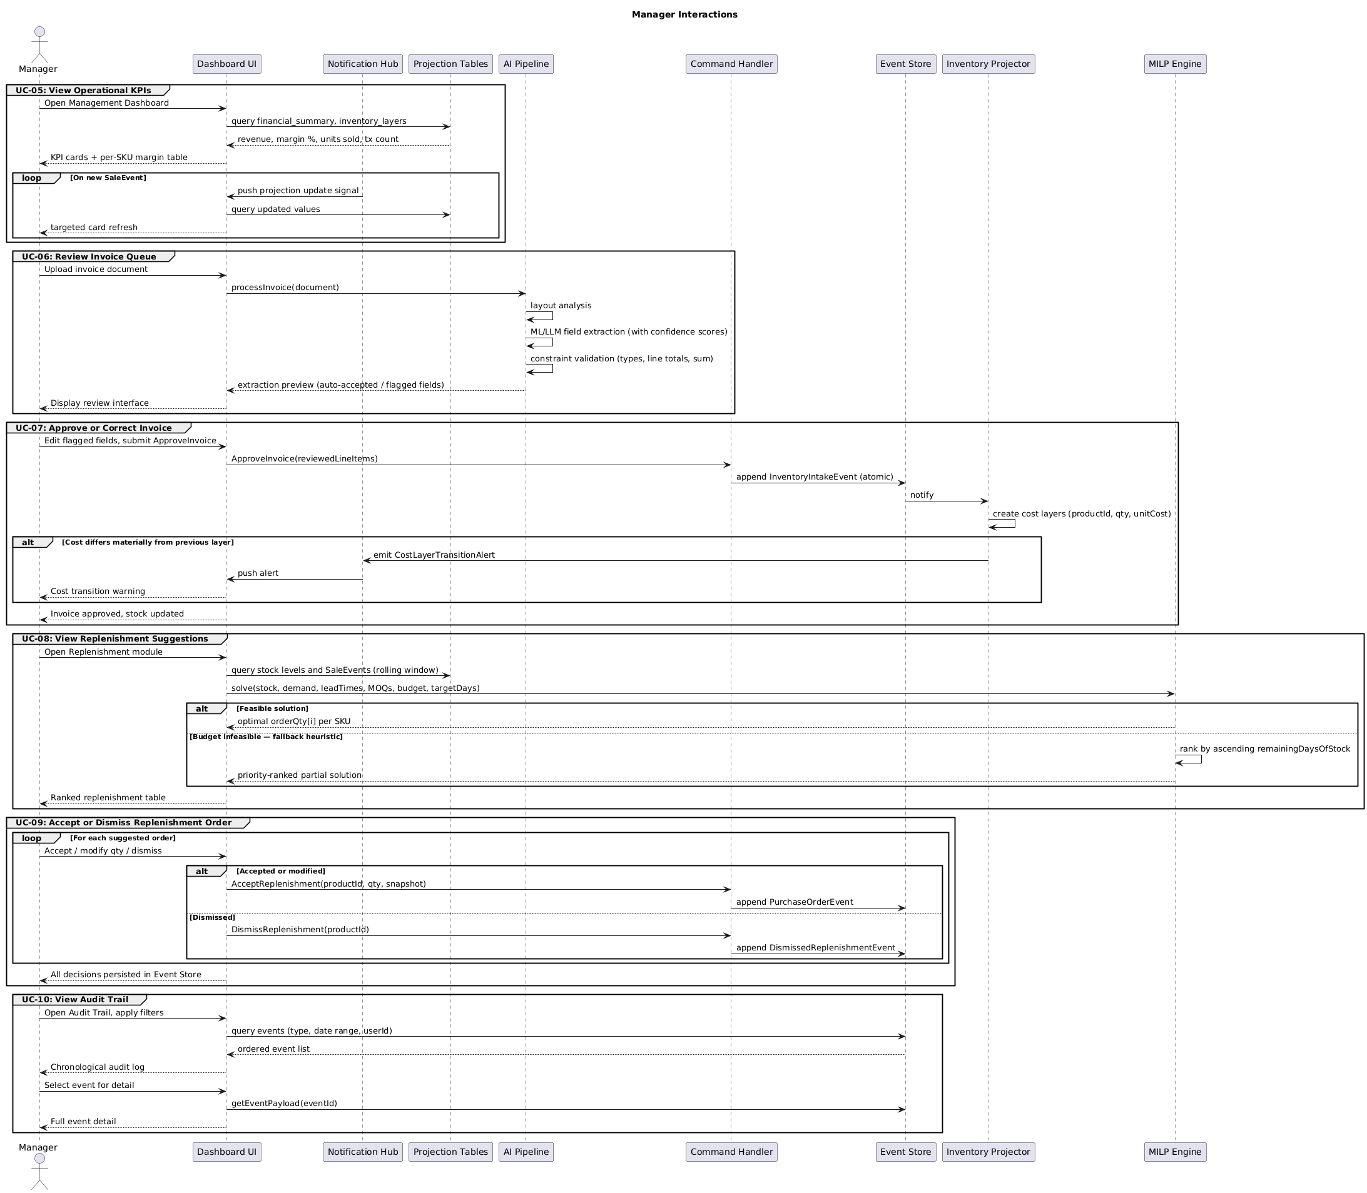
Figure 3-3: UML Sequence Diagram — Manager Dashboard context interactions covering KPI monitoring, AI-driven invoice review and approval, MILP replenishment suggestions, order acceptance, and audit trail access (UC-05 to UC-10).

System Administrator — Administration Context
System Administrators are technical users responsible for the operational integrity of the SAGE platform. They inherit all Manager use cases through a generalisation relationship and additionally hold unrestricted access to administrative and configuration interfaces not available to other roles. Their two exclusive use cases govern the cross-cutting concerns of user access management and system parameter configuration:

UC-11: Manage Users. The actor creates, modifies, and deactivates user accounts through the administration interface. For each account the actor specifies a display name, email address, and role assignment — Floor Staff, Manager, or System Administrator — which directly governs which use cases and interfaces are accessible to that account at runtime. Deactivated accounts retain their complete event history in the audit trail but cannot initiate new sessions. Precondition: the actor is authenticated with the System Administrator role. Postcondition: the target account exists with the specified configuration and a UserCreatedEvent, UserModifiedEvent, or UserDeactivatedEvent has been appended to the Event Store, logging the change with the administrator’s identity and timestamp.
UC-12: Configure System Parameters. The actor adjusts the operational parameters that govern the behaviour of the AI invoice pipeline and the MILP replenishment engine: the confidence threshold (0.0–1.0) below which extracted invoice fields are flagged for manual review, the replenishment budget ceiling, the target stock coverage horizon in days, and the active inventory costing strategy (FIFO or weighted average). Precondition: the actor holds the System Administrator role. Postcondition: the specified parameters are immediately active and a SystemConfigEvent recording the change, the actor’s identity, and the timestamp has been appended to the Event Store, enabling precise reconstruction of the parameter values in effect at any historical point.

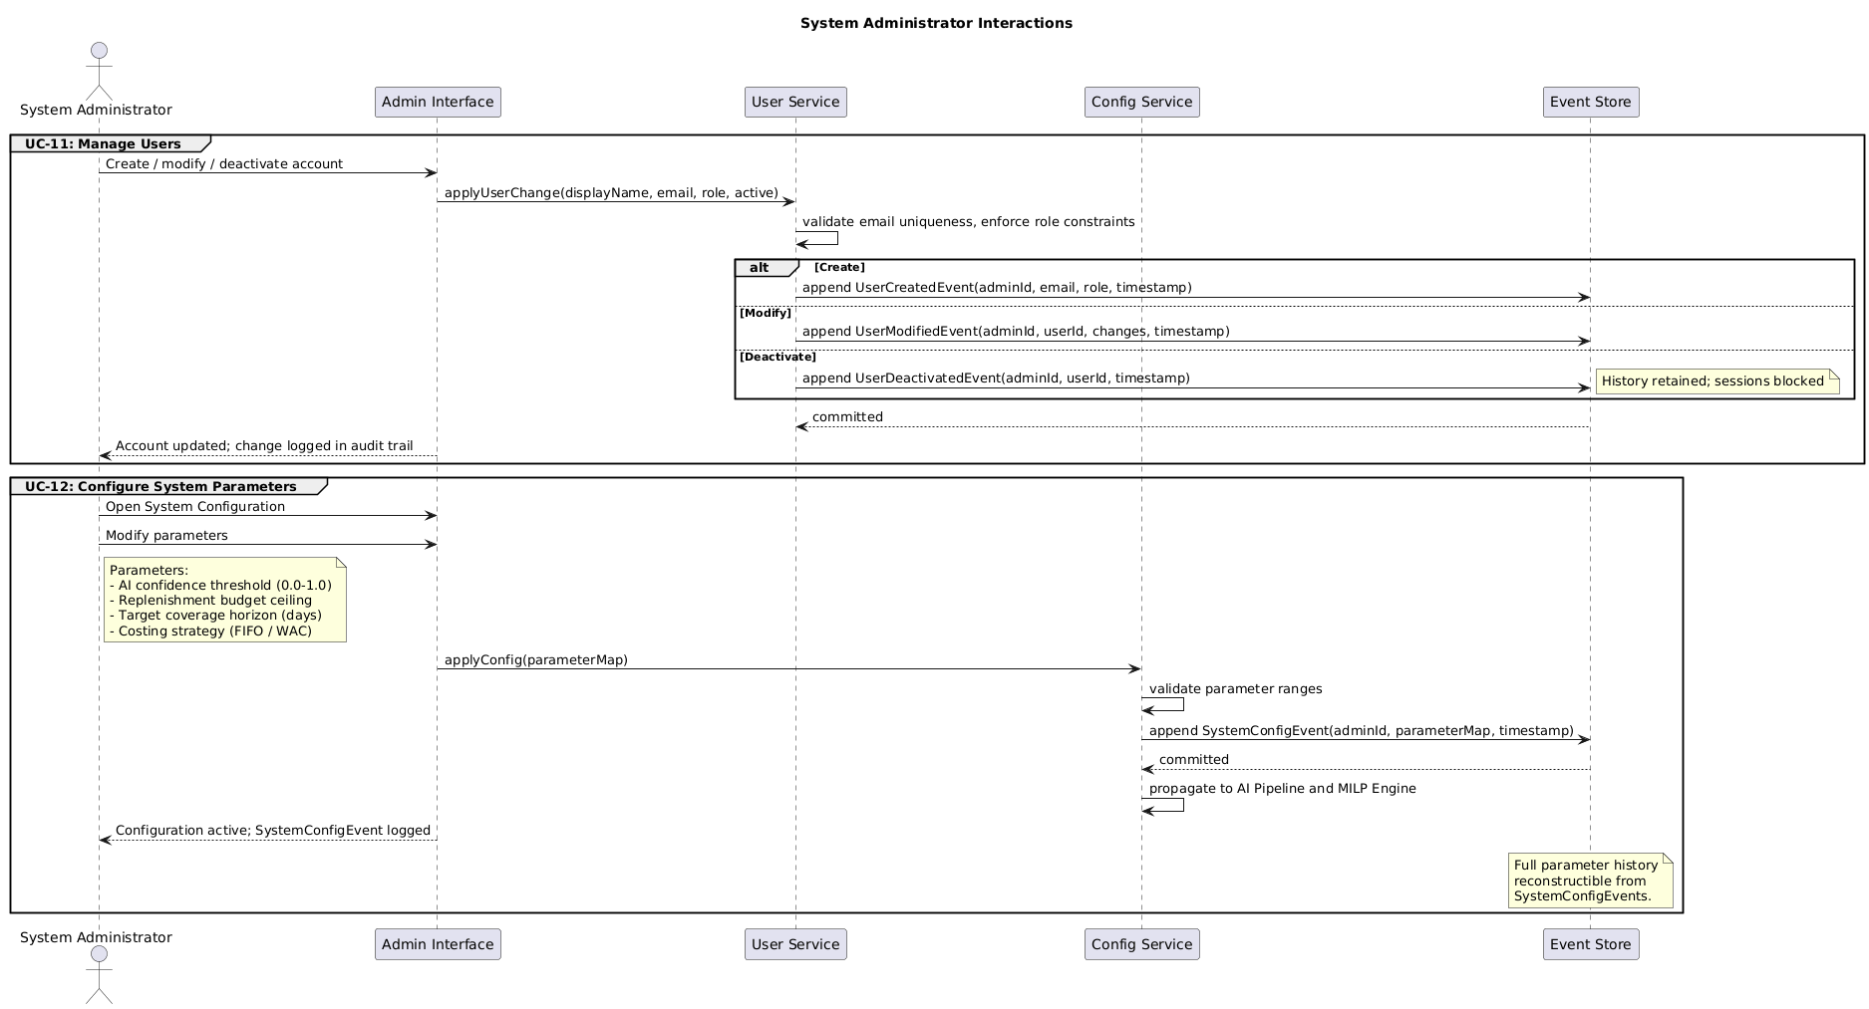
Figure 3-4: UML Sequence Diagram — System Administrator administration context interactions covering user account lifecycle management and system parameter configuration (UC-11 to UC-12).

Non-Functional Requirements
Non-functional requirements establish targets across six dimensions:
- Consistency: The Event Store must guarantee that no event is lost and that events are processed by all projectors in the order they were appended. PostgreSQL serialisable transaction isolation is the minimum acceptable commit guarantee for all Event Store write operations.
- Latency: Dashboard KPI card updates must be delivered to connected clients within 500ms of a SaleEvent being committed to the Event Store, measured under a load of up to 10 concurrent Dashboard sessions on the recommended hardware configuration.
- Auditability: Every state change must be attributable to a specific user, event type, and UTC timestamp, with no mechanism for deletion or retroactive modification. The Event Store must retain all events for a minimum of seven years to satisfy standard commercial audit requirements.
- Scalability: The projection architecture must support the addition of new Projectors without modification to the Event Store schema or any existing Projector implementation. A new Projector must be deployable by registering it with the Projection Engine alone, with no other component changes required.
- Security: Role-based access control must be enforced at the API boundary for every request. Session tokens must expire after a configurable idle period (default 8 hours). All client-server communication must be conducted over TLS 1.2 or higher. No user may access data or invoke operations beyond the privileges of their assigned role.
- Data Integrity: The append-only nature of the Event Store must be preserved as a structural guarantee enforced at the database level through insert-only table permissions — no UPDATE or DELETE may be permitted on the events table. Any derived projection must be fully and deterministically reconstructible from the event stream alone within a time proportional to the total number of committed events.

System Architecture
The system architecture defines the structural organisation of SAGE across two complementary perspectives: the three-tier deployment architecture, which establishes how the presentation, application, and persistence layers are arranged and how they communicate; and the object-oriented class and component model, which specifies the internal structure of the domain and application tiers.

Architectural Overview
SAGE uses a three-tier distributed architecture (Figure 3-5): a presentation layer (browser-based client), an application layer (command and query handling, projection engine), and a persistence layer (Event Store and Projection Tables). The presentation and application tiers communicate through two channels: a synchronous interface for commands and queries, and a real-time push channel for projection updates delivered from server to client. The persistence layer departs from a conventional single-database model: the Event Store is append-only and serves as the authoritative write model, while the Projection Tables are read-optimised views derived from the event stream and kept current by the Projection Engine as new events arrive. This dual-persistence arrangement is the structural consequence of applying the CQRS pattern at the data layer.
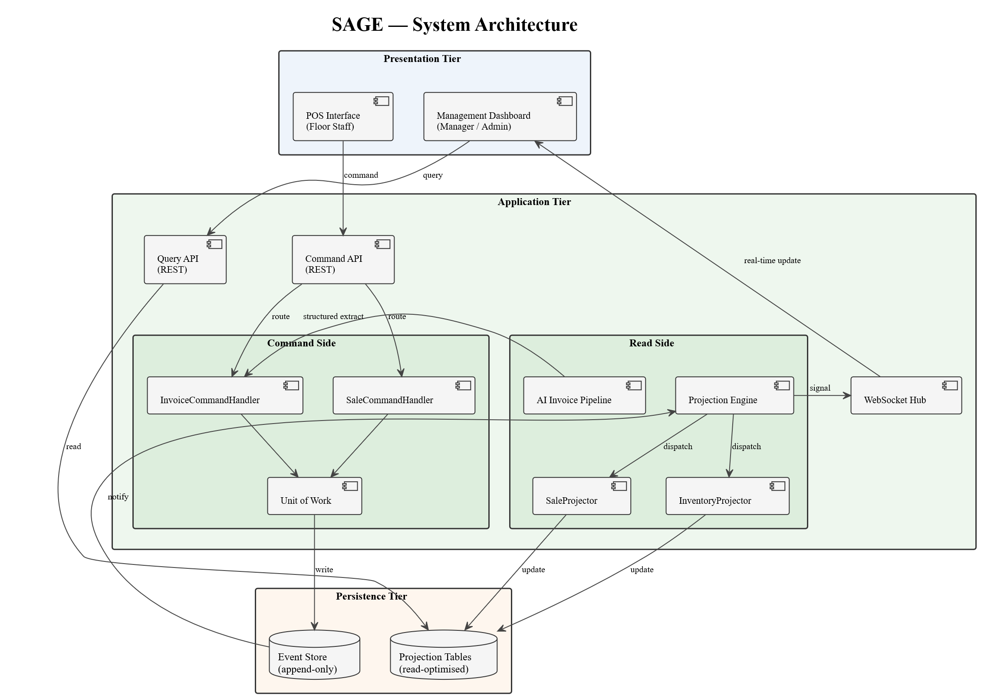
Figure 3-5: Entity-Relationship Diagram — Event Store and Projection Tables with inter-entity associations.
Object-Oriented Class Model
The class diagram (Figure 3-6) illustrates the object-oriented structure of the SAGE domain layer. All domain classes inherit from the abstract AggregateRoot base class, which provides identity, versioning, and event-raising capabilities. The four principal aggregate classes are Product, Category, DraftSale, and InventoryLayer. Product is associated with Category through a many-to-one relationship and with InventoryLayer through a one-to-many relationship representing accumulated cost layers. DraftSale composes a collection of CartItem instances, each linking a Product reference to a quantity and computed line total. The DraftSale aggregate holds a SaleStatus value that governs its lifecycle transitions. The event type hierarchy is rooted in the abstract BaseEvent class, carrying a universal event identifier, aggregate type and instance identifiers, an occurrence timestamp, a global sequence number, and a typed payload. Five concrete event types derive from BaseEvent: SaleEvent, VoidEvent, InventoryIntakeEvent, PriceOverrideEvent, and SystemConfigEvent. DraftSale holds raise-dependencies on both SaleEvent and VoidEvent, representing the events it emits upon finalisation and cancellation respectively.
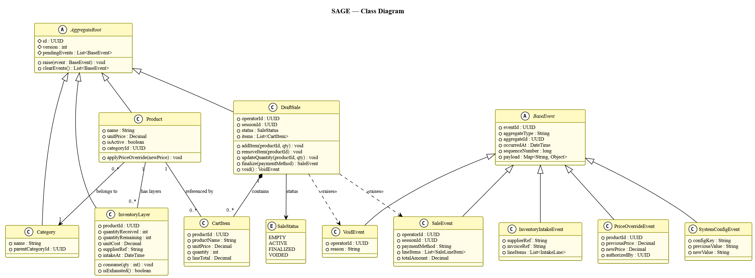
Figure 3-6: UML Class Diagram — domain model with AggregateRoot hierarchy, event type hierarchy, and inter-aggregate associations.

Component Architecture
The application tier is organized into four components. The Command Interface receives commands from the client, validates them, and routes them to the appropriate Command Handler. Each Command Handler loads its target aggregate via the Repository, invokes the aggregate’s domain method, and persists the result through the Unit of Work. The Projection Engine runs as a background process, consuming events from the Event Store and dispatching each event to the registered Projectors, which update the corresponding Projection Tables. The Notification Hub maintains persistent connections to Dashboard clients and delivers real-time update signals whenever the Projection Engine processes a new event.

Behavioral Models
Behavioral models capture the internal architectural flow of the system's two primary workflows at the component level. Unlike the actor-level sequence diagrams in Section 3.1.3, which show what a user triggers and what the system returns, these diagrams trace how a command propagates through the internal component stack — from the Command Handler through the Repository and Unit of Work to the Event Store, and onward through the Projection Engine to the Notification Hub. The DraftSale state machine diagram complements these by specifying the valid lifecycle transitions of the aggregate independently of any actor interaction.
POS Sale Finalization
The sequence begins when the Floor Staff actor selects a payment method on the POS interface, dispatching a FinalizeSale command to the Command Handler. The handler loads the DraftSale aggregate via the Repository, which replays the aggregate’s event history from the Event Store to reconstruct its current state. The aggregate validates the cart contents, computes the transaction total, and raises a SaleEvent, which is persisted atomically through the Unit of Work. The Projection Engine consumes the event and dispatches it to the Sale Projector, which depletes inventory layers in FIFO order, updates the financial summary projection, and checks for a cost layer transition. The Notification Hub then delivers an update signal to all connected Dashboard clients.

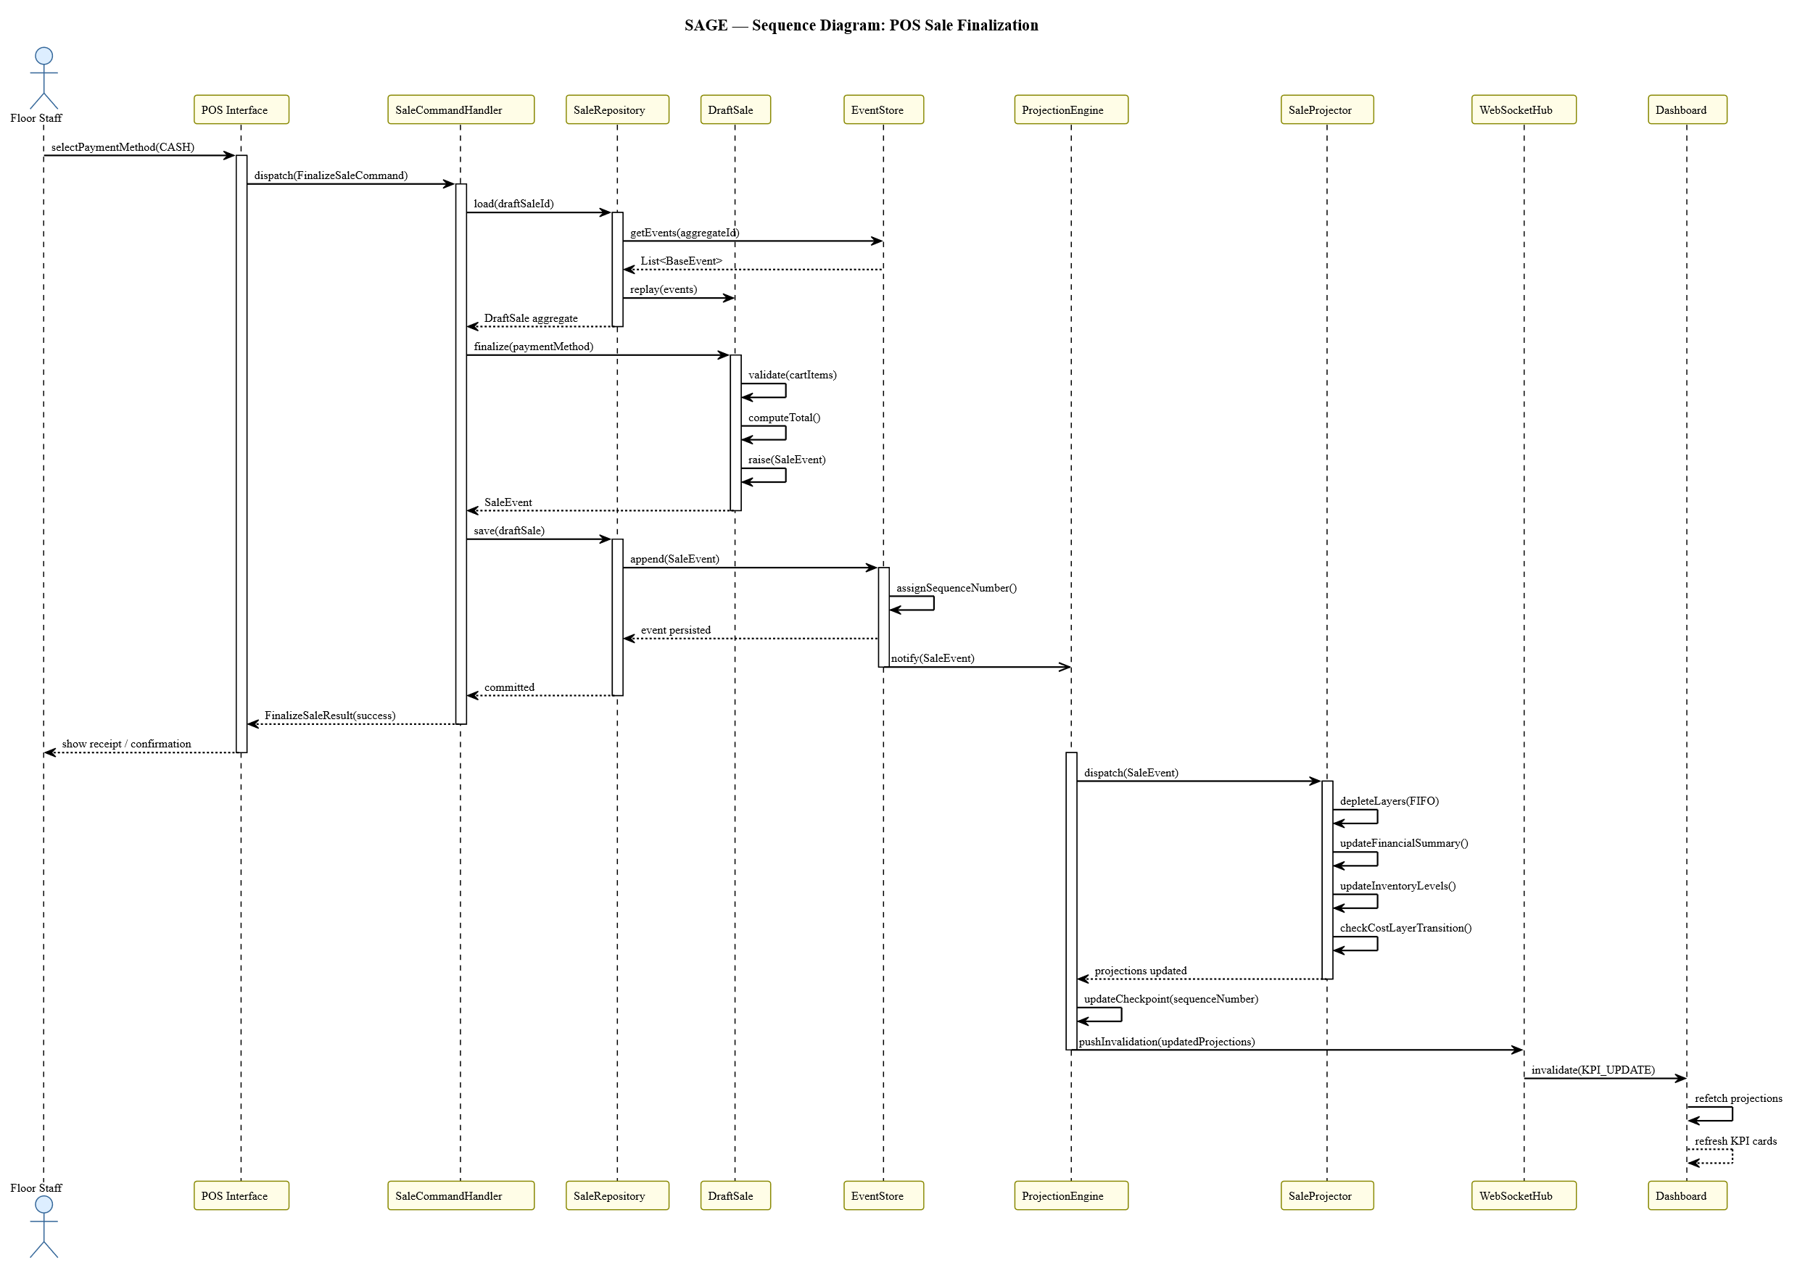
Figure 3-7: UML Sequence Diagram — POS sale finalization from operator action through event store append to dashboard projection update.

Invoice Approval
The sequence begins when a Manager uploads an invoice document through the Dashboard. The Invoice Pipeline performs layout analysis, text extraction, and field-level confidence scoring. If all fields exceed the configured confidence threshold the pipeline returns an auto-accepted preview; otherwise it flags low-confidence fields for manual correction. On manager approval, an ApproveInvoice command is dispatched to the Command Handler, which constructs an InventoryIntakeEvent from the reviewed line items and persists it atomically through the Unit of Work. The Projection Engine consumes the event and dispatches it to the Inventory Projector, which creates new inventory cost layers per intake line. If any new layer’s unit cost differs materially from its predecessor for the same product, a CostLayerTransitionAlert is delivered to the Dashboard via the Notification Hub.
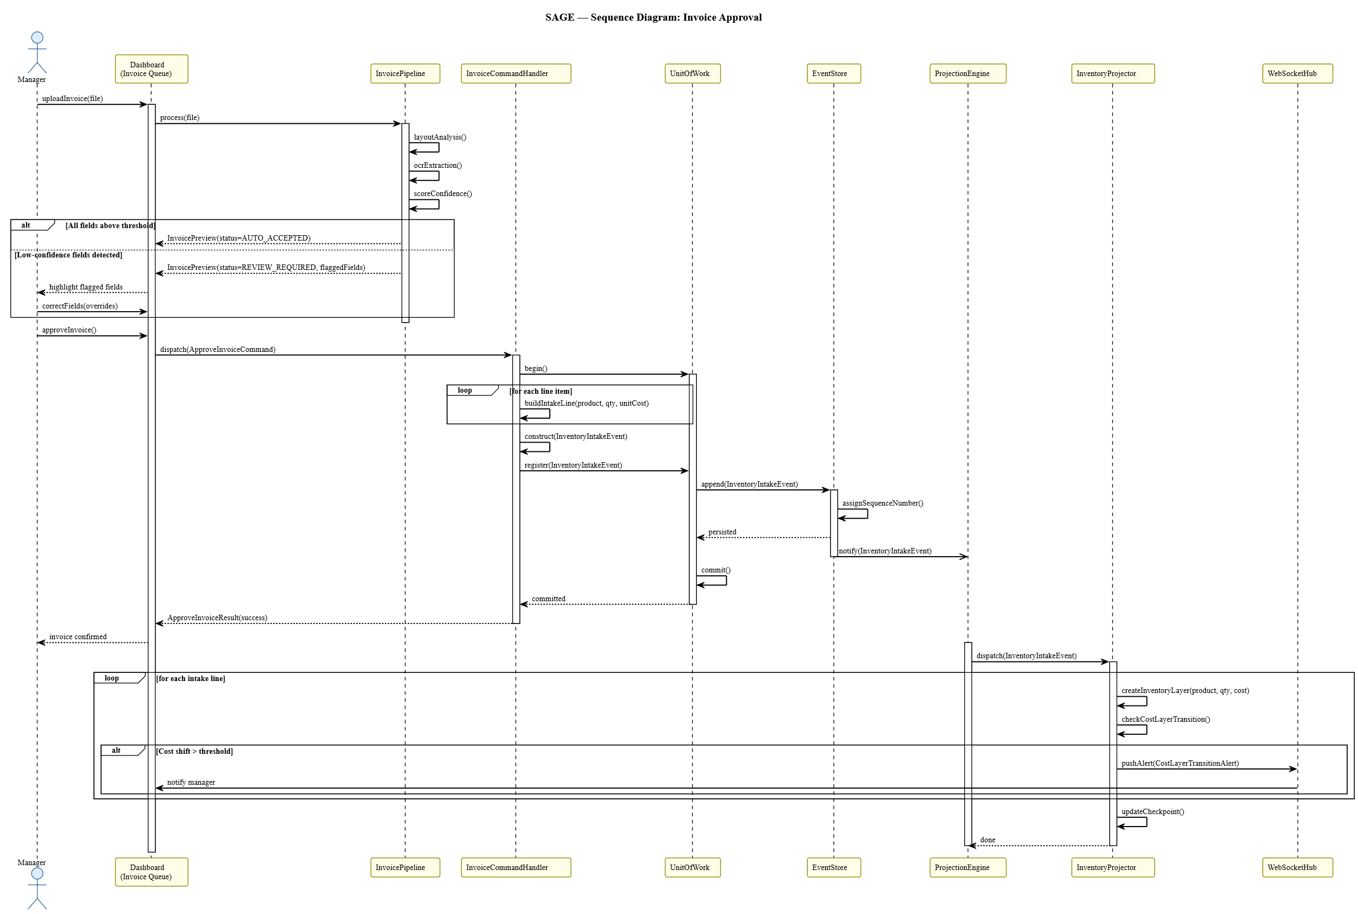
Figure 3-8: UML Sequence Diagram — invoice approval flow from document upload through AI extraction and manager review to InventoryIntakeEvent.

DraftSale Lifecycle
The DraftSale aggregate transitions through four states. It is created in the Empty state when a transaction is initiated. The first AddItem command transitions it to the Active state. From Active, further AddItem, RemoveItem, and UpdateQuantity commands keep the aggregate in the Active state while modifying cart contents. A FinalizeSale command, subject to the guard condition that the cart is non-empty, transitions the aggregate to the terminal Finalized state and raises a SaleEvent. From either Empty or Active, a VoidTransaction command transitions the aggregate to the terminal Voided state and raises a VoidEvent. Both Finalized and Voided are absorbing states: no further transitions are possible once either is reached.

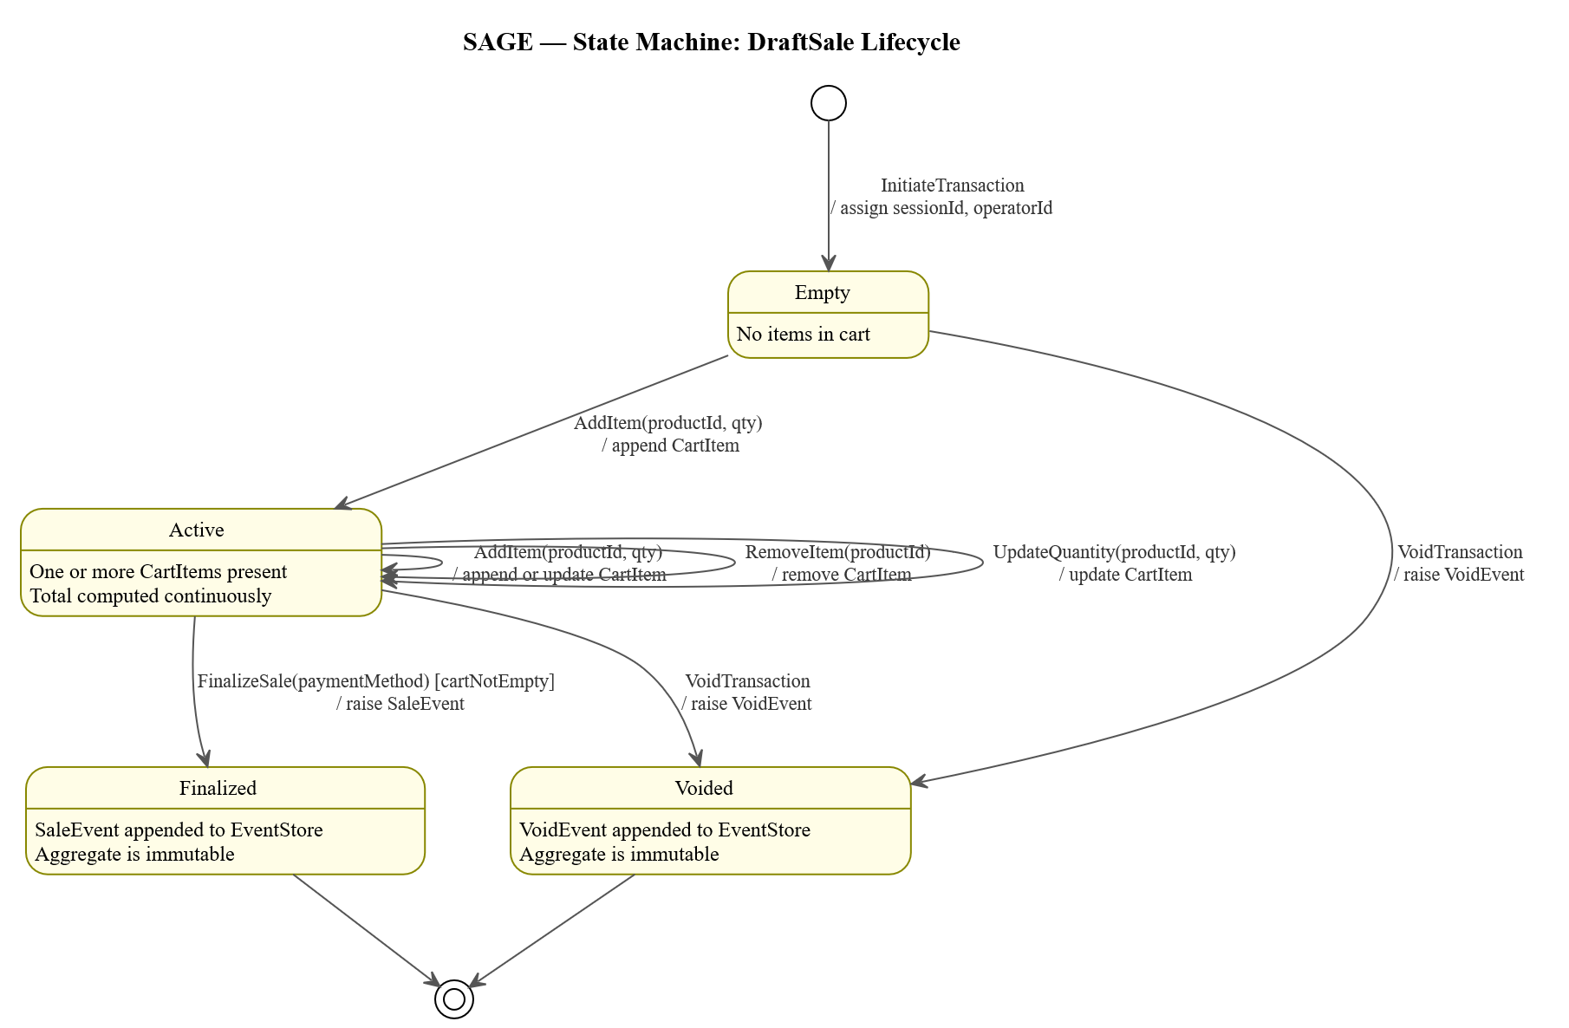
Figure 3-9: UML State Machine Diagram — DraftSale aggregate lifecycle from Empty through Active to Finalized or Voided terminal states.

Data Design
Data design encompasses the Event Store schema, the Projection Tables schema, and the relationships between them, as captured in the Entity-Relationship Diagram (Figure 3-5).
Event Store Schema
The Event Store is built around a single append-only table. Each record captures: a unique event identifier, the type and identity of the aggregate that raised the event, the event type, a monotonically increasing global sequence number, a timestamp of occurrence, a typed payload carrying event-specific data, and an optional causation reference linking the event to the command or prior event that produced it. The sequence number is the mechanism by which the Projection Engine tracks its progress through the event stream, allowing each Projector to resume from where it left off after a failure. Because the payload is typed and self-describing, new event types can be introduced without modifying the Event Store structure.

Projection Tables Schema
The projection layer consists of five read-optimised tables, each populated exclusively by the Projection Engine. The products and categories tables maintain the current state of the product catalogue, including the hierarchical category structure. The inventory layers table holds one record per delivery batch per product, tracking quantities received and remaining so that FIFO depletion can be applied accurately against each sale. The financial summary table aggregates daily trading metrics including revenue, cost of goods sold, gross margin, and transaction counts. The projection checkpoints table records each Projector’s progress through the event stream. The relationship between the Event Store and the Projection Tables is strictly unidirectional: the projection layer holds no references back into the event log. Any projection can be discarded and rebuilt deterministically by replaying the full event stream from the beginning.

Core Functionality Design
This subsection examines the four key technical subsystems whose design is most directly shaped by the architectural choices above: the OOD pattern layer, the FIFO inventory valuation engine, the AI invoice processing pipeline, and the MILP replenishment optimization model.
Object-Oriented Design Patterns
- CQRS: The overarching architectural pattern of SAGE separates operations that change system state (commands) from operations that read it (queries). Command Handlers write only to the Event Store; queries are served only from Projection Tables. The two paths share no data access layer and make no calls to each other.
- Observer: The Projection Engine implements the Observer pattern. The Event Store is the subject; it notifies registered Projectors whenever a new event is appended. Each Projector is a concrete observer implementing a typed event handler interface. New projectors can be registered without modifying the Event Store or existing projectors, adhering to the Open/Closed Principle.
- Strategy: The inventory valuation engine applies the Strategy pattern to support interchangeable costing algorithms. The valuation engine accepts a costing strategy at construction time, with FIFO and weighted average as the two concrete implementations. Switching the costing method requires only a configuration change, with no modification to the surrounding projection logic.
- Repository: Each aggregate type has a corresponding Repository that abstracts Event Store access behind two operations: loading an aggregate, which replays all its recorded events to reconstitute its current state, and saving it, which appends any newly raised events. Command Handlers work exclusively with in-memory domain objects and delegate all persistence to the repository.
- Unit of Work: The Unit of Work pattern is applied at the command handling boundary to ensure atomic commits. When a command results in multiple aggregate changes — such as an invoice approval that affects several products simultaneously — the Unit of Work collects all pending events and persists them in a single atomic write. If any part of the write fails, the entire operation is rolled back and no partial state is committed.
FIFO Inventory Valuation Engine
The valuation engine computes the Cost of Goods Sold for each sale by depleting inventory layers in the order they were created — oldest first. When a sale event is processed, the engine identifies the available cost layers for each sold product and deducts the sold quantity from the oldest layer first, proceeding to the next if the first is exhausted, until the full quantity is accounted for. For each layer consumed, a partial COGS contribution is computed as the depleted quantity multiplied by that layer’s unit cost. The sum of all partial contributions is the total COGS for the transaction. This ensures that the cost figure used to compute gross margin always reflects the actual acquisition cost of the specific items sold, eliminating the distortion that a simple average would introduce when procurement prices fluctuate between deliveries. The weighted-average strategy provides an alternative costing method for contexts where layer-level traceability is not required. Under this method, a single blended unit cost is always maintained per product. When a new inventory intake event is processed, the weighted-average cost is recalculated as: WAC = (Q_existing × WAC_previous + Q_new × C_new) / (Q_existing + Q_new), where Q_existing is the current on-hand quantity, WAC_previous is the prior weighted-average cost, Q_new is the incoming quantity, and C_new is the unit cost of the new intake. All subsequent COGS computations use this recalculated WAC until the next intake event. Switching between FIFO and weighted-average requires only a configuration change at the valuation engine’s construction point, with no modification to the surrounding projection logic.
AI Invoice Processing Pipeline
The invoice pipeline operates in three sequential stages. In Stage 1 (Layout Analysis), the input document is analysed using a layout-aware heuristic approach to identify its structural regions. The heuristic operates by detecting typographic and spatial signals in the document: the header region is identified as the contiguous block of text preceding the first detected tabular structure, characterised by dense key-value pairs such as supplier name, invoice date, and reference number. The line-item table is identified by scanning for horizontally aligned columns with consistent indentation and delimiter patterns across multiple rows. The footer region is identified as the block following the last table row, typically containing aggregated numeric values and payment terms. For documents that do not expose a parseable digital text layer — such as scanned paper invoices — Tesseract OCR is invoked as a fallback to produce a text representation before layout analysis proceeds. In Stage 2 (Field Extraction), an ML/LLM-based parsing component processes the content of each identified region to extract structured fields — product name or code, quantity, unit, unit price, and line total — each assigned an individual confidence score. This approach delegates the semantically complex task of field identification across diverse, format-varying invoice layouts to the LLM, while the preceding heuristic stage constrains the input to a well-bounded region, reducing hallucination risk. In Stage 3 (Review Routing and Validation), extracted fields are first subjected to constraint-based validation: numeric fields are checked for type correctness and non-negativity, line totals are verified against the product of quantity and unit price, and the sum of line totals is cross-checked against the invoice footer total where present. Any field that fails a constraint is automatically flagged regardless of its confidence score. An overall confidence score is then computed per line item from the LLM-assigned field-level scores. Items where all fields pass validation and exceed the configured confidence threshold are accepted automatically; those that fail either check are routed to the manager’s review queue with failed constraints and low-confidence fields highlighted. The manager confirms, corrects, or removes any line item before approving the invoice and triggering the intake event chain.

MILP Replenishment Optimization
The replenishment module determines, for each product below its reorder threshold, the optimal quantity to order. Let N denote the set of candidate products.
Decision variable
- xᵢ ∈ ℤ⁺ — order quantity for product i ∈ N.
Parameters
- cᵢ — unit acquisition cost from the most recent InventoryLayer
- dᵢ — projected daily demand, derived from a rolling average of SaleEvents
- sᵢ — current on-hand stock from the inventory_layers projection
- lᵢ — supplier lead time in days
- mᵢ — minimum order quantity
- B — total purchasing budget
- T — target coverage horizon in days
Objective
Minimise Σ_{i∈N} cᵢ · xᵢ
Subject to
- Budget: Σ_{i∈N} cᵢ · xᵢ ≤ B
- Coverage: sᵢ + xᵢ ≥ dᵢ · (lᵢ + T) ∀i ∈ N
- Minimum order quantity: xᵢ ≥ mᵢ ∀i where xᵢ > 0
- Integrality: xᵢ ∈ ℤ⁺

The model is solved at the time the Replenishment module is accessed. The solver first attempts to find a feasible solution satisfying all constraints simultaneously. If the budget constraint B renders the full coverage target infeasible — that is, no combination of order quantities can satisfy the coverage constraint for all products within budget — the system falls back to a two-phase post-solve prioritisation heuristic. In the first phase, each candidate product i is assigned a remaining coverage score defined as r_i = s_i / d_i, representing the number of days of stock remaining at the current consumption rate. Products are ranked in ascending order of r_i, so that products closest to a stockout appear first. In the second phase, the solver is re-run iteratively: beginning with the highest-priority product, products are added to the candidate set one at a time in order of ascending r_i, and the model is solved for the current candidate set at each step. This continues until adding the next product would cause the budget constraint to be violated, at which point the iteration stops and the current solution is returned. This approach was selected over encoding priority as a secondary objective within the MILP formulation because it avoids the computational overhead and potential instability of multi-objective mixed-integer programming, while producing a deterministic and interpretable result. The output is presented to the manager as a set of suggested purchase orders which may be accepted, modified, or dismissed.

UI Architecture and Wireframes
The interface design follows a Functional Bipolarity model, separating the Transaction Space (POS) from the Analysis Space (Dashboard). Each context is optimized for the cognitive demands of its target user role: minimal friction and immediate feedback for the POS operator, information density and analytical depth for the Dashboard user.
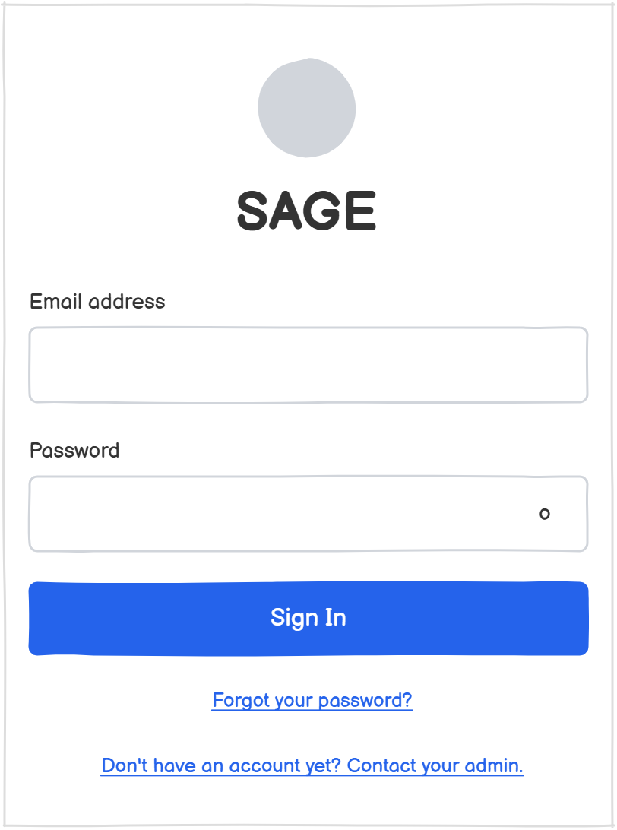
Figure 3-10: SAGE Login Portal

POS Interface
The POS UI is designed to solve the problem of high-latency item lookup in large catalogs. The interface uses a Grid-Breadcrumb Hybrid: a dynamic grid where each cell represents an AggregateRoot (Category or Product), with a Stack-Based Breadcrumb where each movement into a subcategory pushes a new state onto the navigation stack, enabling O(1) time complexity for back operations. The cart panel is an Asynchronous Cart Projection — a real-time projection of the DraftSale aggregate. As the user interacts with the grid, events are emitted locally to update the cart state without requiring a full server-side re-calculation.

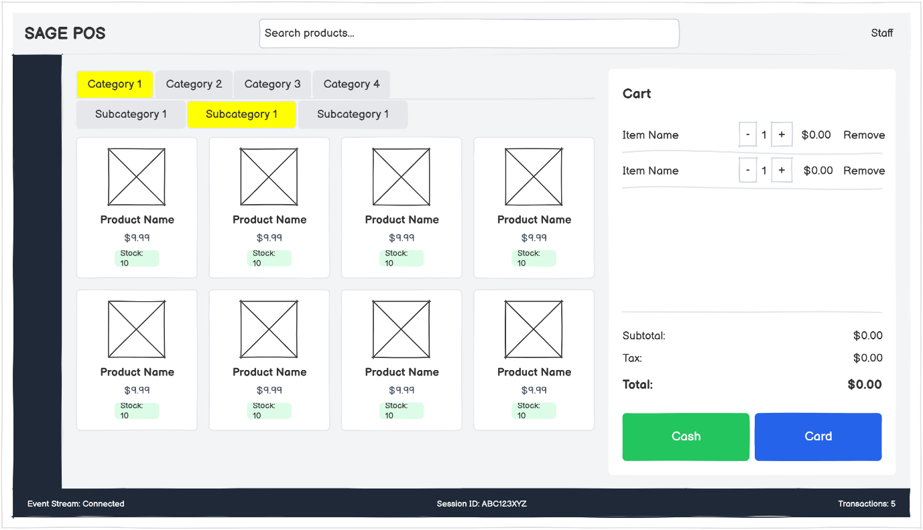
Figure 3-11: Point-of-Sale Interface — hierarchical product catalog, active cart panel, and transaction finalisation controls.

Management Dashboard
The Dashboard is organised with a persistent sidebar and a primary content area. The KPI card row uses a Reactive Projection Display pattern: each card subscribes to a specific projection and updates independently when a new signal arrives from the Notification Hub. This ensures that a high-volume sales period triggers targeted updates only to the affected metrics rather than a full refresh. The Invoice Queue and Replenishment panels present actionable items without requiring the manager to navigate away from the primary overview.
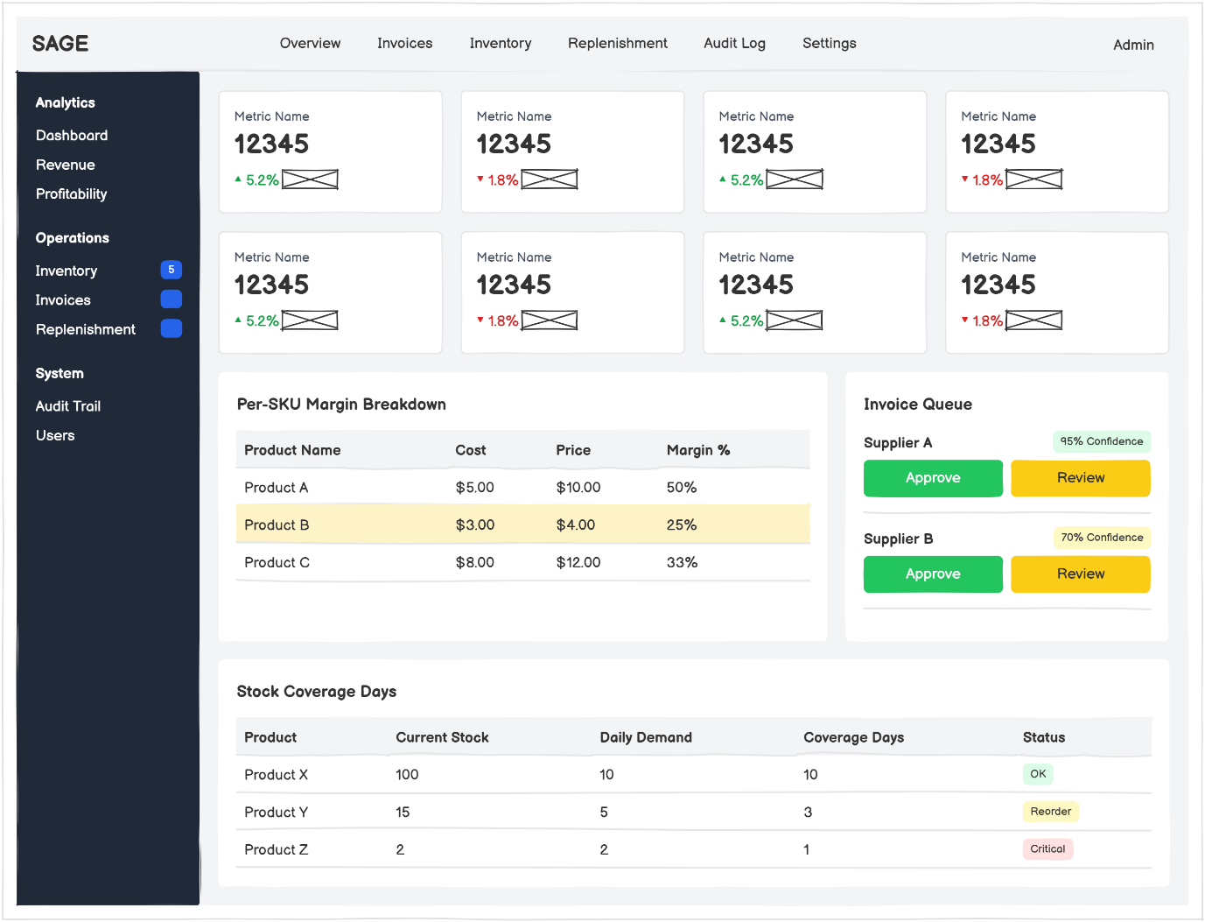
Figure 3-12: Management Dashboard — real-time KPI overview, per-SKU margin breakdown, invoice queue, and stock coverage table.

List of Figures
Figure 2-1: High-Level Workflow Diagram — five-stage operational flow from transaction processing through logistics automation, cost layer creation, and replenishment optimization to strategic decision-making. 9
Figure 3-1:UML Use Case Diagram — system actors and their interactions across the POS, Dashboard, and Admin contexts. 15
Figure 3-2: UML Sequence Diagram — Floor Staff POS context interactions covering transaction browsing, cart management, sale finalisation, and void operations (UC-01 to UC-04). 17
Figure 3-3: UML Sequence Diagram — Manager Dashboard context interactions covering KPI monitoring, AI-driven invoice review and approval, MILP replenishment suggestions, order acceptance, and audit trail access (UC-05 to UC-10). 19
Figure 3-4: UML Sequence Diagram — System Administrator administration context interactions covering user account lifecycle management and system parameter configuration (UC-11 to UC-12). 20
Figure 3-5: Entity-Relationship Diagram — Event Store and Projection Tables with inter-entity associations. 22
Figure 3-6: UML Class Diagram — domain model with AggregateRoot hierarchy, event type hierarchy, and inter-aggregate associations. 23
Figure 3-7: UML Sequence Diagram — POS sale finalization from operator action through event store append to dashboard projection update. 24
Figure 3-8: UML Sequence Diagram — invoice approval flow from document upload through AI extraction and manager review to InventoryIntakeEvent. 25
Figure 3-9: UML State Machine Diagram — DraftSale aggregate lifecycle from Empty through Active to Finalized or Voided terminal states. 26
Figure 3-10: SAGE Login Portal 30
Figure 3-11: Point-of-Sale Interface — hierarchical product catalog, active cart panel, and transaction finalisation controls. 31
Figure 3-12: Management Dashboard — real-time KPI overview, per-SKU margin breakdown, invoice queue, and stock coverage table. 32

