About me:

* A photo of myself

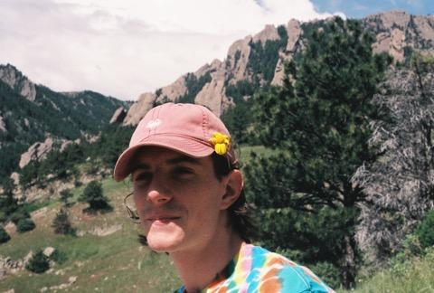

* At least one (non-statistics) question you would like to know the answer to that could be answered by analyzing data
  + I would like to know the most effective methods of educative retention and learning (e.g. how to study best, how to communicate between students and teachers best, etc.)
* What you would love to be doing six months after graduation and then five years after that (what would make you excited to be doing?)
  + What I would love to be doing 6 months after graduation would be to study under some of the greatest voices in philosophy (one of my majors) while working towards some meaningful contribution within my fields of interest. 5 years after graduation I would love to be building myself into a great thinker and writer, challenging and being challenged by some of the brightest minds in history.
* What you hope your greatest career accomplishment will be
  + I hope my greatest career accomplishment will be to have pushed forward meaningful and pressing models for new and old questions in metaphysics. I would like to have learned as much as possible from the brightest people possible over my career. I believe I would be especially happy to become a person who it would be meaningful to learn from.
* …and given these hopes and goals, what you are hoping to learn/accomplish/do in this course
  + I am interested in statistics and probability insofar as they relate to metaphysics. In enriching myself as a statistician and mathematician I develop necessary perspectives to succeed in my goals.
* You must also include something of your own choosing not described above. Anything. Be creative!
  + Something I am very proud of is the effort that I am taking to improve myself not only as a student but also as an athlete. I am currently in my third year of rowing for Colorado Crew and I have fallen in love with the sport and the community of my team.