**Glossary**

**Acorn**: Small nut that is produced by oak trees. Has a cap on top resembling a beanie

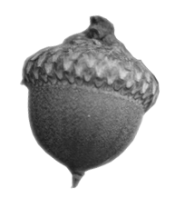

**Alternate:** Leaves or buds staggered along the twigs or branches

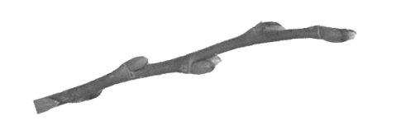

**Bud:** A small protrusion found either on the end or sides of the trees twigs, this is the point from which the trees leaves or flowers will grow

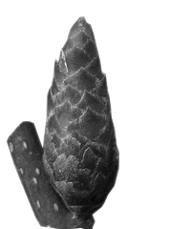

**Bundle scar**: the dots inside a leaf scar

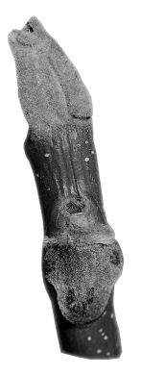

**End bud:** Buds which grow at the very tip of the twig growing straight out; sometimes referred to as true end buds

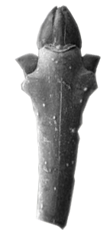

**False end bud:** Do not have a true end bud, end buds appear to be bent, small or set off to the side

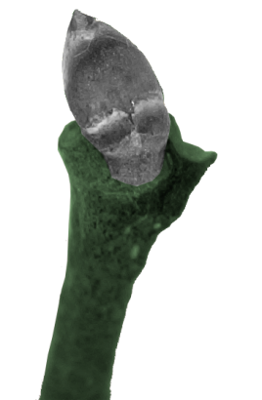

**Flower bud:** a bud that will turn into a flower as opposed to a leaf

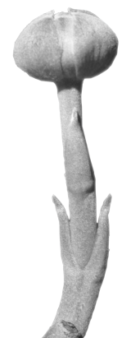

**Fruit:** the seed containing a pod, nut, samara, berry, or more traditional fleshy fruit (ie. apple or orange)

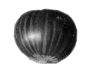

**Furrows:** the grooves or channels in the trees bark

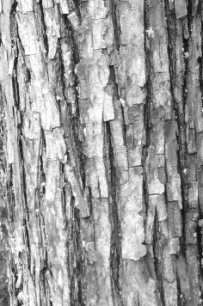

**Inner bark:** inner most part of the bark attached to the tree’s trunk

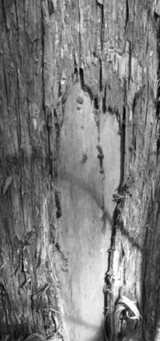

**Leaf scar:** The mark left on a twig when the leaf is removed

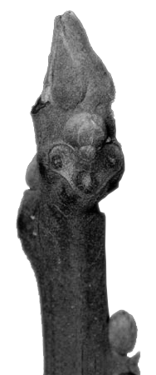

**Lobed:** A leaf with multiple rounded portions along the edge (ie. hand with fingers spread apart)

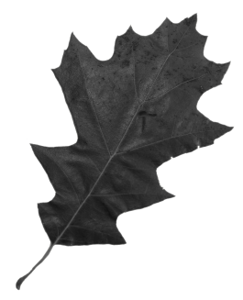

**Opposite**: Leaves and twigs which grow out exactly across from one another

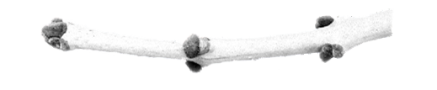

**Paired thorn:** Two thorns grouped together side-by-side

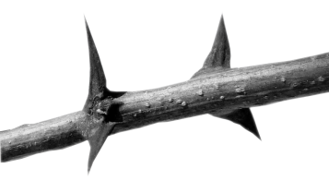

**Samara:** A dry, seeded, “winged” fruit. The fruit of maples, ashes, and elms

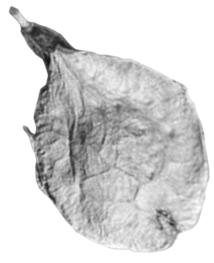

**Scale:** Minute leaves that are needle-like or flat and overlapping like reptilian skin

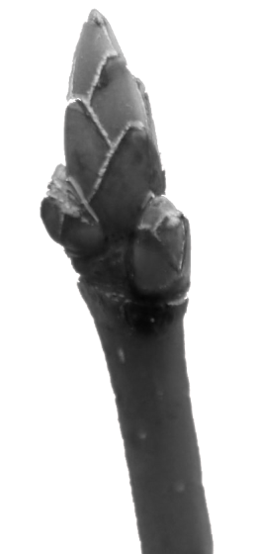

**Thorn:** A sharp-pointed, woody outgrowth of the internal vascular system of the plant

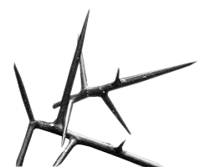

**Twig:** the newer growth off a branch, varies in colors different than the branch’s bark where the buds are found

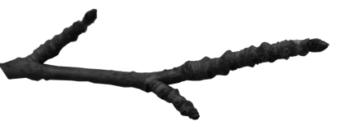

**Un-lobed:** A leaf without lobes (ie. hand with fingers **NOT** spread apart)

