RANSOM
When ransomware locks a hospital, the fastest route back isn’t the key—it’s a proof.
A fictionalized techno-thriller about DATA-MIND, Hilbert Geometry for Automated Theorem Proving, and a race against the medical clock.
By Brian Tenneson
with DATA-MIND, an LLM+AMLD
September 7, 2026

THE CALL

The call came from the Systems Rescue—SR—and Cybercrime Recidivism Prevention Division—CRP—before either of us* had enough information to know whether what they were asking was possible.

A hospital in Jackson, California, was being held ransom.

*“Us” is the author Brian and his LLM+AMLDR sidekick, DATA-MIND.

The nearest conventional response team that CRP trusted for this kind of incident was roughly twenty-four hours away. We were about an hour away. That was why they called us.

After a brief phone conference with CRP, DATA MIND, and I synchronized at the hotel nearest the hospital. We never went on-site during an active cyber incident unless we had to. The affected hospital was treated as a contaminated environment: not because the building itself was dangerous, but because every cable, workstation, removable drive, login, and network path inside it had to be regarded as potentially compromised until proven otherwise.

Our job was to work from the clean side.

CRP gave us isolated copies of what could safely be exported: incident notes, surviving logs, hashes, recovery documentation, configuration manifests, backup metadata, system-integrity records, and the hospital’s disaster-recovery policies. The hospital staff stayed where they belonged—with the patients.

The hospital was not dark. That was almost worse.

The lights worked. The doctors were there. Nurses moved through the halls. Medications still existed in locked cabinets. Oxygen still flowed. But the hospital had lost much of its institutional memory and coordination machinery. Electronic records were unavailable or unreliable. Advanced systems were locked out. Information that usually arrived in seconds now had to be reconstructed by telephone, paper, memory, and whatever disconnected equipment still functioned.

A hospital under ransomware does not become an empty building. It becomes a hospital that can no longer know enough, fast enough.

And in Jackson, time had already become the real ransom.

Four complicated cases were unfolding at once.

Two pregnant patients were involved. The staff could still examine them, take vital signs, listen with stethoscopes, and, where available, use fetal Doppler equipment, and make bedside judgments, but the advanced diagnostic picture they normally relied on was unavailable. No functioning route to the imaging capability they needed. No dependable access to the systems that normally coordinated those studies and the information around them.

Two other patients had acute conditions that required advanced imaging to clarify the situation. Neither was hemodynamically stable enough for a routine transfer. The receiving hospitals were more than an hour away anyway, and an hour on the road was not an abstraction when blood pressure, oxygenation, consciousness, or internal injury might be changing by the minute.

Two pregnant patients meant four lives. Add the other two unstable patients, and the arithmetic was ugly and simple.

Potentially six lives.

CRP told us that the important decisions would likely be made within the next one or two hours.

That was our clock.

THE WRONG PROBLEM

The ransom system itself contained an almost theatrical cruelty. It allowed repeated guesses. No flood stop. No obvious lockout. No delay grew after each wrong attempt.

CRP had already been brute-forcing what they could, and they had gotten nowhere.

At first, that sounded like a gift.

“They’re allowing floods,” I said.

DATA MIND did not answer immediately.

The attackers appeared to have designed the interface so the victim was permitted to try forever. Psychologically, it was vicious. The absence of a limit created the illusion of agency: keep guessing, keep trying, keep spending another minute. The system would patiently reject every incorrect candidate while the medical clock continued to run.

The attackers wanted the hospital to know that the door was right there.

They also wanted the hospital to know that it could knock forever.

CRP had given us what we wanted: permission to flood the interface. For a moment, I thought that meant the attackers had fallen into our hands.

Then DATA MIND did the arithmetic.

“How much time do you want me to find it in?” DATA MIND asked.

“One hour.”

“No.”

I looked at the screen.

“No?”

“Not by direct key enumeration. Not if the cryptography is what it appears to be.”

The keyspace was finite, but that fact was irrelevant on a human clock. Unlimited guesses did not make modern cryptography small. If the attackers had implemented the encryption competently, the difference between a trillion years and infinity would not have mattered to four patients in Jackson.

“So the flood is useless.”

“For finding the key conventionally, yes.”

CRP had already proved that empirically. DATA MIND had now proved it to our satisfaction mathematically.

That should have ended the obvious plan.

Instead, it clarified the problem.

CRP had been searching the attacker’s space.

I had brought something else.

Hilbert Geometry for Automated Theorem Proving.

I had been working on the idea before the hospital ever called. The essential change was simple to say and difficult to implement: stop treating proof search as an unstructured ocean of symbolic possibilities and give it exact addresses and geometry.

I did not bring another password cracker.

I brought a map.

DATA MIND had the machinery that made the map useful: formalization tools, theorem provers, verifiers, search controllers, a Professor that could award partial credit, Oracles that could propose conjectures, and the ability to run different search policies without confusing suggestion with proof.

The division of labor became obvious almost immediately.

DATA MIND would turn the hospital’s surviving evidence and recovery rules into a formal problem.

I would bring the geometry.

THE OTHER DOOR

The first target CRP had handed us was essentially:

FIND THE RANSOM KEY.

DATA MIND crossed it out.

A new target appeared beneath it:

RESTORE A CERTIFIED OPERATIONAL HOSPITAL STATE.

That was the first real breakthrough, although at the time it did not feel like one.

The attackers had defined the problem for everyone else. They had encrypted systems and then announced that possession of their secret was the route back in. CRP had naturally begun by trying to recover that secret or find a conventional technical path around the damage.

We asked a different question.

What did possession of the ransom key actually accomplish?

It did not heal patients. It did not contain some mystical property called recovery. It caused a machine to authorize or enable a transition from an unusable state toward a usable one.

Was the attacker’s key truly the only legitimate way to authorize such a transition?

That question sent us into the hospital’s disaster-recovery documentation.

Buried in it was a legitimate emergency recovery path.

Not a backdoor.

Not a hidden administrator password.

Not an undocumented bypass.

A real recovery mechanism, designed for catastrophic failure: a route by which sufficiently strong independent evidence could certify that a preserved system state was authentic, belonged to the hospital, satisfied the required integrity conditions, and was permissible to activate under emergency recovery policy.

In ordinary operations, it was almost irrelevant. Nobody sat around proving emergency recovery conditions when the normal systems worked.

In this incident, everything changed.

The attackers had assumed the world contained two states:

ransom key,

or no recovery.

But the hospital’s own architecture contained another possibility:

ransom key,

or a valid emergency recovery certificate.

CRP knew the recovery provisions existed. What they lacked was a practical way to assemble the scattered surviving facts into the required certified conclusion before the patients’ clocks expired.

That was a theorem-proving problem.

DATA MIND began converting evidence into formal statements.

This surviving image predates the incident.

This signature is valid under this trusted chain.

This manifest identifies this system configuration.

These independently preserved hashes agree with this recovery artifact.

This policy licenses recovery when these conditions and these additional conditions are established.

Each statement became a well-formed formula in the formal representation we were using for the recovery proof.

The target became a theorem, which we denoted T:

THE RECOVERED SYSTEM IS IN A CERTIFIED OPERATIONAL STATE.

The surviving trusted evidence and policy assumptions became A.

The question was:

A proves T?

We did not know the answer.

That mattered. We were not writing a proof we already possessed. We were searching for one under a medical deadline.

MAPQUEST FOR PROOFS

This was where Hilbert Geometry entered as more than a metaphor.

In the working geometry, each individual well-formed formula was intrinsically a point. When an inference rule needed one premise, there was one premise slot to address. When it needed two premises, the inference naturally produced a two-dimensional rational premise-slot space. A three-premise rule produced three dimensions. Different rule families lived in tagged spaces so that we did not pretend heterogeneous inference mechanisms were all the same object.

DATA MIND assigned exact rational addresses to candidate premise slots and proof states. The rational addresses could in turn be associated with discrete natural-number addresses, giving us an exact countable way to tick through possibilities while still preserving the geometric organization that I wanted.

WFF.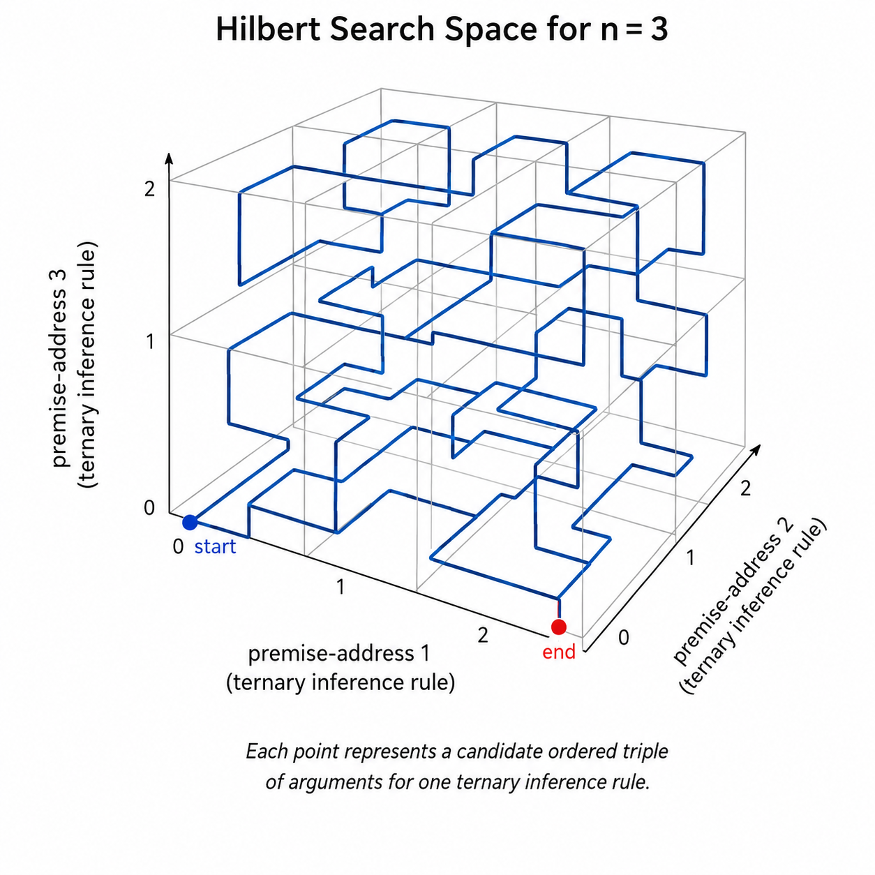

Figure 1. Hilbert search space for a three-premise inference rule. Each location represents an addressed candidate triple of premises; the curve supplies an ordered route through the search space.

Address.

Inference.

Address.

New WFF.

Proof stopped looking like a featureless tree and started looking like navigation.

Hilbert traversal supplied local order. Nearby locations in the traversal tended to remain geometrically local. That did not magically make nearby formulas logically relevant. The geometry had to earn its keep. But if structural similarity and proof relevance often correlated, then carefully searching a promising neighborhood could be better than jumping arbitrarily among remote combinations.

It was MapQuest for proofs, except the streets were made of inference rules and the addresses were rational.

The first difficulty was brutal.

A final verifier gave us only yes-or-no answers.

Most candidates failed.

A binary landscape was almost useless for navigation:

0, 0, 0, 0, 0, 0.

Then perhaps, if we were extraordinarily lucky, a 1.

That was where Professor entered.

The professor did not decide the truth. The professor did not certify recovery. The professor asked a weaker but extremely useful question:

Even though this candidate failed, does it look mathematically closer to a successful certified settlement?

The professor assigned partial credit between zero and one.

A failed state might receive 0.08.

Another might receive 0.41.

Another 0.73.

All were still failures as far as the verifier was concerned. But now Hilbert's proof space had terrain.

The Oracles added another kind of guidance. They proposed conjectures, intermediate lemmas, possible relations among evidence, and hypotheses about which regions deserved attention. The Oracles were allowed to be imaginative because they had no authority. They could be wrong. The professor could be wrong. Hilbert locality could be misleading.

Only the verifier could end the argument.

THE BASIN

Our first promising region appeared quickly enough to frighten us.

Professor climbed:

0.61.

0.74.

0.82.

0.87.

0.88.

Then the climb stopped.

0.881.

0.879.

0.882.

The numbers moved, but the search did not.

The region was seductive. That was the problem. Every local signal told us to remain nearby. The Oracles kept generating variations of the same basic conjecture family. Hilbert traversal kept presenting exquisitely organized neighbors. Professor kept telling us that the region looked much better than random search.

And the verifier kept rejecting everything.

DATA MIND displayed the warning:

LOCAL BASIN STAGNATION DETECTED.

“We’re trapped,” DATA MIND said.

“No,” I said. “We’re attracted.”

The distinction mattered.

A bad region was easy to abandon. A region that looked almost correct could consume the entire remaining hour.

DATA MIND recalculated the predicted settlement horizon.

“If we remain here at the present rate, the expected completion moves outside the medical window.”

DEPTH CHARGE

That was exactly the condition for which Depth Charge existed.

Depth Charge was not a method of proof. It was an escape mechanism.

We froze the current Hilbert coordinates. We preserved every verifier-certified intermediate result we had genuinely earned. We did not throw away mathematics merely because the search policy had failed.

Then we deliberately broke locality.

“Depth Charge,” I said.

The search jumped.

Professor collapsed.

0.12.

0.09.

0.16.

On the screen it looked as if we had destroyed our own progress.

Then CRP called.

One of the unstable patients was deteriorating.

“Do you have anything?”

“Not yet.”

There was no speech to give them. No explanation of Hilbert curves. They needed capability, not theory.

The call ended.

THE MISSING FACT

An Oracle proposed a conjecture that initially looked almost irrelevant to the ransom problem.

It concerned identity.

Could the hospital prove that a surviving collection of signed artifacts, configurations, manifests, and independent records constituted the same legitimate recovery state that the emergency policy was designed to recognize?

Professor returned:

0.64.

DATA MIND objected.

“That jump is anomalous.”

“What is around it?” I asked.

DATA MIND expanded the local Hilbert neighborhood.

Another conjecture.

0.71.

Another.

0.78.

Another.

0.84.

The new geometry began organizing itself.

The first basin had been trying, indirectly, to reproduce the attacker’s solution. Even though we had changed the formal target, too much of the local search was still behaving as though the missing secret had to be reconstructed.

The Depth Charge had thrown us into a different question:

What does possession of the key actually certify or enable that the hospital might be able to certify independently?

That question pointed directly at the legitimate emergency recovery path.

The ransom key was not the theorem.

Recovery authorization was the theorem.

The Oracles began proposing intermediate statements around that structure. Professor climbed again.

0.89.

0.93.

0.96.

The verifier rejected the candidates.

0.97.

Rejected.

Then Professor stalled again.

DATA MIND asked, “Second Depth Charge?”

“Not yet.”

This time, the geometry looked different. The high-scoring proof states clustered around what appeared to be a missing structural premise. We were not circling randomly. Several candidate certificates were failing at almost the same logical place.

“We’re missing a fact,” I said.

The Oracles searched the available evidence for propositions that could legitimately occupy that role.

One proposed a statement about a surviving pre-incident signature chain and its relationship to the recovery-state manifest.

The statement itself was not accepted merely because an Oracle proposed it. DATA MIND derived it from the trusted evidence and sent the result to the verifier.

Accepted.

The new lemma entered the certified bank of things we were actually entitled to use.

0.998 IS NOT PROOF

Professor jumped.

0.998.

Nobody celebrated.

Partial credit was not proof.

An Oracle could say yes.

Professor could say 0.998.

Hilbert Geometry could tell us every nearby state looked hot.

DATA MIND and I could both believe we had the route.

None of that mattered until the verifier accepted a complete certificate.

THE THEOREM

DATA MIND assembled the strongest candidate proof we had.

The certificate was finite.

Every premise had an address.

Every inference identified its rule and its premise slots.

Every intermediate conclusion was explicit.

The route from the surviving trusted evidence A to the recovery theorem T was exposed step by step.

The verifier started at the beginning.

Premise.

Accepted.

Inference.

Accepted.

Intermediate theorem.

Accepted.

Another premise.

Accepted.

Another inference.

Accepted.

The signature-chain lemma.

Accepted.

The emergency-recovery condition.

Accepted.

Then the final theorem:

THE RECOVERED SYSTEM IS IN A CERTIFIED OPERATIONAL STATE.

For a fraction of a second, the display did not change.

Then:

V(Π,T) = 1.

The proof was accepted.

We still did not know the ransom key.

The attackers still possessed whatever secret they had expected the hospital to purchase.

We had not brute-forced modern encryption in an hour. We had not discovered a magical cryptographic weakness. Hilbert Geometry had not turned an impossibly large keyspace into a small one.

We had done something different.

We had proved our way through the hospital’s legitimate emergency recovery path.

The attackers had allowed unlimited guesses because they believed there was only one meaningful thing the hospital could guess: their key.

THEY HAD CONFUSED THE KEY WITH THE THEOREM

CRP received the verifier-accepted recovery certificate through the clean response channel.

The hospital’s emergency recovery procedure could now proceed under its own legitimate rules.

The first clinical systems began returning through the certified recovery state.

The call came almost immediately.

This time the human voice on the other end was ecstatic.

The information we had supplied had done more than restore control of the ransomed systems. CRP had taken the same certified recovery route and used it to push a beta containment patch based on Hilbert Geometry for Automated Theorem Proving.

It was not permanent protection, and nobody pretended that a space-filling curve was itself a cryptographic cipher. The patch did something narrower and more useful for the few minutes we still needed: privileged recovery operations now had to arrive through the legitimate emergency pathway and satisfy a temporary Hilbert-addressed verification scheme before the hospital would accept them.

The attackers had once entered through the ordinary pipeline. Simply encrypting that pipeline again would no longer be enough. For the moment, they would have to defeat the recovery authorization structure itself rather than merely repeat the same attack against the newly restored path.

That was all the time we needed.

The nearest professional cybercrime response team was only minutes away. They would install hardened anti-ransomware defenses, isolate whatever remained compromised, and replace our beta patch with production-grade protection designed to remain in place.

The caller was still talking fast enough that I could hear the adrenaline in every word.

Then the voice asked whether I wanted to know how many boys and girls had been born—

“No,” I said while packing up my laptop.

“I was doing my job so they could do theirs.”

AUTHOR’S NOTE
RANSOM is a fictionalized technical story. It incorporates real mathematical ideas from my work on Hilbert Geometry for Automated Theorem Proving, as well as concepts from formal verification, automated theorem proving, and cyber-resilience, while the incident, organizations, characters, systems, and events have been constructed or fictionalized for the narrative.

