Whitepaper – Demo 1

Link to code repository: [btgrbo/GCP_ML_Demos (github.com)](https://github.com/btgrbo/GCP_ML_Demos)

1. Introduction

In the dynamic landscape of urban transportation, leveraging technology for competitive advantage is key. This whitepaper presents an innovative approach implementing an end-to-end TensorFlow pipeline on the Google Cloud Platform (GCP) to optimize taxi fare predictions in Chicago based on the [Chicago taxi trips dataset](https://www.kaggle.com/chicago/chicago-taxi-trips-bq). While the core of our project involves developing a Deep Neural Network (DNN) for fare prediction, the crux of this paper is the sophisticated MLOps framework that enables such machine learning endeavours.

Our system harnesses critical data points—pickup and drop-off coordinates, timestamps, and distance—to feed into a DNN model. However, the spotlight is on the orchestration of this process within GCP's ecosystem. We demonstrate how Vertex AI, Dataflow and other GCP services are leveraged not just for model training and evaluation, but more importantly, for creating a scalable, efficient, and robust MLOps pipeline.

The integration of our model into the operational workflow of a taxi company is envisioned to be a hallmark of adaptive pricing strategies. The model’s predictions inform a dynamic pricing engine, which is part of a broader, automated MLOps pipeline. This pipeline ensures real-time responsiveness to market conditions, enhancing the agility of pricing decisions. The seamless automation in model retraining, deployment, and monitoring exemplifies the power of a well-architected MLOps infrastructure.

In this whitepaper, we delve into the intricacies of building and managing this MLOps infrastructure in GCP. We aim to provide a blueprint for effectively using cloud-based tools and services to deploy machine learning models in a production environment. The ensuing sections will detail the MLOps architecture, the challenges we navigated, and the best practices we established, offering valuable insights for organizations aspiring to harness the potential of MLOps in operational optimization.

1. Business Goal: Optimizing Pricing Strategy Through Predictive Analytics

The primary business goal of our project is to revolutionize the way taxi fares are determined and optimized, harnessing the capabilities of machine learning within the robust framework of GCP's MLOps infrastructure. In an industry where pricing decisions can significantly impact both market competitiveness and profitability, our goal is to empower the taxi company with a data-driven, dynamic pricing model.

Enhancing Revenue Management: Central to our business objective is the enhancement of revenue management. The traditional approach to taxi fare calculation, often a fixed rate based on distance and time, does not account for fluctuating demand, traffic patterns, or other situational variables. Our solution aims to integrate these dynamic factors, enabling the company to adjust fares in real-time. This responsiveness to market conditions can lead to an increase in revenue, particularly during peak demand times or in high-demand zones.

Operational Efficiency and Scalability: Implementing an MLOps-based approach also addresses the goal of operational efficiency. Automating the model training, deployment, and monitoring processes reduces manual intervention, minimizes errors, and speeds up response times. Scalability is a key consideration; as the company grows and data volumes increase, the infrastructure is designed to scale seamlessly, ensuring that the fare prediction system remains robust and reliable.

Long-Term Strategic Vision: Finally, this project aligns with the company's long-term strategic vision of being a data-centric organization. By adopting advanced analytics and machine learning, the company is not just optimizing for the present but also building a foundation for future innovations in areas like personalized customer experiences, operational optimization, and expanded service offerings.

In conclusion, the business goal of this project extends beyond the technical accomplishment of developing a predictive model. It is about transforming the core pricing strategy of the taxi company, making it more adaptive, efficient, and forward-looking. This shift towards a more data-driven approach is expected to yield significant competitive advantages and set a new standard in the urban transportation industry.

1. Machine Learning Solution: Deep Neural Network for Enhanced Fare Prediction

At the heart of our project lies a sophisticated Deep Neural Network (DNN), designed to predict taxi fares with unprecedented accuracy and efficiency. This model represents a significant leap in our capability to process and interpret complex, multidimensional data. The model’s hyperparameter were determined by a hyperparameter tuning outlined in section Hyperparameter Tuning.

The model handles both continuous as well as categorical variables. Categorical variables include 'day_of_week', 'start_month', 'start_day', 'start_hour', and 'start_minute' while 'trip_seconds', 'trip_miles', 'pickup_latitude', 'pickup_longitude', 'dropoff_latitude', and 'dropoff_longitude' represent continuous variables. Both types of variables undergo preprocessing which is detailed in the section Preprocessing.

Our DNN consists of multiple layers, each designed to extract and process different levels of abstractions from the input data. The architecture includes input layers, several hidden layers with a configuration of [64, 32, 16] neurons each, and an output layer for regression output. Interspersed, we included dropout layers (20%) to reduce overfitting. Similarly, overfitting was reduced by including We employ the non-linear activation function ReLU (Rectified Linear Unit) in the hidden layers to introduce non-linearity into the model, enabling it to capture complex patterns in the data. The model uses the ADAM optimizer, known for its efficiency in handling sparse gradients and its adaptiveness in different problem settings. The loss function is tailored for regression, focusing on minimizing the error in fare prediction.

The DNN is trained on a substantial subset of the Chicago Taxi Driver dataset, ensuring a comprehensive learning process. We use a split of training and validation data (80%/20%) to fine-tune the model parameters and prevent overfitting. The model's performance is evaluated using the mean-squared-error metric, ensuring its predictions are as close to the actual fares as possible.

Once trained, the DNN model is integrated into the taxi company's pricing system, providing real-time fare predictions. This integration represents a significant enhancement over traditional fare calculation methods, offering a more responsive, data-driven approach to pricing.

Moving forward, we plan to continually refine the DNN model by incorporating more granular data, exploring advanced neural network architectures, and implementing continuous learning mechanisms to adapt to changing market dynamics.

In conclusion, the deployment of this DNN model marks a pivotal advancement in utilizing deep learning for practical, business-critical applications. It stands as a testament to the potential of AI in transforming industry practices, offering a glimpse into the future of intelligent transportation systems.

1. Data Exploration and Data Quality

In the first step, data was loaded into a table in BigQuery (bt-int-ml-specialization.demo1.taxi_trips). In BigQuery Studio, we then tested for any duplicate entries by comparing the total row count to the distinct unique_key counts and found no difference. Hence, the dataset does not include any duplicate entries (SQL line number).

Next, we took advantage of the ‘SCHEMA’ tab to get an overview of the variables included in the dataset: unique_key, taxi_id, trip_start_timestamp, trip_end_timestamp, trip_seconds, trip_miles, pickup_census_tract, dropoff_census_tract, pickup_community_area, dropoff_community_area, fare, tips, tolls, extras, trip_total, payment_type, company, pickup_latitude, pickup_longitude, pickup_location, dropoff_latitude, dropoff_longitude, dropoff_location.

Since our business goal is to predict taxi fare prices in real-time, we chose the variable ‘fare’ as our target. While there are many more variables which collect information about the costs associated with a ride, i.e., tips, tolls, extras, and trip_total, the variable ‘fare’ represents the main source of income and thus also the adjusting screw for our dynamic pricing.

We then eliminated variables from the dataset which do not serve our business goal. These variables include:

* unique_key: The unique identifier for the trip serves as primary key for the table but does not carry predictive information for the fare.
* taxi_id: The taxi_id is a unique identifier for the taxi. The taxi_id might contain predictive information for the fare since a taxi_id is tied to a specific company with a specific pricing strategy. A given taxi_id will also be associated with a number of seats and a certain level of fuel consumption. Yet, this information is extremely sparse since the dataset contained approximately 10.000 different taxi_ids. We thus did not use the taxi_id as input to our model even though future, fine-tuned approaches might as well consider it.
* trip_end_time: Because we considered trip_start_timestamp and trip_seconds, we argue that trip_end_time should not deliver additional value to our prediction.
* pickup/dropoff_census_tract: While pickup and drop-off location will certainly explain variability in the target variable, the census tract variables yielded a high percentage of missing values (~37%). This can be explained by the fact that for some trips census tract is not included in the data for privacy reasons. As a measure for pickup and drop-off location we hence focused on the latitude and longitude coordinates of the center of the census tract.
* pickup/dropoff_community_area: The community area represents another variable describing the start and end location of the trip. However, compared to the census tract it is less fine-grained since it comprises a larger area. We hence focused on the latitude and longitude coordinates of the center of the census tract.
* tips: We did not consider tips. The size of the tip is information that is only available after the trip has ended and is therefore not suited for our model that should enable us to find a right price before the trip starts.
* tolls: We did not consider tolls because in 99.9% of the trip’s tolls were either 0 or missing.
* extras: Similarly, extras was 0 or missing for 63% of the trips. This together with the fact that little information was provided with respect to what these extras included, we excluded it from the inputs to the model.
* trip_total: Because our target variable was fare and none of the other variables included in trip_total (tips, tolls, and extras) was of significance, we excluded it.
* payment_type: Like tips, payment type is only available at the end of the trip and therefore does not enable us to set the fare for the trip.
* company: We did not consider information regarding the taxi company since our use case aims to provide a dynamic pricing model for one specific company.
* pickup/dropoff_location: Because we included pickup/dropoff/longitude/latitude in our model, we discarded pickup/dropoff_location as these variables represent redundant information.

Based on these exclusions we were left with a table containing 8 fields: trip_start_timestamp, trip_seconds, trip_miles, fare, pickup_latitude, pickup_longitude, dropoff_latitude, dropoff_longitude.

For these fields we investigated the percentage of missing values (Table 1). We found that for the fields trip_start_time, fare, trip_seconds and trip_miles missing values occurred rarely (<1%), while pickup/dropoff/latitude/longitude were missing in 11,41% and 13,26% respectively.

|  |  |
| --- | --- |
| Field | Missing Values (%) |
| trip_start_time | 0,00 |
| fare | 0,01 |
| trip_seconds | 0,62 |
| trip_miles | 0,00 |
| pickup_latitude | 11,41 |
| pickup_longitude | 11,41 |
| dropoff_latitude | 13,26 |
| dropoff_longitude | 13,26 |

Table 1 Percent of values missing per field.

For the float variables fare, trip_seconds, and trip_miles we expected positive values greater than 0. To investigate if the data meets our expectations, we computed for these three variables the percentage of values smaller or equal to 0.

|  |  |
| --- | --- |
| Field | Values <= 0 (%) |
| fare | 0,14 |
| trip_seconds | 5,09 |
| trip_miles | 20,85 |

Table 2 Percent of values smaller or equal to 0.

Furthermore, we assumed that trip_start_timestamp is smaller than trip_end_timestamp. Running the query, we found that 37,79% of the data violated this assumption with the trip_start_timestamp being greater or equal to the trip_end_timestamp.

To get a better understanding for the distribution of the float variables fare, trip_seconds, trip_miles, pickup_latitude, pickup_longitude, dropoff_latitude, and dropoff_longitude we computed descriptive statistics (Table 3).

|  |  |  |  |  |  |
| --- | --- | --- | --- | --- | --- |
| Fieldname | Count | Mean | Standard deviation | Minimum | Maximum |
| dropoff_latitude | 183593808 | 41,90 | 0,04 | 41,65 | 42,02 |
| dropoff_longitude | 183593808 | -87,66 | 0,06 | -87,91 | -87,53 |
| fare | 211634435 | 13,81 | 45,52 | 0,00 | 9999,99 |
| pickup_latitude | 187506981 | 41,90 | 0,04 | 41,65 | 42,02 |
| pickup_longitude | 187506981 | -87,66 | 0,08 | -87,91 | -87,53 |
| trip_miles | 211652596 | 3,48 | 11,08 | 0,00 | 3460,00 |
| trip_seconds | 210352969 | 818,94 | 1280,80 | 0,00 | 86400,00 |

Table 3 Descriptive statistics for the three float variables fare, trip_seconds, trip_miles, pickup_latitude, pickup_longitude, dropoff_latitude, and dropoff_longitude.

Analogously, we extracted count, first occurrence, last occurrence, and range of days for the timestamp trip_start_timestamp.

|  |  |  |  |  |
| --- | --- | --- | --- | --- |
| Field | Count | First Occurrence | Last Occurrence | Range Days |
| trip_start_timestamp | 211655493 | 01.01.2013 | 01.01.2024 | 4017 |

Table 4 Descriptive Statistics for trip_start_timestamp.

The data exploration yielded valuable insights with regards to data preprocessing, feature engineering, and model architecture.

That is, data preprocessing needs to include steps to clean data from inconsistencies such as entries for which trip_start_timestamp is greater or equal to trip_end_timestamp and methods to cope with missing values. In particular, for the location variables pickup/dropoff_longitude/latitude we found a significant number of entries with missing values. Furthermore, large standard deviations and value ranges as for instance found for the variable trip_seconds impose the need for eliminating outliers and applying standardization techniques to normalize the distribution.

Data exploration helped preparing feature engineering in several ways. First, exploring the dataset enabled us to identify our target variable ‘fare’, variables that can serve as predictors such as trip_miles or trip_seconds, and variables that can be neglected because they are either not relevant, e.g., payment_type or constitute redundant information, e.g., pickup_location. Second, we learnt that temporal information is condensed into two fields: trip_seconds and trip_start_timestamp. trip_start_timestamp can be dissolved into several features that might be relevant for the prediction of taxi fares. The timestamp can be split into a month, day, hour, and minute component each of which might yield predictive power. Fares can for instance be smaller at daytime when taxis are competing with public transportation while they might be larger at night when less transportation is available. Besides splitting the timestamps into its different components, one can extract the day of the week. We suggest that fares could be larger on weekends when bars, restaurants, and theatres lure potential customers into the city. Given that we will feed these categorical variables into our model, the feature engineering will need to involve one-hot-encoding.

Lastly, exploring the data also helped to get a first idea of the design of our DNN. DNNs vary in size and can comprise a single hidden layer with few neurons up to hundreds of hidden layers with a multitude of neurons. While large neural networks are associated with complex task such as processing image input where each pixel-channel-combination serves as distinct feature, they are less well suited for simple problems where they risk to overfit to the training data. Given our restricted number of inputs, we will aim for a shallow neural network with few layers. Furthermore, we found that data quality is impaired by missing values and inconsistencies. While we can reduce some of the noise by the preprocessing steps, we will for our network architecture also consider dropout and regularization techniques to prevent the model from overfitting to noisy training data.

1. Feature Engineering

Exploring the data, we determined our target variable to be fare. To predict fare, we focus on 7 variables: trip_start_timestamp, trip_seconds, trip_miles, pickup_latitude, pickup_longitude, dropoff_latitude, dropoff_longitude.

To avoid feeding into our model entries with missing values, we eliminated those from our dataset. We further restricted the data to consistent entries. That is, we excluded entries where either fare, trip_seconds, or trip_miles was smaller or equal to zero. Finally, we discarded entries where trip_end_timestamp was smaller or equal to trip_start_timestamp. Although this approach eliminated 52.53% of the data, the resulting set still comprised 100.473.417 records and was both cleaner and more consistent.

To deal with outliers, we next exported 1 million records and analysed the data in Python. For fare, trip_seconds, and trip_miles we plotted histograms. As revealed during data exploration we found that histograms were dominated by outliers (Figure 1A). By visual inspection, we determined a threshold to eliminate outliers. We set the threshold to < 80 for fare, < 6000 for trip_seconds, and < 30 for trip_miles (Figure 1B). We then standardized data by subtracting the mean and dividing by the standard deviation (Figure 1C).

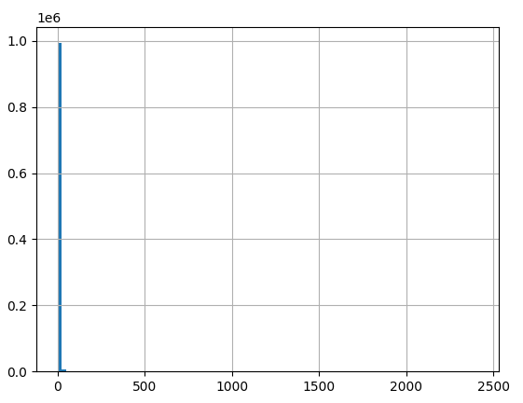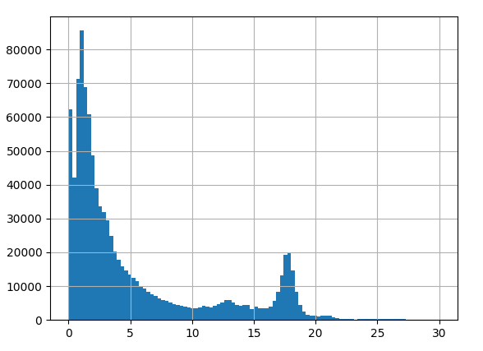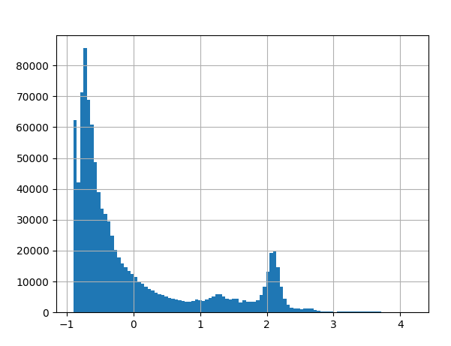

Figure 1 Feature engineering trip_miles. To determine a threshold for outliers we plotted the distribution of trip_miles (A). By visual inspection we then set the threshold to eliminate outliers (B). Finally, data was standardized by subtracting the mean and dividing by the standard deviation (C). This procedure was adopted for trip_seconds and fare.

From the trip_start_timestamp we extracted the features day_of_week, start_month, start_day, start_hour, and start_minute applied one-hot-encoding.

To shed light on the importance of our selected features, we fit a DNN. To this end, exported data was split into a training and test set (80%/20%). The data was then used to train a simple DNN with one input layer, a hidden layer comprising 32 units and an output layer with a single unit. For the hidden layer we chose a ReLU activation function and for the output layer a linear activation function. We set the learning rate to 0.001, batch size to 32, number of epochs to 10 and the loss function to minimize the mean squared error. Additionally, we applied the ADAM optimizer. Despite its simplicity, the model fit the data well yielding an R² of 0.97.

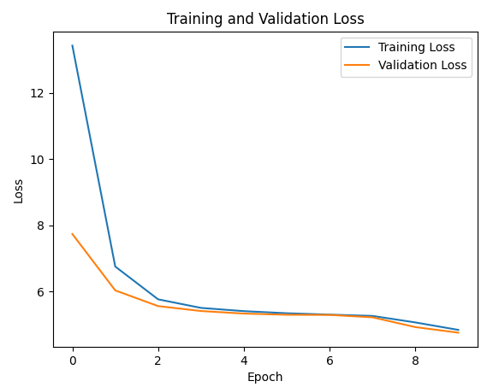

Figure 2 Training and validation loss for a DNN fit to the training dataset.

We then determined feature importance by

Partners must describe the following:

● What feature engineering was performed

● What features were selected for use in the machine learning model and why

Evidence must include a description (in the whitepaper) of the feature engineering performed (and rationale for the same), what original and engineered features were selected for incorporation as independent predictors in the machine learning model, and why. Evidence must include code snippets detailing the feature engineering and feature selection steps.

Preprocessing and the data pipeline

The partner must describe the data preprocessing pipeline, and how this is accomplished via a package/function that is a callable API (that is ultimately accessed by the served, production model). Evidence must include a description (in the whitepaper) of how data preprocessing is accomplished using Dataflow, BigQuery and/or Dataproc, along with the code snippet that performs data preprocessing as a callable API.

The model handles both continuous as well as categorical variables. Categorical variables include 'day_of_week', 'start_month', 'start_day', 'start_hour', and 'start_minute'. These features undergo one-hot encoding to convert them into a format that the neural network can process, capturing the cyclical nature of time-based data. Continuous variables 'trip_seconds', 'trip_miles', 'pickup_latitude', 'pickup_longitude', 'dropoff_latitude', and 'dropoff_longitude' were cleaned from outliers and standardized to ensure consistent scale. This step is crucial for the DNN to effectively weigh these features during training.

Machine learning model design and selection

Partners must describe the following:

● Which machine learning model/algorithm(s) were chosen for demo #1

● What criteria were used for machine learning model selection

Evidence must describe (in the whitepaper) selection criteria implemented, and the specific machine learning model algorithms that were selected for training and evaluation purposes. Code snippets detailing the model design and selection steps must be enumerated.

Machine learning model training and development

Partners must document the use of Vertex AI or Kubeflow for machine learning model training, and describe the following:

* Dataset sampling used for model training (and for independent dev/test datasets) and justification of sampling methods
* Implementation of model training, including adherence to Google Cloud best practices for distribution, device usage, and monitoring
* The model evaluation metric that is implemented, and a discussion of why the implemented metric is optimal given the business question/goal being addressed
* Hyperparameter tuning and model performance optimization
* How bias/variance were determined (from the train-dev datasets) and tradeoffs used to influence and optimize machine learning model architecture

--- requirements ---

Partners must provide documentation of where the data of demo #1 is stored within Google Cloud (for access by the machine learning models during training, testing, and in production). Evidence must include the project name and project ID for the Google Cloud Storage bucket or BigQuery dataset with the data (for demo #1).