SQL Assignments

Assignment 1

1. Write a query to get a Product list (id, name, unit price) where current products cost

less than $20.

select ProductID, ProductName, UnitPrice from dbo.Products where UnitPrice < 20 and Discontinued != 0

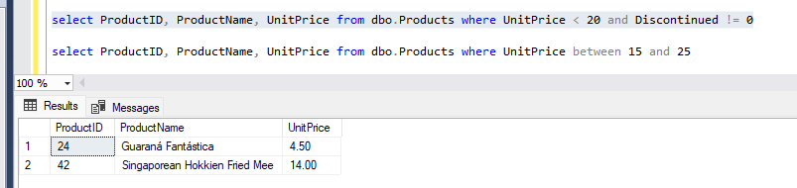

2. Write a query to get Product list (id, name, unit price) where products cost between

$15 and $25

select ProductID, ProductName, UnitPrice from dbo.Products where UnitPrice between 15 and 25

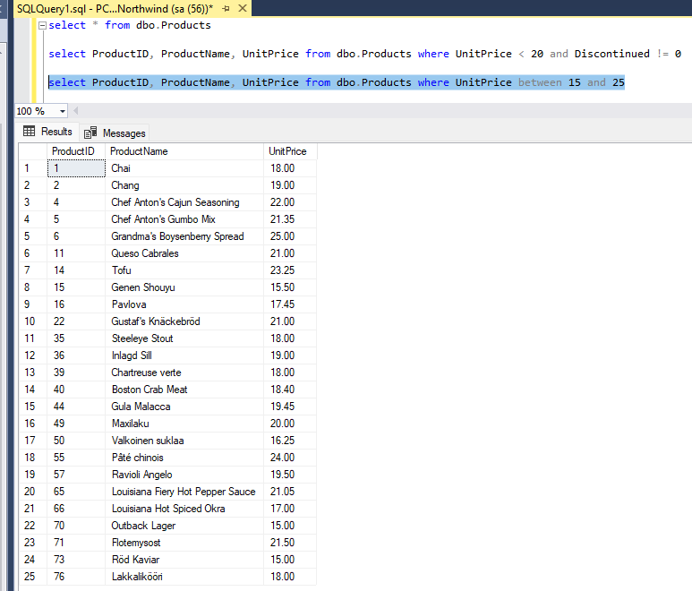

3. Write a query to get Product list (name, unit price) of above average price.

select ProductName, UnitPrice from dbo.Products where UnitPrice > (select avg(UnitPrice) from Products)

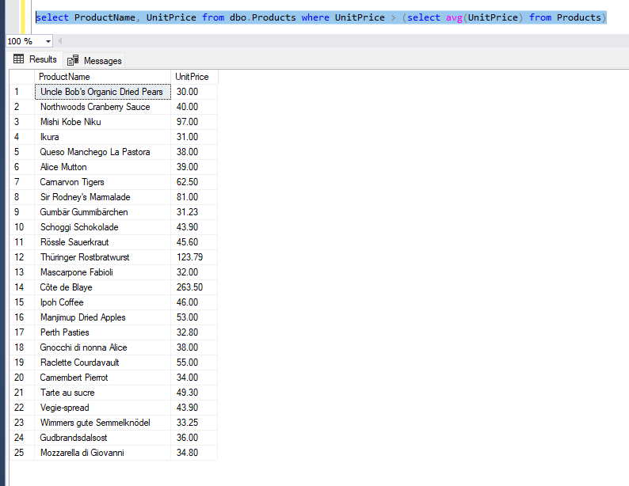

4. Write a query to get Product list (name, unit price) of ten most expensive products

select TOP 10 UnitPrice, ProductName from dbo.Products order by UnitPrice DESC

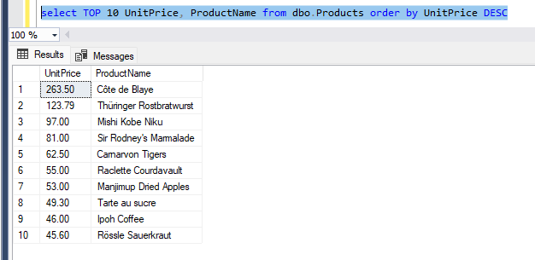

5. Write a query to count current and discontinued products

select count(ProductID) from dbo.Products group by Discontinued

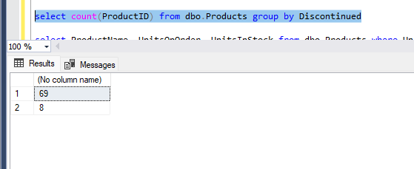

6. Write a query to get Product list (name, units on order , units in stock) of stock is less

than the quantity on order

select ProductName, UnitsOnOrder, UnitsInStock from dbo.Products where UnitsInStock<UnitsOnOrder

