**FlyAway Project Screenshots**

By Binu Thankachan

|  |  |
| --- | --- |
| **Version # and Author** | **Version History** |
| 1.0 – Binu Thankachan | Created document with project screenshots |
|  |  |
|  |  |

Contents

FlyAway web application customer landing page screenshot 3

Screenshot of when a customer clicks “Search for flights” on landing page 4

Screenshot of flights database table 4

Screenshot of customer entering information on the “Search for flights” page 5

Screenshot of next page of flight results with a flight “Book” option for each flight 5

Screenshot of next page after clicking ‘Book’ link 5

Screenshot of customer filling in their registration info 6

Screenshot of next screen after customer clicks Register button 7

Screenshot of customer filling in the screen with payment and billing information 7

Screenshot of next screen (Confirm and Submit) after customer clicks ‘Submit Payment Info’ button 8

Screenshot of next screen after customer clicks ‘Submit Booking’ button 10

Screenshot of booking table in database showing record with id 3 that was added 10

Screenshot of customer table in database showing record with id 26 that was added as part of the booking 10

Screenshot of flight table in database showing record with id 5 that is part of the booking 11

Screenshot of payment_details table in database showing record with id 22 that was added as part of the booking 11

Screenshot of when a customer clicks “List all flights” (this is an additional feature not requested by the project specifications) 13

Screenshots of when a user clicks “Login as an Admin” on landing page 14

Screenshot of when wrong login credentials are entered 15

Screenshot of when correct Admin credentials are entered, the Admin portal is shown 15

Screenshot of when an Admin user clicks “Update Password” 17

Screenshot of user passwords in user table in database before updating password 17

Screenshots of entering a value on Update Password page for user “sam7” and clicking Update 18

Screenshot of user database table after updating user “sam7”’s password to “def123” using the “Update Password” page 19

Screenshot of logging back in with “sam7” and new password “def123” 19

Screenshot of flight table in database 21

Screenshot of clicking “Master List of Airlines” 21

Screenshot of clicking “Master List of Airports” 22

Screenshots of a customer before attempting to access a restricted Admin page and the error page they are displayed after they hit enter 23

# FlyAway web application customer landing page screenshot

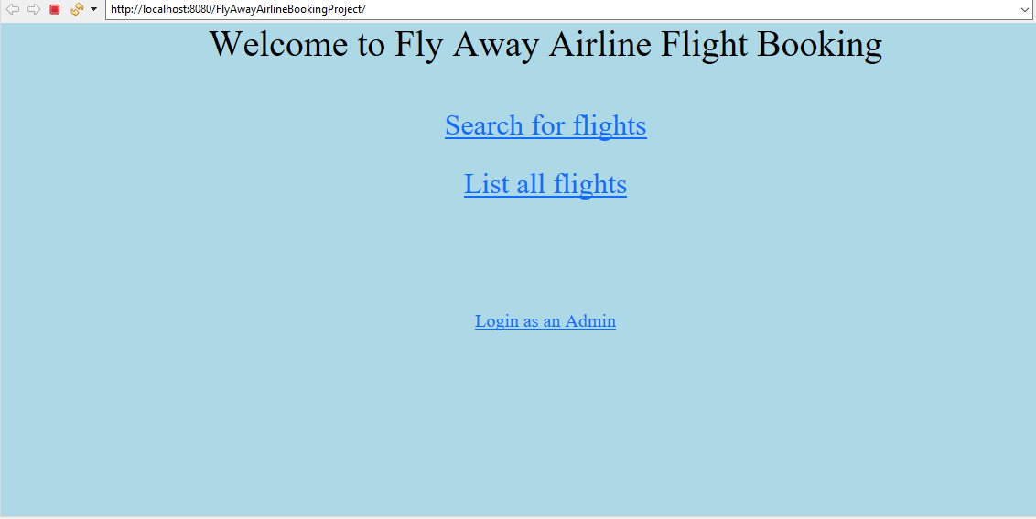

# Screenshot of when a customer clicks “Search for flights” on landing page

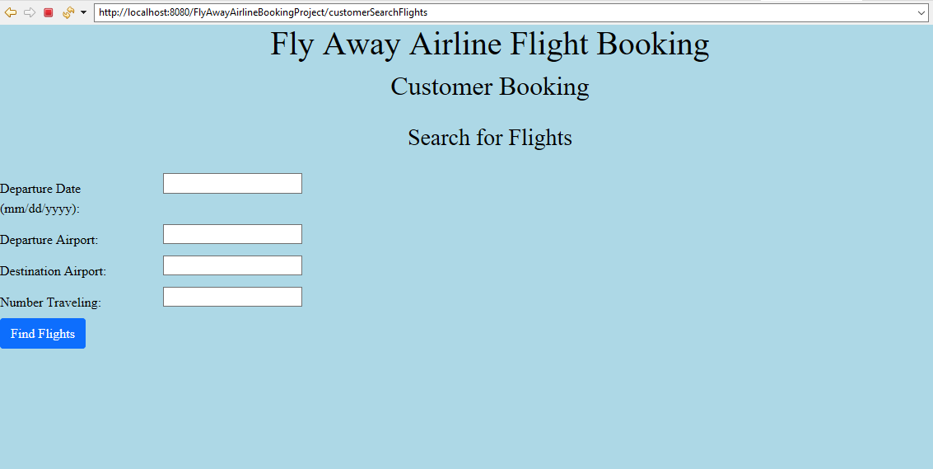

## Screenshot of flights database table

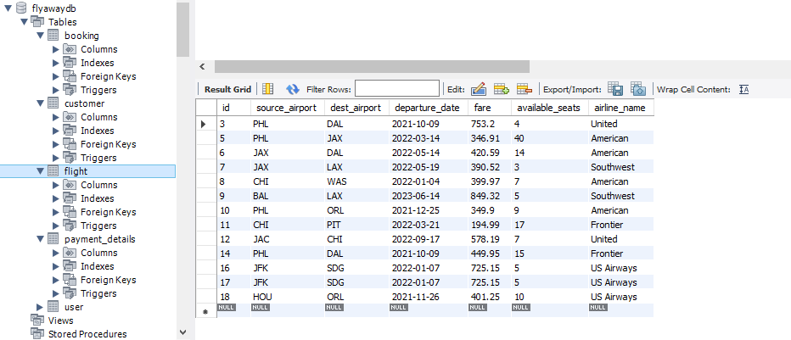

## Screenshot of customer entering information on the “Search for flights” page

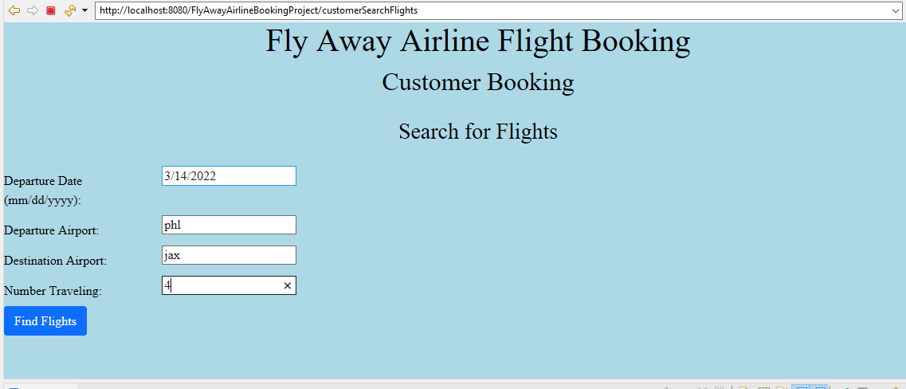

## Screenshot of next page of flight results with a flight “Book” option for each flight

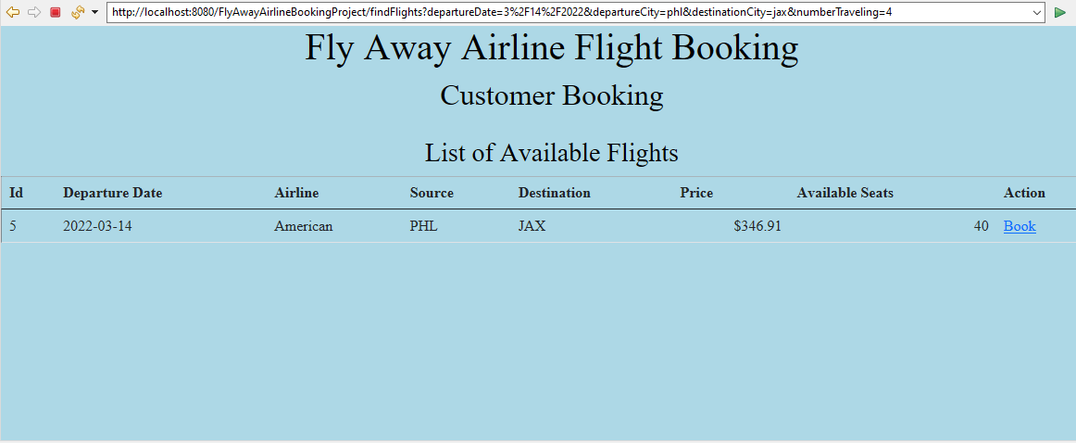

## Screenshot of next page after clicking ‘Book’ link

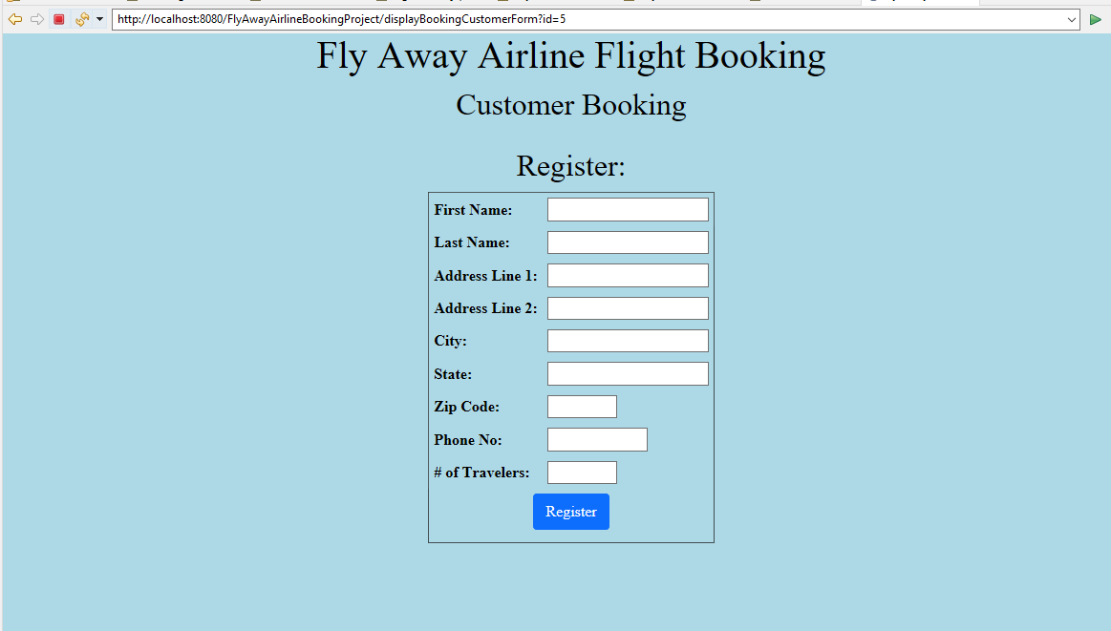

## Screenshot of customer filling in their registration info

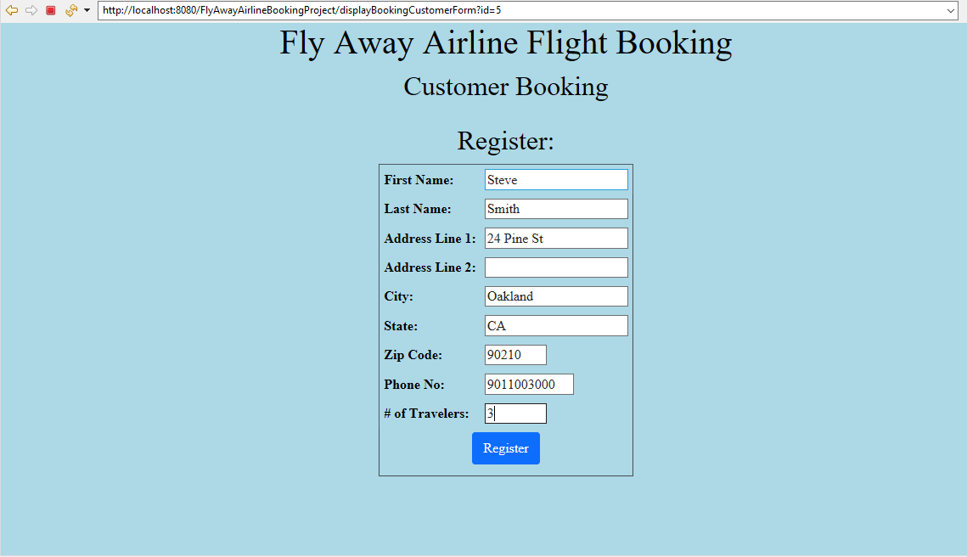

## Screenshot of next screen after customer clicks Register button

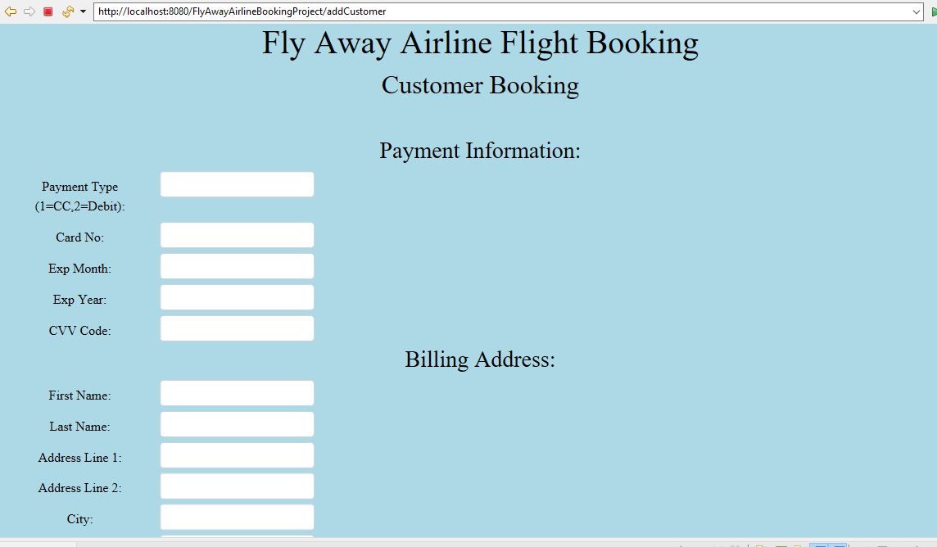

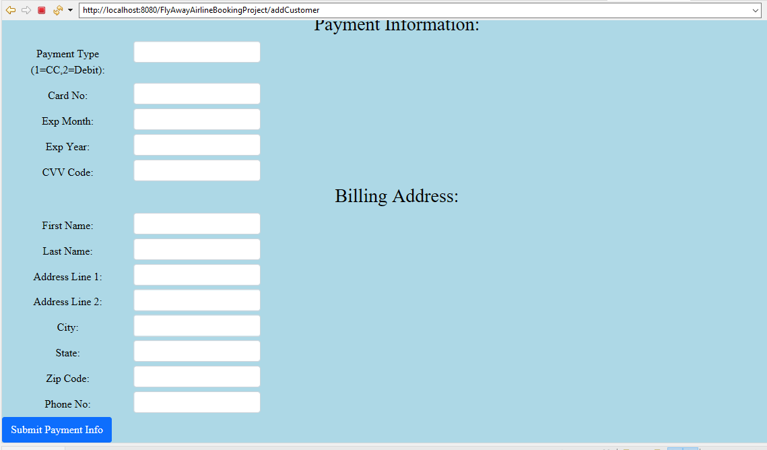

## Screenshot of customer filling in the screen with payment and billing information

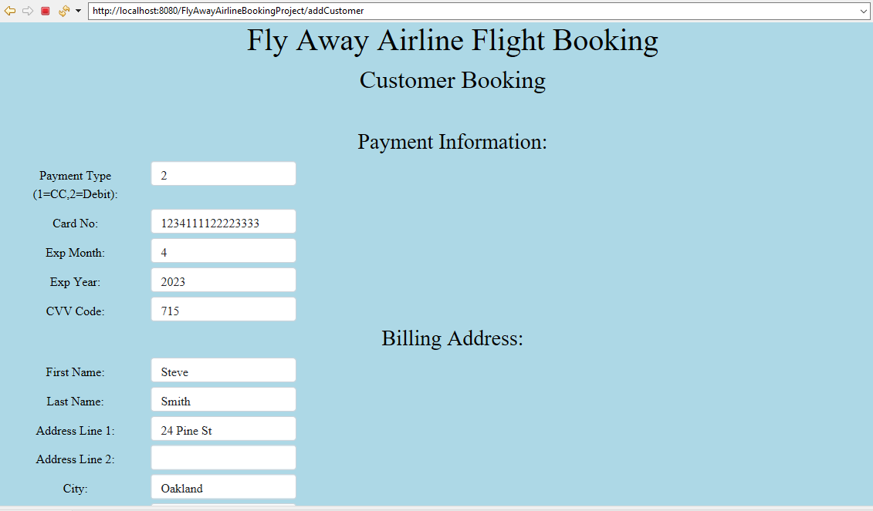

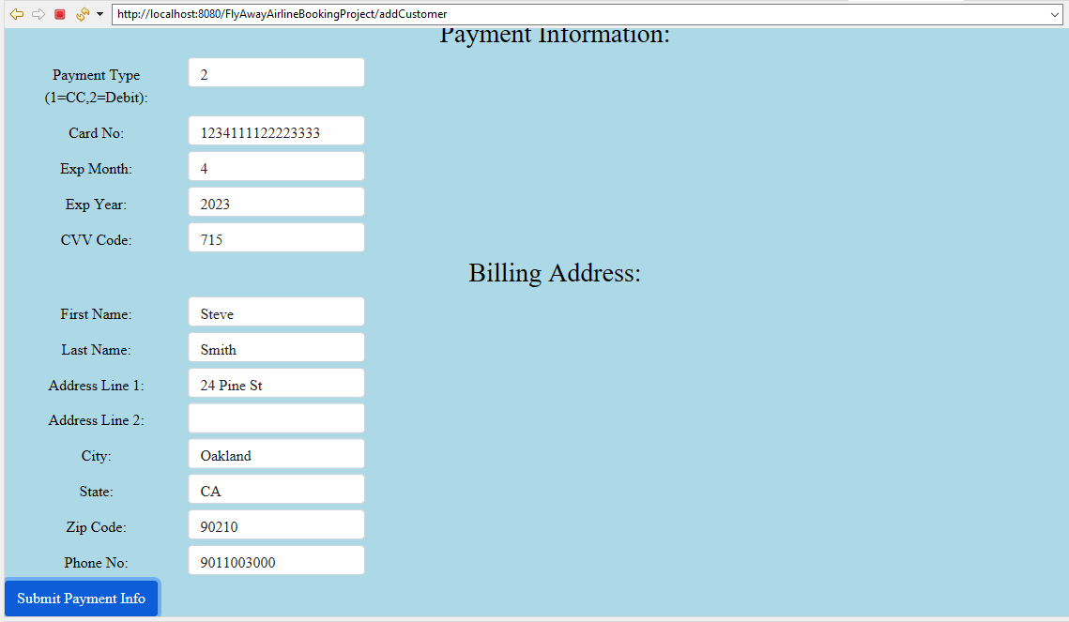

## Screenshot of next screen (Confirm and Submit) after customer clicks ‘Submit Payment Info’ button

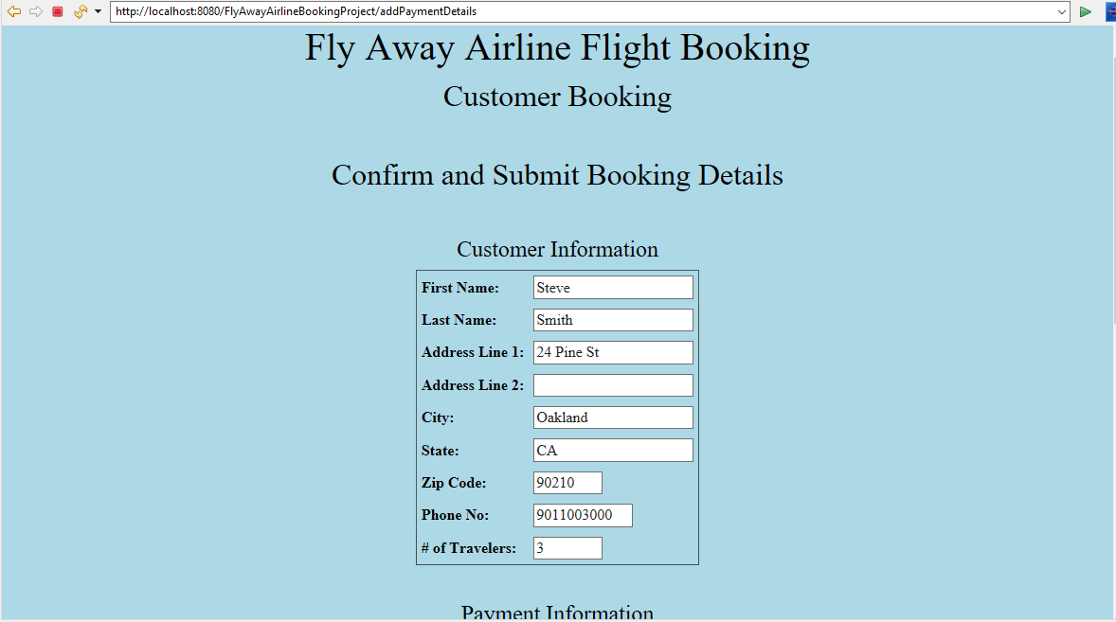

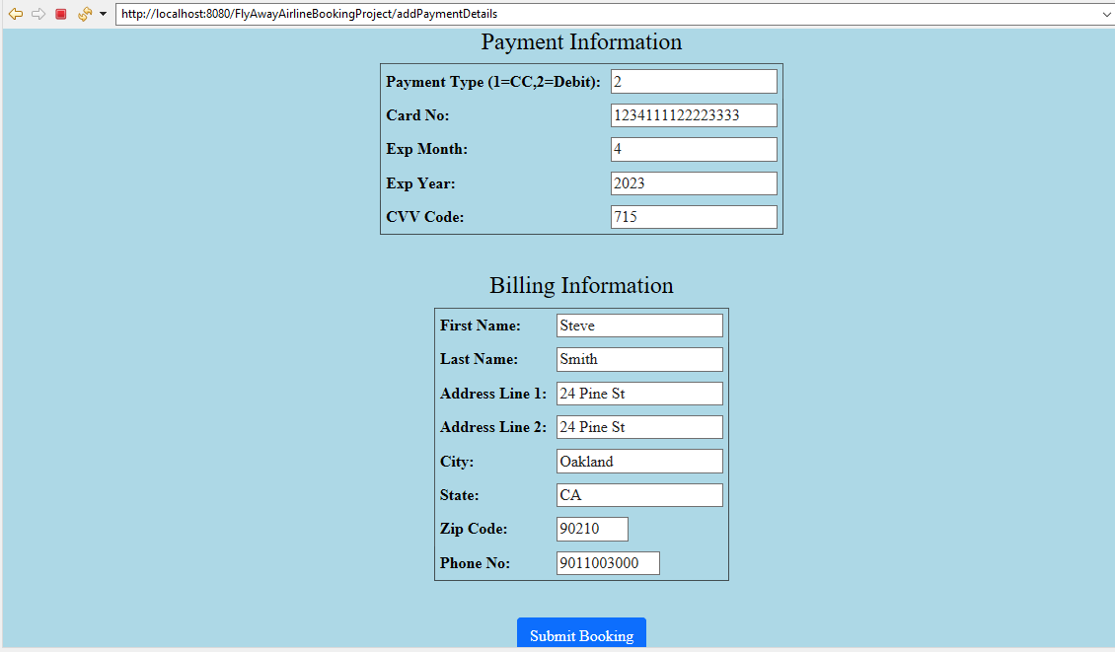

## Screenshot of next screen after customer clicks ‘Submit Booking’ button

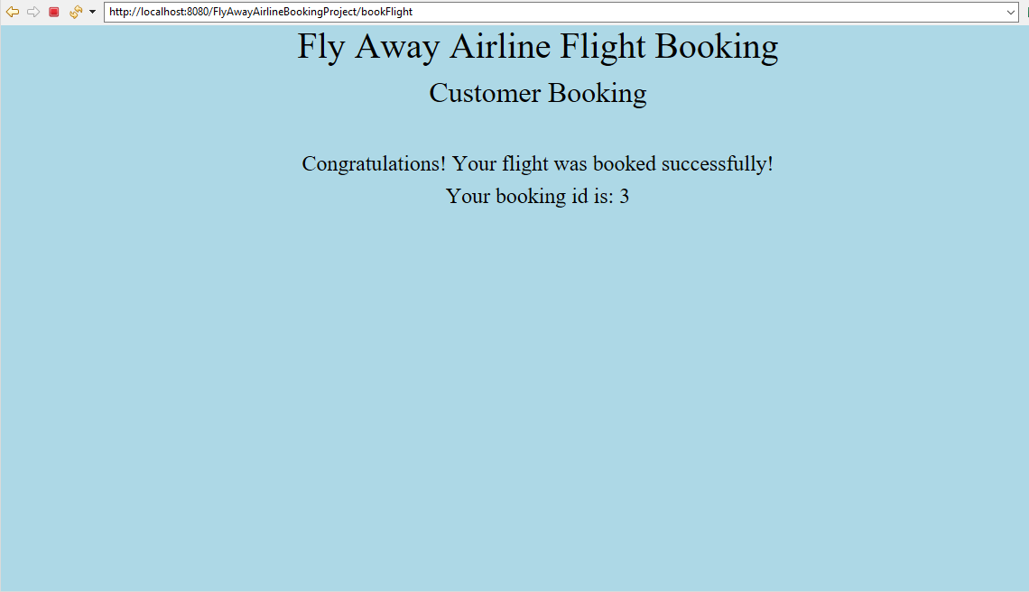

## Screenshot of booking table in database showing record with id 3 that was added

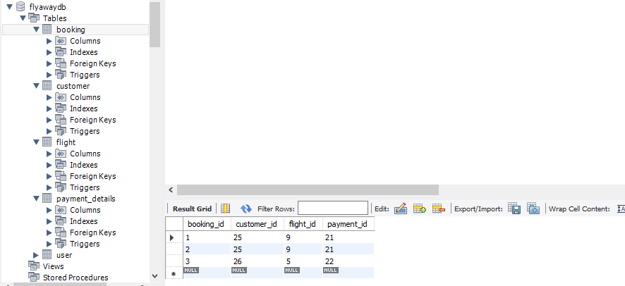

## Screenshot of customer table in database showing record with id 26 that was added as part of the booking

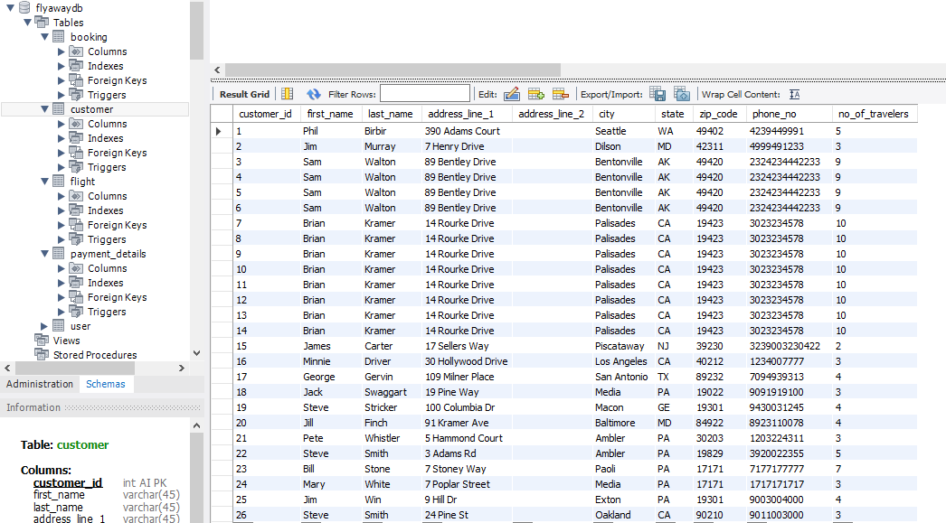

## Screenshot of flight table in database showing record with id 5 that is part of the booking

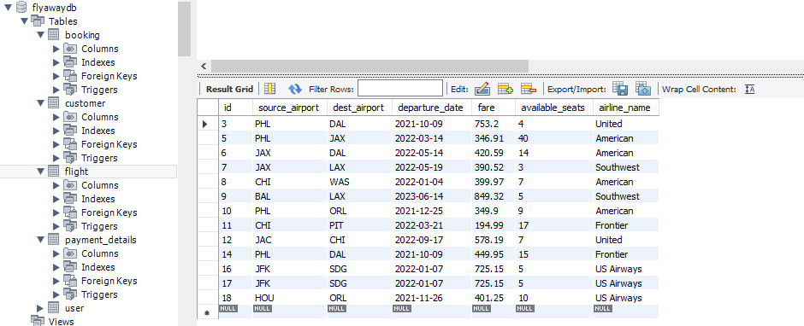

## Screenshot of payment_details table in database showing record with id 22 that was added as part of the booking

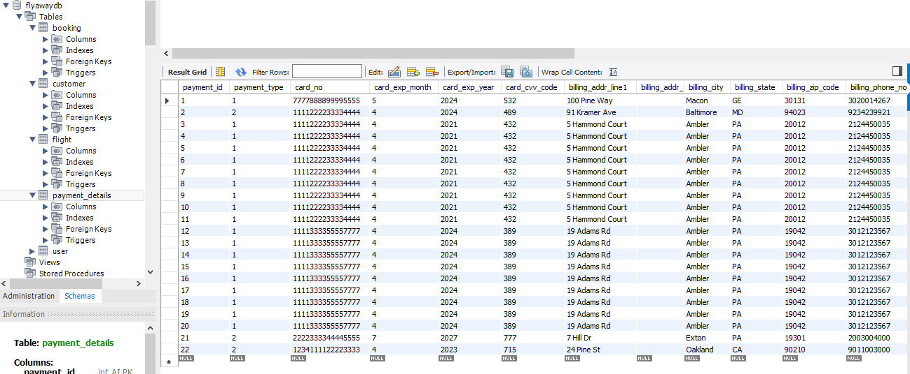

# Screenshot of when a customer clicks “List all flights” (this is an additional feature not requested by the project specifications)

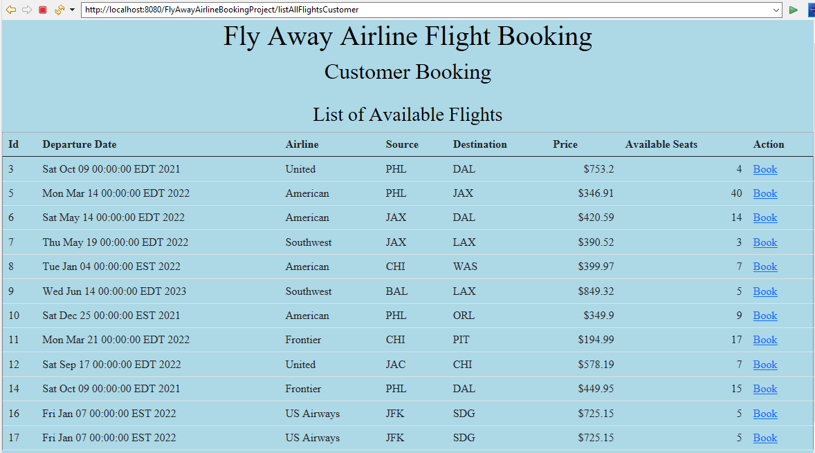

# Screenshots of when a user clicks “Login as an Admin” on landing page



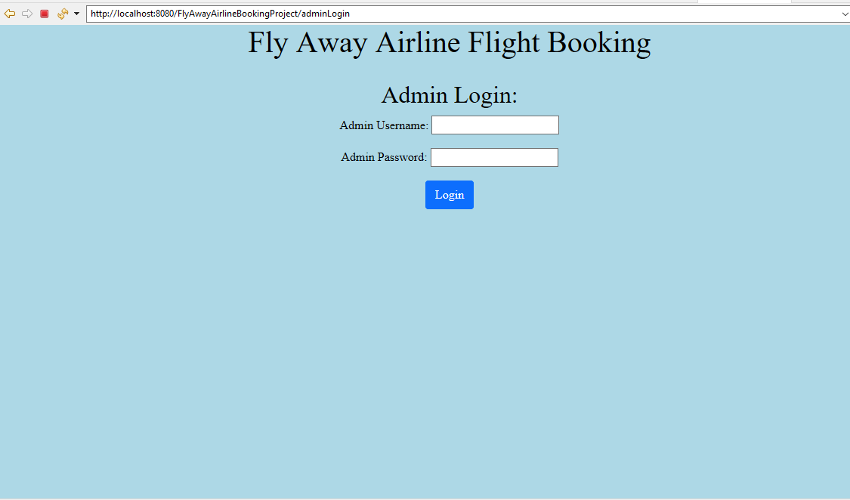

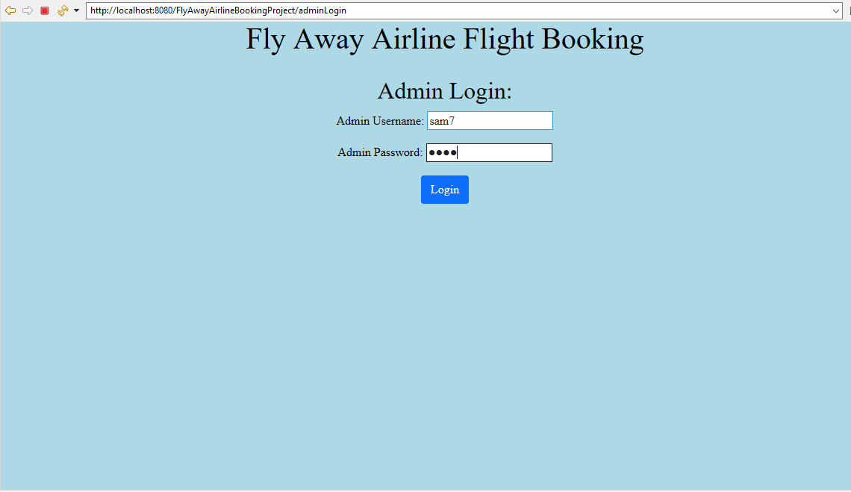

## Screenshot of when wrong login credentials are entered

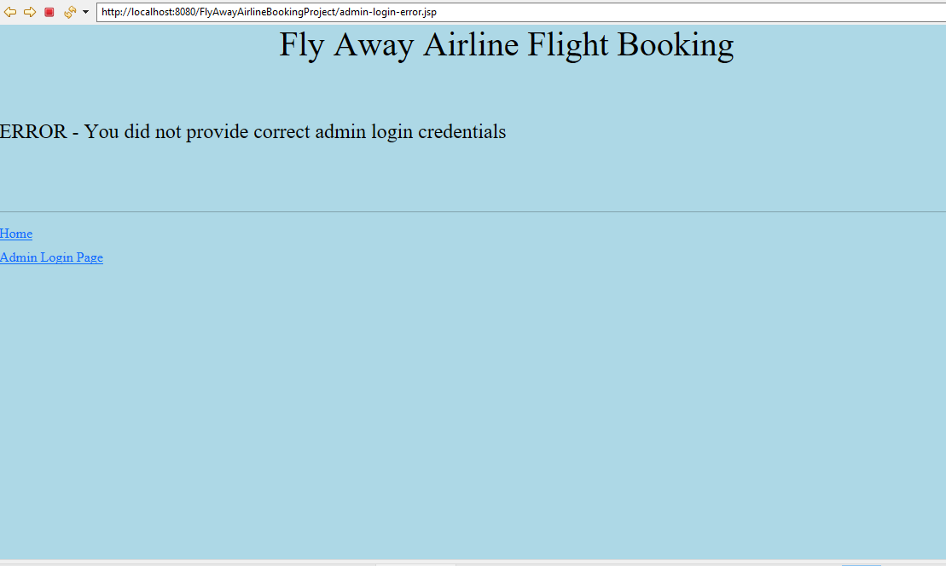

## Screenshot of when correct Admin credentials are entered, the Admin portal is shown

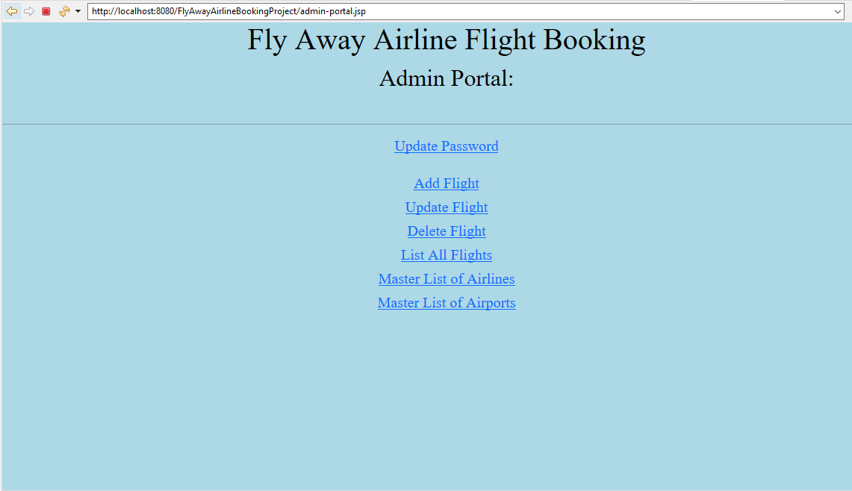

## Screenshot of when an Admin user clicks “Update Password”

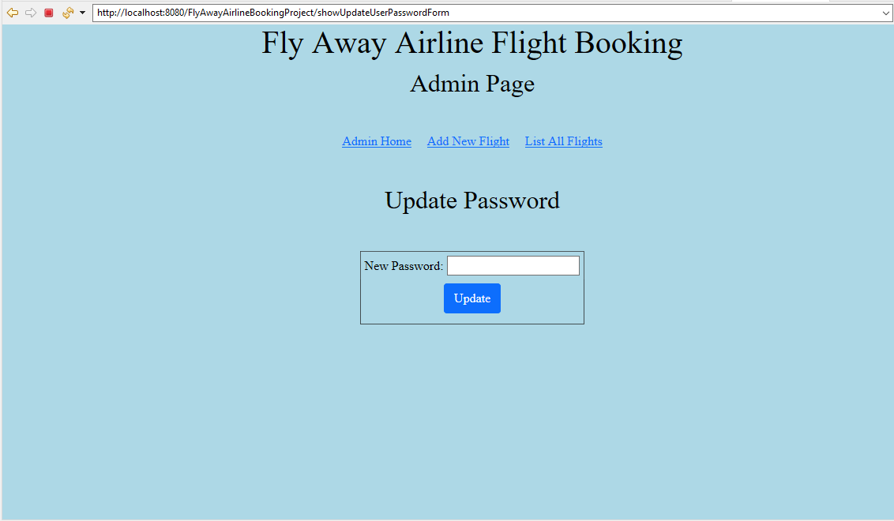

## Screenshot of user passwords in user table in database before updating password

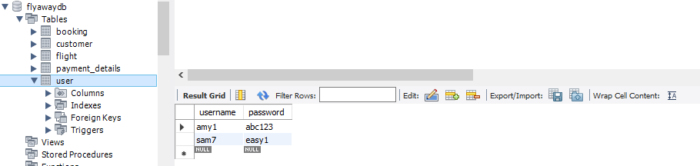

## Screenshots of entering a value on Update Password page for user “sam7” and clicking Update

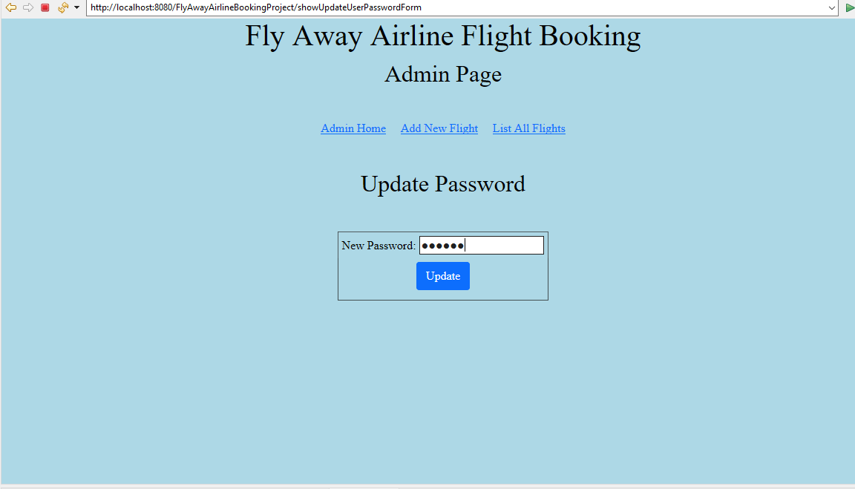

## 

## Screenshot of user database table after updating user “sam7”’s password to “def123” using the “Update Password” page

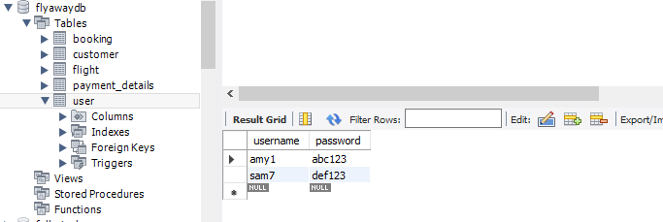

## Screenshot of logging back in with “sam7” and new password “def123”

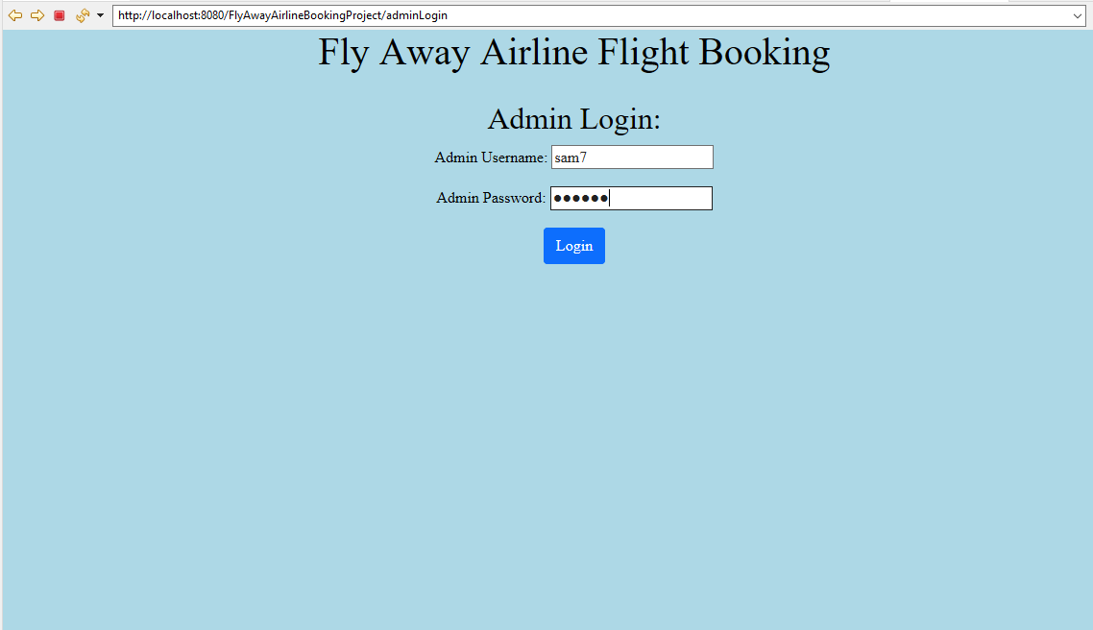

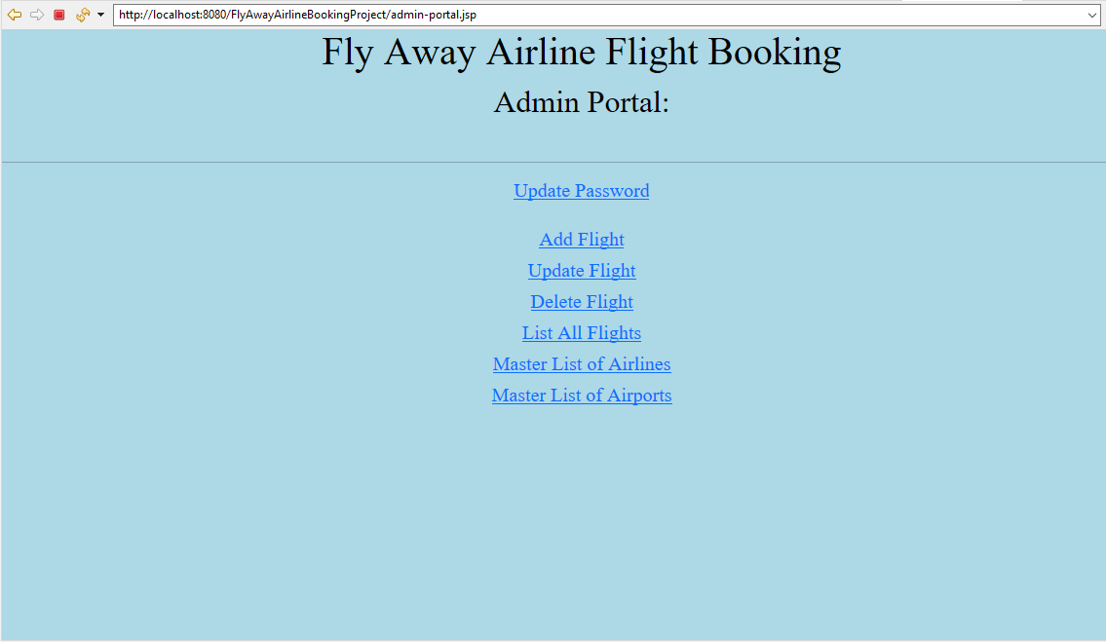

## Screenshot of flight table in database

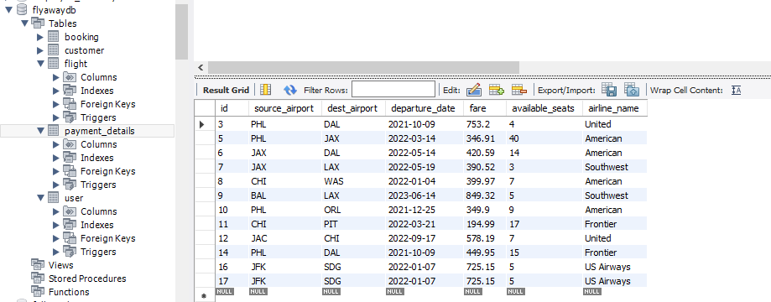

## Screenshot of clicking “Master List of Airlines”

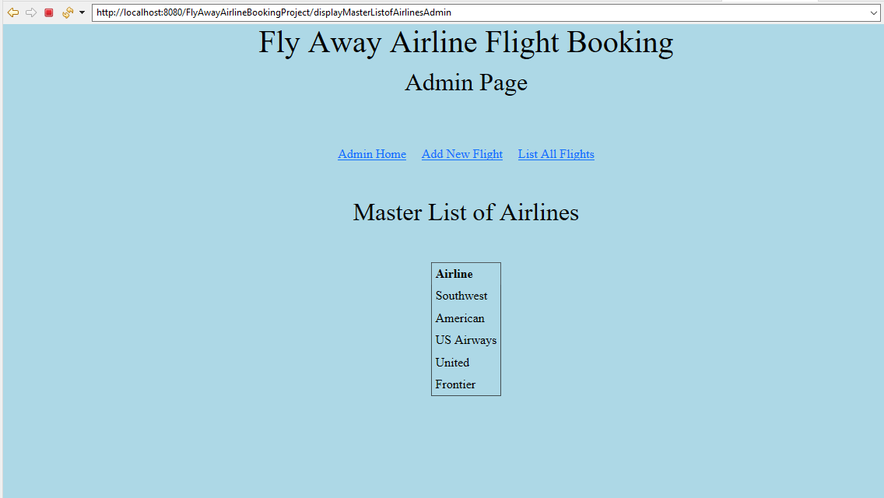

## Screenshot of clicking “Master List of Airports”

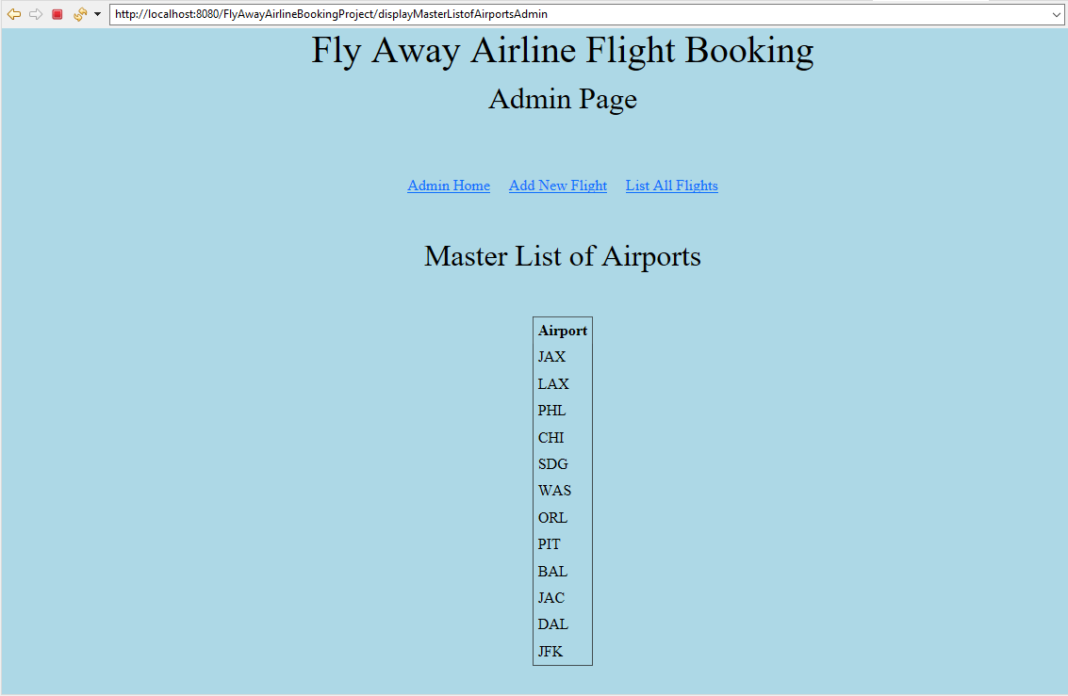

## Screenshots of a customer before attempting to access a restricted Admin page and the error page they are displayed after they hit enter

