**LockedMe.com Project Screenshots**

By Binu Thankachan

|  |  |
| --- | --- |
| **Version # and Author** | **Version History** |
| 1.0 – Binu Thankachan | Created document with project screenshots |
|  |  |
|  |  |

Contents

Application Main Menu Screenshots 3

Application List Files in Directory Screenshots 4

Application Add File in Directory Screenshots 6

Application Search File in Directory Screenshots 9

Application Delete File in Directory Screenshots 12

Application Exit Menu Screenshots 16

Error Handling Screenshots 17

# Application Main Menu Screenshots

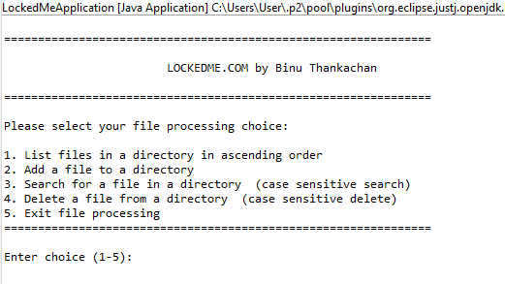

# Application List Files in Directory Screenshots

**The content of the directory that will be listed:**

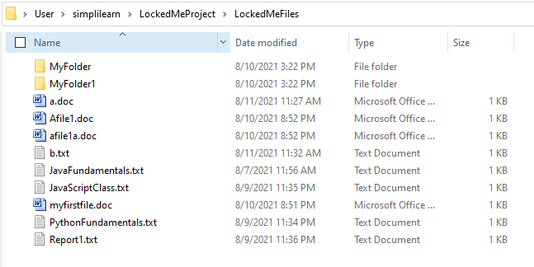

**Program execution:**

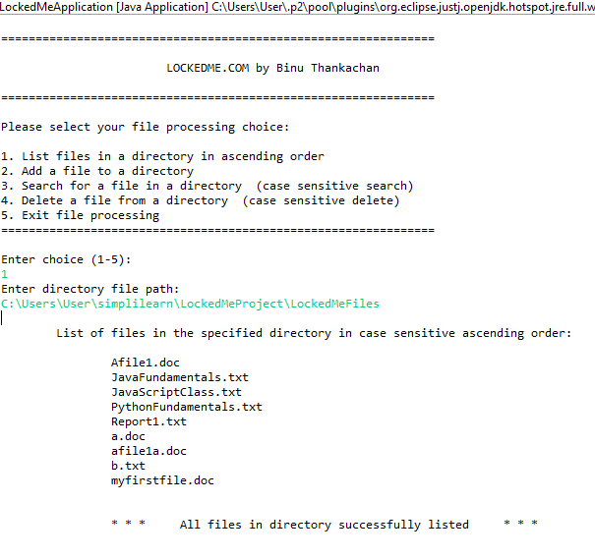

# Application Add File in Directory Screenshots

**The content of the directory that will be listed:**



**Program execution:**

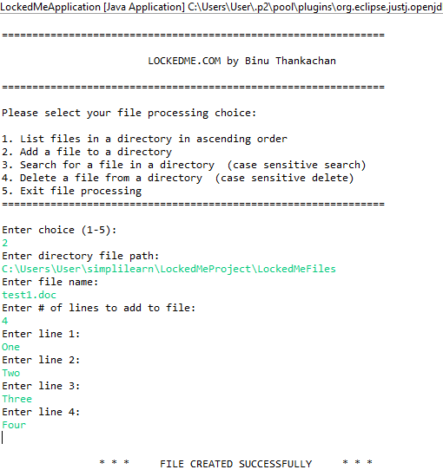

**Directory content after the add:**

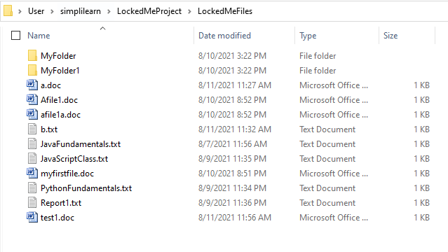

**Displaying the content of file test1.doc:**

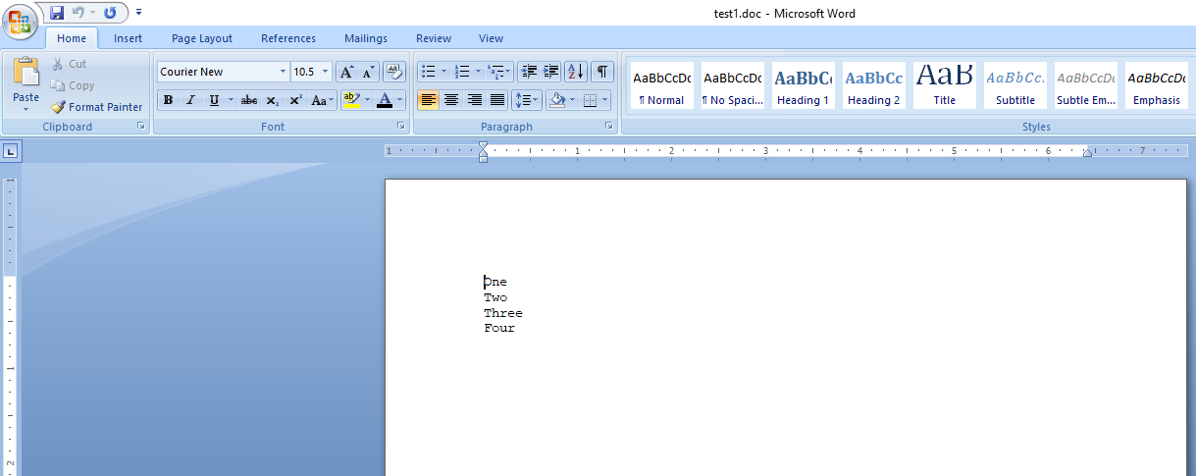

# Application Search File in Directory Screenshots

**Directory content before search:**



**Program execution showing case sensitive search capability (B.txt does not exist whereas b.txt does exist):**

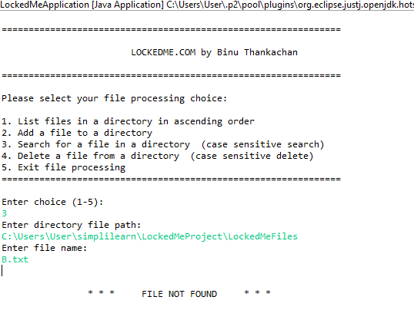

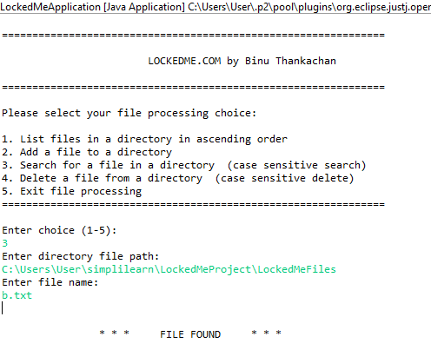

# Application Delete File in Directory Screenshots

**Directory content before delete:**



**Program execution showing case sensitive delete capability (B.txt does not exist whereas b.txt does exist):**

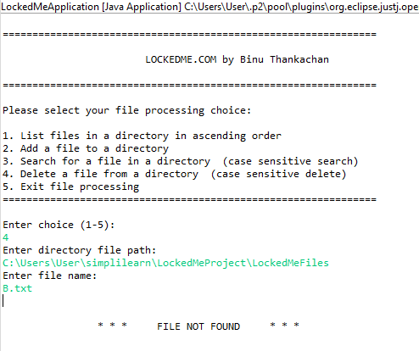

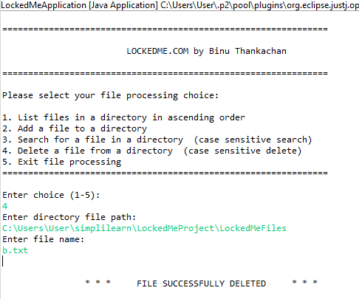

**Directory content after delete:**

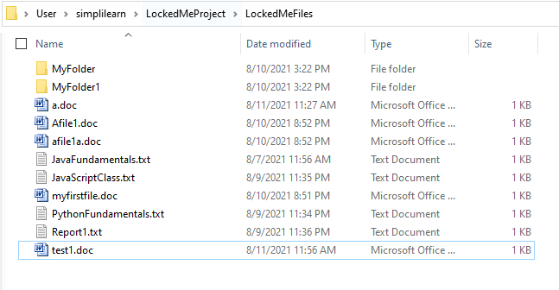

# Application Exit Menu Screenshots

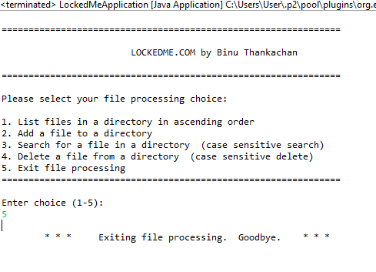

# Error Handling Screenshots

**Entering an invalid value during menu selection:**

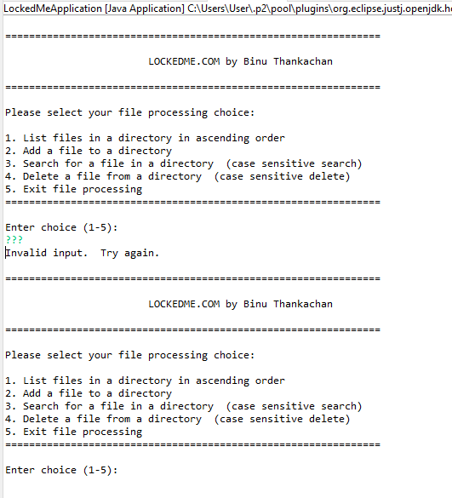

**Entering an invalid directory:**

