**LockedMe.com Project Specification**

|  |  |
| --- | --- |
| **Version # and Author** | **Version History** |
| 1.0 – Binu Thankachan | August 11, 2021 - Created document with the following sections: |
|  |  |
|  |  |

Contents

Sprints planned and the tasks achieved in them 3

Project Epic: 3

User Stories and Sprint Assignments: 3

Algorithms and flowcharts of the application 4

Modules developed for the application 5

Core concepts used in the project 7

Link to the GitHub repository 8

Conclusion on enhancing the application and defining the Unique Selling Points 9

# Sprints planned and the tasks achieved in them

## Project Epic:

Create a command line application that will repeatedly prompt the user with the following options:

1 – List all files in a computer directory in ascending order

2 – Add a file to a computer directory

3 – Search for a file from a computer directory (case sensitive search)

4 – Delete a file from a computer directory (case sensitive delete)

5 – Exit file processing

## User Stories and Sprint Assignments:

|  |  |
| --- | --- |
| **User Story** | **Planned Sprint** |
| As a user I want a command line application that will repeatedly prompt me to either, 1 – List All Files in a directory, 2 – Add a file to a directory, 3 – Search for a file from a directory, 4 – Delete a file from a directory, 5 – Exit file processing   * Develop application control structure skeleton without file processing functionality | 1 |
| As a user I want to be able to **exit** from the application | 1 |
| As a user I want to be able to **list** the files in a computer directory I specify in ascending order | 2 |
| As a user I want to be able to **add** a file to a computer directory I specify | 2 |
| As a user I want to be able to **search for** a file from a computer directory I specify | 3 |
| As a user I want to be able to **delete** a file from a computer directory I specify | 3 |
|  |  |
|  |  |

# Algorithms and flowcharts of the application

Develop a loop that continuously loops until the user chooses to exit the loop

* Within the loop, display a menu allowing the user to choose 1 of 5 options.
  + Option 1 will display the list of all files in a user specified directory
  + Option 2 will add a new file with content to a user specified directory
  + Option 3 will search the user specified directory for a file
  + Option 4 will delete a file from a user specified directory
  + Option 5 will exit the loop

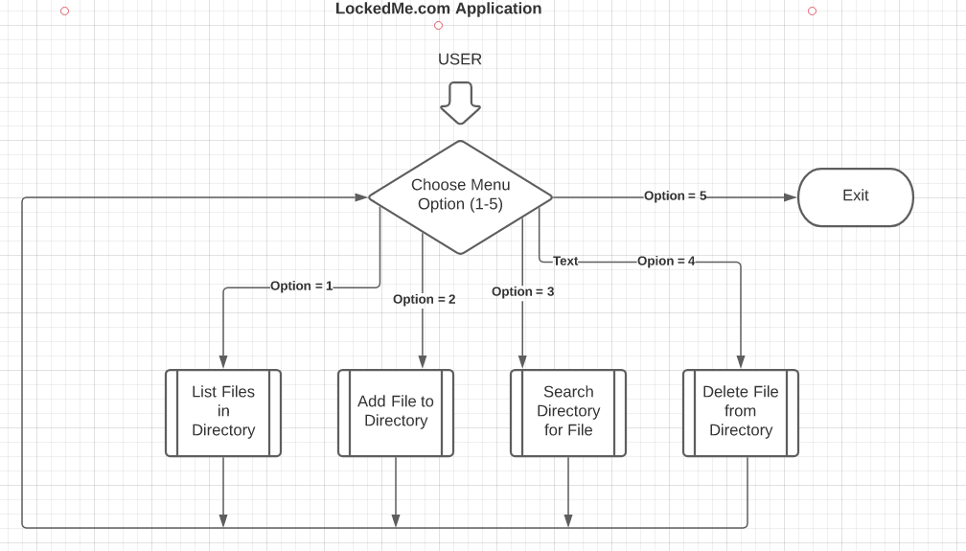

# Modules developed for the application

1. **The LockedMeApplication class** is the main entry point for the application.
2. The **LockedMeConsole class** encapsulates console user prompt handling for the LockedMeApplication.
3. The **LockedMeUserInput class** encapsulates console user input handling for the LockedMeApplication.
4. The **FileManager class** encapsulates file handling functions for the LockedMeApplication.

# Core Java concepts used in the project

The core concepts used in this project were:

* Object Oriented Programming
  + Utilizing classes to represent entities
* File handling
  + Creating, reading, finding and deleting files in the file system
* Terminal I/O
  + Scanner
* Exception handling
  + Intercepting and processing application errors
* Code modularity
  + Separating processing via separate classes
* Collections
  + ArrayList
* Data Structures
  + ArrayList used to hold names of files
  + List.sort() used to sort the ArrayList in ascending order
* Control mechanisms
  + While loop to control user prompts, input and exit
  + Sentinal value used to control loop entry and exit

# Link to the GitHub repository

<https://github.com/bthank/LockedMeProject>

# Conclusion on enhancing the application and defining the Unique Selling Points

Future application enhancements could include:

* Converting the application to a Web based user interface
* Adding file update functionality
* Adding the ability to create folders within directories
* Adding the ability to clone a directory and it’s contents
* Adding the ability to search for text across all files within a directory
* Adding registration and login functionality in order to use the application
* Adding security to allow authentication and authorization in order to use the application
* Adding roles to govern how users can interact with the data