**Sporty Shoes Project Screenshots**

By Binu Thankachan

|  |  |
| --- | --- |
| **Version # and Author** | **Version History** |
| 1.0 – Binu Thankachan | Created document with project screenshots |
|  |  |
|  |  |

Contents

Sporty Shoes web application customer landing page screenshot 3

Screenshot of when a customer clicks “List All Sporty Shoes” on landing page 4

Screenshot of when user clicks Buy 4

Screenshot of when user clicks Display cart 5

Screenshot of when user clicks Checkout 5

Screenshot of when user clicks “Add Shipping Choice” 6

Screenshot of when user clicks “Add Payment Details” 6

Screenshot of when user clicks “Add Payment Details” 7

Screenshot of when user clicks “Submit Order Page” 7

Screenshot of when user clicks “Submit Order” button 8

Screenshot of when user clicks “Customer home” 8

Screenshot of when user clicks “Customer home” 9

Screenshot of landing page before logging in as admin 9

Screenshot of when user clicks “Login as an Admin” 10

Screenshot of when user enters wrong admin login credentials 10

Screenshot of when user enters the correct admin login credentials and clicks “Login” 11

Screenshot of when user clicks “Update Admin password” 11

Screenshot of when user clicks “Add Shoe to Inventory” 12

Screenshot of when user clicks “Display List of Users Who Signed Up” 13

Screenshot of when user clicks “Display Purchase Report” 14

Screenshot of when user clicks “Search Shoe Orders ” 14

Screenshot of MySQL database schema 16

Screenshot of address database table 17

Screenshot of admin database table 18

Screenshot of customer_cart database table 19

Screenshot of customer_cart_order_item database table 20

Screenshot of order_item database table 21

Screenshot of payment_detail database table 22

Screenshot of shipping database table 23

Screenshot of shoe database table 24

Screenshot of shoe_order database table 25

Screenshot of shoe_order_order_items database table 26

# Sporty Shoes web application customer landing page screenshot

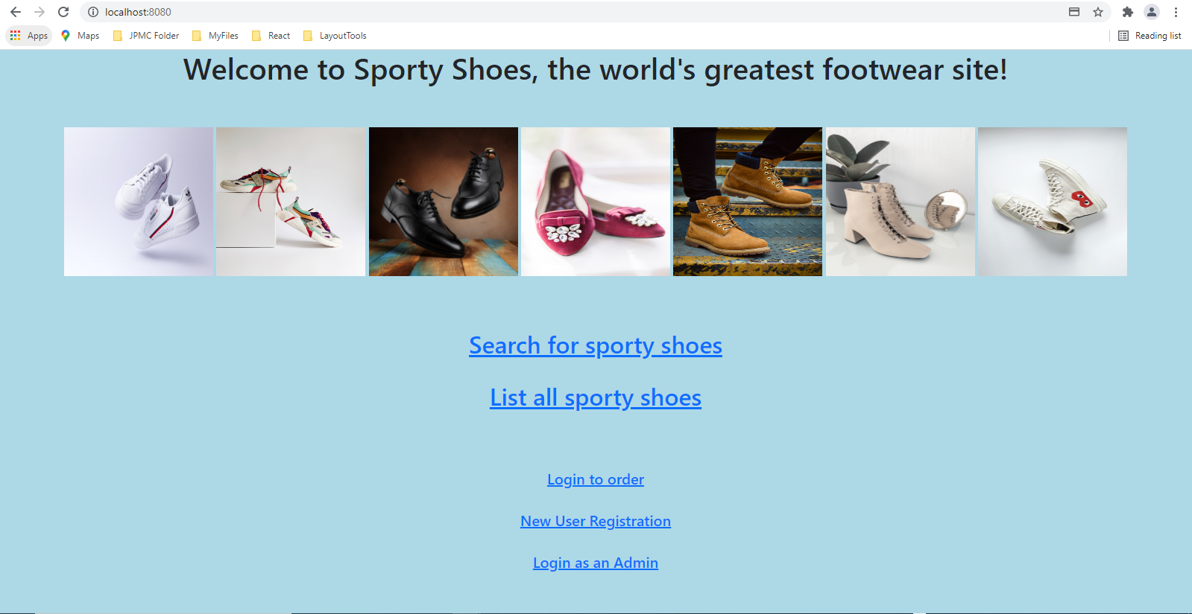

# Screenshot of when a customer clicks “List All Sporty Shoes” on landing page

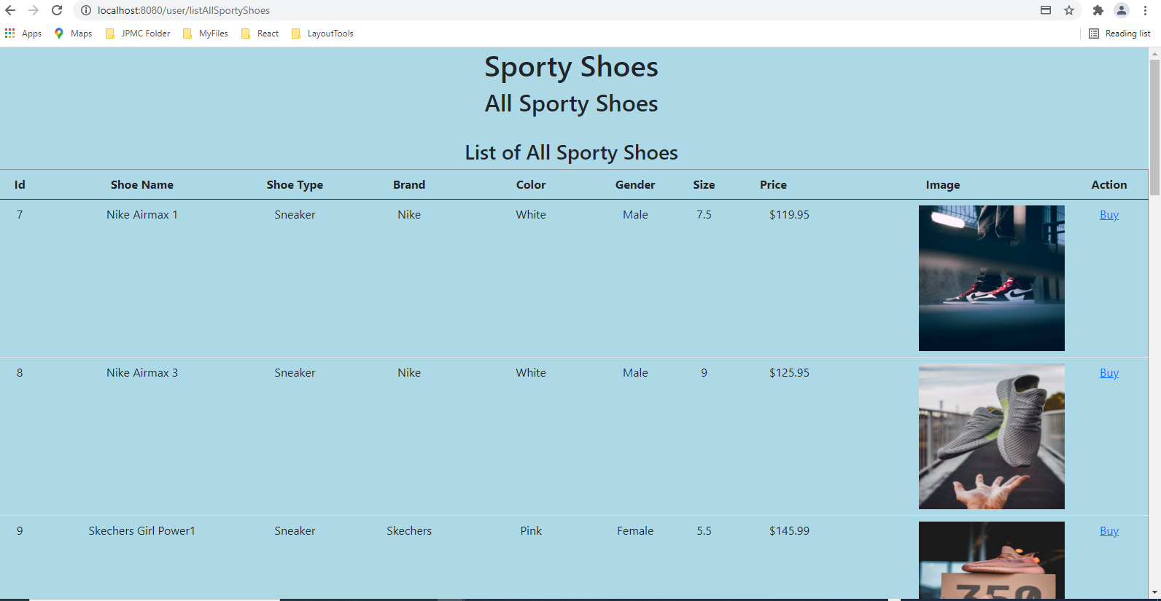

## Screenshot of when user clicks Buy

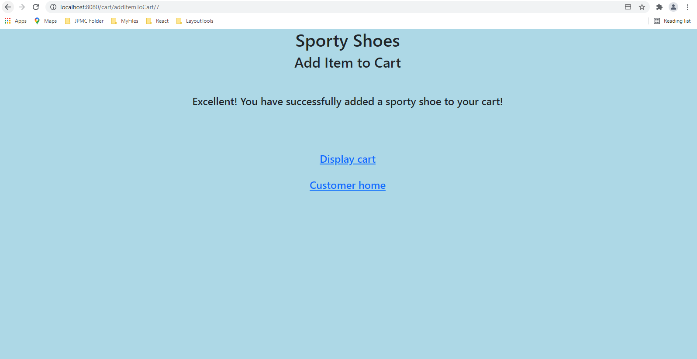

## Screenshot of when user clicks Display cart

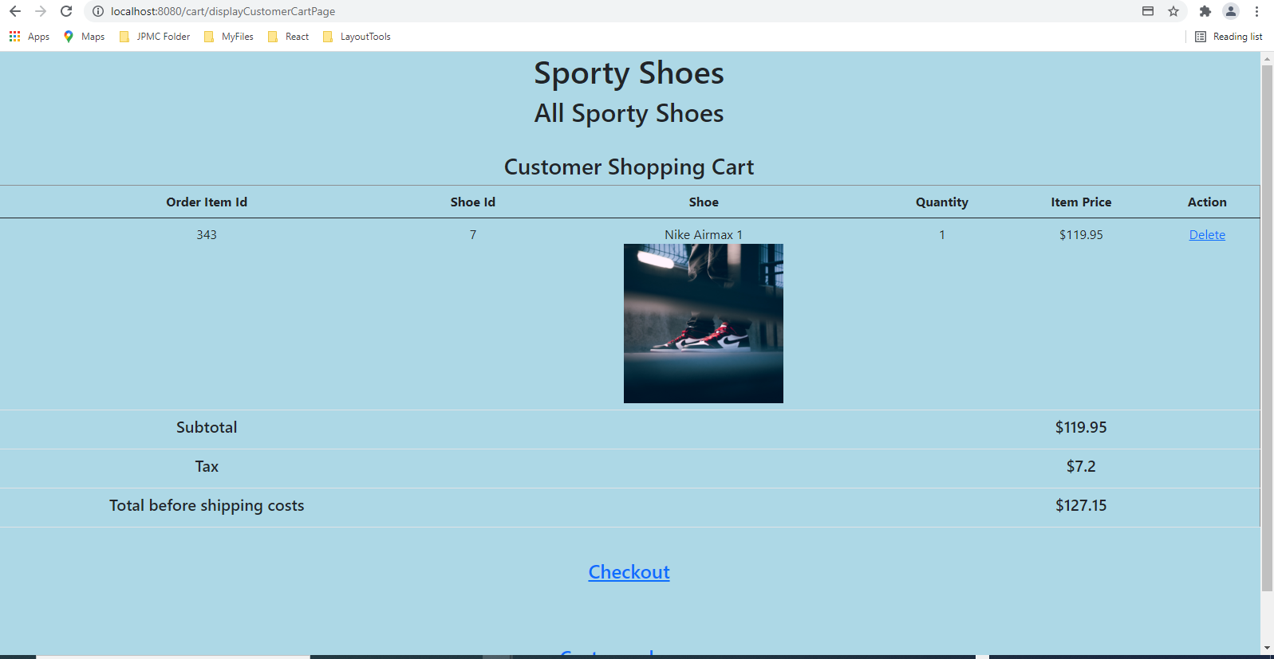

## Screenshot of when user clicks Checkout

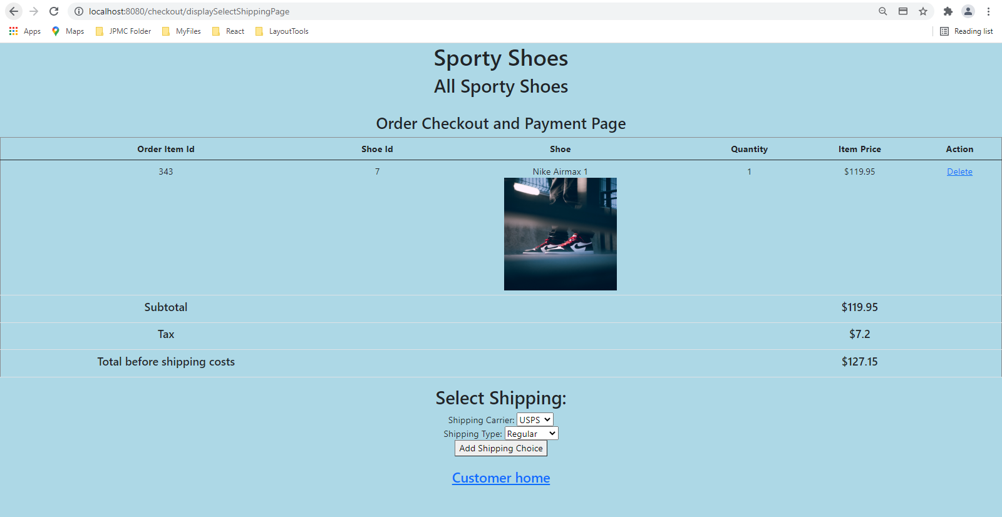

## Screenshot of when user clicks “Add Shipping Choice”

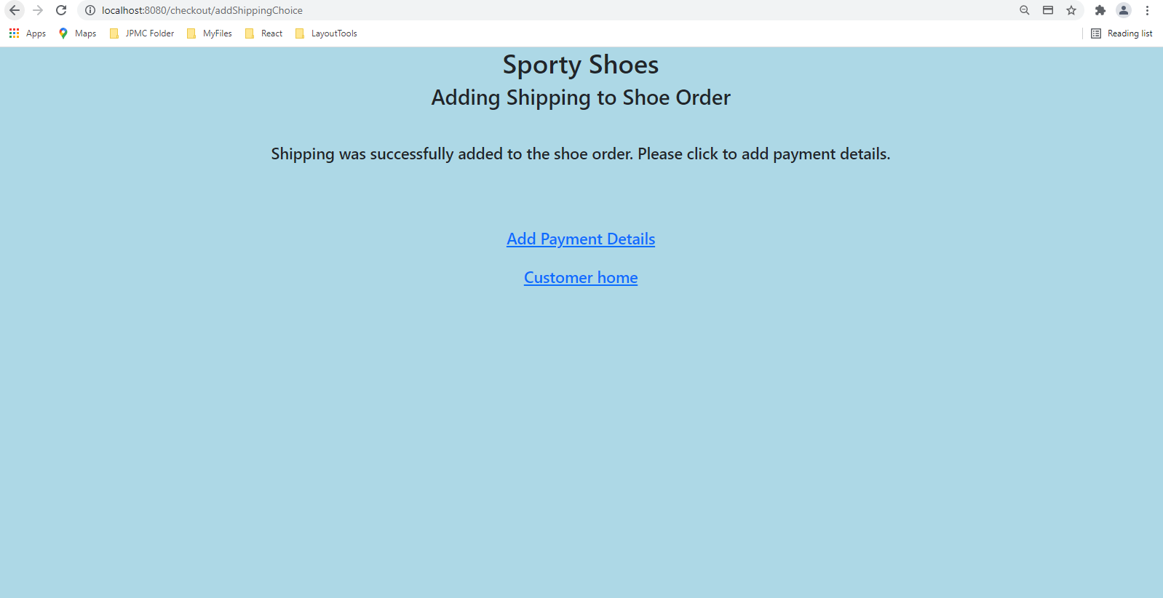

## Screenshot of when user clicks “Add Payment Details”

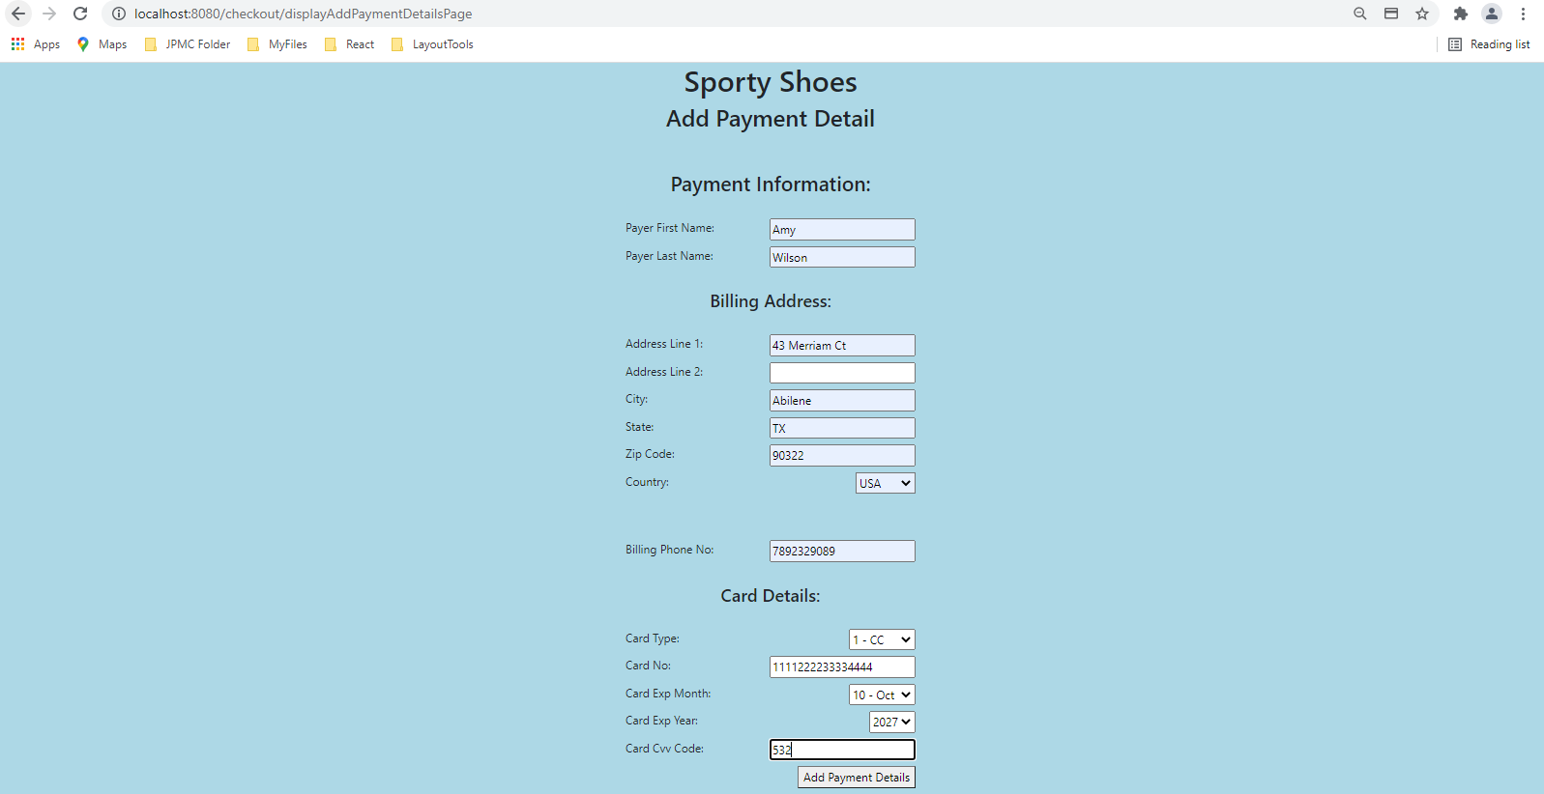

## Screenshot of when user clicks “Add Payment Details”

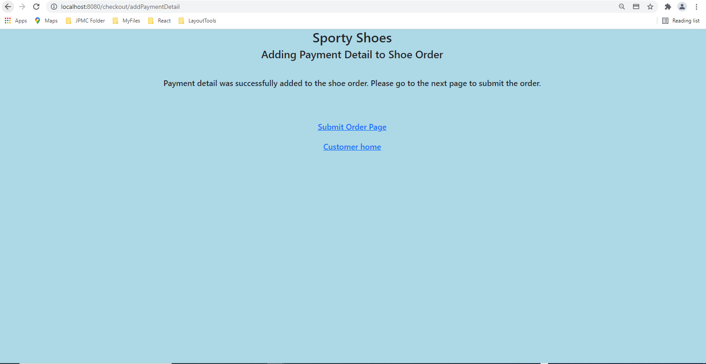

## Screenshot of when user clicks “Submit Order Page”

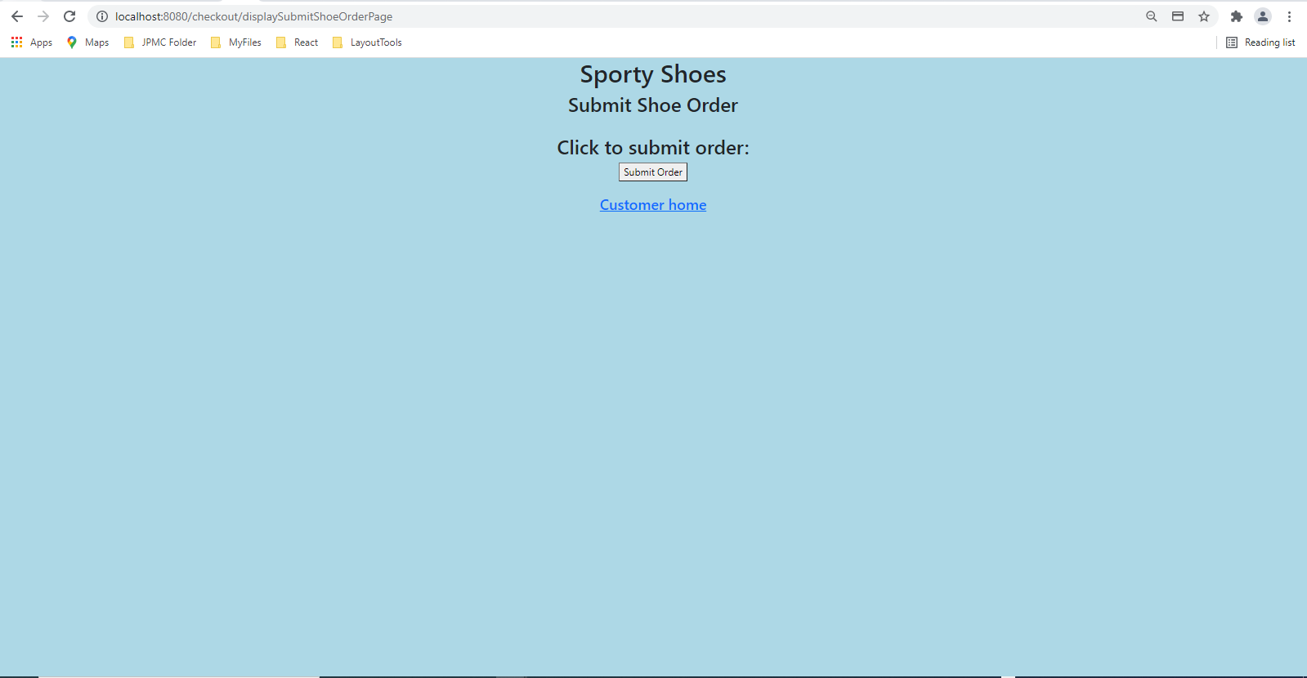

## Screenshot of when user clicks “Submit Order” button

## 

## Screenshot of when user clicks “Customer home”

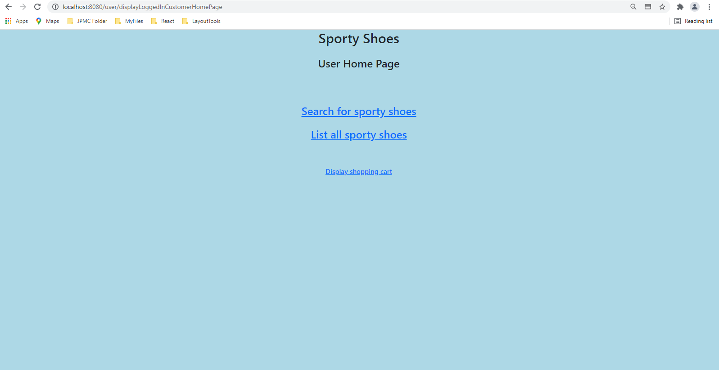

## Screenshot of when user clicks “Customer home”

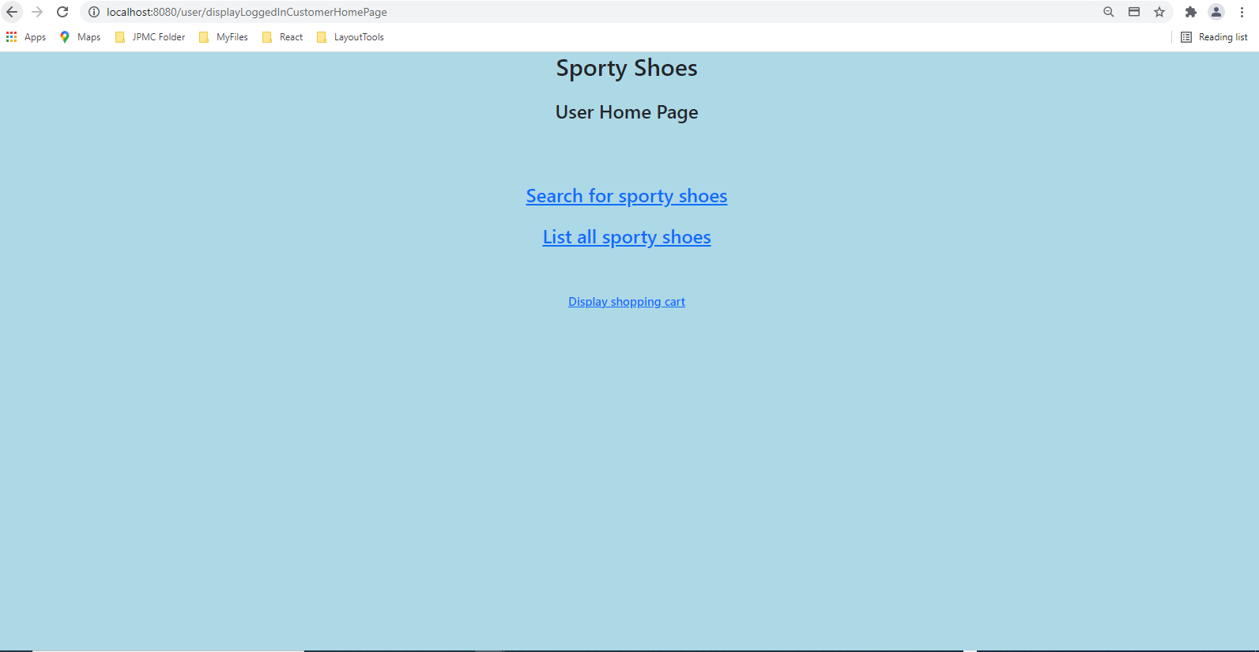

## Screenshot of landing page before logging in as admin

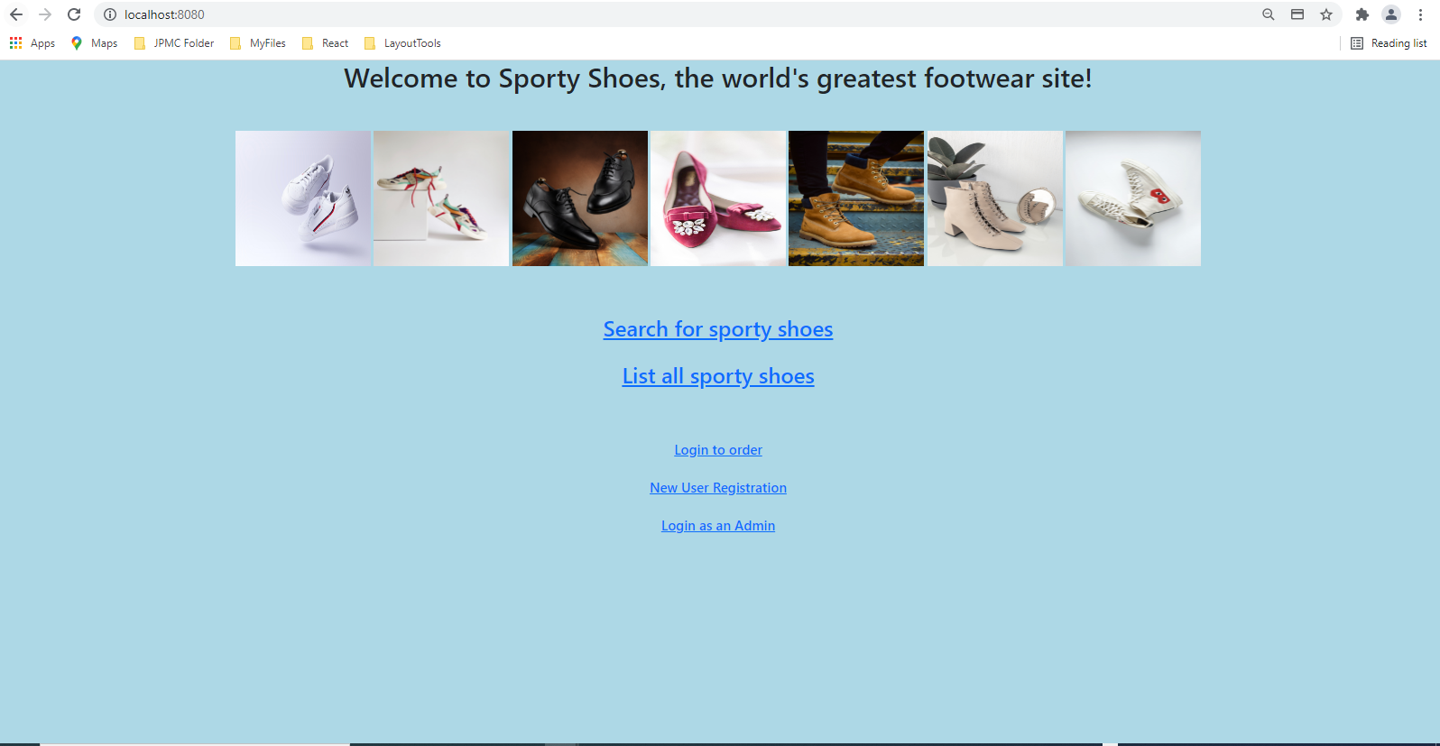

## Screenshot of when user clicks “Login as an Admin”

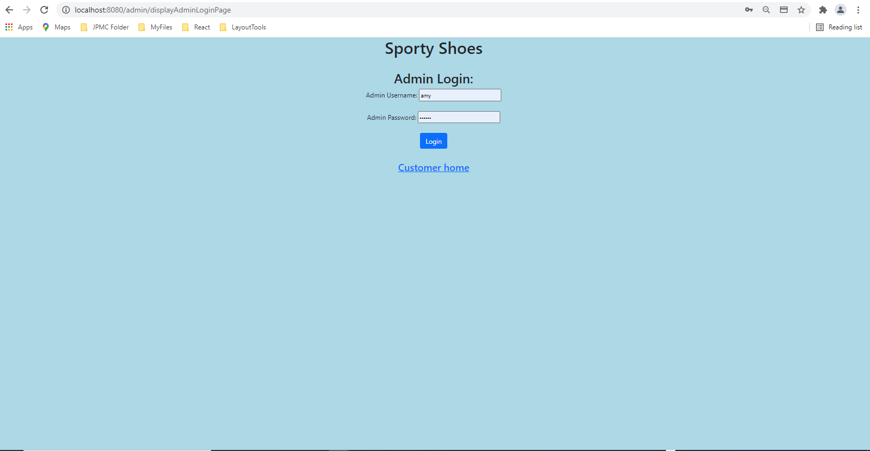

## Screenshot of when user enters wrong admin login credentials

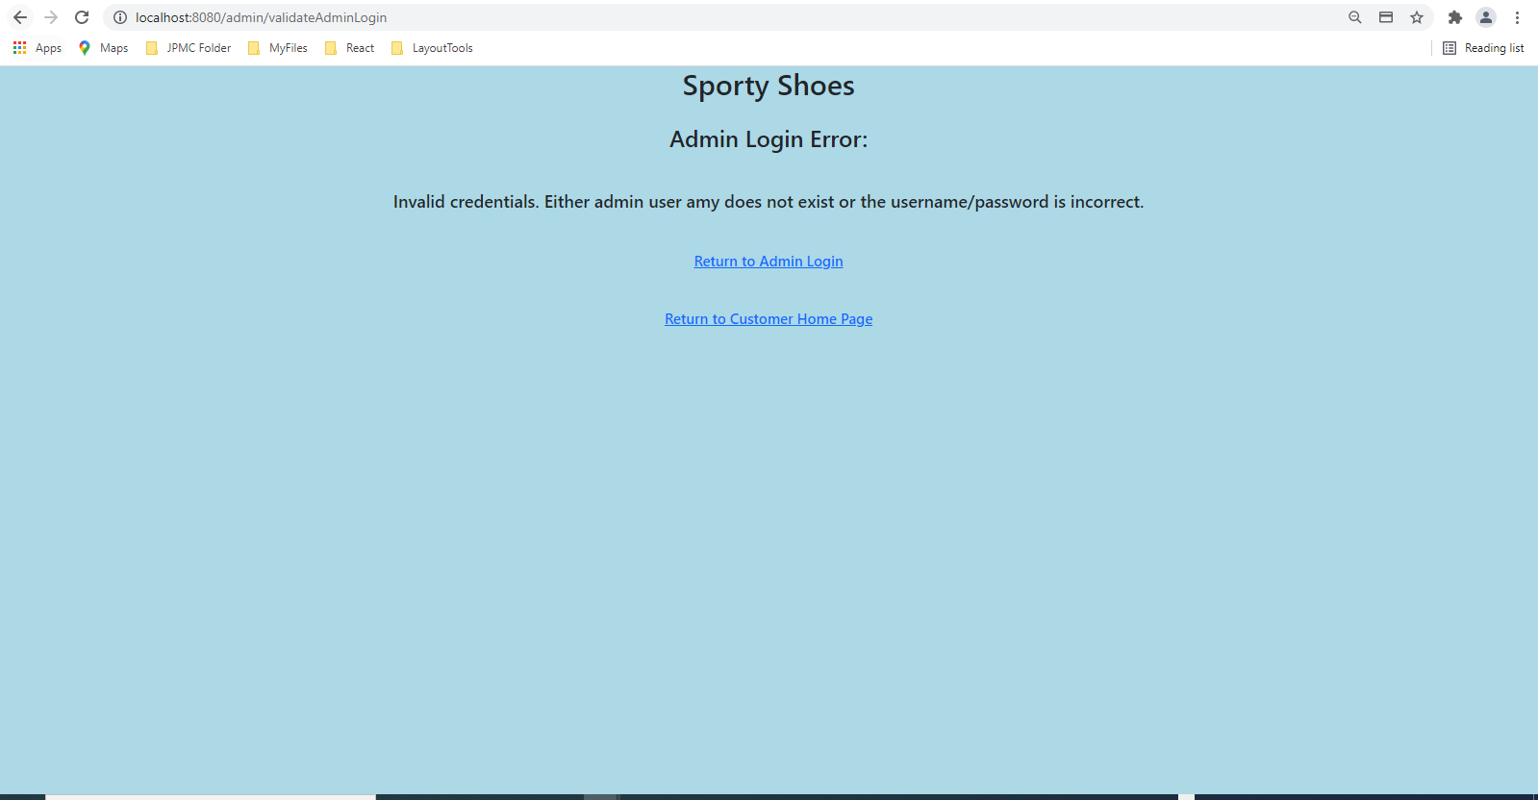

## Screenshot of when user enters the correct admin login credentials and clicks “Login”

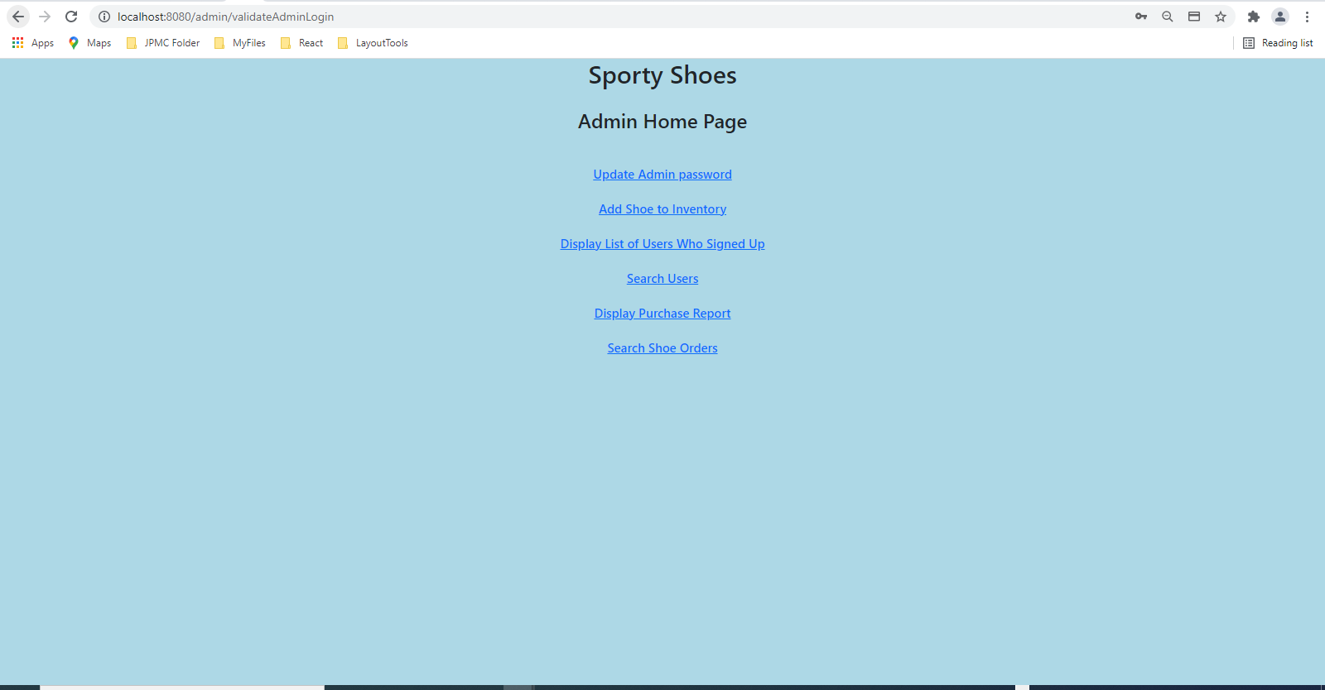

## Screenshot of when user clicks “Update Admin password”

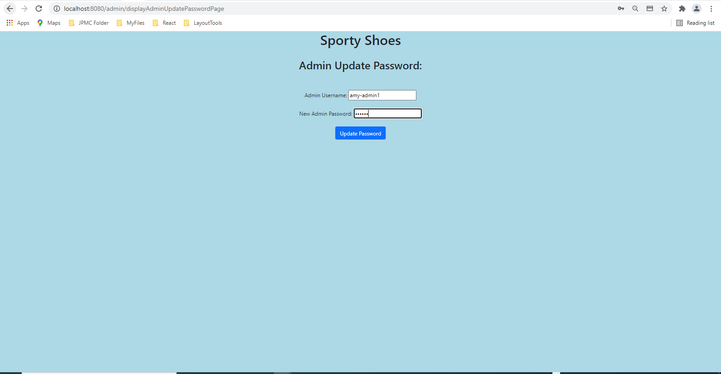

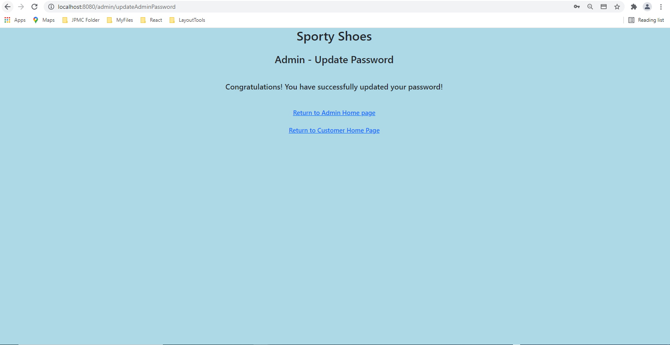

## Screenshot of when user clicks “Add Shoe to Inventory”

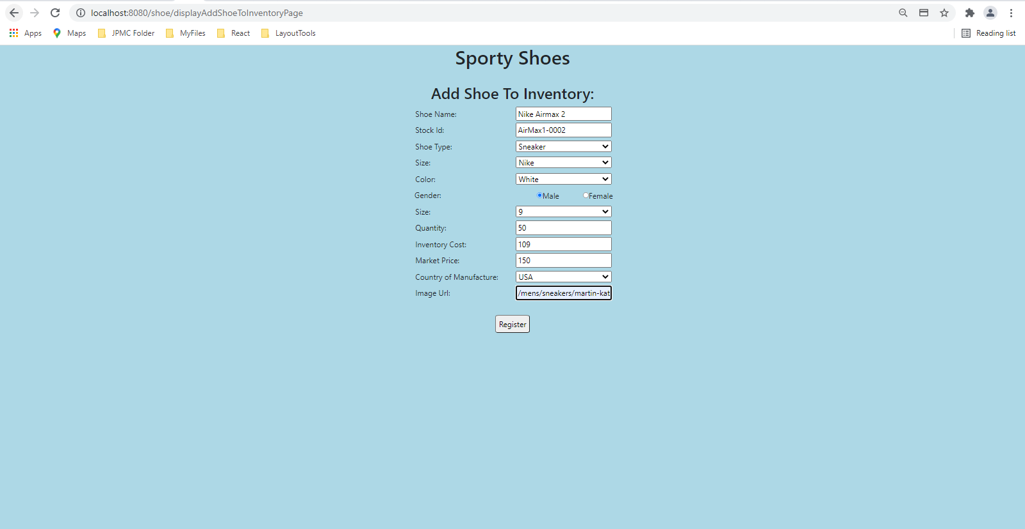

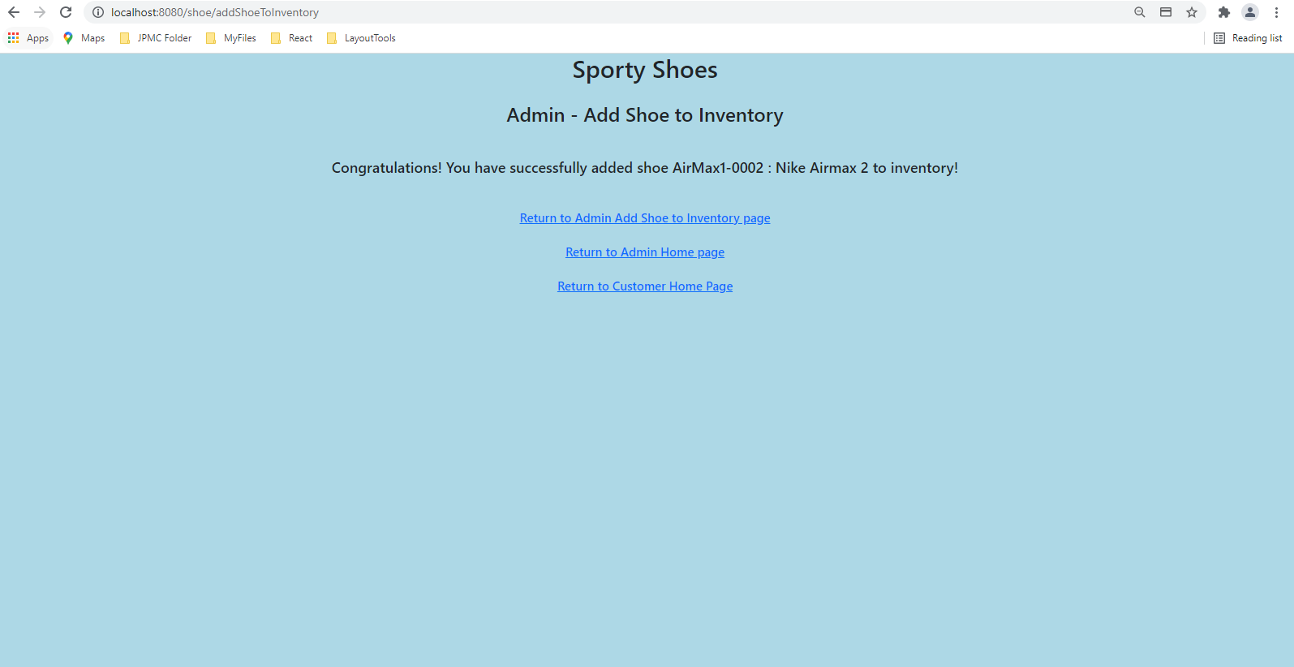

## Screenshot of when user clicks “Display List of Users Who Signed Up”

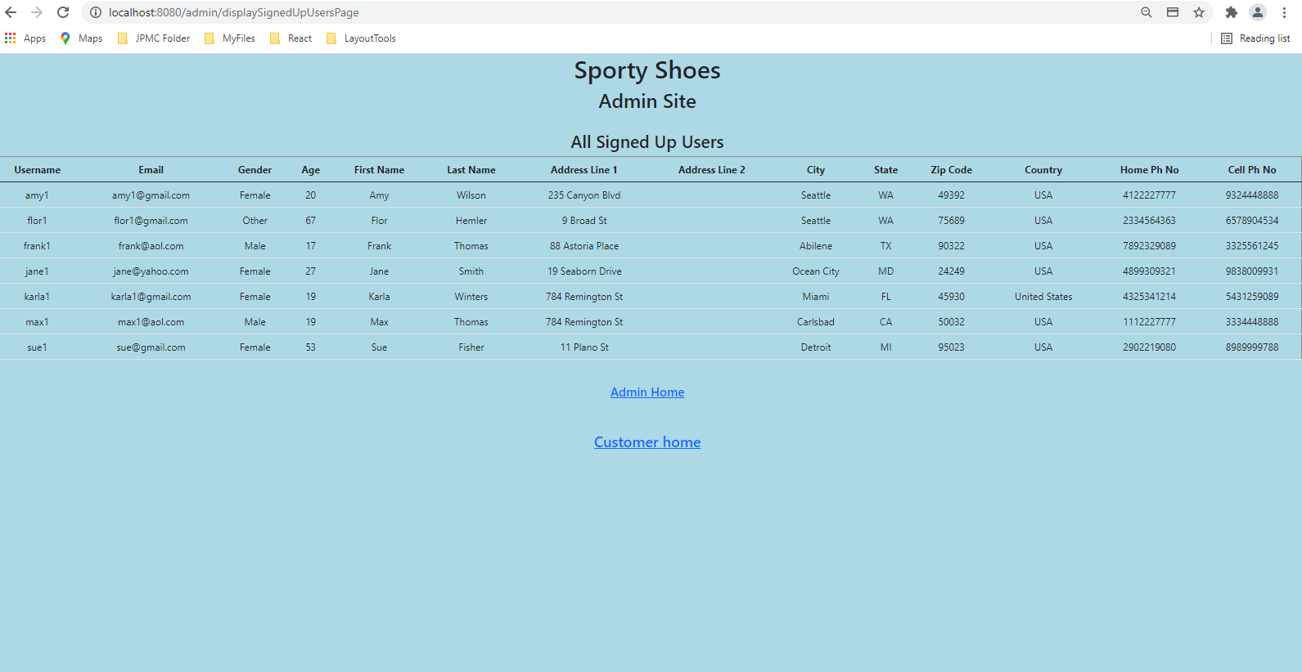

## Screenshot of when user clicks “Display Purchase Report”

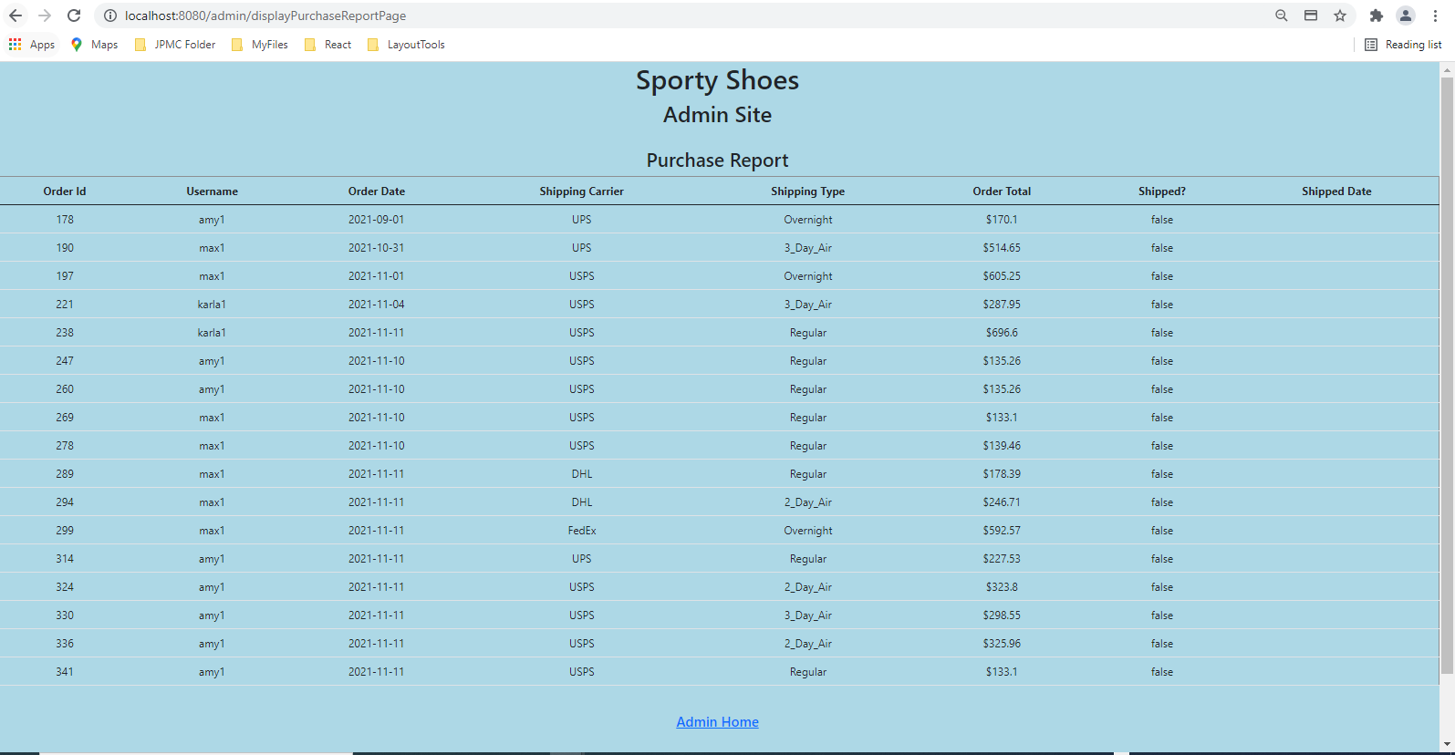

## Screenshot of when user clicks “Search Shoe Orders ”

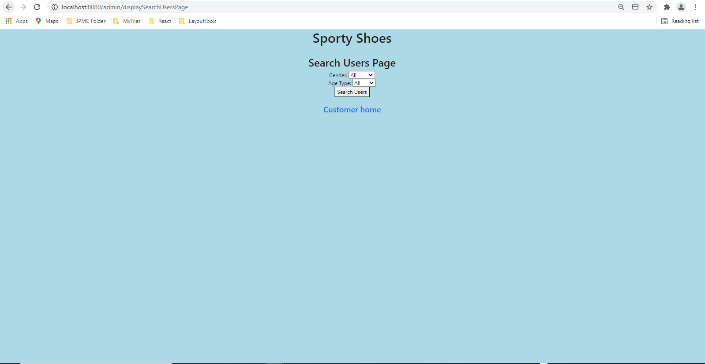



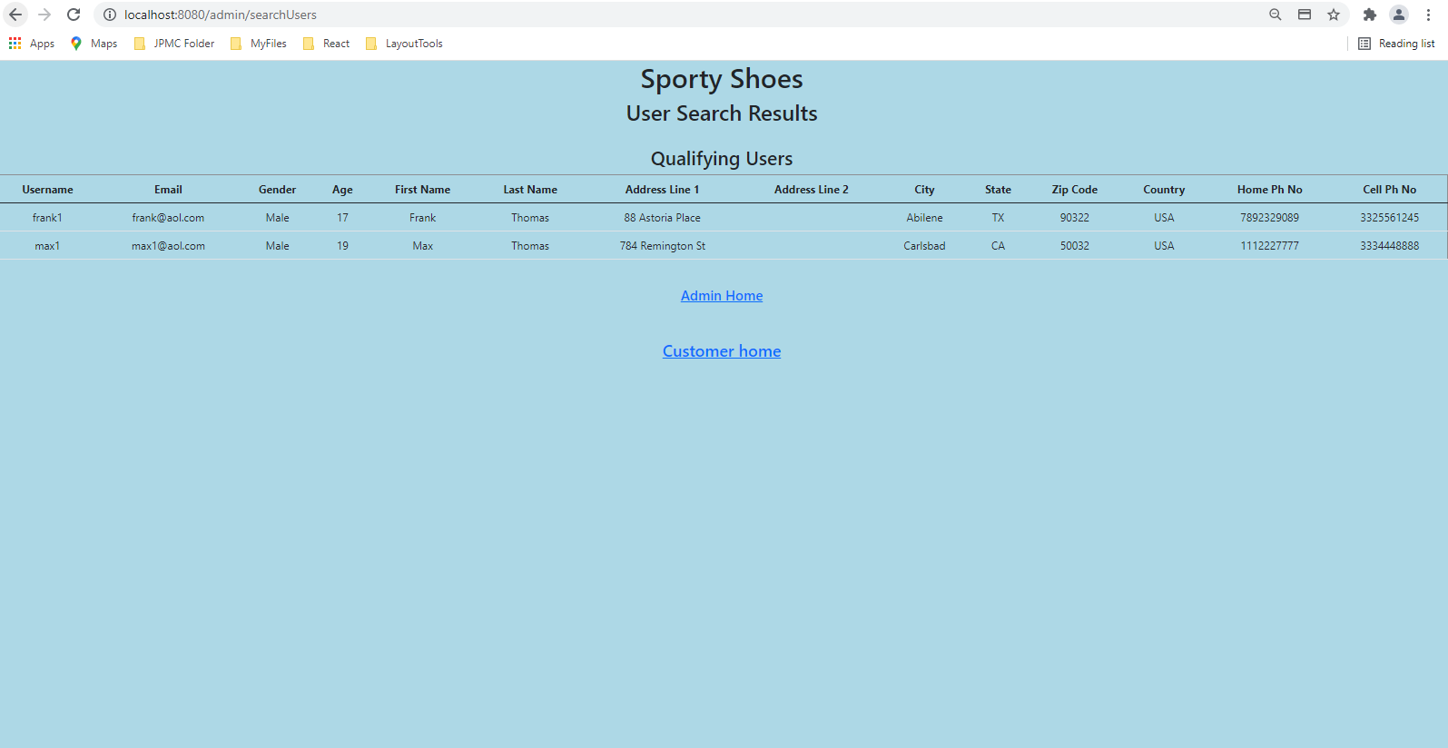

## Screenshot of MySQL database schema

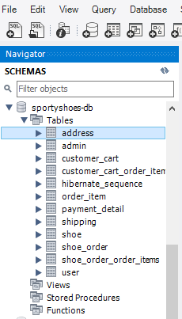

## Screenshot of address database table

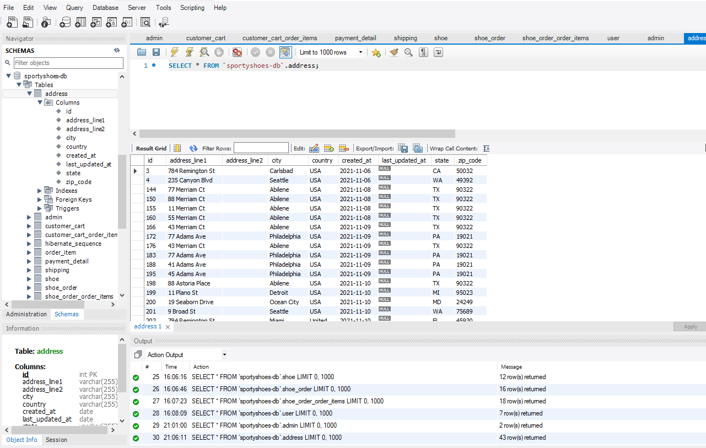

## Screenshot of admin database table

## 

## Screenshot of customer_cart database table

## 

## Screenshot of customer_cart_order_item database table

## 

## Screenshot of order_item database table

## 

## Screenshot of payment_detail database table

## 

## Screenshot of shipping database table

## 

## Screenshot of shoe database table

## 

## Screenshot of shoe_order database table

## 

## Screenshot of shoe_order_order_items database table

