Insurance AI Platform
Architecture & Design Document
Local-First AI Insurance Risk & Fraud Intelligence Platform
Covers: Phase 1 (Foundation) — Phase 2 (Core Domain) — Phase 3a (Risk Scoring Engine, in progress)
Repository: github.com/btholath/insurance-ai-platform
Author: Biju Tholath | Generated: August 2026
Living document
Every diagram and claim in this document reflects the real, verified, currently-committed state of the codebase — not aspirational design. Where a component is still in progress, it is labeled explicitly. See readme-runbook-phase1.md, readme-runbook-phase2.md, and readme-runbook-phase3.md in the repository for the full, session-by-session build history behind every decision described here.

Table of Contents

1. Executive Summary
The Insurance AI Platform is a local-first, no-cloud-dependency system for insurance risk, fraud, and claims intelligence, built entirely through spec-driven development: every feature begins as a written specification, is planned and task-broken before any code exists, and is implemented against a governing project constitution that is itself version-controlled and amendable.
As of this document, three of nine planned phases are substantially complete. Phase 1 established the platform's foundation — a custom identity model with nine organizational roles, a single reusable role-based access control mechanism, an append-only audit log enforced at the database level, and a health-check surface. Phase 2 built the real business domain on top of that foundation: Customer, Policy, and Claims, each with full CRUD APIs, sharing the same RBAC mechanism and audit infrastructure. Phase 3a, in progress, adds the platform's first genuinely AI-adjacent capability: a transparent, tiered risk-scoring engine with a dedicated explainability endpoint, directly satisfying the project's constitutional requirement for explainable outputs.
The core architectural bet
Every module — Customer, Policy, Claims, and now Risk — reuses exactly one permission mechanism (HasRole) and exactly one audit-refusal mechanism (a small registry mapping URL prefixes to role sets). New modules register a few lines of data; they do not modify shared, already-tested code. This bet was made explicit in Phase 2b and proven — literally, via a byte-identical diff on the shared handler file — when Claims was added in Phase 2c as the registry's third consumer.
This document describes each major architectural component, how real data flows through the system end-to-end, and how the components work together. Every diagram reflects verified, committed code — most figures (row counts, coverage percentages, specific factor weights) were independently re-derived from the project's real seeded dataset or test output while this document was assembled, not copied from design intent.

2. System Architecture
The platform runs as three Docker Compose services on a single host, with no required external network dependency — a constitutional requirement (Principle I: Local-First) verified in practice by bringing the stack up under a deliberately network-isolated Docker configuration and confirming the application continues to function.
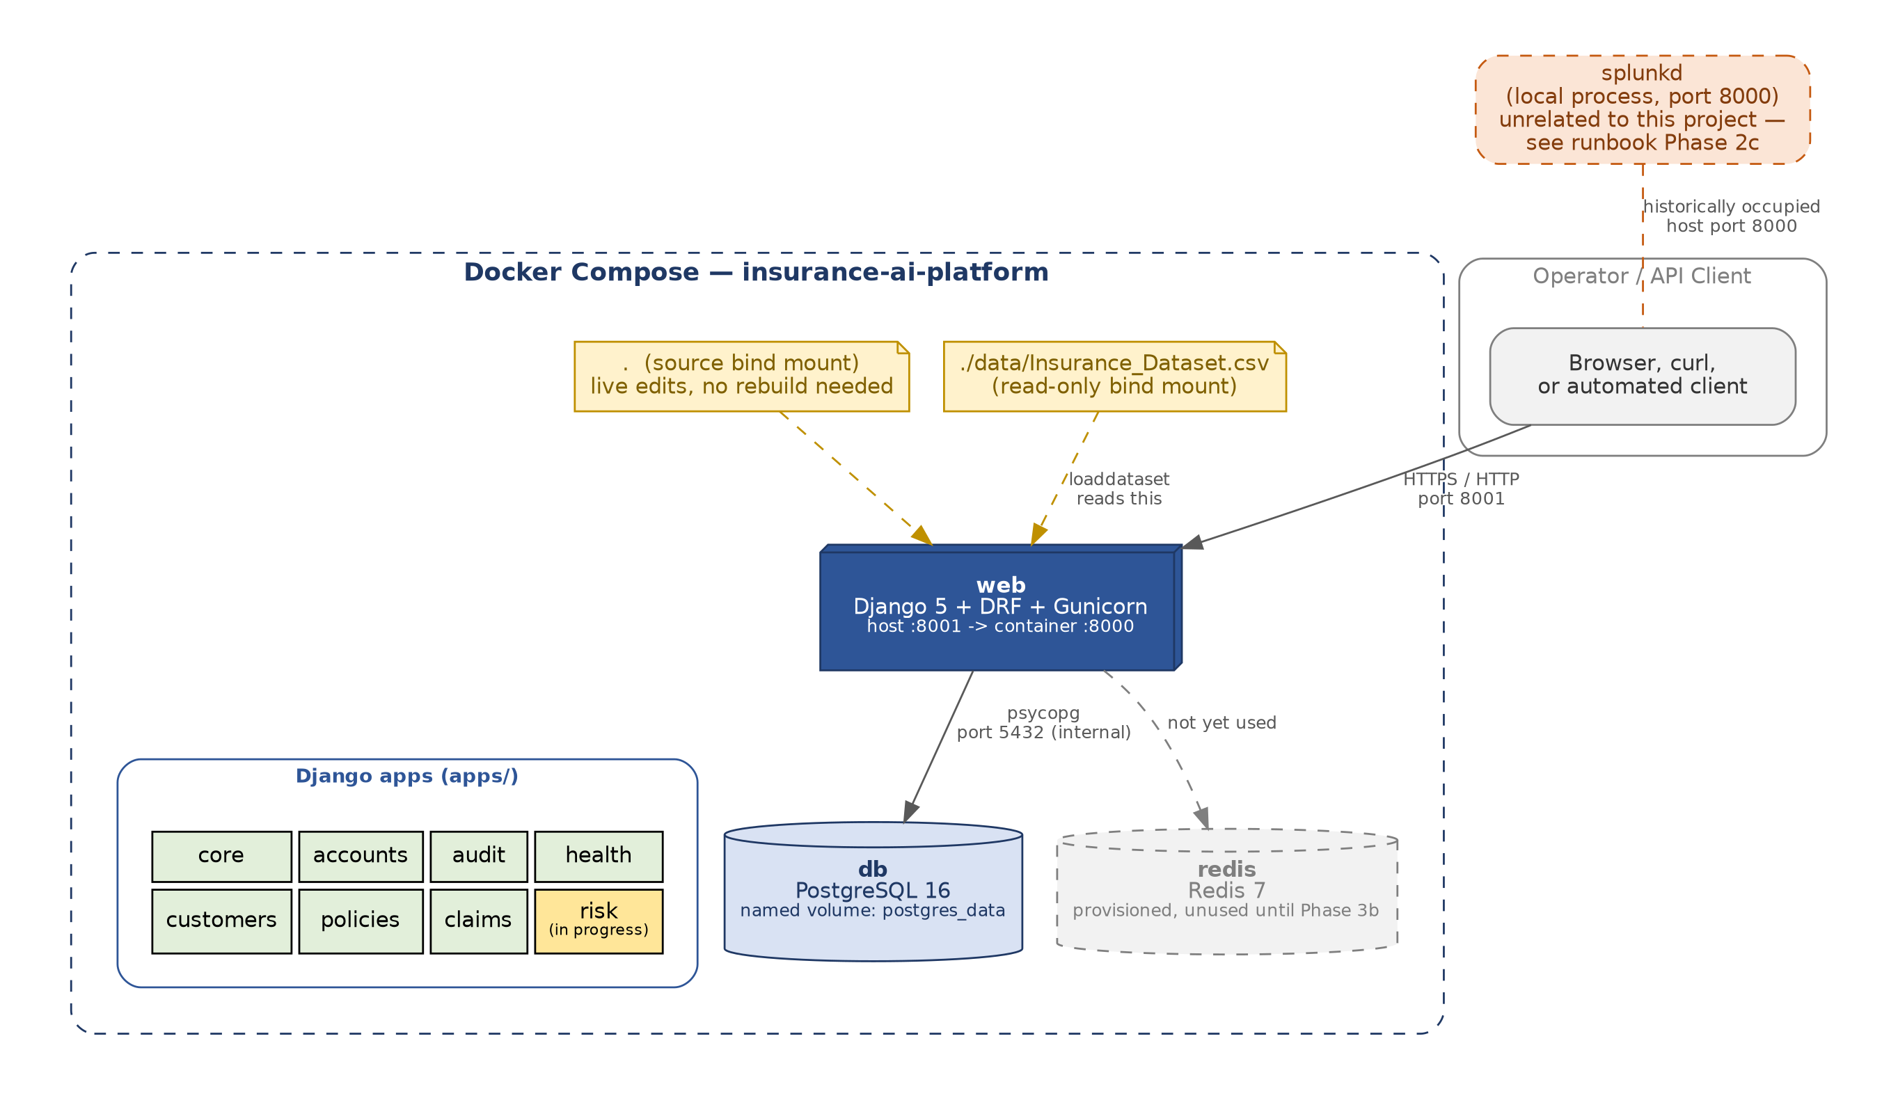
Figure 1 — System architecture: Docker Compose services, volumes, and network boundaries

2.1 Services
Service | Role | Notes
web | Django 5 + Django REST Framework, served by Gunicorn | Host port 8001 -> container port 8000. Remapped from 8000 after discovering a local process (splunkd) occupying that port on the host — see §2.3.
db | PostgreSQL 16 | Named volume (postgres_data) for durability across restarts. Holds every application table plus the append-only audit log and its enforcing trigger.
redis | Redis 7 | Provisioned as infrastructure since Phase 1, deliberately unused until Phase 3b introduces asynchronous, automatic risk recomputation via Celery.

2.2 Development ergonomics: two bind mounts
Two read-only or shadowing bind mounts were added deliberately, each for a specific, documented reason:
- A source bind mount ( . -> /app ) added in Phase 3a lets the running container see code edits immediately, without a rebuild — closing, structurally, a real failure class from Phase 2b in which a stale, never-rebuilt image produced a clean-looking test pass against code that no longer existed on disk.
- A read-only dataset bind mount ( ./data -> /app/data ) added in Phase 2c keeps the source CSV out of the Docker image layer entirely, consistent with the project's ongoing caution around that specific file (it was, at one point, at real risk of being committed to the public repository before a .gitignore rule closed the gap).

2.3 A resolved infrastructure incident, worth documenting architecturally
During Phase 2c, a Docker Desktop connectivity failure led to a misdiagnosis, a genuine loss of the project's accumulated audit-trail data (recovered via the deterministic CSV loader, though the historical audit entries themselves were not recoverable), and — as a byproduct of the investigation — the definitive resolution of a months-old, previously “closed” anomaly: intermittent Server: Splunkd responses on port 8000, originally attributed to unfixable host-network interference. The actual cause was a local security/monitoring process on the same machine occupying that exact port. The fix was a one-line port remap, not a network-level workaround. Full incident detail is preserved in readme-runbook-phase2.md.

3. Domain Model
The core business entities form a strict, one-directional dependency chain — Customer, then Policy (which references Customer), then Claim (which references Policy) — matching the order in which they were specified, planned, and implemented across Phase 2a, 2b, and 2c respectively. Phase 3a adds RiskAssessment and RiskFactor as a new, parallel structure hanging off Customer.
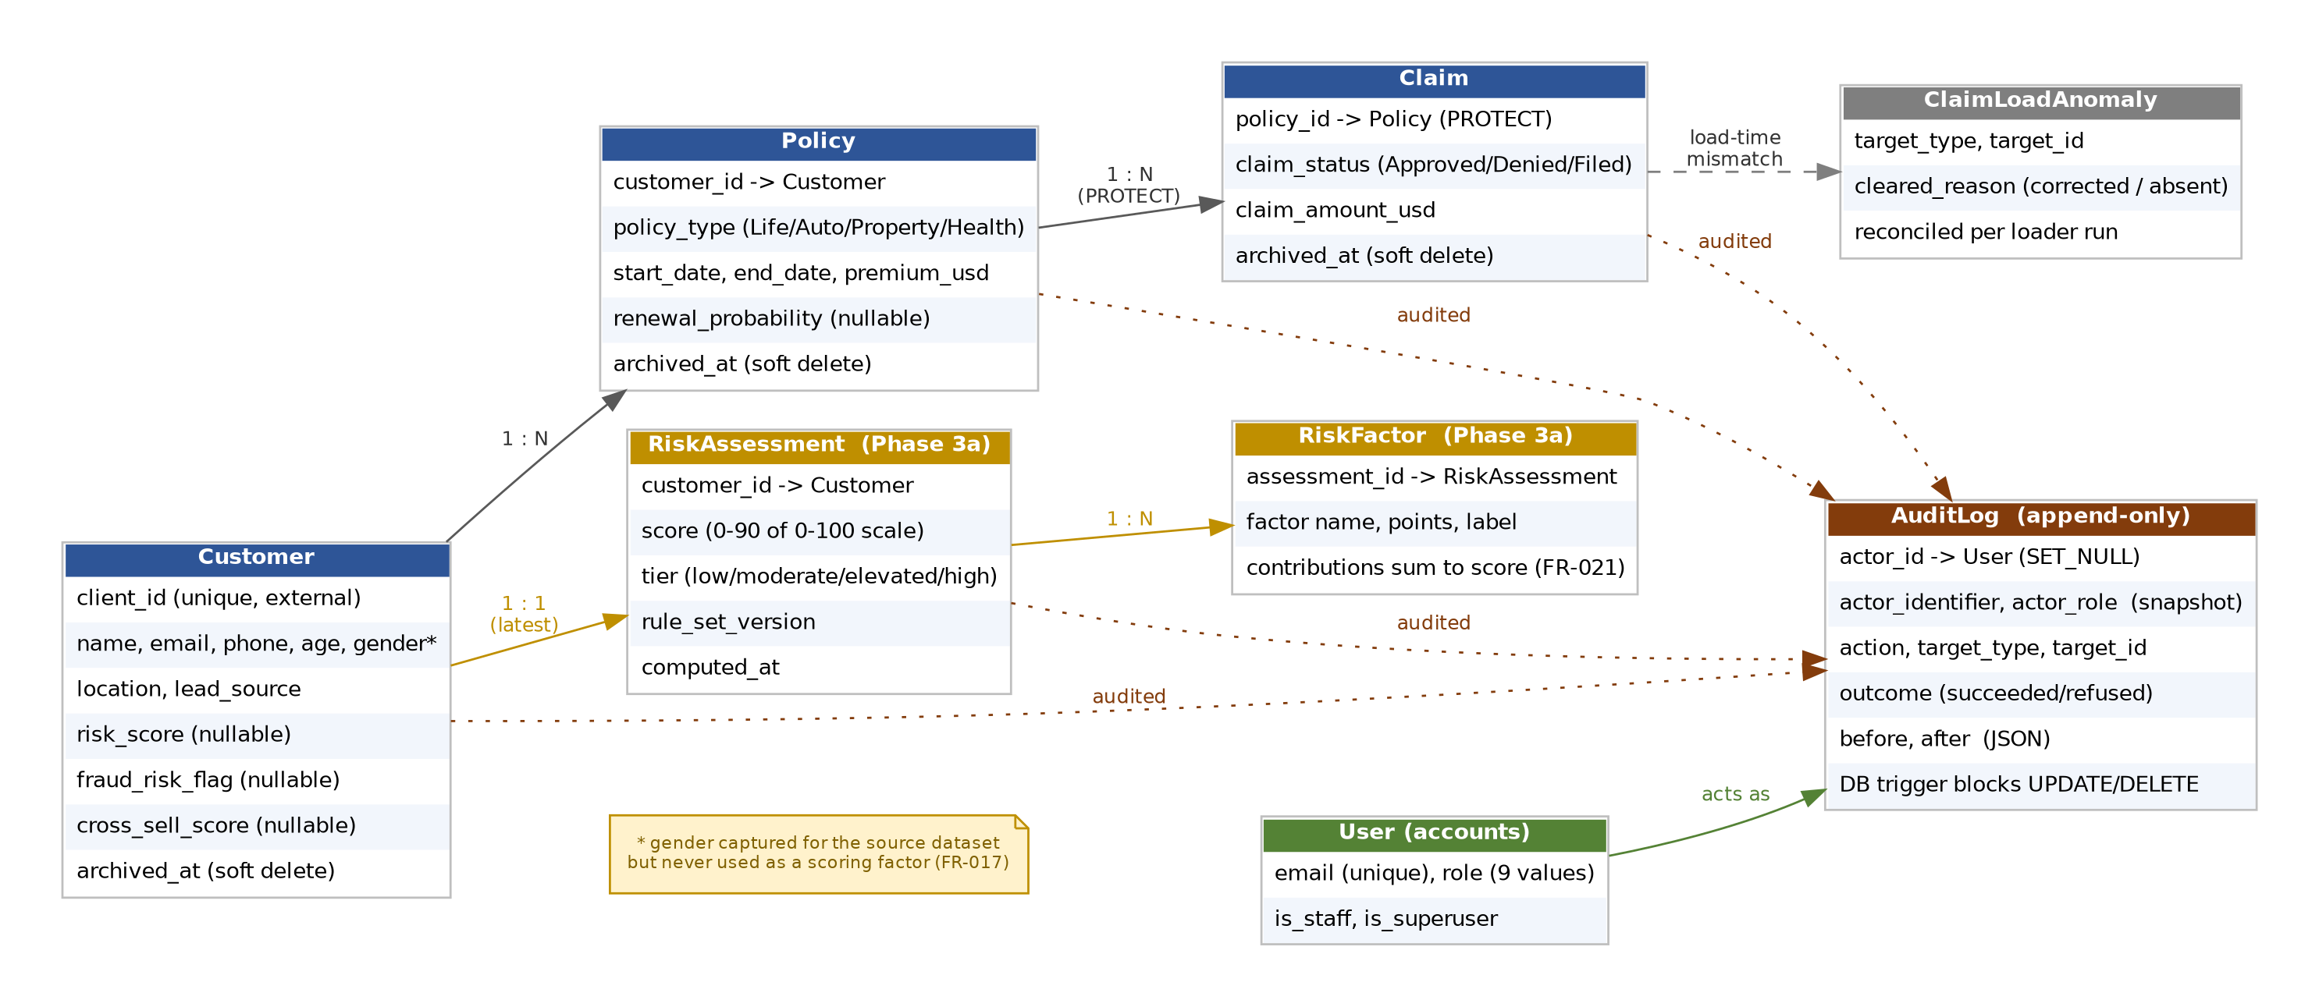
Figure 2 — Entity-relationship model, including the audit and identity subsystems

3.1 Soft deletion and the dual-manager pattern
Every business entity supports archival rather than hard deletion: an archived_at timestamp, paired with two Django managers on each model — objects (the default, excluding archived rows) and all_objects (seeing every row, archived or not). This pattern exists specifically to make reconciliation and cross-entity visibility correct:
- The CSV loader must be able to find an already-archived Customer or Policy by its external reference on a re-run, to reconcile in place rather than create a duplicate and collide on a uniqueness constraint. This requires all_objects.
- A live Claim against an archived Policy must remain visible — archiving a policy is a coverage-lifecycle event, not a reason to hide claim history. This is deliberately the opposite instinct from hiding an archived parent's children, and is enforced with a dedicated test (Phase 2c/3a pattern, see Figure 2's PROTECT annotation on the Policy → Claim relationship).
- Policy’s (customer, policy_type) uniqueness constraint is deliberately live-scoped — the opposite of Customer's client_id, which stays reserved forever once archived. An archived policy must release its coverage-type slot so a customer can be re-issued the same type of policy later; Customer's external reference must never be reissued to someone else.

3.2 Referential integrity: PROTECT, not CASCADE
Both Policy → Customer and Claim → Policy use Django's PROTECT on_delete behavior at the database level: a hard delete is refused outright if dependent rows exist. Combined with the archival pattern above, hard deletion is effectively unreachable through any normal application path — the only way to remove a record from view is to archive it, which never cascades and never orphans anything.

4. Request Lifecycle: Access Control, Explainability & Audit
Every API request in the platform passes through the same sequence of checks, regardless of which module it targets. This uniformity is deliberate and load-bearing: it is what allowed Claims (Phase 2c) to add audit-refusal tracking as a single registry entry, with zero changes to the shared permission or exception-handling code — a claim verified, not merely asserted, via a byte-identical diff against the pre-Claims baseline.
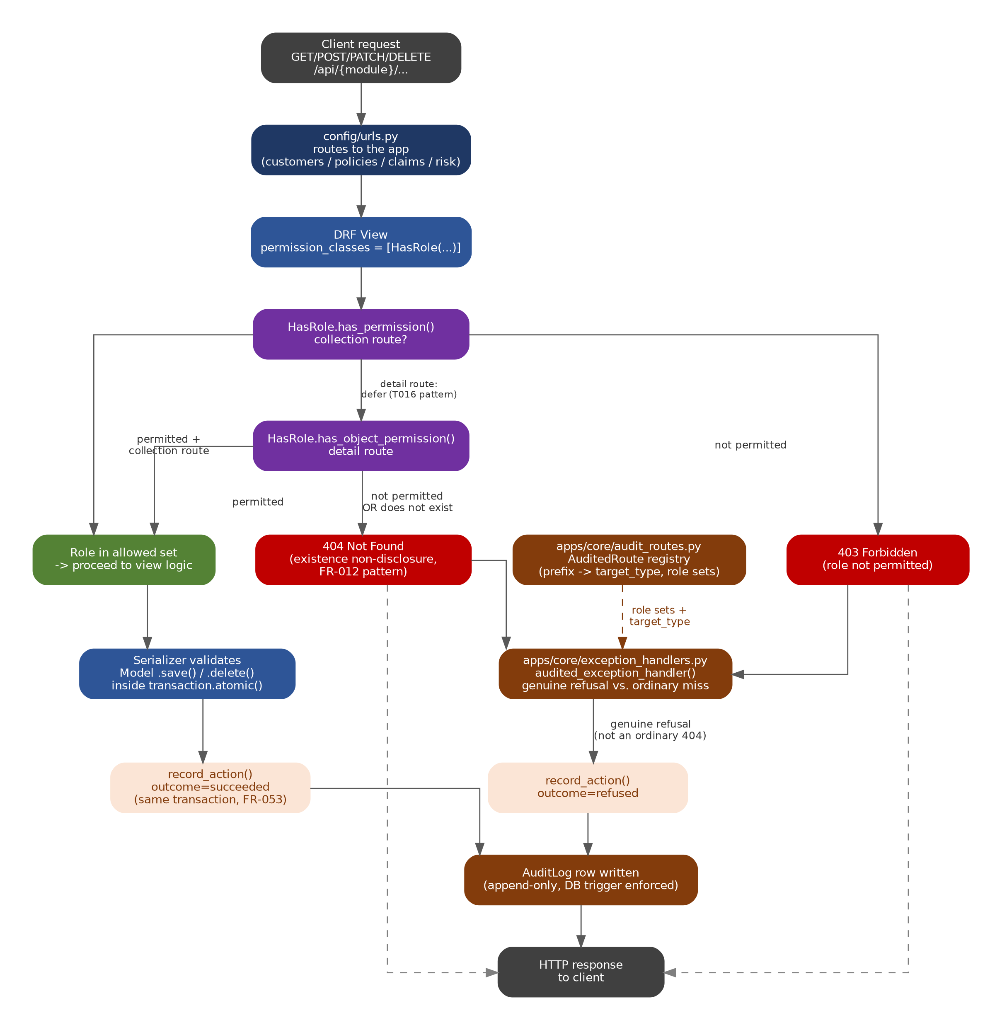
Figure 3 — Request lifecycle: permission evaluation, existence non-disclosure, and audit write sequencing

4.1 HasRole: one permission mechanism for every module
HasRole(*roles) is a factory function producing a Django REST Framework permission class bound to a specific set of allowed roles. It enforces three properties that are easy to get wrong individually and were each independently verified during implementation:
- No superuser bypass. Only the requesting user's role field is ever checked; is_superuser is never consulted by the permission class itself. An administrator is not an unrestricted backdoor.
- Deny-by-default. Role membership is checked as a positive inclusion test against the allowed set, never as a negative exclusion test against a disallowed value — so a null, blank, or unrecognized role fails closed without any special-casing required.
- Existence non-disclosure on detail routes. An unauthorized request for a specific record returns 404, not 403 — a 403 would itself leak the fact that the record exists. This required a real, non-obvious fix during Phase 2b: Django REST Framework evaluates has_permission() before has_object_permission(), so a naive implementation blocks the request one layer too early, before the object-level logic that is supposed to produce the 404 ever runs. The corrected version explicitly defers to object-level evaluation on detail routes.

4.2 The audit-refusal registry
apps/core/audit_routes.py holds a small, declarative registry mapping URL prefixes to a target type and two role sets (view and write). apps/core/exception_handlers.py consults this registry once, in a single shared exception handler, to decide two things for every denied request: which entity type to attribute the refusal to, and — critically — whether a given 404 represents a genuine permission refusal or an ordinary, non-suspicious miss (a permitted user simply requesting a record that does not exist).
This distinction matters operationally: without it, every mistyped record ID from a legitimate, permitted user would be logged as a security-relevant refusal, burying real signal in noise. The registry-and-handler split also means the entire cost of adding a new audited module is one data entry — proven directly when Claims was added as the registry's third consumer with no modification to the shared handler at all.

5. Data Loading Pipeline
The platform seeds itself from a single 3,000-row source dataset via one idempotent management command, manage.py loaddataset, extended incrementally as each domain module (Customer, then Policy, then Claims) was built. Idempotency is not assumed — it was empirically demonstrated by running the loader twice against the same database and confirming the audit trail's own record count held steady rather than doubling.
Figure 4 — Per-row data loading pipeline, with real observed row counts

5.1 A real data-modeling decision: absence is not a record
754 of the 3,000 source rows carry a Claim_Status of “No Claim” — representing the absence of a claim, not a claim with a status. Storing these as Claim rows would create 754 records asserting a claim exists whose own status denies it. The loader correctly treats a skipped row as a legitimate outcome, not a refusal, and reports it truthfully rather than silently.

5.2 A harder case: status/amount mismatches
390 of those 754 “No Claim” rows carry a non-zero claim amount in the source data — an internal contradiction in the raw dataset itself. The platform's resolution treats status as authoritative (no fabricated claim event is created) while never silently discarding the anomaly: each mismatch is recorded in a dedicated, reconcilable ClaimLoadAnomaly table, explicitly distinguishing whether a later load finds the row corrected versus simply no longer present — because, as reasoned through during specification, silence is not the same fact as confirmation of a fix.
Why not just log this to the audit trail?
The audit log is append-only by design. Logging a load-time anomaly there directly would mean every re-run of the loader adds a fresh duplicate entry for the same 390 rows, inflating any future mismatch count by the number of times the loader has ever run. The reconcilable anomaly table avoids this; a separate, genuinely append-only audit entry is still written for the anomaly's full lifecycle, preserving permanent history without corrupting a live count.

6. Risk Scoring Engine (Phase 3a — In Progress)
The risk scoring engine is the platform's first genuinely explainable-AI-adjacent component, and the first phase where constitution Principle IV (Explainable AI Outputs) is directly exercised — every earlier phase correctly marked it not applicable, since no scoring or AI surface existed yet.
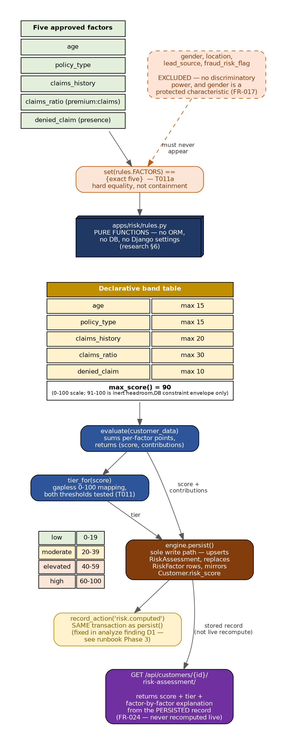
Figure 5 — Risk scoring engine: factor selection, pure-function evaluation, and the explainability guarantee

6.1 Factor selection: statistical and ethical screening, independently verified
Every candidate scoring factor was checked against the real 3,000-customer seeded database before being accepted or rejected. Two exclusions are worth stating precisely, because they were decided for different reasons: gender was excluded both because it showed no discriminatory power in the data (a near-uniform split, independently re-verified) and, separately and more fundamentally, because it is a protected characteristic that should not be used in insurance risk scoring regardless of what any measurement shows. The platform's existing, previously-stored risk_score field (inherited from the original source dataset) was replaced outright after being shown, not merely assumed, to be statistical noise — 91 distinct values across 3,000 rows, with near-zero correlation to age or premium and a flat mean across every fraud-risk band.

6.2 A declarative, pure-function rule engine
apps/risk/rules.py contains no ORM calls, no database access, and no dependency on Django settings — a deliberate boundary that makes the scoring logic fast to unit test and, more importantly, guarantees FR-002's determinism requirement: the same input always produces the same score, verifiably, without needing a database fixture.
The five approved factors' point values are declared once, in a single table, and summed by max_score() rather than restated as a literal anywhere else in the codebase. This design choice caught a real bug during implementation: two docstrings independently claimed the scale summed to 100, while the actual table — and every already-completed 3,000-row validation run against it — genuinely summed to 90. Because max_score() derives its answer from the table rather than a hardcoded number, the code itself was never wrong; only the prose describing it was. The fix corrected the documentation to match the verified-correct table, deliberately avoiding the far more expensive alternative of changing a point value to force the total to 100, which would have invalidated the entire existing validation and required a formal rule-set version bump.

6.3 Explainability as a structural guarantee, not a convention
Two requirements make the explainability endpoint trustworthy by construction rather than by convention: factor contributions are required to sum exactly to the total score (a testable mathematical invariant, not a vague obligation), and the explanation returned by the API is always read from a persisted record captured at computation time — never recomputed live against whatever the underlying data happens to look like now. This mirrors the same principle behind the platform's audit design (an audit entry's actor_role is a snapshot, not a live lookup): a shown explanation should describe what actually happened, not what the current data would produce if asked again right now.
Because scoring is on-demand only in this phase (no automatic recompute exists until Phase 3b), a stored score can legitimately go stale as the customer's underlying Policy or Claims data changes after the fact. Rather than leave this as an undisclosed gap, the specification deliberately includes a staleness-disclosure requirement, so a consumer of the explainability endpoint is told when a score may no longer reflect current data — a design decision that was offered as optional during specification review and explicitly kept, since silently dropping it would have undercut the same explainability guarantee from the other direction.

7. Governing Principles
Every phase of this platform is built against a single, version-controlled project constitution, ratified before any application code existed and amended twice since (each amendment itself documented and justified). Six principles are treated as non-negotiable across every module:
Principle | Requirement | Where it is enforced
I. Local-First | No required dependency on any external cloud service. | Verified by running the full stack under a deliberately network-isolated Docker configuration.
II. Auditability | Every module that creates, modifies, or acts on business data must write to the audit log. | The audit-refusal registry (§4.2); enforced at the database level via an append-only trigger.
III. RBAC | Access decisions are enforced server-side, never by hiding UI options alone. | HasRole (§4.1), applied uniformly across every module.
IV. Explainability | AI-generated or scored outputs must include a structured explanation, with human review possible. | The Risk Scoring Engine's persisted, factor-level explanation (§6.3) — the first phase this principle actively governs.
V. Test-First | Business-rule code is written test-first, with meaningful coverage required. | Every module in Phases 1–3a; current overall suite exceeds 800 tests.
VI. Disposable Prototyping | Throwaway spikes (Phase 0) never become a dependency of real phases. | The Phase 0 Streamlit spike is explicitly excluded from every later phase's dependency list.

8. Current Status & Roadmap
Phase | Scope | Status
0 | Streamlit spike — local LLM feasibility (Ollama) | Complete (disposable, per Principle VI)
1 | Foundation — identity, RBAC, audit, health checks | Complete
2a / 2b / 2c | Customer / Policy / Claims — full CRUD, shared RBAC & audit | Complete
3a | Risk Scoring Engine — on-demand, explainable | In progress (rules.py verified; remainder of implementation ahead)
3b | Automatic recompute via Celery | Not started
4–8 | AI/LLM integration, Fraud & Behavior, Insights, Multi-Agent, Production Readiness | Not started

The throughline across every completed phase
Static review, however careful, has repeatedly found its limits in this project. Every one of the real bugs documented in the phase runbooks — a permission-dispatch ordering bug, an audit-trigger interaction with a foreign-key cascade, an unbounded database timeout, a stale-container false test baseline, and others — was found only by actually exercising the system under real conditions: a real request, a real cascade, a real re-run, a real infrastructure failure. That pattern is the platform's real engineering discipline, more than any single diagram in this document.

