Assignment 3 Report

Brian Thompson

Ricky Bernstein

Vince Capodanno

**Part 1**

Contributors: Brian Thompson and Vince Capodanno

Implementation:

For training the data, we read in the data from the training images and populated an array. For each pixel in each image in each class, we stored three values: the number of times that that coordinate is white, gray and black in that class. We then divide by the total number of images in that class to get the probabilities needed. For a smoothing factor, we chose k=0.2 because that resulted in the highest overall classification accuracy (0.778). For training, we would read the images in and calculate the probability of each class given all of the pixel values from that image (we use log to avoid underflow). We choose the largest one and classify it to that class.

Classification Rate for each class (from 0 to 9)

0.833 0.954 0.767 0.800 0.776 0.685 0.802 0.736 0.612 0.810

Confusion Matrix

0 1 2 3 4 5 6 7 8 9

0 **0.833** 0.000 0.011 0.000 0.000 0.067 0.033 0.000 0.056 0.000

1 0.000 **0.954** 0.000 0.000 0.000 0.019 0.009 0.000 0.019 0.000

2 0.010 0.029 **0.767** 0.039 0.010 0.010 0.068 0.019 0.049 0.000

3 0.000 0.010 0.000 **0.800** 0.000 0.040 0.020 0.060 0.020 0.050

4 0.000 0.000 0.000 0.000 **0.776** 0.009 0.019 0.009 0.019 0.168

5 0.022 0.011 0.011 0.130 0.033 **0.685** 0.011 0.011 0.022 0.065

6 0.000 0.033 0.044 0.000 0.044 0.055 **0.802** 0.000 0.022 0.000

7 0.000 0.057 0.028 0.000 0.028 0.000 0.000 **0.736** 0.028 0.123

8 0.010 0.010 0.029 0.117 0.029 0.087 0.000 0.010 **0.612** 0.097

9 0.010 0.000 0.000 0.020 0.100 0.020 0.000 0.020 0.020 **0.810**

Highest and lowest posterior probabilities

Class 0 : lowest probability (image number 610 )

++++++#+++

+##########+

+##############

+###############+

########++ ++###+

#######+ ####

+###+ +###+

+### +###+

#### ###+

#### ####

###+ ####

#### ####

####+ ####

+####+ ####

+#### ####

+###++ ####

+#####++++#####

+############+

+##########+

+++#######

Highest probability (image number 261 )

+++++

+#####+

+########+

+#########+

+##+ ++###+

+##+ +##+

+### +###

+##+ +##+

+##+ ##+

+## ##+

##+ +##

##+ +#+

+## +##+

+## +###

+## +###+

##+ ++###+

###+++####+

+########+

+######+

++++++

Class 1 : lowest probability (image number 527 )

++#

+##+

+##+

+##+

+##+

+##+

+##+

+##+

+##+

+####+

+#####

++ +##

+##+

+##+

+###

####+

++++++####+

+##########+

+##########+

+++##+++++

Highest probability (image number 897 )

++

+#

##

##

##

+##

+#+

+##+

+##+

+##

+##

##+

##+

##+

##

+##

###

###+

###

+++

Class 2 : lowest probability (image number 790 )

+++++###+

+++###########

+###############+

+#################+

+##########++#######

+#########+ ######+

####++++++ +#####+

###+ ++#####+

##+ +#######+

+#+ +########+

++ ########

######++

+######++

+#########+

+#########+

+#######+

++#####

+###

Highest probability (image number 262 )

+#+

+###+

#####+

#+++##+

+ ##+

+##

##+

+#+

+#+

##+

+##

+#+

++ +#+

+##++##

#######

#######

#######+

+#######+

++#+++###+

+##+

Class 3 : lowest probability (image number 128 )

+++++++++++

+##############++

#################+

###++++++++########+

++ ++#####

++#####

++++++########

+#############+

+#############+

++###########+

++ +####+

+#####+

+++++######+

+##########+

+#########+

++++++

Highest probability (image number 205 )

+#####++

+########+

+++####+

++##

+##+

+##+

++##+

+###+

+###+

+#####+

###+###+

++ +##+

+#+

+##

+##

+##+

++##+

+++++++++###+

+##########+

+++#####++

Class 4 : lowest probability (image number 253 )

+#+

+##

+## ++#+

+## +##+

+### +##+ +

+### +##+ +#+

+### +##+ +#+

+### +##+ +#+

+##+ +### +##+

+##+ +## ++###+

+##+ +##+#####+

+##+ ++++#######++

+#############++

+###########++

++++++++###

###+

+##+

+##+

+##

+#

Highest probability (image number 111 )

+ +#

+#+ +#

##+ +#

+##+ +++#

+### +##+

+##+ +##+

### +##+

##+ +###+

#+ ++####+

++####+######

+++#######++

+++++##+

+#+

+#+

##+

+##+

+#+

+#+

+#+

+#+

Class 5 : lowest probability (image number 896 )

+++++++++#+

++############

+############++

+##++++++++++

##+

+#+

+##+

+##++++++++++++

+##############+

+##############+

+++++++ +++ +##+

+##+

+##+

+##+

++ +##+

#+ +##

##+ +##+

+##+++++++++###+

+###########+

++#######+

Highest probability (image number 879 )

+++#+

++#####+

+######+

+####++

+#+

+#+

##+

+##

+##++

####+

+#####+

++++###

+#+

+#+

+#+

+##+

+##+

+++##++

+###++

+++

Class 6 : lowest probability (image number 444 )

+##

+##+

+##+

###+

###

+## +++

### ####+

+##+ +####+

+##+ +#####

+##+ ######+

### ######+

+## ######+

+##+ ######+

+##+ +#####+

+##+ +####+

+##+ +###+

+##+ +###

+###++++####++

+########+

++++#++

Highest probability (image number 632 )

+#+

+###+

+###+

+###+

+###+

+###+

+###+

+##+

+##+

+###+

+##+

+##+ ++##+

+###+ +####+

+###++######+

+##+ +######+

+###+#######+

+#########+

+#######+

+#####+

+##+

Class 7 : lowest probability (image number 119 )

###+++ ++++

##############+

+#############+

++++#########+

+#####

++###++

####+

+####+

+++++####+

+########+

+###########+

+###########+

+####++++++++

++###+

+###+

+###+

+###+

####+

####+

+#+

Highest probability (image number 564 )

+##+++++

+#########+

+###++######

###+ +##+

+#+ +##

+#+

+##+

+#+

+#+

+##

+#+

+#+

+##

+#+

##+

+#+

+#+

##+

+##+

+++

Class 8 : lowest probability (image number 101 )

+++++

#######++

+#########+

##########+#+

##########+#+ +

+####+##+++#++#+

+###++ ++####+

+####+++####++

+###########

+#########+

+########++

+##########++

+####+######+

++###+#+++####+

+#####++#####+

+############+

++###########

+##########

+#+######+

+++++

Highest probability (image number 572 )

+####+

++#####+

++#######+

+#########+

+###+ +#+###

###+ +###

###+ +##++

+##+ +##++

###++##+

+#####+

+####+

#####

+##+##+

##++##+

+##++##+

+##+##+

+#####+

+####+

+###+

+#+

Class 9 : lowest probability (image number 801 )

+##++++

++#########+

++############+

++###########+####

+#######++#+++ ++##

+####+ +#+

####+ ##+

###+ ++##+

###+ +++####+

#####++++##########+

+###################

+##########++ +###

++++++++ +###

+###

+##+

+##+

+###

+##+

+##+

+##+

Highest probability (image number 58 )

++#++

++#####

+###++##+

+###+ +#+

+## +#+

+## +#+

+#+ +##

+## +##+

+##+#####

+######+

++##

+#+

##+

+##

+##+

+##

##+

+##

+#+

+#+

Feature likelihoods and odds ratio

Highest confusion pair: [4, 9]

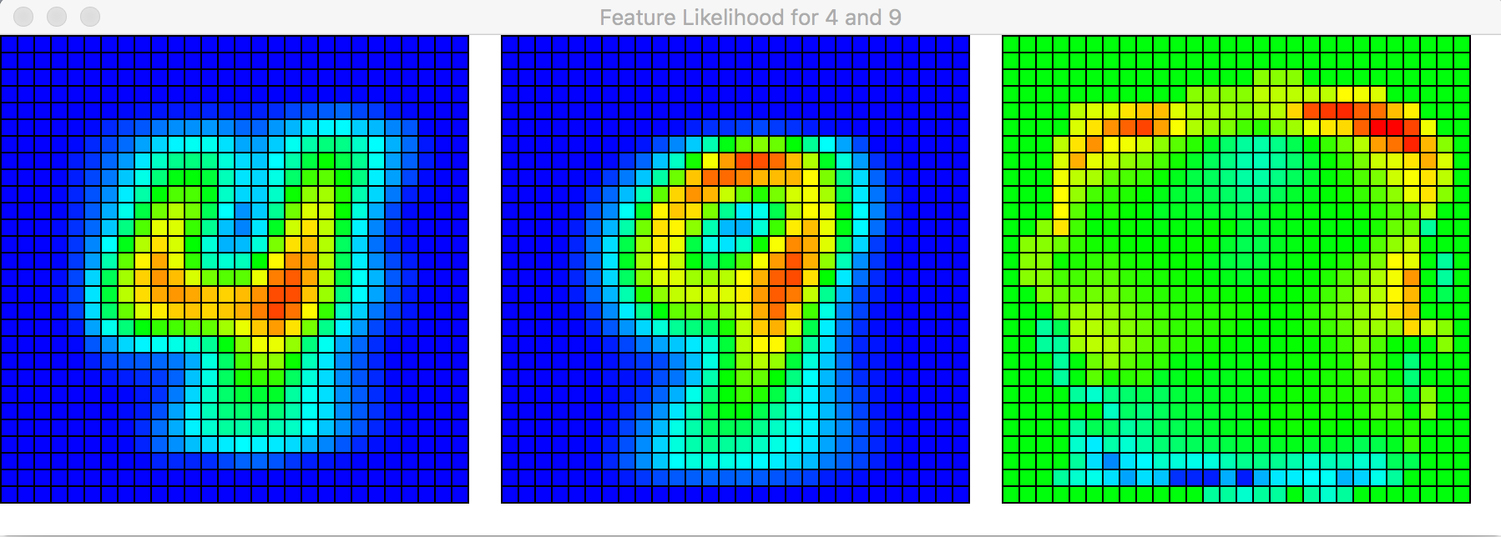

Second highest confusion pair: [5, 3]

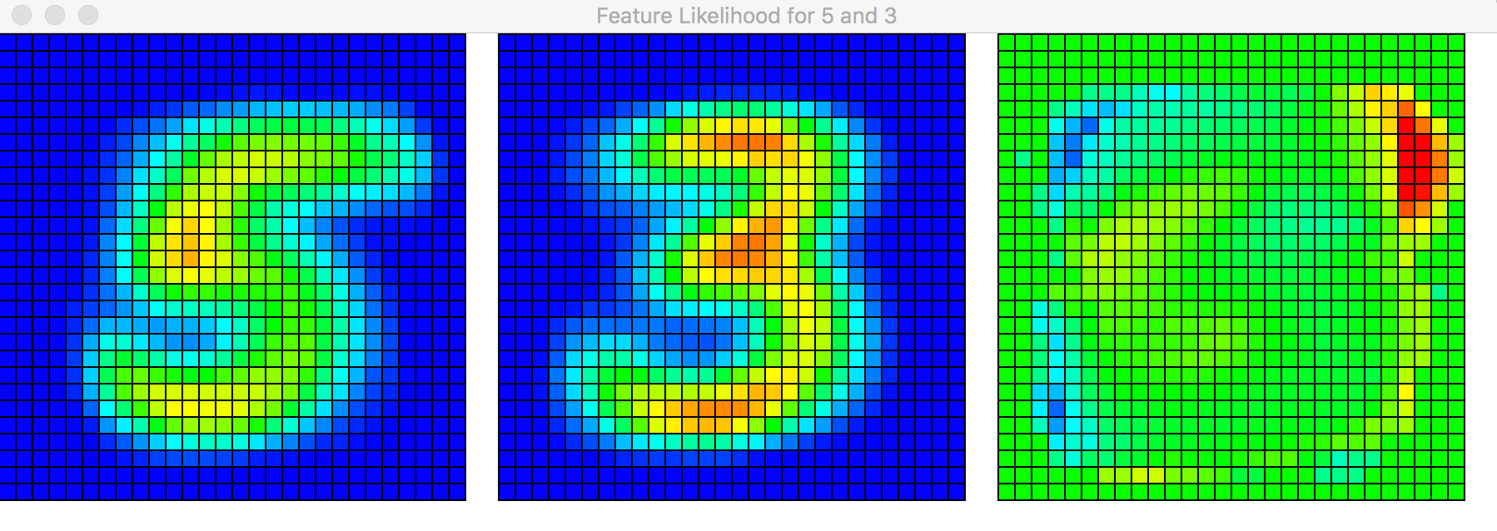

Third highest confusion pair: [7, 9]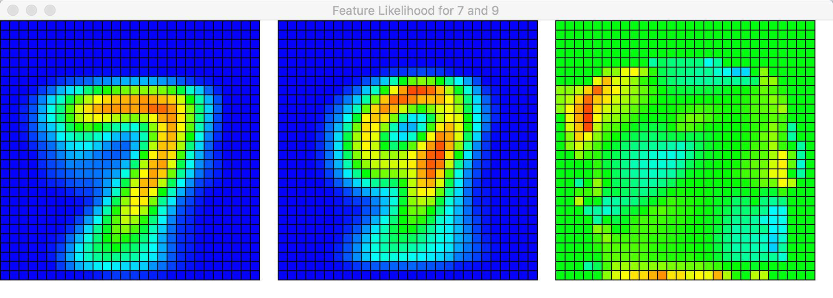

Fourth highest confusion pair: [8, 3]

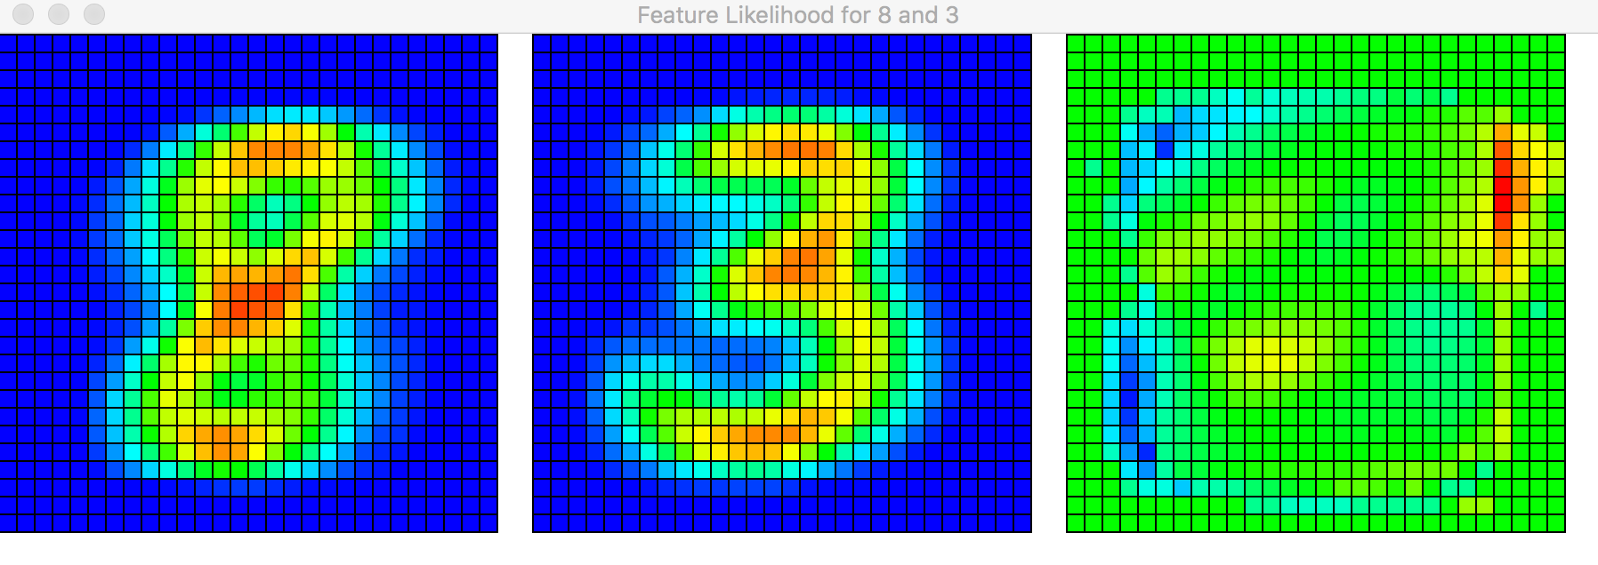

**Part 2**

Contributors: Brian Thompson and Ricky Bernstein