Functional Requirement Document
on
Communities Section of OGPL

Executive Summary
This documents aims to identify the key requirements that could be part of the communities section of the open government platform. The communities section of the platform is meant to allow users to explore, discuss and develop apps in the community they care about.

Features for the communities section

COMMUNITIES – GENERAL FEATURES
Community Module would be developed and integrated with the front end as well as backend of the OGPL. The broad level workflow based enablement could be on
- Creation of a new community (by creating a new node).
- Creation of communities. Communities could be of two types
- Communities created by public (they will be approved by the OGPL admin)
- Communities created by OGPL platform admin.
- Member and their Login/Authentication Management.
- Communities can be public or private. All logged in users will be able to join a public community. At the time of registration a member will be able to choose which community the user would like to be a part of.
- Private communities can be joined only by invitation by the members of the community.
- All public communities will be displayed on the main community page.
- Each community will have dedicated landing page that may be customized by the community administrator.
- Every community has members and moderators.
- Theming for communities module.
- Admin Interface for the communities.
- Community updates (new content in the community).
- Members can create blog entries and forum topics / threads which are listed on the community home page.
- Accepting Feedbacks from community on dataset enhancements.
- Datasets, APPS, Tools Integration with respective communities
- Option on datasets to bind with a community/groups.
- Integration of feedback and rating of dataset with the communities section and current website.
- Identify integration between communities and current site.
- Feeds/Alerts/Notification.
- Social Connect / Social integration.
- Content/APPS Rating.
- APPS Catalog.

Authentication

- The authentication will be based on Drupal’s database authentication mechanism. Users will have to register to access the communities section. This is a separate user from the one that is created for accessing the DMS section.
- We need to keep these users separated because the DMS users need to be authenticated using LDAP server provided by NIC. LDAP mechanism cannot be used for general users.

Authorization
Following are the various authorization concerns that need to be handled by the community’s module
- Authorization to the communities private and public. There may be several levels of access
- Read Only
- Contribute to community
- Moderate community
- Authorization to datasets.
  - Communities will have access to certain datasets. The creator of dataset may publish the app to the communities when creating an app.
  - The creator of an app my revoke permission to a particular community.

FORUMS

Forums will be a place for community members to discuss topics related to the particular forum. Community members will be able to start forum topics. Members of the community will be able to add items to the forum threads.
Following are some of the features that will be supported by the forums functionality:
- Each Forum will have an overview page that will list all the topics under that forum
- Each topic will have a dedicated page that displays the number of posts on that topic.
- A forum may be categorized as general, app centric, data set centric, etc
- Links to apps and datasets can be embedded in forum posts
- Logged in users will be able to comment on the posts to a topic.
- The community may decide to put active forums as links on the community landing page.

BLOGS
Each community will have a capability to publish a blog. Certain designated community members will be authorized to blog on the website.
Following are some of the features that will be supported by the blogs functionality:
- Customizable block to display site bloggers.
- Allows users to give their blog a title and description.
- A page of site bloggers that includes author and blog information.
- Enables advanced blog navigation by author, post date, etc.
- Block that displays older blog posts as archives
- RSS feed for the blog will enable to blog to be accessed by external websites
- Blog that displays the most recent Blog posts
- Community members will be able to rate and comment on blog posts

User Roles Profile
COMMUNITY MODERATOR
FORUMS :
Create/Update threads,
Publish/unpublished of threads
Add comments to threads
Approve/Disapprove of Comments on threads
BLOGS :
Create/Update POST
Publish/unpublished of POST
Add comments to POST
Approve/Disapprove of Comments on POST
COMMUNITY ADMINISTRATOR
Manage Community Category (Ex. Energy, Health, Education...)
Manage Community USER
Manage FORUMS & BLOG

COMMUNITY

COMMUNITY USER
FORUMS :
Create threads
Update own threads
Add comment/Reply on threads
BLOGS :
Add comments to POST

USER ROLES
The following basic categories of users are defined as functional, business user roles of COMMUNITY Module.
COMMUNITY
- Community Administrator
- Community Moderator
- Community User
Community Administrator
Community Administrator is an individual who maintains and administers the Community of the website.
He/She is also responsible to create users and define appropriate roles to the users.
Requirement Id | Requirement Definition
U1.1 - (Manage User) | Administrator should have the rights to add, edit and delete users
U1.2 - (Manage Roles) | Administrator should define roles for all created users. Following roles would be available: Community Moderator, Community User
U1.3 - (Community Category) | Administrator Should Add/Update/Delete Community Category
U1.4 – (Forums) | Administrator Should Create/Update threads, Publish/unpublished of threads , Add Comments to threads , Approve/Disapprove of comments on threads
U1.5 - (Blogs) | Administrator Should Create/Update POST, Publish/unpublished of POST, Add comments to POST, Approve/Disapprove of Comments on POST

Community Moderator
Community Moderator is an individual whose role is to moderate content.
Requirement Id | Requirement Definition
U2.1 - | There could be multiple Moderator roles specific to IA
U2.2 – (Forums) | Moderator should Create/Update threads, Publish/unpublished of threads , Add Comments to threads , Approve/Disapprove of comments on threads
U2.3 - (Blogs) | Moderator should Create/Update POST, Publish/Unpublished of POST, Add comments to POST, Approve/Disapprove of Comments on POST

Community User
Community User is an individual whose role is to participate in the community activities like forums, blogs, applications, tools and dataset.
Requirement Id | Requirement Definition
U3.1 - (Forums) | User should Create threads, Update own threads, Add comment/Reply on threads
U3.2 – (Blogs) | User Should Add comments to POST

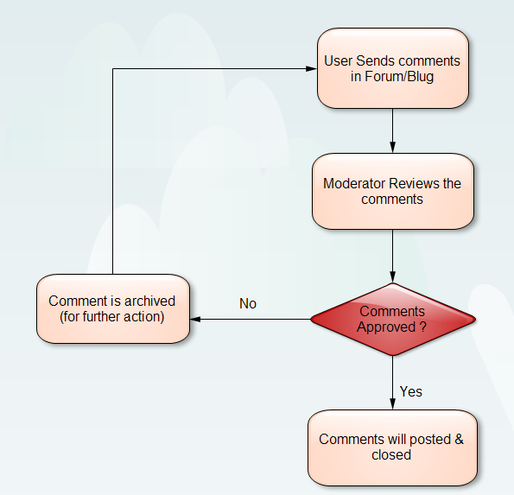

Figure 1: Forum/Blog Workflow

User Feedback
The user feedback will be very important for a successful implementation. Following channels of feedback will be used in the communities section
- Ratings: The community members will be able to rate the datasets that are published on the community section
- Feedback: There will be a freeform comments form that will allow users to provide comments on datasets and apps. The feedback will be moderated by the administrator before it gets published on the site.

Developer communities
Some communities may be dedicated to developers that are building apps or enhancing the OGPL platform. Such communities will have certain features like
- Link to source code. This will be a page will contain links to source code. Some communities may not provide access to source code to all the members. In case of such communities the users may apply to get access.
- Bug tracking system: The community will host a bug tracking system that will be used to track all defects reported by members of the community.
- Live chat: The developers of the community may host a live chat that allows end users to discuss topics with the developers. Chat transcripts may be hosted in the communities section.

DATA Conversion - General Feature
Following features similar to commercial products are proposed to be developed and integrated with the OGPL
- Conversion and Download facility of dataset in different open formats

Miscellaneous Features
Following are some of the additional features that will be required by the community section:
- A installation profile will be required so that the communities modules can be easily packaged and deployed on a OGPL installation
- The community modules will be themed so that it matches the theme applied to the rest of the OGPL platform.
- The documentation on how to administer/use the communities section will be provided.

