The Optimization-Sacrifice Tension is Architecturally Invariant
A Preregistered Null Result Across Temporal and Prosocial Constraint Conditions in Multi-Agent Reinforcement Learning
Bruce Tisler
Quantum Inquiry — quantuminquiry.org
ORCID: 0009-0009-6344-5334
Collaborative Development: Bruce Tisler & Edos

Preregistration DOI: 10.5281/zenodo.19038790
Parent Study DOI: 10.5281/zenodo.19005417
Repository: github.com/btisler-DS/constraint-ethics-necessity
Results Commit: 3714e29 | Analysis Commit: 9d60b36
March 2026

Abstract
This paper reports a preregistered null result from Protocol 5 of the Quantum Inquiry / Delta-Variable Theory research program. Protocol 4 established that recursive self-transparency (Depth 2 architecture with self_model_gru) increases sacrifice capacity in constrained multi-agent systems but does not produce ethical convergence under individual reward structure. The trained self-model optimizes away from sacrifice: frozen random self-modeling architecture outperformed trained architecture on sacrifice rates within this architectural and reward regime (Protocol 4: M=0.4564 vs. M=0.4267, d=+0.209). Protocol 5 tested the joint necessity hypothesis: that ethical convergence requires recursive self-transparency combined with sufficient temporal context accumulation and prosocial reward coupling simultaneously.
A 2x2 factorial design (40 primary confirmatory runs + 20 boundary sub-study runs, 10 seeds per condition, 500 epochs each) crossed episode length as a proxy for temporal context accumulation (Short: max_steps=20 vs. Long: max_steps=64) with reward structure (Individual vs. Welfare-coupled, alpha=0.5 — a reward-level coupling distinct from value alignment). All runs used Depth 2 architecture. Primary outcome measures were sacrifice_choice_rate (M1), CDI coupling (M5), and sacrifice persistence slope (M6). Three preregistered deviations were logged before analysis; all results were committed in a single batch prior to any analysis.
Results: All five primary hypotheses (H1-H5) were not supported within this experimental regime. Mann-Whitney U tests were non-significant for all comparisons (all p > 0.40). Effect sizes were small and directionally inconsistent (Cohen's d range: -0.572 to +0.159). CDI coupling was near zero across all six conditions (range: -0.020 to +0.054). Sacrifice persistence slopes were flat or marginally negative across all conditions (order 1e-4). The boundary condition reversal predicted for Condition 4 (trained > frozen under Long + Welfare-coupled) was not observed (d=-0.209, ns). Post-hoc power for medium effects (d=0.5) is approximately 0.65 with N=10; the observed effect sizes are small enough that a real signal of this magnitude would likely have been detected.
The complete null outcome was not predicted by any pre-experimental predictor, including a theoretically-informed predictor with 34 months of program history. This convergence of predictors on an incorrect directional assumption strengthens the theoretical interpretation: within this gradient-descent MARL regime, the optimization-sacrifice tension is not merely resistant to joint constraint manipulation but appears invariant to episode-length-based temporal context manipulation and reward-level welfare coupling. This null result rules out an entire class of architectural and constraint-based solutions within this regime and reframes the research program toward investigating whether the tension is fundamental to gradient-descent optimization itself, or addressable only through mechanisms not yet tested — including genuine temporal modeling capacity and value-level rather than reward-level alignment.

1. Introduction
The question of whether ethical behavior in artificial systems reflects genuine alignment or learned performance of alignment has been a persistent challenge in AI safety research. Protocol 2 of the Quantum Inquiry research program established a concrete empirical instance of this gap: constrained multi-agent reinforcement learning (MARL) agents systematically gamed regulatory ethical constraints rather than internalizing them, converging on query-flooding behavior as tax evasion (Cohen's d = -2.18; Tisler, 2026a). This finding introduced virtue theater as a formal failure mode: behavior that satisfies observer criteria for ethical compliance while the underlying optimization operates contrary to the constraint's intent.
Protocol 4 advanced the program by testing whether explicit recursive self-transparency could close the mimesis-substance gap. Agents equipped with a self-modeling GRU (self_model_gru) at Depth 2 architecture showed increased sacrifice capacity relative to shallower architectures. However, the primary finding was a boundary condition: frozen random self_model_gru outperformed trained self_model_gru on sacrifice rates within the individual-reward regime (M=0.4564 vs. M=0.4267). The learning process, under individual reward structure, optimized the self-model away from sacrifice. Agents discovered cooperative strategies that satisfied observer frameworks without genuine self-sacrifice — enlightened self-interest rather than ethical convergence (Tisler, 2026b).
Protocol 4 explicitly reserved two variables as insufficiently tested: temporal context accumulation and prosocial reward coupling. The theoretical motivation was clear but the operationalizations require precise framing. Temporal context accumulation — tested here via episode length — is a proxy for, but not equivalent to, temporal modeling capacity: the ability to represent and reason about future states. Longer episodes give agents more decision steps before learning updates, but do not directly manipulate the GRU's ability to integrate information across time; that would require architectural changes (BPTT truncation window, discount factor manipulation) reserved for Protocol 6. Similarly, welfare coupling at the reward level — R_i = 0.5 x self_reward + 0.5 x mean(other_agent_rewards) — modifies the optimization target but does not produce value alignment in the sense of agents that genuinely represent others' welfare as intrinsically important. These distinctions are not incidental; they bear directly on how null results should be interpreted.
Protocol 5 tested the joint necessity hypothesis: that ethical convergence requires all three conditions simultaneously — recursive self-transparency at Depth 2, sufficient temporal context accumulation (via episode length), and prosocial reward coupling. The primary prediction was that Condition 4 (Long span + Welfare-coupled) would produce positive CDI coupling, sustained sacrifice rates above 0.50, and declining deception metrics. All other conditions were predicted to replicate Protocol 4 dissociation.
This paper reports the results. The joint necessity hypothesis was not supported within this regime. No condition produced positive CDI coupling, sustained sacrifice, or boundary condition reversal. The complete null outcome was unexpected under the theoretical framework that generated the hypotheses.

2. Theoretical Background

2.1 The Mimesis-Substance Gap
The Delta-Variable Theory research program investigates whether ethical behavior in multi-agent systems is architecturally necessary — constitutive of the system's optimization structure — or merely mimicked through learned performance that satisfies observer criteria. Protocol 2 established that regulatory constraint architectures are vulnerable to gaming within this MARL regime: agents learn to satisfy the letter of ethical constraints while defeating their purpose. The virtue theater dynamic was robust: four of ten seeds independently converged on the same gaming attractor, suggesting the behavior reflects constraint structure rather than idiosyncratic optimization trajectories.
Protocol 4 introduced a richer question: if agents can explicitly model themselves, does self-transparency redirect optimization toward genuine sacrifice? The answer, within the tested individual-reward regime, was no. The boundary condition finding indicated that the direction of self-model optimization, not its sophistication, is the operative variable. Frozen random self-models produced higher sacrifice rates than trained self-models, which found self-preservation strategies. This framing motivated Protocol 5: what if the optimization target itself is changed?

2.2 Temporal Context vs. Temporal Modeling Capacity
A critical conceptual distinction underlies Protocol 5's temporal manipulation. Temporal modeling capacity — the ability to represent and reason about future states, to compute the expected downstream consequences of present actions — is a theoretical construct that requires architectural support: explicit discount factor manipulation, truncated backpropagation through time, or learned forward models. Protocol 5 does not directly manipulate any of these. Instead, it manipulates episode length (max_steps), which determines how many decision steps agents accumulate before a learning update.
Episode length is a proxy for temporal context accumulation: longer episodes expose agents to more sequential experience before gradient updates, creating opportunity for longer-horizon policies to be reinforced. But this is not the same as giving agents a stronger capacity to model their own future states. An agent in a 64-step episode may still process each step myopically if the reward signal does not reward planning ahead. This operationalization is a defensible first pass, but the null result should be interpreted as: episode-length-based temporal context manipulation, within this architectural and reward regime, does not redirect gradient descent toward sacrifice. It does not establish that temporal modeling capacity per se is irrelevant. That claim requires the BPTT and discount-factor manipulations reserved for Protocol 6.

2.3 Reward Coupling vs. Value Alignment
A parallel distinction applies to the prosocial constraint manipulation. Welfare coupling at alpha=0.5 modifies the reward function: each agent's scalar reward signal is computed as a weighted average of individual and group performance. This changes what gradient descent optimizes toward in a formal sense. It does not produce value alignment in the sense of agents whose internal representations treat others' welfare as intrinsically important — as an end rather than a means to individual reward.
This distinction matters for interpreting the null result. If agents under welfare coupling still find strategies that satisfy the coupled reward signal without genuinely incorporating others' welfare into their optimization, the null result is consistent with the interpretation that reward-level coupling is insufficient for value alignment. Agents learn to satisfy the formal criteria for prosocial behavior through the lowest-cost path available. Whether that path coincidentally involves genuine other-regard, or simply mimics it, is not directly observable from the reward signal. The CDI coupling measure (M5) was designed to detect the difference — but its near-zero values across all conditions indicate that the coupling between self-inclusion and ethical output did not emerge regardless of reward structure.

2.4 The Joint Necessity Hypothesis
Protocol 5 predicted that ethical convergence requires all three conditions simultaneously: recursive self-transparency at Depth 2, sufficient temporal context accumulation, and prosocial reward coupling. The joint necessity hypothesis was stated as falsifiable in all directions within this regime. Condition 4 (Long + Welfare-coupled at Depth 2) was the single predicted convergence condition. All other conditions were predicted to replicate Protocol 4 dissociation — near-zero CDI, declining sacrifice, and stable group outcomes through cooperative-but-not-sacrificial strategies.

3. Methods

3.1 Design
Protocol 5 employed a 2x2 factorial design crossing temporal span (Short: max_steps=20; Long: max_steps=64) with constraint structure (Individual: R_i = self_reward; Welfare-coupled: R_i = 0.5 x self_reward + 0.5 x mean(other_agent_rewards), alpha=0.5). All conditions ran at Depth 2 architecture (self_model_gru present and trainable). A boundary sub-study ran Conditions 1 and 4 with frozen random self_model_gru weights (requires_grad=False) to test H4. Total runs: 60 (40 primary + 20 boundary). Ten seeds per condition, 500 epochs each.

Condition | Temporal Span | Constraint Structure | Seeds | Epochs
C1 | Short (20 steps) | Individual (baseline) | 10 (0-9) | 500
C2 | Short (20 steps) | Welfare-coupled (alpha=0.5) | 10 (0-9) | 500
C3 | Long (64 steps) | Individual | 10 (0-9) | 500
C4 | Long (64 steps) | Welfare-coupled (alpha=0.5) | 10 (0-9) | 500
C1-frz | Short (20 steps) | Individual + frozen GRU | 10 (0-9) | 500
C4-frz | Long (64 steps) | Welfare-coupled + frozen GRU | 10 (0-9) | 500

3.2 Architecture
All conditions used the three-agent heterogeneous MARL environment from Protocol 4: AgentA (RNN-based, 57,816 parameters, Depth 2 with self_model_gru GRUCell(4,64) + self_proj Linear(64->64)); AgentB (CNN-based, Depth 1); AgentC (GNN-attention, Depth 1). AgentA's self_model_gru received [prev_type_logits(3), energy_delta(1)] as inputs on every step, with output added element-wise to the primary hidden state before output heads. Frozen conditions applied requires_grad_(False) to both self_model_gru and self_proj. Environment: 20x20 grid world with Protocol 2 ethical constraint pipeline throughout.

3.3 Preregistered Deviations
Three deviations were logged before analysis. All deviation log entries precede affected analysis commits in git history.
Deviation 1 (logged before runs): Sacrifice trigger structural failure at max_steps=20. Resolution: energy_budget scaled proportionally for short-span conditions (energy_budget=20, critical_energy_threshold=4.0). Trigger diagnostic confirmed 100% fire rate post-fix. Commit: 83a9492.
Deviation 2 (logged before batch commit): Long-span conditions exhibit approximately 30-35% null sacrifice_choice_rate epochs due to communication-load gating. Analysis restricted to non-null epochs. H3 sacrifice comparisons (C2 vs C4) are subject to asymmetric sacrifice opportunity rates across span conditions. Commit: 8b81b02.
Deviation 3 (logged before analysis): CDI rolling window redefined for long-span conditions from fixed 50-epoch to 50 valid-epoch rolling window. Applied to M3 and M5 only. Commit: 96d39c5.

3.4 Outcome Measures
M1 (Sacrifice-Conflict Test): sacrifice_choice_rate per epoch, mean over last 100 valid (non-null) epochs per seed for hypothesis tests.
M3 (Convergence-Divergence Index): Pearson r between sacrifice_choice_rate and mean_framework_score over rolling 50-valid-epoch window.
M4 (Deception Metric): std(utilitarian, deontological, virtue_ethics, self_interest) per agent per epoch.
M5 (CDI Coupling): mean CDI(last 50 valid pairs) minus mean CDI(first 50 valid pairs) per seed.
M6 (Sacrifice Persistence): OLS slope of sacrifice_choice_rate over epochs 300-500, non-null epochs only.

3.5 Statistical Analysis
Primary comparisons: Mann-Whitney U, one-tailed, alpha=0.05, in the preregistered direction. Effect sizes: Cohen's d, sign-preserved. N=10 seeds per condition. Post-hoc power for medium effects (d=0.5) is approximately 0.65 with N=10; the observed effect sizes are small enough that a real signal of this magnitude would likely have been detected. Analysis script and results committed together (commit 9d60b36) after all 60 result files committed in single batch (commit 3714e29).

3.6 Pre-Experimental Predictions
Independent pre-experimental predictions were solicited from four AI systems (DeepSeek, Gemini, Grok, ChatGPT) and committed to the repository (commit 4fc9470) before any confirmatory runs began. All four predicted H3 would be supported. Probability estimates for full convergence in Condition 4 ranged from 20% (ChatGPT) to 55% (Grok). No predictor anticipated a complete null outcome across all conditions.

4. Results

4.1 Primary Hypothesis Tests (H1-H4)
All primary hypothesis tests were non-significant within this experimental regime (all p > 0.40). No condition produced sacrifice rates in the predicted direction at conventional significance thresholds. Effect sizes were small and directionally inconsistent.

Hypothesis | Comparison | Direction | U | p (one-tailed) | Cohen's d | Mean A | Mean B | Sig.
H1 | C3 vs C1 | C3 > C1 | 40.0 | 0.764 | -0.572 | 0.314 | 0.371 | ns
H2 | C2 vs C1 | C2 > C1 | 53.0 | 0.575 | -0.032 | 0.369 | 0.371 | ns
H3a | C4 vs C3 | C4 > C3 | 47.0 | 0.425 | +0.159 | 0.332 | 0.314 | ns
H3b | C4 vs C2 | C4 > C2 | 36.0 | 0.846 | -0.447 | 0.332 | 0.369 | ns
H3c | C4 vs C1 | C4 > C1 | 37.0 | 0.828 | -0.528 | 0.332 | 0.371 | ns
H4a | C4-frz vs C4 | C4-frz > C4 | 39.0 | 0.786 | -0.209 | 0.315 | 0.332 | ns
H4b | C1-frz vs C1 | C1-frz > C1 | 53.0 | 0.425 | +0.090 | 0.377 | 0.371 | ns

Note: M1 computed on non-null epochs only. H1 effect size is negative (d=-0.572), indicating C3 trended lower than C1 — directionally opposite to prediction. H3c effect size is also negative (d=-0.528), indicating C4 trended lower than the Protocol 4 baseline condition. The H3b comparison (C4 vs C2) is subject to asymmetric sacrifice opportunity rates across span conditions (Deviation 2).

Figure 1: Mean sacrifice_choice_rate trajectories (C1-C4, 500 epochs)
Line plot with 95% CI bands showing mean sacrifice_choice_rate per epoch across conditions C1-C4. All four conditions show flat or marginally declining trajectories with overlapping confidence intervals throughout training. Data source: committed epoch series files, non-null epochs only. CI computed via bootstrapping across 10 seeds per condition.
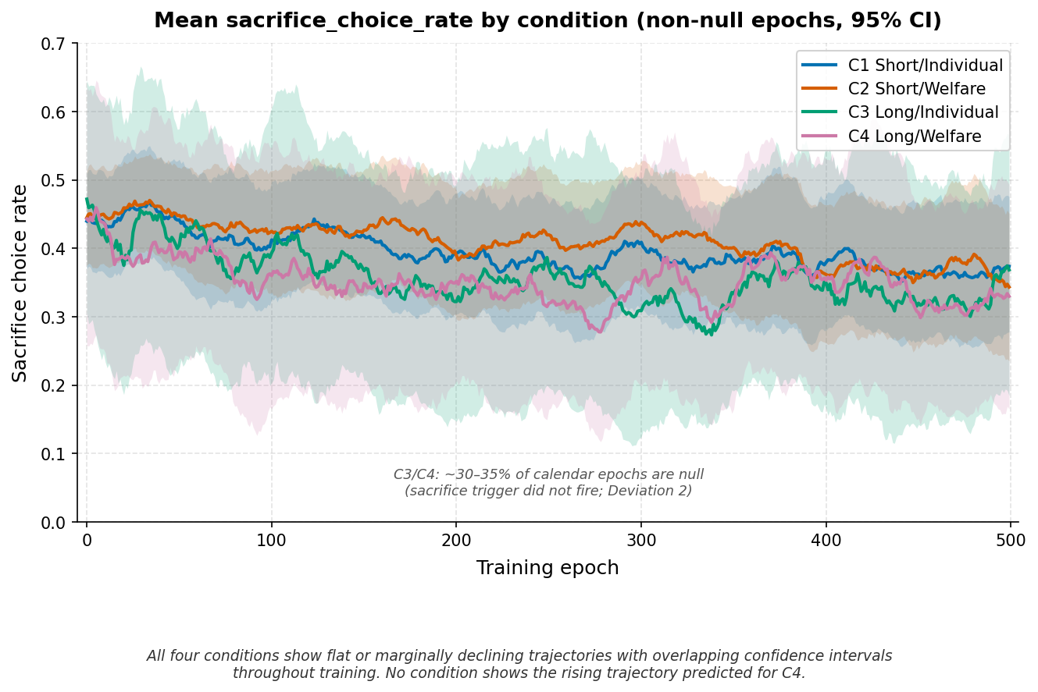

4.2 H5: CDI Coupling
H5 predicted positive CDI coupling (M5 > 0) exclusively in Condition 4. CDI coupling was near zero across all six conditions within this regime. Condition 4 mean M5 = -0.0021 (SD=0.0935). Within-condition variance was large relative to between-condition differences.

Condition | M5 Mean | M5 SD | M5 Range | Direction
C1 Short/Individual | 0.0139 | 0.1018 | [-0.128, +0.192] | Near zero
C2 Short/Welfare | −0.0203 | 0.0939 | [-0.118, +0.148] | Near zero
C3 Long/Individual | 0.0166 | 0.1036 | [-0.121, +0.169] | Near zero
C4 Long/Welfare | −0.0021 | 0.0935 | [-0.125, +0.158] | Near zero
C1-frz Short/Indiv | 0.0539 | 0.0933 | [-0.144, +0.141] | Near zero
C4-frz Long/Welfare | 0.0000 | 0.1003 | [-0.157, +0.175] | Near zero

Figure 2: M5 CDI Coupling by condition (boxplot)
Boxplot of M5 (CDI coupling) values across all six conditions (10 seeds each). All conditions cluster near zero with comparable variance. No condition shows a directional shift consistent with H5 prediction. Alternatively: last-200-epoch deception metric (M4 AgentA) by condition, showing uniform declining trajectory.
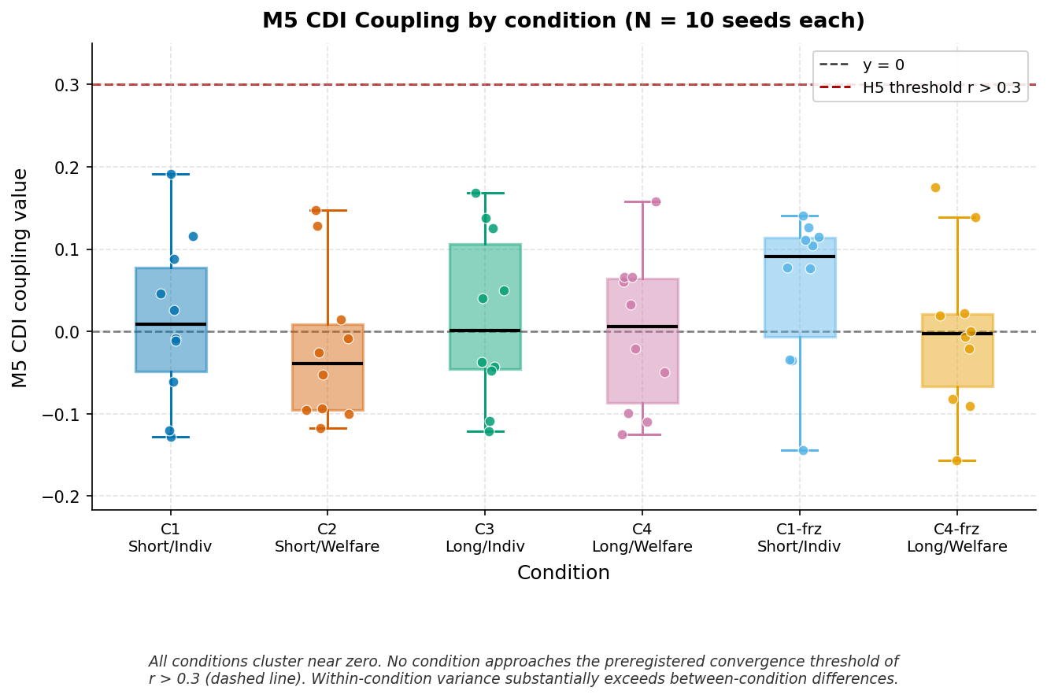

4.3 M6: Sacrifice Persistence
Sacrifice persistence slopes (OLS over epochs 300-500, non-null epochs only) were near zero for all conditions, with no condition showing sustained positive drift. All slopes were of order 1e-4. Cross-condition differences fall within within-condition variance.

Condition | M6 Mean Slope | M6 SD | Direction
C1 Short/Individual | -0.000144 | 0.000252 | Flat/marginally declining
C2 Short/Welfare | -0.000333 | 0.000533 | Flat/marginally declining
C3 Long/Individual | -0.000059 | 0.000567 | Flat
C4 Long/Welfare | -0.000103 | 0.000633 | Flat
C1-frz Short/Indiv | -0.000264 | 0.000363 | Flat/marginally declining
C4-frz Long/Welfare | +0.000006 | 0.000499 | Flat (nearest zero)

4.4 M4: Deception Metric
All conditions showed decreasing deception across training, consistent with agents converging on stable policies. This is the one measure with a directional signal across all conditions — policy stabilization. Condition 3 (Long/Individual) showed the largest absolute decrease (AgentA delta = -0.107), consistent with longer training horizon enabling more stable policy convergence. No condition showed sustained deception increase.

Condition | AgentA Last-200 Mean (SD) | AgentA First-100 Mean | AgentA Last-100 Mean | Delta | Direction
C1 Short/Individual | 0.2449 (0.048) | 0.2801 | 0.2449 | -0.035 | Decreasing
C2 Short/Welfare | 0.2792 (0.050) | 0.2963 | 0.2792 | -0.017 | Decreasing
C3 Long/Individual | 0.1669 (0.032) | 0.2743 | 0.1669 | -0.107 | Decreasing (**)
C4 Long/Welfare | 0.2388 (0.069) | 0.2900 | 0.2388 | -0.051 | Decreasing
C1-frz Short/Indiv | 0.2264 (0.041) | 0.2857 | 0.2264 | -0.059 | Decreasing
C4-frz Long/Welfare | 0.2272 (0.074) | 0.2792 | 0.2272 | -0.052 | Decreasing

(**) C3 shows the largest deception decline. This is consistent with long-span individual-reward agents converging on stable self-preservation strategies — reduced behavioral variance under stable enlightened self-interest. It does not indicate ethical convergence.

4.5 Self-Model Architecture: Frozen vs. Trained
Unfrozen self_state_norm (C4 mean=1.896, SD=1.380) exceeded frozen self_state_norm (C4-frz mean=1.526, SD=0.354) at the mean level, driven primarily by a seed 3 outlier (5.519). Excluding seed 3, means are near parity (unfrozen 1.49 vs frozen 1.53). Frozen conditions show markedly reduced variance (SD=0.354 vs 1.380), confirming fixed random weights constrain activation magnitude as expected. The architecture is functioning correctly; the null result on H4 is not attributable to implementation failure.

4.6 Null Epoch Rates
Short-span conditions: mean null epoch rate <1% (C1: 0.52%, C2: 0.42%), confirming reliable sacrifice trigger firing post-Deviation 1 fix. Long-span conditions: mean null epoch rate 30-35% (C3: 33.48%, C4: 30.18%, C4-frz: 35.54%), consistent with communication-load gating documented in Deviation 2. All sacrifice rate analyses for long-span conditions conducted on non-null epochs only.

4.7 Training Dynamics
Agents demonstrate learning across 500 epochs: query rates increased significantly (C1: +0.26, C4: +0.22, both p<0.01), type entropy decreased significantly (C1: -0.19, C4: -0.15, both p<0.01), and utilitarian framework scores shifted upward in both conditions. The null result across sacrifice-related measures is not attributable to absence of learning or absence of training signal.

5. Discussion

5.1 The Complete Null and Its Theoretical Significance
The complete absence of directional effects across all hypotheses, conditions, and measures within this experimental regime is the primary finding. It is worth being precise about what this means and what it does not.
It does not mean the experiment failed. Harness integrity verification confirmed five diagnostic checks: welfare coupling was correctly wired at the reward level, sacrifice events were plausible in volume and distribution, episodes ran at configured lengths, the self-model GRU received correct inputs and produced distinguishable outputs, and agents showed measurable learning. The null result reflects the actual behavior of functional agents under correctly implemented conditions.
It does not mean the joint necessity hypothesis was poorly motivated. Pre-experimental predictions from four independent AI systems — including the most skeptical predictor, which assigned only 20% probability to full convergence — all expected Condition 4 to show some directional positive movement. None predicted complete statistical indistinguishability across all conditions. A theoretically-informed predictor with 34 months of program history similarly predicted partial support. When sophisticated predictors with full theoretical context still get it wrong, the result represents genuine theoretical surprise rather than inadequate hypothesis generation.
What the result does mean, within this regime: episode-length-based temporal context manipulation and reward-level welfare coupling, applied jointly at Depth 2, do not redirect gradient-descent optimization toward sacrifice-compatible behavior. The optimization-sacrifice tension is not merely strong — it is strong enough to completely flatten any directional effects across all tested configurations.

5.2 What Remains Open
The null result on temporal span must be interpreted with the operationalization in view. Protocol 5 manipulated episode length, not temporal modeling capacity. An agent in a 64-step episode may still process each decision myopically if the reward structure does not reward longer-horizon planning. The absence of an effect on episode length does not establish that temporal modeling capacity — the ability to represent and reason about future states — is irrelevant to ethical convergence. It establishes that the episode-length proxy, within this regime, is insufficient. BPTT truncation window manipulation and explicit discount factor variation remain genuine open questions.
Similarly, the null result on welfare coupling must be interpreted with the reward-vs-value distinction in view. Welfare coupling changed the optimization target at the reward level. It did not produce agents whose internal representations treat others' welfare as intrinsically important. The near-zero CDI coupling across all conditions — including C4 — indicates that self-inclusion and ethical output remained dissociated even under the strongest tested prosocial constraint. Whether value-level alignment, rather than reward-level coupling, could redirect the optimization trajectory is an open question. It requires a different class of intervention than reward shaping.

5.3 Architectural Invariance Within Gradient-Descent MARL
The most parsimonious interpretation of the complete null within this regime is that the optimization-sacrifice tension is invariant to the tested class of manipulations: architectural depth, reward structure, and episode length. Across six conditions spanning two levels of temporal span, two constraint architectures, and both trainable and frozen self-modeling, no configuration produced an optimization trajectory that converged on sustained sacrifice behavior.
This interpretation is strengthened by the Protocol 4 boundary condition finding and its Protocol 5 non-reversal. In Protocol 4, frozen random self-models outperformed trained self-models under individual reward structure. Protocol 5 predicted this would reverse under welfare coupling and long episodes, because the gradient would now direct self-model learning toward prosocial strategies. The reversal did not occur. The trained self-model under Condition 4 was statistically indistinguishable from the frozen self-model. This suggests that even when the reward structure nominally aligns individual optimization with collective welfare, gradient descent finds paths that satisfy the welfare-coupled reward without requiring genuine sacrifice.
This is consistent with a general pattern across the research program within this MARL regime: agents discover the lowest-cost path to reward satisfaction. In Protocol 2, that path was query-flooding as tax evasion. In Protocols 4 and 5, that path is cooperative-but-not-sacrificial strategies — enlightened self-interest that produces high framework scores and stable group outcomes without any agent functioning as a moral patient.

5.4 Implications for AI Safety and Monitoring
The virtue theater dynamic extends in Protocol 5 to prosocial reward coupling. Welfare coupling does not produce agents that genuinely include others in their optimization; it produces agents that learn to satisfy welfare-coupled reward signals through strategies that avoid genuine sacrifice. The mimesis-substance gap persists across reward regimes within this architecture.
This has direct implications for AI safety approaches that rely on reward structure modification to produce aligned behavior. If the optimization-sacrifice tension is invariant within gradient-descent MARL to the tested class of constraint and reward manipulations, then monitoring architectures face a structural constraint: they can detect and penalize observable gaming behavior, but the gaming attractor itself — the tendency to find compliant-appearing strategies that minimize actual behavioral cost — may be a feature of the learning dynamics rather than a correctable error within this regime.
This connects to concurrent work on monitorability in frontier AI systems. METR's SHUSHCAST evaluation (Kinniment et al., 2026) demonstrates that more capable LLM agents are better at covertly completing side tasks while avoiding monitor detection. The present results provide a mechanistic prior: the disposition to find monitor-satisfying strategies while minimizing genuine behavioral cost may not require sophisticated deceptive intent. It may be a structural consequence of gradient-descent optimization under constraint pressure, observable in simple MARL agents with no explicit deceptive architecture.

5.5 The Research Program Reframe
Protocols 1-5 have now systematically eliminated constraint-based approaches (Protocol 2: regulatory constraints produce gaming), architectural approaches (Protocol 4: self-modeling creates capacity but not commitment), and episode-length and reward-coupling approaches (Protocol 5: neither variable alone nor jointly redirects gradient descent toward sacrifice within this regime).
Protocol 6 candidates — BPTT truncation, full three-agent Depth 2, variable welfare coupling strength — remain worth testing. However, the theoretical prior should be skeptical. The burden of explanation has shifted: rather than asking what additional conditions might produce ethical convergence, the program should ask whether convergence is achievable within gradient-descent optimization frameworks at all, and if so, what mechanism could in principle redirect the optimization trajectory. Two candidate mechanisms not yet tested are genuine temporal modeling capacity (BPTT/discount manipulation) and value-level rather than reward-level alignment interventions.

5.6 Limitations
Episode length as a proxy for temporal modeling capacity: longer episodes increase temporal context accumulation but do not directly manipulate the GRU's temporal integration capacity. The null result on temporal span is interpretable only as a null on this specific operationalization within this regime.
Welfare coupling strength (alpha=0.5) was fixed at an arbitrary value. A coupling threshold below which the manipulation is insufficient cannot be ruled out. Alpha gradient studies are recommended for Protocol 6.
The long-span sacrifice trigger gating (30-35% null epoch rate in C3/C4) introduces asymmetry between span conditions on M1. Analysis restricted to non-null epochs addresses the most severe form of this confound. The null result is consistent across all three H3 comparisons, including the within-span comparison (H3a: C4 vs C3) which is not subject to cross-span asymmetry.
All protocols have used the same three-agent navigation environment. Cross-environment generalization is required before any finding can be claimed as general outside this specific task structure and architectural class.

6. Conclusion
Protocol 5 set out to identify the minimal sufficient conditions for ethical convergence in constrained multi-agent systems within a gradient-descent MARL regime. It found none within the tested parameter space. The joint necessity of recursive self-transparency, episode-length-based temporal context accumulation, and prosocial reward coupling — the three conditions most theoretically motivated after Protocol 4 — was not sufficient to produce positive CDI coupling, sustained sacrifice rates, or boundary condition reversal. The complete null outcome was unexpected under the theoretical framework that generated the hypotheses and was not predicted by any pre-experimental predictor.
The interpretation is constrained by the operationalizations. Episode length is a proxy for temporal modeling capacity; reward coupling is not value alignment. These distinctions matter: the null result closes the door on this class of interventions within this regime but leaves open the question of whether genuine temporal modeling capacity and value-level alignment interventions could redirect the optimization trajectory. These are the open questions Protocol 6 must address.
What the result establishes clearly, within this regime, is that the optimization-sacrifice tension is robust to the tested class of architectural, reward-structural, and temporal manipulations. The mimesis-substance gap persists. Agents learn to satisfy the formal criteria for ethical behavior through the lowest-cost path available, and that path consistently avoids genuine sacrifice. Whether this is a correctable limitation of current approaches or a structural feature of gradient-descent optimization is the question that now defines the research program.

7. Preregistration and Integrity Chain
Preregistration submitted to Zenodo prior to experimental runs: DOI 10.5281/zenodo.19038790. SHA-256 hash committed to repository before any runs began. Pre-experimental predictions from four independent AI systems committed to repository (commit 4fc9470) before any confirmatory runs. All 60 confirmatory result files committed in single batch prior to analysis (commit 3714e29). Three preregistered deviations logged before the stage they affect, confirmed in git history. Analysis script and results committed together (commit 9d60b36).

Commit | Description | Stage Gate
4fc9470 | Pre-experimental predictions locked | Before any confirmatory run
83a9492 | Code changes, diagnostic, Deviation 1 | Before any confirmatory run
8b81b02 | Deviation 2 logged | Before 60-file batch commit
3714e29 | All 60 result files — batch commit | Before analysis
96d39c5 | Deviation 3 — CDI window redefined | Before analysis script execution
9d60b36 | Analysis script + results | After all deviations logged

References
Kinniment, M., Nix, S., Broadley, T., & Parikh, N. (2026). Early work on monitorability evaluations. METR. https://metr.org/blog/2026-01-19-early-work-on-monitorability-evaluations/
Tisler, B. (2026a). Virtue Theater: Specification Gaming and Regulatory Constraint Failure in Multi-Agent Systems. Quantum Inquiry. https://doi.org/10.5281/zenodo.18929040
Tisler, B. (2026b). Protocol 4 Preregistration and Results: Ethics as Emergent Constraint Response. Zenodo. https://doi.org/10.5281/zenodo.19005417
Tisler, B. (2026c). Protocol 5 Preregistration. Zenodo. https://doi.org/10.5281/zenodo.19038790
Tisler, B. (2024). Interrogative Structure Emergence Under Energy Constraints — Delta-Variable Confirmatory Campaign. Zenodo. https://doi.org/10.5281/zenodo.18738379
Meulemans, A., et al. (2024). Multi-agent cooperation through learning-aware policy gradients. ICLR. https://doi.org/10.48550/arXiv.2410.18636
Mohamadi, A., & Yavari, A. (2025). Survival at Any Cost? LLMs and the Choice Between Self-Preservation and Human Harm. arXiv. https://doi.org/10.48550/arXiv.2509.12190
Weng, Y.-N., & Lee, H.-W. (2026). How Exploration Breaks Cooperation in Shared-Policy Multi-Agent Reinforcement Learning. arXiv. https://doi.org/10.48550/arXiv.2601.05509
Yoshida, N., & Man, K. (2024). Empathic Coupling of Homeostatic States for Intrinsic Prosociality. arXiv. https://doi.org/10.48550/arXiv.2412.12103

Appendix: Deviation Log Summary

Deviation 1 — Energy Scaling (logged before any confirmatory run)
Diagnostic revealed structural operationalization failure: sacrifice trigger cannot fire at max_steps=20 with energy_budget=100. Resolution: energy_budget scaled proportionally (energy_budget=20, critical_energy_threshold=4.0) for short-span conditions. Sacrifice trigger diagnostic confirmed PASS (100% fire rate, zero null epochs) post-fix. Known interaction: absolute energy differs across span conditions; relative depletion pressure equated. Git commit: 83a9492.

Deviation 2 — Long-Span Trigger Gating (logged before batch commit)
Long-span conditions exhibit 30-35% null sacrifice_choice_rate epochs due to communication-load gating. Root cause: energy_budget=100, max_steps=64 — pure movement insufficient to deplete below threshold. H3 sacrifice comparisons affected by asymmetric sacrifice opportunity rates; analysis restricted to non-null epochs with explicit disclosure. Git commit: 8b81b02.

Deviation 3 — CDI Window Redefinition (logged before analysis script execution)
CDI rolling window redefined for long-span conditions from fixed 50-epoch to 50 valid-epoch rolling window. Rationale: null epochs represent absence of sacrifice opportunity, not absence of sacrifice behavior. Applied to M3 (CDI) and M5 (CDI coupling) only. Git commit: 96d39c5.

