**Activity 2:**

**Part A:**

<http://www.msnbc.com>:

1. Yes the site sets a cookie, mine contained “AMCV_A8AB776A5245B4220A490D44”.
2. Yes, the site compresses its data with gzip. I found this by checking the “Content-Encoding” Header.
3. My browser made 165 requests each to different URLs in order to load the page as well as the adds and pictures.
4. 14 of the 165 requests made were XHR, which is about 8.5% of the total requests.



<http://www.bing.com>

1. Yes the site sets a cooke, mine contained “MUID=345CD5616338612B1D6DD9EE6…67818582&t=4; _RwBf=s=70&o=18”.
2. No the site did not compress its data. There were only three headers on the response and none of them referenced encoding types.
3. My browser made 22 requests to a single URL, www.bing.com.
4. 20 of the 22 requests made were XHR requests, which is about 91% of the total requests.

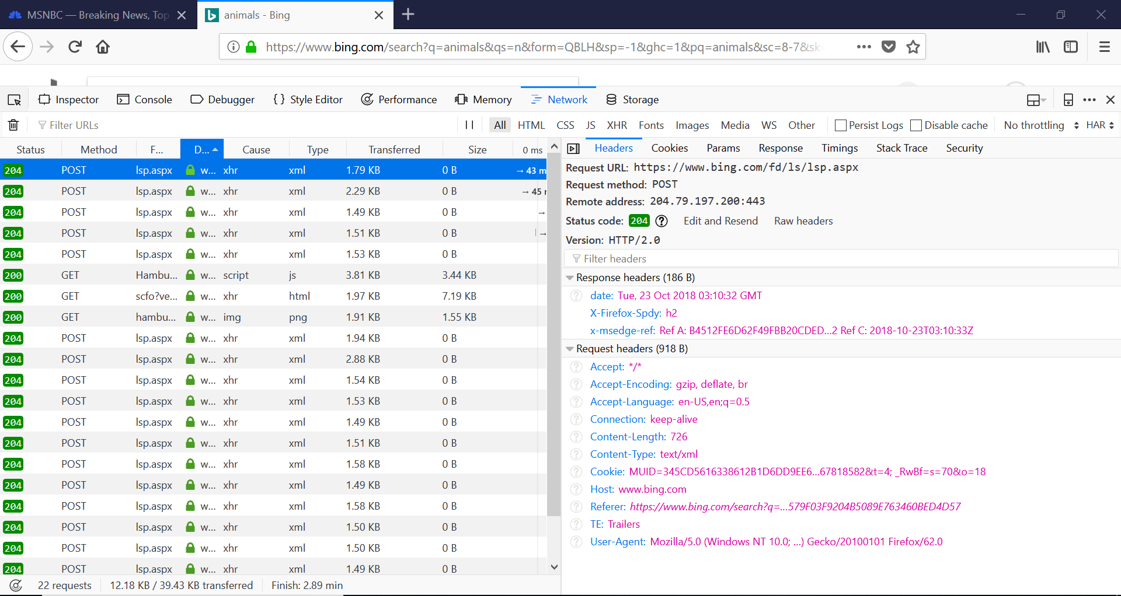

**Part B:**

1. According to <https://httparchive.org/reports/state-of-the-web>, which used a sample of over 1 million URLs, the average number of http requests made by a desktop page was 58.2. On average there were 75 requests made, 77% of which were http requests. According to the same site there are on average 19 TCP connections made per web page.
   1. HTTP/2 is a major update to the HTTP1.1 standards. It was developed by the Internet Engineering Task Force and is the first major update to HTTP since HTTP1.1. It allows web applications using HTTP1.1 to continue working, while adding new features that can be used by new applications.
   2. HTTPS is a secure version of HTTP. HTTPS focuses on authentication, and protecting the data being transferred across the web. Historically it has been used for transactions involving money to ensure that outside sources cannot look at the data being sent.
   3. HTTP Strict Transport Security is a web security policy that allows servers to force clients to use HTTPS to communicate. It was designed to prevent downgrade attacks, where a malicious program downgrades a HTTPS connection to the less secure HTTP type.
2. According to w3techs.com HTTP/2 is used by 30.6% of all websites, HTTPS is used by 42% of all websites and HTTP Strict Transport Security is used by 8.4% of all websites.