Identifiers=unique and descriptive

Use capitals or underscores for multiple words

Class=container for program

Packages=organized groups for classes

* To use packages write import statement : import packageName . *;
* For specific class rather than whole package of classes: import packageName. ClassNAme;

Scanner : import java.util.Scanner;

Method needs a () after : object.method();

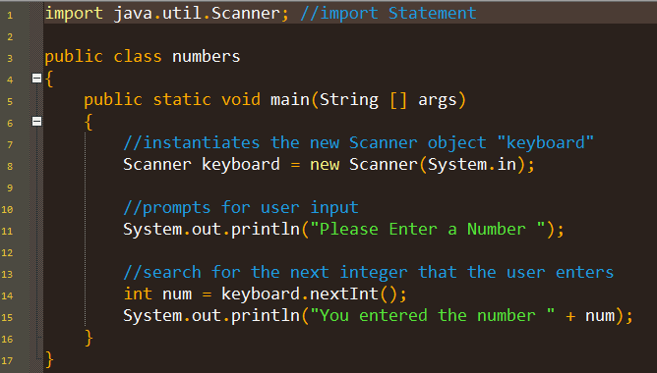

Yields:

Please Enter an integer: 77

You typed the number 77

|  |  |
| --- | --- |
| **Scanner Methods in the AP Subset** | |
| **Name** | **Return Value** |
| **nextInt()** | returns the next int value in the input |
| **nextDouble()** | returns the next double value in the input |
| **nextFloat()** | returns the next float value in the input |
| **nextLong()** | returns the next long value in the input |
| **nextByte()** | returns the next byte value in the input |
| **nextShort()** | returns the next short value in the input |
| **next()** | returns the next one word string value in the input |
| **nextLine()** | returns the next multi-word String value in the input |