TOBB UNIVERSITY OF ECONOMICS AND TECHNOLOGY

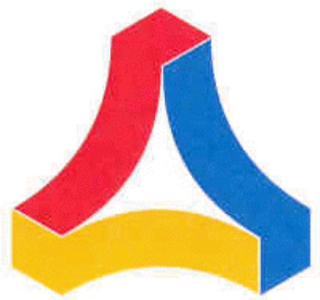

ELE495-SENIOR DESIGN PROJECT REPORT

Project Name
Batu Kaan Özen | 141201079
Selahattin Çağdaş Akalın | 141201051
Hande Yıldırım | 141201047
Burak Han Demirbilek | 151201022

SPRING 2019
CONTENTS

- Abstract…………………………………………………………………….…3
- Literature Analysis ……………………………………..………………….....3
- Method……………………………………………………………….……….3
- Time plan & Labor Division ………………………….……………………...5
- References…..……………….…………………………………………..........6

- Abstract
The main objective of this project is to create four robotic systems that can carry flags to find other robot systems and to make them to transfer their flags to other robots in the obstacle area.We are aiming to achieve one centered system which can control our four robotic devices. This main system consist of a microcontroller and a camera and four robotics devices include also microcontroller,motors and electromagnet. While developing this module, our plan is to detect robots and obstacles in the platform at a certain height with a camera located out of the platform. In addition, the basic working principle of this system is to detect robots and obstacles and to establish routes by color detection. With the routes calculated, we will use the route information to move our robots to the next destination. The technical process of the project is mainly based on the Image Processing, Embedded Systems, Robotics and Control Systems.

- Literature Analysis

The study of robotics has increased significantly in recent years. The definition of a robot is any man-made machine that can perform work or other actions normally performed by humans. In today’s world, robots contribute to many situations; from working in factories, to working in certain medical situations and, in some cases, exploring underwater. Some argue that robots are negative in our society because they take away potential jobs; but the significant rate of improvement is something that is hard to ignore.

- Method
- Design Ideas
We are planning to build four main modules as brain module, communication module, flag changing module and movement module. Brain module contains a Raspberry Pi 3 B+ and a camera.
In this module, we will put our camera upper side of platform, where this module is used for image processing. For instance, we have some obstacles across our first Robotics machine. First of all, we are going to select obstacles and our robots. Then, we will generate a route to find the next machine. To make an example, we can support the idea by following pictures. For better explanation of the camera footage of the platform and color separation and detecetion techniques, you can see some examples in pictures 1, 2 and 3 :

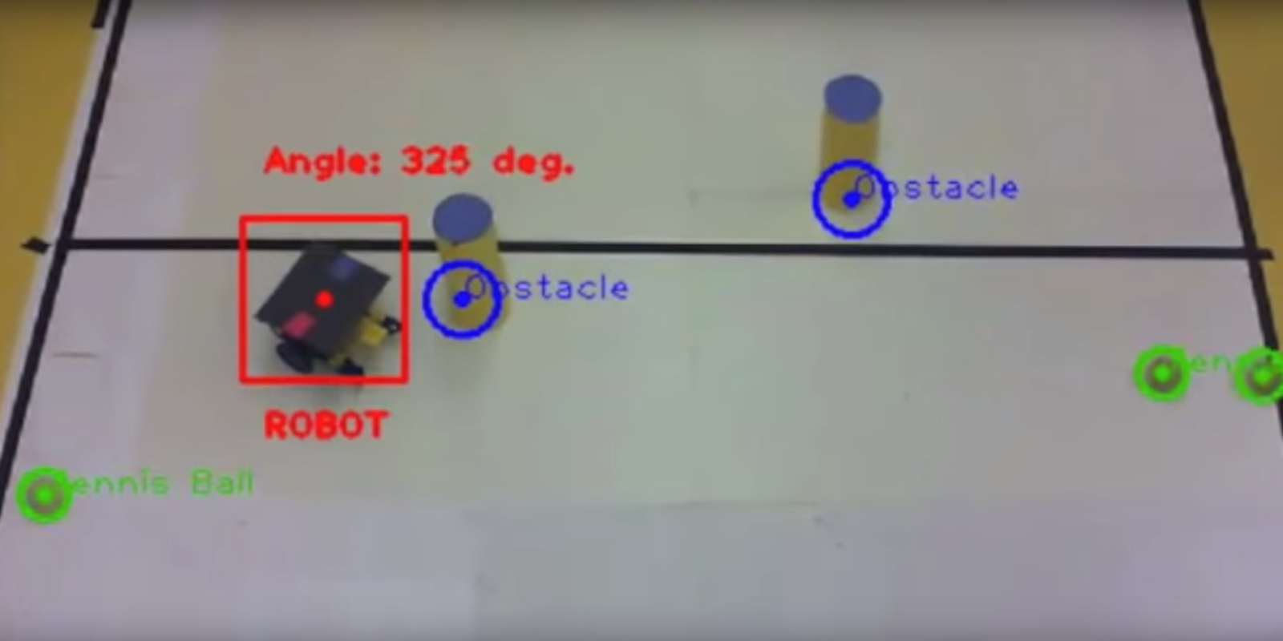
Picture 1 : Example camera footage for better explaining the module

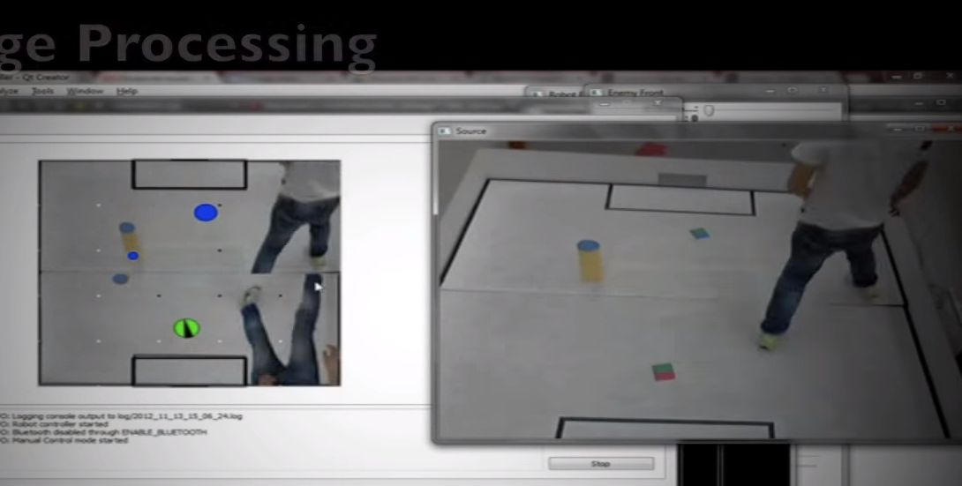
Picture 2 : Another example camera footage for better explaining the module

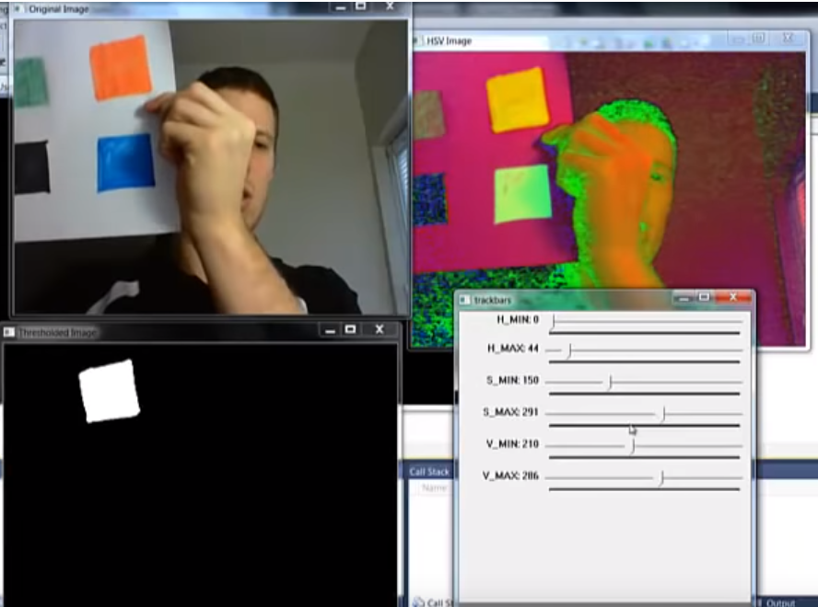
Picture 3 : Example color separation with modifying H,S,V values of the image(Hue, Saturation, Value(brightness))

Also, to generate a route you can see picture 4:

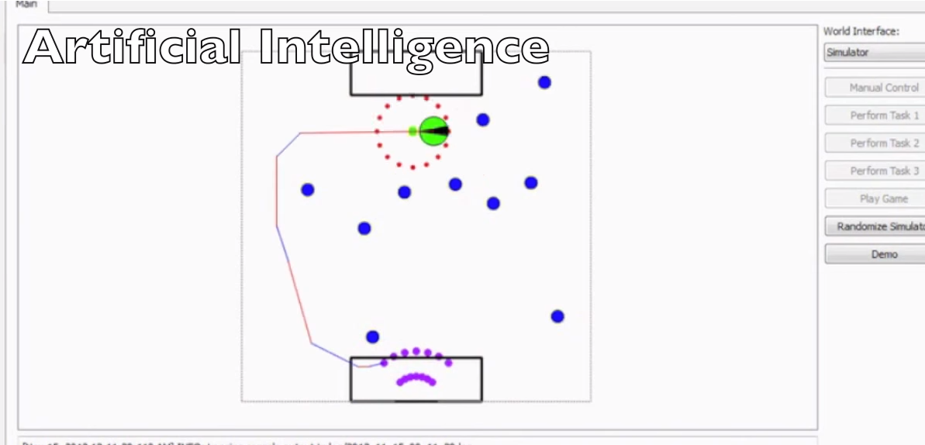
Picture 4 : Example generated route image with obstackles and robots.

Communication module is for connecting our devices by a radio transceiver chip called nRf24L01. We will send information between robots and our brain module. By doing this we are going to receive data from Raspberry Pi 3B+.

Flags changing module is aiming change flag between our robots. In this module, we used electromagnet module for changing flag between our robots and we achieved this part.
Movement module has 8 dc motors, 4 motor drivers(L298N), 4 Arduino-Uno microcontrollers, 16 tires and 4 bodies. To control the motors, normally we are planning to use on-off controller in our code but we have also another idea about using PID controller to achieve high performance and efficiency.

- Our Aim To Reach At The End Of The Semester

At the end of our project as a group, we are aiming to gain knowledge about Robotics system, Image Processing and Embedded systems and also increase teamwork skills furthermore ability of making project.

4. Time Plan & Labor Division

- Weekly Time Plan

January 21st to 27th | Completing the introductory report
January 28th to February 3rd | Completing Communication module and movement module
February 4th to 10th | Working on Brain Module and completing the demo design
February 11st to 18th | Working on Brain Module and gathering the equipment
February 18th to 23th | Completing the Brain Module and starting the installation
February 23th to February 26th | Completing the second improvement report
February 26th to March 12th | Testing on platform, optimization for our system and
March 12th to 17th | Post normalization
March 18th to March 22th | Completing the whole project

- Who is Primarily Responsible Of Which Part Of The Project
1. Brain Module : Burak Demirbilek, Çağdaş Akalın
2. Communication Module : Batu Kaan Özen, Burak Demirbilek
3. Flag Changing Module : Çağdaş Akalın, Hande yıldırım
4. Motion Module : Hande Yıldırım, Batu Kaan Özen
However, it does not mean that, they are going to make this spesific part of the project. It means that they are head of this part. We are going to work all parts together and also collaboratively to minimize the problems.

5. References

[1] https://sites.google.com/site/jmauldin3529/improvement-of-robotics
[2] http://www.dis.uniroma1.it/~bloisi/papers/bloisi-robocup2016-draft.pdf
[3] http://www.cs.cmu.edu/~rasc/Download/AMRobots5.pdf
[4] https://www.tandfonline.com/doi/pdf/10.1080/15599610802301243
[5] https://arxiv.org/ftp/arxiv/papers/1610/1610.03660.pdf
[6] http://ml.informatik.unifreiburg.de/former/_media/publications/lauercsr10.pdf
[7] https://www.youtube.com/watch?v=I3GhKfl4Rdc
[8] https://www.youtube.com/watch?v=g37BRulcyuc
[9] https://www.youtube.com/watch?v=25k-Y4_DdTw
[10] https://www.youtube.com/watch?v=s5ROKdRUkuI

