SegNet: A Deep Constitutional Encoder- Decoder Architecture for Image Segmentation:

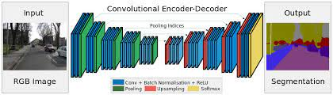

Segnet has an encoder network and a corresponding decoder network, followed by a final pixel wise classification. The final decoder output is fed to a multi-class soft-max classier to produce class properties for each pixel independent.

1.1 : Encoder:

- At the encoder, convolutions and max pooling are performed.
- There are 13 convolutional layers from VGG-16. (The original fully connected layers are discarded.)
- While doing 2×2 max pooling, the corresponding max pooling indices (locations) are stored.

1.2 : Decoder :
- At the decoder, upsampling and convolutions are performed. At the end, there is softmax classifier for each pixel.
- During upsampling, the max pooling indices at the corresponding encoder layer are recalled to upsample as shown above.
- Finally, a K-class softmax classifier is used to predict the class for each pixel.

1.3 Pytorch SegNet Implementation:

https://github.com/say4n/pytorch-segnet/blob/master/src/model.py

1.4 Pytorch SegNet Train:

https://github.com/say4n/pytorch-segnet/blob/master/src/train.py
Other Implementation:

https://github.com/say4n/pytorch-segnet/blob/master/src/train.py

https://learnopencv.com/pytorch-for-beginners-semantic-segmentation-using-torchvision/

Sources:

1. https://towardsdatascience.com/review-segnet-semantic-segmentation-e66f2e30fb96

